ASL Signed Presentation Rubric/4,3,2,1,0 Scale

Family Tree
Teacher Name: Mrs.TrimbleSmith
CATEGORY | 4 0 | 3 0 | 2 0 | 1 0
Sign Accuracy =  5 Parameters | Signs are clear and accurate during most or the entire presentation | Signs are accurate and clear about 80% of the time | Sign placement and direction are correct 50% of the time | Signs are difficult to read
Props/Visual  Aids =  Family Tree Display | Student props shows considerable work/creativity and made the presentation better. | Student props shows some work/creativity | Student props shows minimal effort | The student uses no props OR the props chosen detract from the presentation.
Facial Expression & NMM/NMS | Uses appropriate facial expression & mouth movement during entire presentation to indicate grammar and stress. Did NOT mouth the words. | Uses good facial expression & mouth movement during most of presentation | Uses some facial expression only when making an emphasis. Mouthed some of the words | No facial expression noted. Mouthed almost the entire time.
Presenting w/ Clarity and Fluidity =  You are connected to the audience and signing smoothly. | Establishes eye contact with everyone in the room during the presentation. Insures class is engaged and not just presents info. | Establishes eye contact with everyone in the room during the presentation. Presents info but engages class some of the time. | Sometimes establishes eye contact. Presents info but does not engage the class. | Does not engage the class or present much info.
Conceptually Accurate =  GLOSS – Using ASL structure not ENGLISH | Entire presentation is ASL and ideas are presented with appropriate conceptual sign & GLOSS | Students mixes some concepts with English sign but corrects self and tries to GLOSS | Some concepts are signed in ASL but uses a lot of fingerspelling and very little GLOSS. | Presentation is conducted in English literal language and uses no GLOSS
TOTAL Score

Comments:

Good job on:
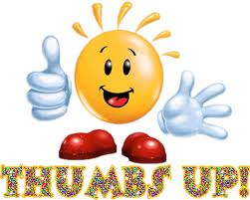

Suggestions for improvement:
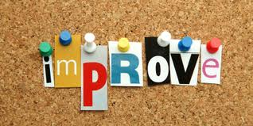
/ 200

