Appendix 2 (Rope Bridge) to Annex A to Operations Order Number 1 (SFC Roland F. Chu Memorial Competition SY 2013/2014) (Host Unit, Alhambra HS JROTC)

- General. This Appendix provides guidance for the completion of the One-Rope Bridge portion of the SFC Roland F. Chu Competition.

- Purpose. This station will test the leadership ability of the adventure team commander, and the team’s ability to execute a timed “water” obstacle crossing.

- Safety. All rope bridge participants will be hooked onto the rope bridge while crossing. A Swiss seat with carabineer hooked up is required for the One-Rope Bridge. Blouses are worn with sleeves down for the entire event. Cadets will not wear pistol belts, canteens, camelbacks, etc. during the event.

- Concept.

  - A team consists of 12 members; a minimum of 2 must be female.

  - Each team arrives on the site and receives a FRAGO that will initiate team actions to do the following:

    - All team members must cross the “water” obstacle

    - Team must move ALL equipment across the water obstacle

    - The team must successfully transport a casualty across the obstacle

  - Each team will construct a One-Rope Bridge across the water obstacle.

  - Bridging equipment: The team commander will be issued 1 unmarked Kernmantle bridge rope, 1 Green 120’ hauling rope, two additional 10’ ropes, 13 carabineers, 2-3 duffel bags and 2-3 parachute bags to carry equipment and complete their mission. They will also be provided with a simulated casualty secured to a military liter, and additional equipment that the team must get across the obstacle as directed in the FRAGO. Teams must supply their own individual sling ropes to construct Swiss seats and carabineers to attach themselves to the bridge while crossing.

  - After receiving the FRAGO, the Team Commander ha s up to 10 minutes to prepare his team for the river crossing. If the Team Commander is prepared before the 10 minute preparation time has expired, he will inform the evaluator and the graded portion of the event may begin. During the preparation period, no team member may enter or cross the obstacle. The crossing rope and hauling rope will be laid flat, with no knots, loops or other markings on the rope. The team may observe, but not touch the casualty, litter or the other equipment provided by the rope bridge evaluator. Team members will tie and prepare their individual Swiss seat during the preparation period. Once the team commander notifies the evaluator the team is prepared to cross the obstacle, no one may touch the ropes or equipment until the evaluator says “BEGIN”. Time starts on the command “BEGIN” and ends when the ropes are coiled (either mountain-coiled or butterfly-coiled) and placed on the ground on the far side of the obstacle.

  - Upon completion of the event the team will receive a debriefing, and recover/return all issued equipment. The team is then directed to the next event site.

  - All teams will complete the event even if team members are disqualified.

- Bridge Construction and Crossing. The One-Rope Bridge will be constructed using the Kernmantle (static) rope as the bridge rope and the Green 120’ rope as the hauling line. See Chapter 7, Section III, FM 3-97.61 (Military Mountaineering) for details on construction.

  - The far side anchor point will use a tensionless anchor or round turn with two half hitches. The first and last swimmer will be hooked onto the rope to “swim” the “water” obstacle by either a Swiss seat with carabineer in the back or front; or a standard Swiss seat rope wrapped twice around the waist secured with a square knot with carabineer in the back or front. An anchor knot that does not require constant tension will secure the swimmer to the rope. If the first or last swimmer is not hooked into the rope (i.e. holds the rope and attempts to cross, he/she is declared swept away and will be penalized at the conclusion of the crossing.

  - The transport tightening system (the knot and carabineer used to tighten the rope) will use the wireman’s knot or a directional figure eight knot. A carabineer, dowel or other object may be placed within the wireman’s knot or the directional figure eight knot to assist in breaking the knot at conclusion of event.

  - The near side will be tied off using a round turn with two half hitches.

  - No more than 7 cadets can be used to tighten or apply tension to the rope prior to crossing. (6 pullers plus 1 cadet used to tie off the rope to the near side anchor point)

  - Teams must cross the obstacle by using the following techniques:

    - Commando or Ranger Crawl. The crosser lies on top of the rope with the left instep hooked on the rope and the left knee bent, the right leg hanging straight to maintain balance. Progression is made by pulling with the hands and arms.

    - Rappel Seat Method. The crosser hangs below the rope suspended by a carabineer hooked to a Swiss Seat with the hands crossed over the top of the rope. Progression is made by pulling with the hands and arms.

  - Team members may assist other Team members getting on and off the rope. They may not, however, touch the water at any time during the event.

  - A maximum of 3 cadets may be attached to the rope simultaneously during crossing.

  - Construct a Hauling Line and anchor it to the near and far side.

  - Properly attach all equipment and liter to the rope bridge and transport the equipment across the obstacle.

  - Do not further “injure” the “casualty” by placing equipment on the casualty or liter. Do not attach additional equipment to the casualty or liter.

  - Ensure ALL equipment crosses the obstacle.

  - Coil both ropes after crossing the obstacle.

- Bridge Construction Evaluation.

  - Teams are evaluated on the amount of the time taken to:

    - Build their bridge with correctly tied knots and anchor points.

    - Cross the obstacle on a one-rope bridge

    - Successfully complete the mission (crossing the obstacle with the all team members, casualty, equipment and recovering all bridge equipment, to include coiling the rope)

  - This is a timed event with the maximum time limit of 30 minutes.

  - If any team member except the first and last team member, who are called “swimmers”, falls in, steps in, or touches the “water” while not attached to the rope bridge, he/she will be declared swept away and lost. The team will be penalized for any “lost” team member at the conclusion of the crossing.

  - Either swimmer not properly secured to the rope while touching the water will also be swept away, declared “lost” and the team penalized.

  - The evaluator will first inspect all swiss seats after the commander tells the evaluator they are prepared to execute. This inspection will not be timed, but incorrect swiss seats will be re-tied and penalties will be assessed.

  - The evaluator will inspect all knots during the event. They will not stop a team during the event for an improper knot; instead they will assess penalties at the conclusion of the crossing.

    - Tensionless anchor or round turn and two half-hitches on the far side anchor point

    - Transport tightening system (including installing at least one locking carabineer)

    - Round turn with two half-hitches tied after the team has pulled the bridge tight to the near side anchor point.

    - Figure 8 Knot with carabineer attaching Hauling line to rope bridge

    - Hauling line must be secured to each side of the obstacle

  - The team will be penalized for not properly coiling the ropes on the far side after crossing the obstacle.

  - Penalty times are added to the elapsed time at the conclusion of the event. Time stops when the either mountain-coiled or butterfly-coiled bridging rope “hits” the ground. Total time is cumulative between the one rope bridge completion time and penalty time.

- Scoring. See attached score sheet.

- FRAGO. See attached score sheet.
ROPE BRIDGE SCORE SHEET

SCHOOL: TIME:

Requirement | Executed Correctly | Penalty per Violation | Penalty Time Assessed
Swiss Seat Correct | Yes No | 30 seconds
Far Side Anchor Knot | Yes No | 30 seconds
Tightening Knot System | Yes No | 30 seconds
Near Side Anchor Knot | Yes No | 30 seconds
More than 7 Cadets tightening rope | Yes No | 30 seconds
More than 3 Cadets on rope at one time | Yes No | 10 seconds each
12 Team Members crossed the river | Yes No | 5 minutes
At least 2 Female Team members | Yes No | 5 minutes
Team Member declared “Lost” or Swept Away | Yes No | 30 seconds
Hauling Line correctly constructed | Yes No | 1 minute
Casualty crossed without further injury | Yes No | 2 minutes
All Additional Equipment crossed without loss | Yes No | 1 minute each
Rope properly coiled at conclusion of event | Yes No | 2 minutes
TOTAL PENALTY TIME ASSESSED
CONTRUCTION and CROSSING TIME
TOTAL EVENT TIME
Rope Bridge FRAGO

- SITUATION: Your team is on a patrol behind enemy lines. There is no other friendly support in the area. This is the only suitable water crossing site in the area. An American pilot has been strapped to a liter and brought to this location by local civilians. The pilot is alive but unconscious and severely injured. The civilians also gathered equipment from the helicopter and brought it to your location.

- MISSION: In 10 minutes, the ____________ Adventure team must recover a downed helicopter pilot in the vicinity of Camp Raymond and bring him to the medical treatment facility at CHU I headquarters.

- SPECIFIED TASKS:

  - Recover American Pilot
  - Conduct First Aid as required to keep pilot alive
  - Return pilot and all equipment to CHU I headquarters
  - Construct and deconstruct a one-rope bridge, with hauling line to transport your team, casualty and all equipment across the “water” obstacle.

- SERVICE SUPPORT:
  - Equipment provided:
    - 1 Kernmantle rope to build a bridge
    - 1 Green 120” rope to build a hauling line
    - At least 13 carabineers
    - At least 2 utility ropes
    - Miscellaneous equipment from crash, ammunition, rucks, duffel bags, parachute bags
    - First Aid kit and liter

Chapter 7, Section III, FM 3-97.61 (Military Mountaineering)
Section III. ONE-ROPE BRIDGE
The one-rope bridge is constructed using a static rope. The rope is anchored with an anchor knot on the far side of the obstacle and is tied off at the near end with a tightening system. A one-rope bridge may be built many ways, depending upon the tactical situation and area to be crossed (crossing a gorge above the tree line may require constructing artificial anchors). However, they all share common elements to safely construct and use the bridge: two suitable anchors; good loading and unloading platforms; a rope about 1-meter (waist) high for loading and unloading; a tightening system; and a rope tight enough for ease of crossing. Which side the tightening system is utilized, or whether an anchor knot or retrievable bowline is used, depends on the technique.
7-10. SITE SELECTION
A suitable crossing site must have "bombproof" anchors on both the near side and far side. These anchors must be extremely strong due to the amount of tension that will be placed upon them. Natural anchors, such as large trees and solid rock formations, are always preferred. The site must also have suitable loading and off-loading platforms to facilitate safe personnel movement.
7-11. INSTALLATION USING TRANSPORT TIGHTENING SYSTEM
The transport tightening system provides a mechanical advantage without requiring additional equipment.
a. The rope must first be anchored on the far side of the obstacle. If crossing a stream, the swimmer must be belayed across. If crossing a ravine or gorge, crossing may involve rappelling and a roped climb. Once across, the swimmer/climber will temporarily anchor the installation rope.
b. One man on the near side ties a fixed-loop knot (for example, wireman's, figure-eight slip knot) approximately 3 feet from the near side anchor and places the carabiner into the loop of the knot. The opening gate must be up and away from the loop. If two carabiners are used, the gates will be opposing. At that time, soldiers route the remainder of the rope around the near side anchor point and hook the rope into the carabiner. This system is known as a transport-tightening system (Figure 7-10). The man on the far side pulls the knot out four to six feet from the near anchor.
c. Once the knot has been pulled out, the far side man anchors the rope using a tensionless anchor. The anchor should be waist high.
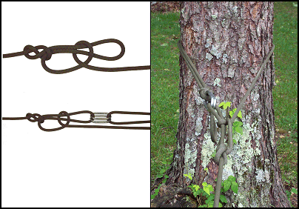
Figure 7-10. Transport tightening system.
d. A three-man pull team on the near side pulls the slack out of the installation rope. The knot should be close enough to the near side anchor to allow personnel to easily load the installation.
e. The rope the can be secured using one of three methods: transport knot (Figure 7-11), round turn around anchor and two half hitches on a bight (Figure 7-12), or a tensionless anchor knot (Figure 7-13).
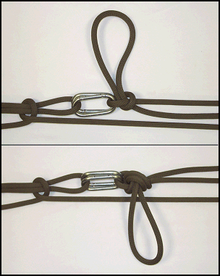
Figure 7-11. Transport knot
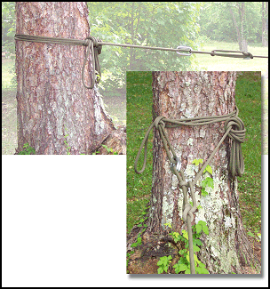
Figure 7-12. Round turn around anchor and two half hitches on a bight.
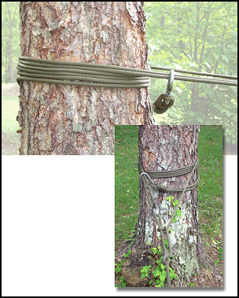
Figure 7-13. Tensionless anchor knot.
7-12. INSTALLATION USING Z-PULLEY TIGHTENING SYSTEM
The Z-pulley tightening system (Figure 7-14) is another method for gaining a mechanical advantage.
a. The rope is brought across the obstacle the same way as discussed in paragraph 7-10.
b. Once across, the far side man anchors the rope.
c. One soldier ties a friction knot (autoblock, web wrap, Kleimheist) with a sling rope onto the bridging rope on the near side bank. Two steel carabiners are inserted with opposing gates into the friction knot.
d. The rope is routed around the near side anchor and through the carabiners, from inside to outside, and is run back to the near side anchor.
e. A second sling rope is tied to the bridge rope and then anchored to the near side anchor. This knot will be used as a progress capture device.
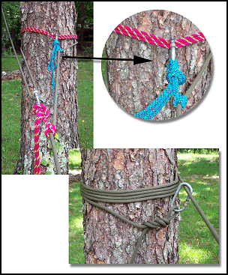
Figure 7-14. Z-pulley tightening system.
f. The three-man pull team on the near side then pulls on the rope, creating a pulley effect that tightens the system. As the rope is pulled tight, one man pushes the friction knot back toward the far side.
g. When the rope is tight, it is tied off with a tensionless anchor knot, transport knot, or round turn around anchor and two half hitches on a bight.

7-13. UTILIZATION
The rope bridge can be used to move personnel and equipment over obstacles. There are several methods of accomplishing this.
a. Method of Crossing. If dry crossing is impossible, soldiers will use the rope bridge as a hand line. Preferably, all soldiers will tie a safety line and attach it to the rope installation as they cross. If the soldier must cross with his rucksack, he may wear it over both shoulders, although the preferred method is to place another carabiner into the top of the rucksack frame, attach it to the bridge, and pull the rucksack across. Soldiers will always cross on the downstream side of the installation. If a dry crossing is possible soldiers will use one of three methods: commando crawl, monkey crawl, and Tyrolean traverse.
(1) Commando Crawl (Figure 7-15). The soldier lies on top of the rope with the upstream foot hooked on the rope and the knee bent close to the buttocks; the downstream leg hangs straight to maintain balance. He progresses by pulling with his hands and arms. To recover if he falls over, the soldier hooks one leg and the opposite arm over the rope, and then pushes down with the other hand to regain position.
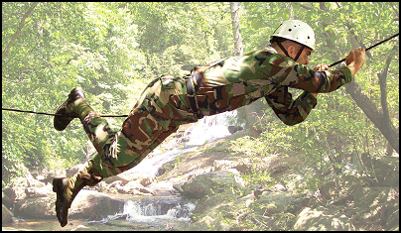
Figure 7-15. Commando crawl.

(2) Monkey Crawl (Figure 7-16). The soldier hangs below the rope suspended by his hands with both heels crossed over the rope. He pulls with his hands and arms, and pushes with his feet to make progress.
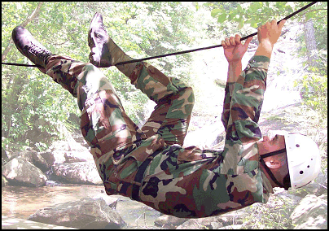
Figure 7-16. Monkey crawl.
(3) Rappel Seat Method (Figure 7-17). The soldier ties a rappel seat (or dons a seat harness) with the carabiner facing up and away from his body. He then faces the rope and clips into the rope bridge. He rotates under the rope and pulls with his hands and arms to make progress. The rappel seat method is the preferred method. If crossing with rucksacks, a carabiner is inserted into the frame and attached to the rope bridge. The soldier the places one or both legs through the shoulder carrying straps and pulls the rucksack across.
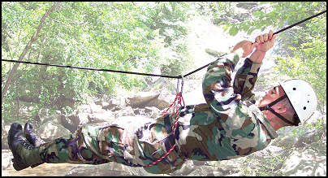
Figure 7-17. Rappel seat method.
7-14. HAULING LINE
A hauling line may be used to move rucksacks or casualties across the rope bridge (Figure 7-18).
a. Construction. An additional rope is brought across the rope bridge and anchored to the far side. The other end is anchored on the near side. All the slack is pulled to the near side, and a figure-eight slip knot is tied at the loading platform. A carabiner is inserted into the loop and clipped onto the rope bridge.
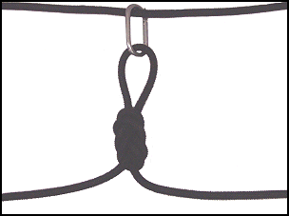
Figure 7-18. Hauling line.
b. Moving Rucksacks. Use carabiners to attach the rucksack frames to the rope bridge. Then clip the carabiner of the hauling line into the carabiner of the rucksack closest to the far side. Personnel on the far side pull the rucksacks across using the hauling line while personnel on the near side manages the slack at all times.
c. Moving Litters. The carabiner of the hauling line will remain on the rope bridge. On each side of this carabiner, using the hauling line tie a middle-of-the-rope clove hitch around both of the horizontal lift straps of the litter. Remove the slack between the carabiners. Then place the carabiners in each of the lift straps onto the rope bridge. The same technique used for the rucksacks is used to pull the litter across.
7-15. RETRIEVAL
Once all except two troops have crossed the rope bridge, the bridge team commander (BTC) chooses either the wet or dry method to dismantle the rope bridge.
a. If the BTC chooses the dry method, he should have anchored his tightening system with the transport knot.
(1) The BTC back-stacks all of the slack coming out of the transport knot, then ties a fixed loop and places a carabiner into the fixed loop.
(2) The next to last man to cross attaches the carabiner to his rappel seat or harness, and then moves across the bridge using the Tyrolean traverse method.
(3) The BTC then removes all knots from the system. The far side remains anchored. The rope should now only pass around the near side anchor.
(4) A three-man pull team, assembled on the far side, takes the end brought across by the next to last man and pulls the rope tight again and holds it.
(5) The BTC then attaches himself to the rope bridge and moves across.
(6) Once across, the BTC breaks down the far side anchor, removes the knots, and then pulls the rope across.
b. If the BTC chooses a wet crossing, any method can be used to anchor the tightening system.
(1) All personnel cross except the BTC or the strongest swimmer.
(2) The BTC then removes all knots from the system.
(3) The BTC ties a fixed loop, inserts a carabiner, and attaches it to his rappel seat or harness. He then manages the rope as the slack is pulled to the far side.
(4) The BTC then moves across the obstacle while being belayed from the far side

