Roman Contributions Documents

Document 1

Executive Branch
The two leaders of the executive branch, the consuls, were elected for just one year by the upper class. They supervised the Senate and ordered the Roman army during wars. Other members of the executive branch were the tax collectors, mayors, city police, and other people in positions of power in cities.
Legislative Branch
The most powerful part of the legislative branch was the Senate. The Senate was a group of about 300 male citizens who owned land. They could tell the consuls how much money they could spend and on what. These men were appointed by the consuls.
Judicial Branch
The judicial branch had six judges who were elected every two years. They were in charge of deciding punishments that criminals would receive. Their job was similar to the job that judges have today in the United States.

- What form of government did early Rome have?

- How was the government divided?

Document 2

Roman Law: Excerpts from The Twelve Tables
Table VII.

9b. Should a tree on a neighbor’s farm be bent crooked by the wind and lean over your farm, you may take legal action for the removal of that tree.

Table VIII.

1a. If any person had sung or composed against another person a song such as was causing slander or insult to another, he shall be clubbed to death.

- What principles of Roman law have been adapted by Western civilization?

Document 3
The Flavian Ampitheatre/Colosseum was a stadium-like structure which held deadly gladiatorial combats and wild animal fights free of charge.

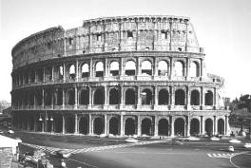

- How has the concept of the Flavian Ampitheatre/Colosseum been reflected in today’s western society?

Document 4

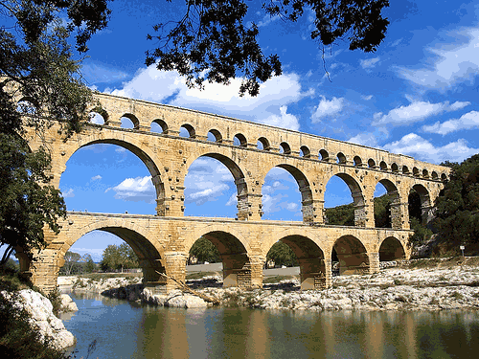

- What Roman innovation is pictured in Document 4?
- What was the purpose of this structure?

Document 5

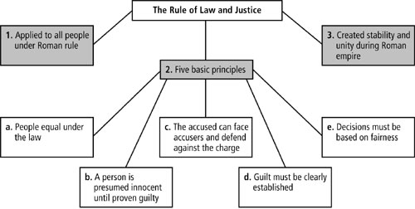

7. What are two principles of Roman law?

Document 6a

    - Citizen Rights
      - commercium  right to own property & enter into contracts
      - connubium  right to marry
      - ius  access to Roman civil law
      - suffragium  right to vote
        - voted as a member of a tribe, not individual

8. What are two rights every Roman citizen were guaranteed?

Document 6b

    - Obligations
      - Tributum  direct property tax
      - Military service  during adulthood or when needed; no limit to term in military

9. What is one responsibility every Roman Citizen had? _______________________________

Document 7

The concept of democracy, or rule by the people, was first developed by ancient Greeks. Leaders of ancient Rome continued that development and expanded it into a republic. Roman men were citizens who could vote for people to represent them. A ruling body, called a Senate, was run by powerful people. Less powerful citizens were given the right to veto or stop an action of the Senate. In these ways, all citizens had a say in the government. One emperor, Claudius, said:

“Let them enjoy indeed the title of citizens.”
—Emperor Claudius, as recorded b Tacitus, A.D. 48

10. What rights did Roman men enjoy as citizens?

Document 8

There is a saying that “All roads lead to Rome”. This was definitely true. The Romans built about 50,000 miles of roads across the empire. The roads were used to link far-away provinces with Rome. The army used them to move soldiers quickly from area to area. Traders used roads to sell goods and food throughout the empire.

Diagram of Roman Road
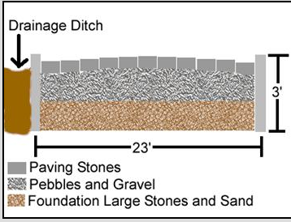

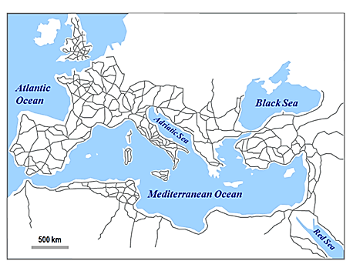
Map of Roman Road Network

11. How would Roman roads strengthen the empire?

Document 9

The ancient Roman Empire covered a huge area and included many groups of people. To rule such a large area, the Romans created a code of laws, the Twelve Tables. Many nations still use the principals of the Twelve Tables to create their laws today. The following principles, or rules, are examples of those developed by the Romans.

- All free people have equal rights before the law.
- A person must be considered innocent until he or she is proven guilty.
- Accused people should be allowed to face their accusers and defend themselves.
- Judges must interpret the law and make decisions fairly.
- People have rights that no government can take away.

12. Which principle prevents a government from becoming too powerful?

13. Which principle prevents someone from going to jail based on a rumor that he or she committed a crime?

