Moving Objects in Game Maker
You can make objects move up, down or across the screen very easily.
Before you can set up movement, you need to understand how the coordinate system in Game Maker works.
The game area and positions of objects in it are measured in pixels. You can set the size of the game area in the room properties, but by default it is 640 pixels across and 480 down, measured from the top left hand corner.
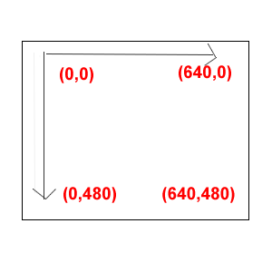
Each object has an x and y variable that stores the coordinates of its position. X is the distance across from the left hand side to the right hand side, and y is the distance down from the top. You can use or change these variables to place objects in certain positions on the screen.
In Game Maker as you move your mouse around a room, you can see the coordinates of the point where your mouse is at the bottom left of the screen.
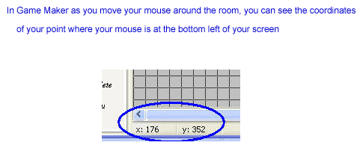
Here is a simple Game Maker 'game' that you can download that will show you what the coordinates of each point are.
Click on this link download a Game that shows you the coordinates
Try this quiz to show that you understand how the coordinates work.
x,y are at position (0,0)
write down what the coordinates are of the points on the chart.
