Complex Numbers Quiz 2

1. $\left|3+4i\right|$

- 34
- 5
- 7
- -34

2. $\left|2−5i\right|$

- 29
- $$\sqrt{\text{29}}$$
- $$\sqrt{\text{21}}$$
- 21

3. Find the product of 4 + i and 4 – i

- 15
- 17
- $$\sqrt{\text{17}}$$
- 16

4. ${\left(3−6i\right)}^{2}$

- 45
- 27
- 9 + 36i
- -27 - 36i

5. $\frac{3+2i}{4−i}$

a. $\frac{\text{10}+2i}{\text{15}}$
b. $\frac{\text{10}+\text{11}i}{\text{17}}$
c. $\frac{\text{14}+5i}{\text{15}}$
d. $\frac{\text{14}+5i}{\text{17}}$

6. 9i(3i)

- 27i
- -27i
- 27
- -27

7. (3i)(2i)

- 6i
- -6i
- 6
- -6

8. ${\left(2i\right)}^{3}$

- 8i
- -8i
- 6i
- -6i

9. $i^{\text{15}}$

- i
- -i
- 1
- -1

- Name the complex number represented on the complex plane:

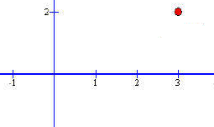
  - (3,2)
  - 2 + 3i
  - 3 + 2i
  - 3 – 2i

