Work, Energy, & Power Problem Set

Answer these Questions:
1. Some driver's license exams have the following question.
A car moving 50 km/hr skids 15 meters with locked brakes. How far will the car skid with locked brakes if it is moving at 150 km/hr?

2. Use the law of conservation of energy (assume no friction) to fill in the blanks at the various marked positions for a 1000-kg roller coaster car.
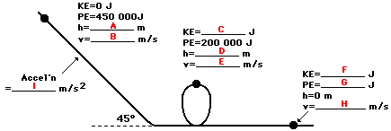

Do these following problems from your textbook:

Pages 278-282: #35, 42, 46, 52, 54, 55, 57, 58, 61

Answers:
35. Joules
42. Each requires the same amount of work because force times distance is the same.
46. a. Both people are doing the same amount of work because they are both climbing the same flight of stairs and they have the same mass.
b. The person who climbs in 25 s expends more power, as less time is needed to cover the distance.

52. 1x10⁴ J
54. 988 J
55. 2.75x10⁴ N
57. 126 W
58. 7.5 J
61. 8.0x10⁴ J

Page 283: #2, 4, 6, 7, 8

Answers:
2. D 4. B 6. B 7. A 8. 71 W

Page 871: #2, 7, 8

Answers:
2. 6.4 J 7. 5.4x10⁵ J 8. 0.45 m

*Note: There will be a couple of pendulum lab questions on the test.

