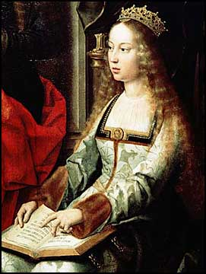
Queen Isabella

“A queen has disappeared who has no equal on earth for her greatness of spirit, purity of heart, Christian piety…and who created a rich patrimony and a strong economy, which is most important for the realm and the people.” – Francisco Jimenez de Cisneros, Archbishop of Toledo, on the death of Queen Isabella in 1504

Isabella, Queen of Castile and Aragon, was a strong ruler who helped unite Spain, increase its identity as a Catholic nation, and launch it toward world empire. While she and her husband, Ferdinand of Aragon, ruled together, her position in Castile, the most powerful Spanish kingdom, was supreme. A marriage agreement allowed that official papers and money would include both king and queen, but her coat of arms came first and subjects paid homage to her, not Ferdinand.
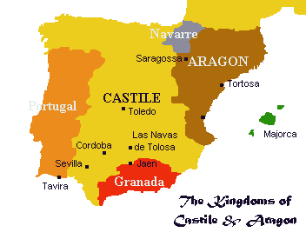
Isabella did not reach the throne easily. In her youth, her half-brother Henry ruled. When her own brother died, Isabella managed to be declared Henry’s heir. But on his death, she had to fight the king of Portugal, who was married to Henry’s daughter and asserted her right to rule.
Helping Isabella win this was her husband. Some years before, she had resisted Henry’s pressure to marry someone else and had chosen Ferdinand as her husband. “It has to be he and absolutely no other,” she said. Their marriage did more than join Spain’s major kingdoms. It fused two able rulers with a single purpose. They were called “los reyes”, the kings, because, wrote a diplomat, “they rule with one mind.”
One goal of their single mind was to complete the Christian reconquest of Spain. That was achieved in 1492 when Granada, the last Muslim kingdom, finally fell to their armies. With their victory, Pope Alexander VI declared them “Los Reyes Catolicos”, the Catholic Kings. Isabella and Ferdinand saw their role not only as leading Spain but also as defending the Catholic faith.
They took steps to reform the Catholic Church. Isabella encouraged Muslims to convert to Christianity. She used the Inquisition to find former Jews and Muslims who did not practice Christianity fully. Finally, Isabella came to believe that Jews did not belong in Spain. In 1492, they were forced to leave the country, forbidden to take any money, weapons, or horses with them.
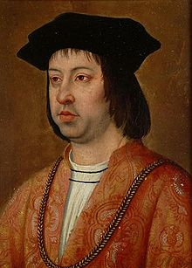
Spain was not unique in this cruel policy: England and France had expelled their own Jewish populations many years before.
In 1492, of course, Isabella also launched a great venture. Her great-uncle had been Prince Henry of Portugal, and she seems to have shared his spirit of adventure. Columbus had been asking for money since the mid-1480’s. Isabella made occasional gifts to him; to be sure he wouldn’t seek help from Portugal. Once Granada was taken, she approved his plan. Tapping into the royal treasury, not as legend has it pawning her jewels, the queen funded the purchase of ships. “We sent Cristobal Colon [Columbus’ name in Spain] with three caravels through the Ocean Sea to the Indies, on some business that touches the service of God and the expansion of the Catholic Faith and our own benefit and utility.”
Columbus’s voyage brought Spain empire and wealth. Isabella’s later years were saddened, however, by the deaths of two children and the growing madness of her oldest daughter. In her will, Isabella asked to be buried in the simple brown robe of the Franciscan order in a monastery in Granada. She also professed her love and devotion to her husband, but insisted that the new overseas empire belonged to Castile. Finally, in accordance with the law, she left her kingdom to her daughter while trying to ensure that Ferdinand retain as much power as possible.

Questions:

- What did Isabella and Ferdinand do as part of their role as protectors of Catholicism?
- What would you say led Isabella to fund Columbus’s voyage?
- How do the provisions of Isabella’s last will reveal her concerns?

