Proposed Chassell to Houghton
Recommended management plan

This plan covers the former Duluth South Shore and Atlantic railroad grade from the US 41 crossing south of Chassell to the Portage Lift Bridge in Houghton, a distance of 9.36 miles. The Department of Natural Resources owns the south eight mile segment. Michigan Technological University owns within its boundaries. Michigan Department of Transportation owns the north segment. The grade began as the Marquette Houghton and Ontonagon Railroad (?), a land grant railroad. The tracks were removed in 199_ and DNR gained ownership in 2003. DNR acquired the grade from SBC Ameritech in a UP wide purchase of railroad grades. SBC maintains an interest in the grade due to its buried fiber optic communications line. Protection of this fiber optic line is extremely important.

The grade width varies considerably. Much of the width in the south is 100 feet wide. There are segments where the width is 50 feet wide, 60 feet wide, and some where the width is 20 feet wide on the east side of the center line, and 50 feet wide on the west side of the center line.

There are numerous existing grade crossings. A trail survey in November 2002 showed 66 crossings. Not all of the existing crossings were under permit from the railroad. The railroad log showed 25 permitted road crossings south of Houghton. The track maps showed a few more crossings, but many fewer than those mapped in 2002.
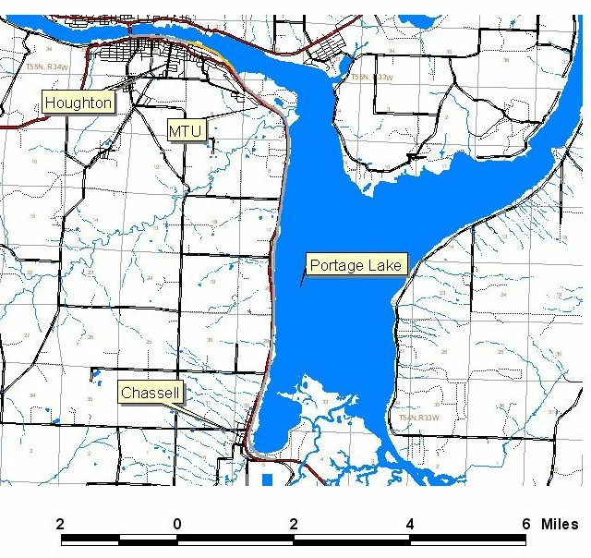
Trail head(s).
The recommended trail head is at the Third Street crossing in the Village of Chassell. Chassell maintains a park, boat launch, parking and toilets at this site. This site has good access and is close to one end of the grade.

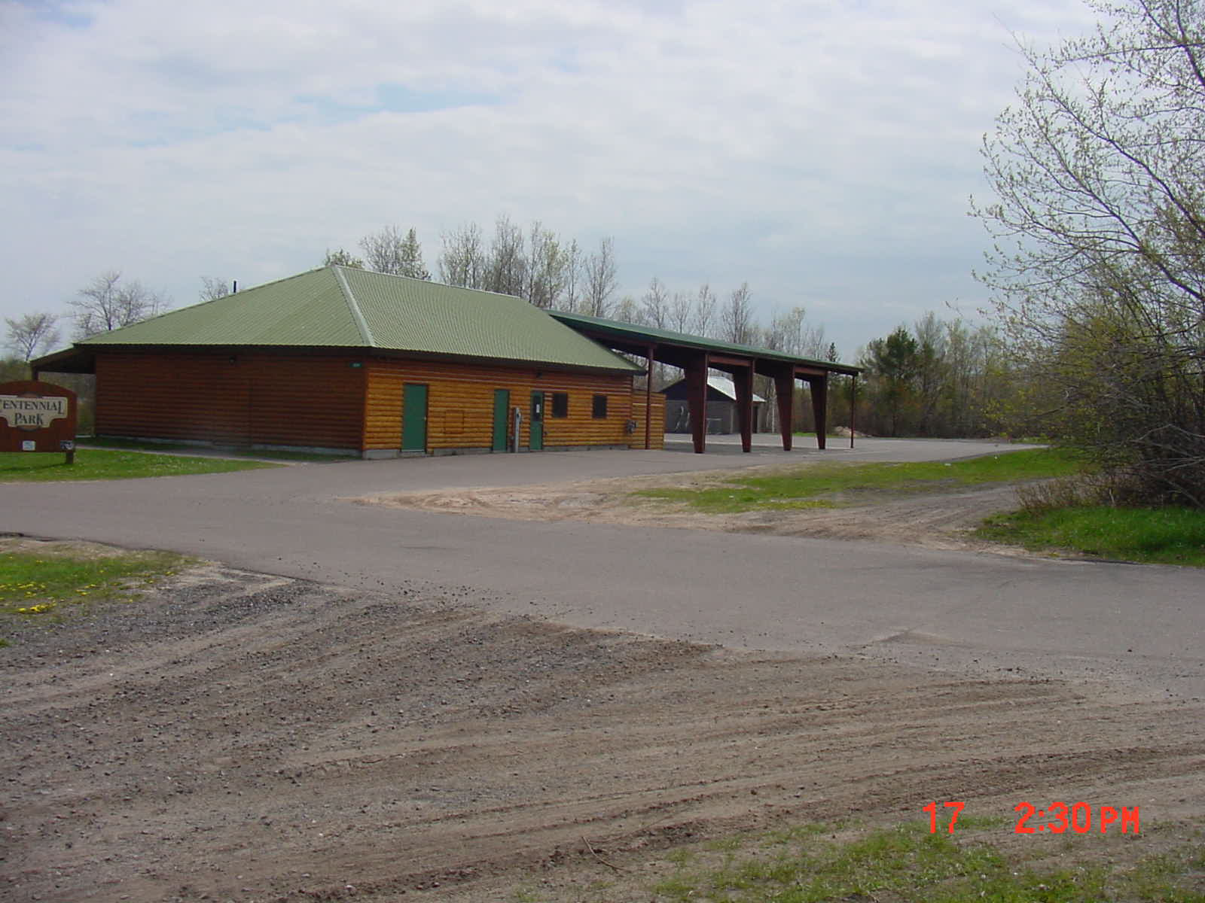
Chassell park south of Third street crossing
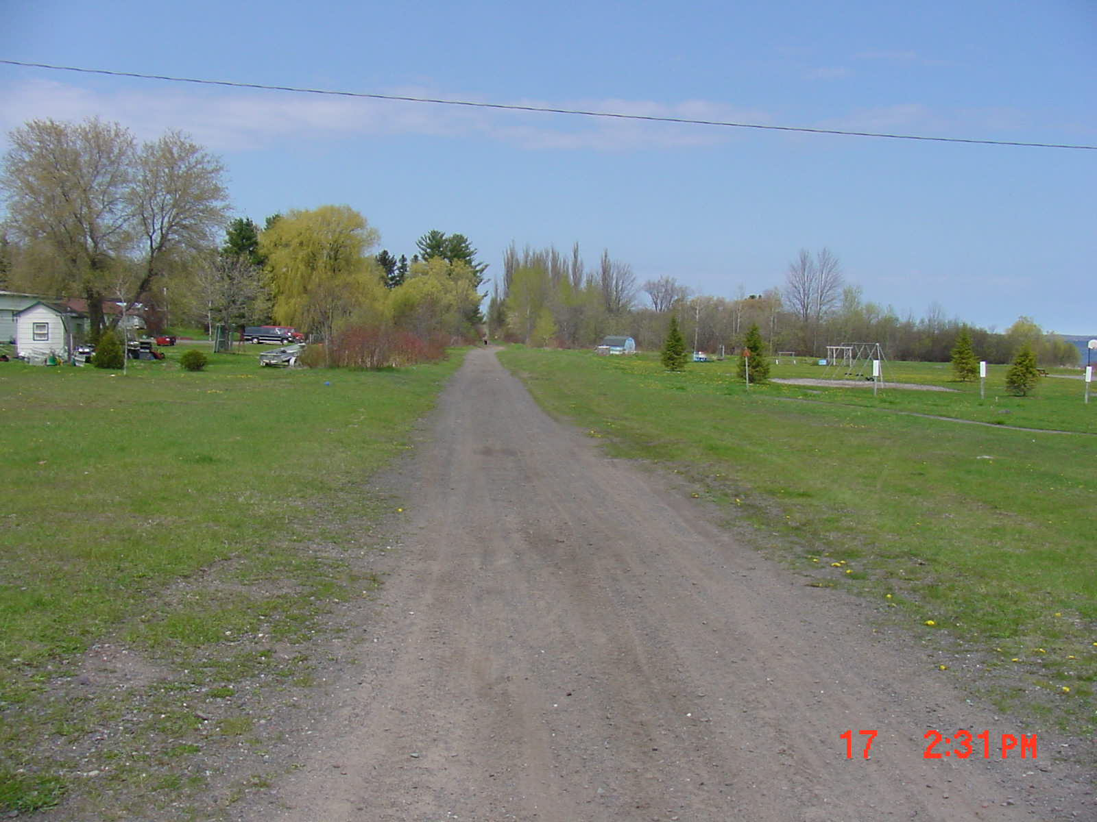
Looking north from third street at Chassell park

A second potential trail head may be in the City of Houghton, at the Ray Kestner Park. The City of Houghton maintains a park, playground, RV Park, beach, and toilet facilities. The city has paved a trail along the lake front that extends to the Pilgrim River crossing.

Existing road crossings:
There are issues with limited access to adjacent properties along parts of the grade. There are existing crossings, and permitted crossings. There are seven county or village road crossings:
- Sandpiper Drive
- Lindala Road
- Lake Shore Drive (north)
- Lake Shore Drive (south)
- Third Street, Chassell
- Fourth Street, Chassell
- Fifth Street, Chassell

In addition, there are some private crossings that provide access to several properties.
- Sheridan Place
- Un-named road
- Cottage Row

Recommended use.
The advisory committee recommended that the trail be primarily non-motorized. They recommended snowmobile use in the winter (December 1st to March 31st), and no wheeled motorized use allowed. They recommended that horses not be allowed.
Michigan Technological University does not want a motorized trail through its part of the grade.

Surface:
The committee recommended that the surface not be paved. The part of the grade north of the Pilgrim River Bridge is already paved. The intent was to keep the remainder as an unpaved trail. There are some issues here that will have to be tracked. Much of the trail in this segment is adequate as is. There are places where we will have to upgrade the surface (wet spots, or lawns) to gravel. Several road crossings will need some gravel approach work. An alternative material of blacktop salvaged from road jobs (applied as gravel) may be worth considering. DNR should review the surface issue after five years of use to determine if the unpaved surface is adequate.
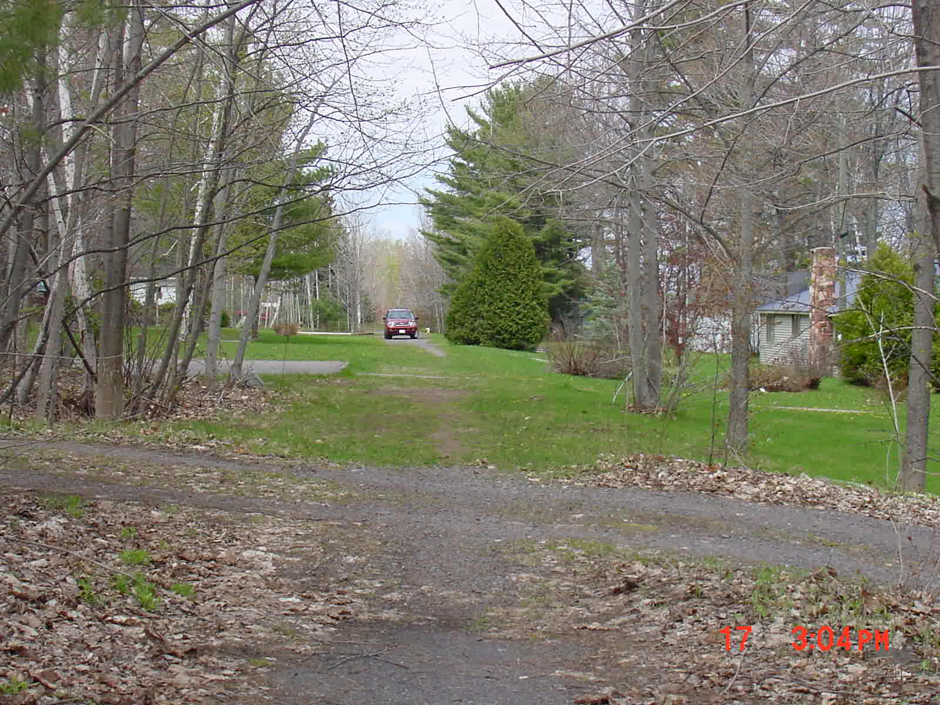

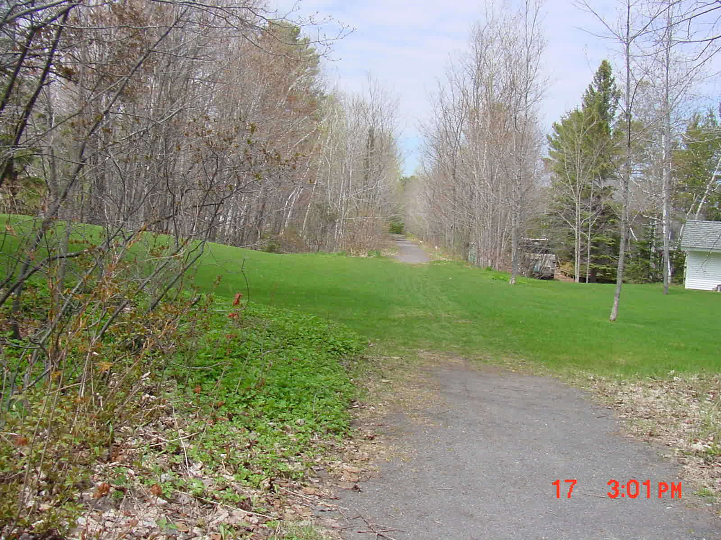
Brushing:
The trail needs to be brushed wide enough for the projected use, and for the maintenance equipment (snowmobile groomers). This means that branches will have to be trimmed. The goal is to have a 12 ft wide by 12 ft high clear area. Where possible, trees adjacent to the trail surface will be retained for shade. Anticipated problems: Several adjacent landowners have planted spruce trees immediately adjacent to the trail surface. It appears that these will have to either be cut or moved. The preferred option is to move them with a tree spade.
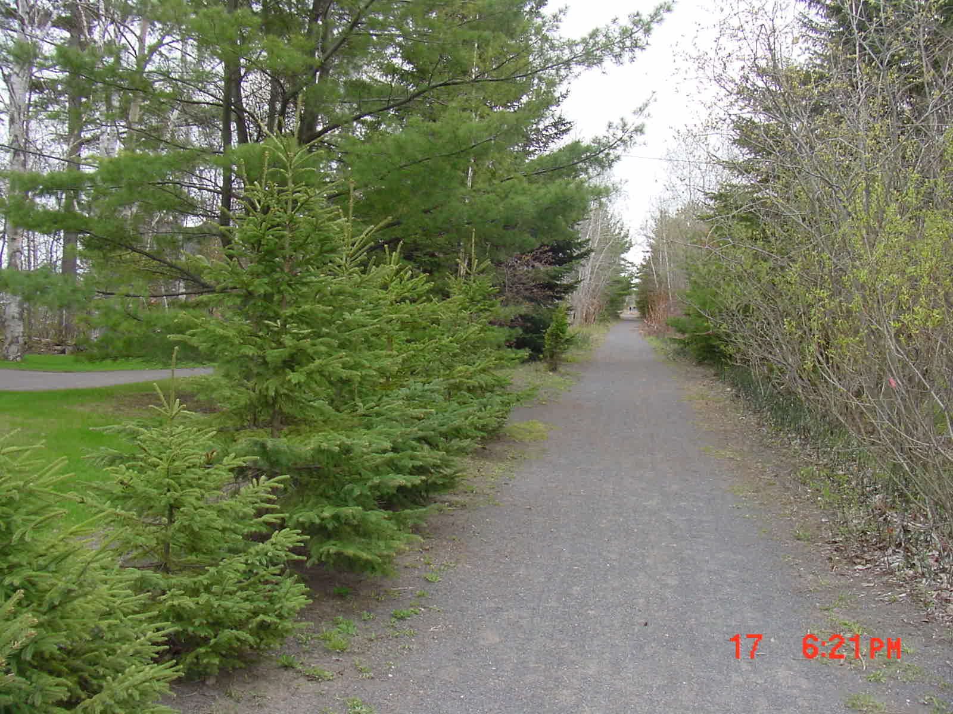
conifers planted too close to the trail

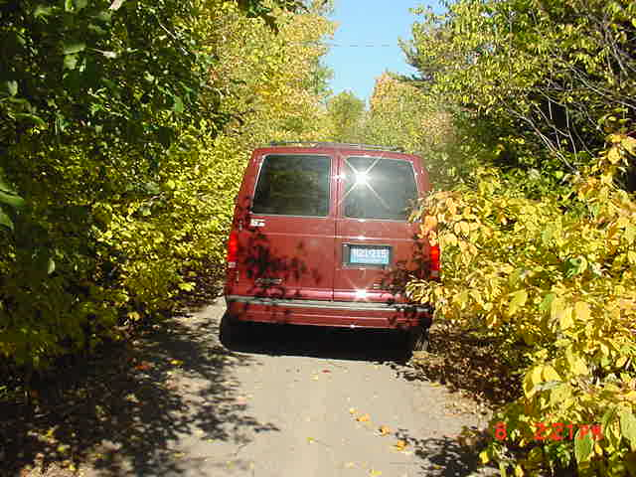
Brush 12 feet wide
Branches too near trail.

Signs:
The trail should be signed with the standard recreation and traffic control signs. (Stop, stop ahead, stay on trail, etc.) In addition, a sign is needed at the trail head. Signs should also be installed on road crossings indicating whether there is public access on the crossing.

Boundary marking:
Some form of boundary marking is needed between the State owned corridor and the private land beyond. The recommended signs are Carsonite posts with stickers showing state ownership on one side and private ownership on the other. The posts at trail crossings should be higher (visible throughout the year). The remainder of the posts could be shorter.

Maintenance:
There are some places where the ditches are not functioning. In one or two places driveways have been built across the grade with no culverts in the ditches. These will have to be upgraded.

Bridges:
The bridge across the Pike River needs a deck and railings. We recommend that a temporary deck and railing system be installed. When funds are available the deck and railings should be upgraded similar to the Firesteel Trestles deck and railings. The deck and railings on the Pilgrim River Bridge should also be reevaluated at that time.
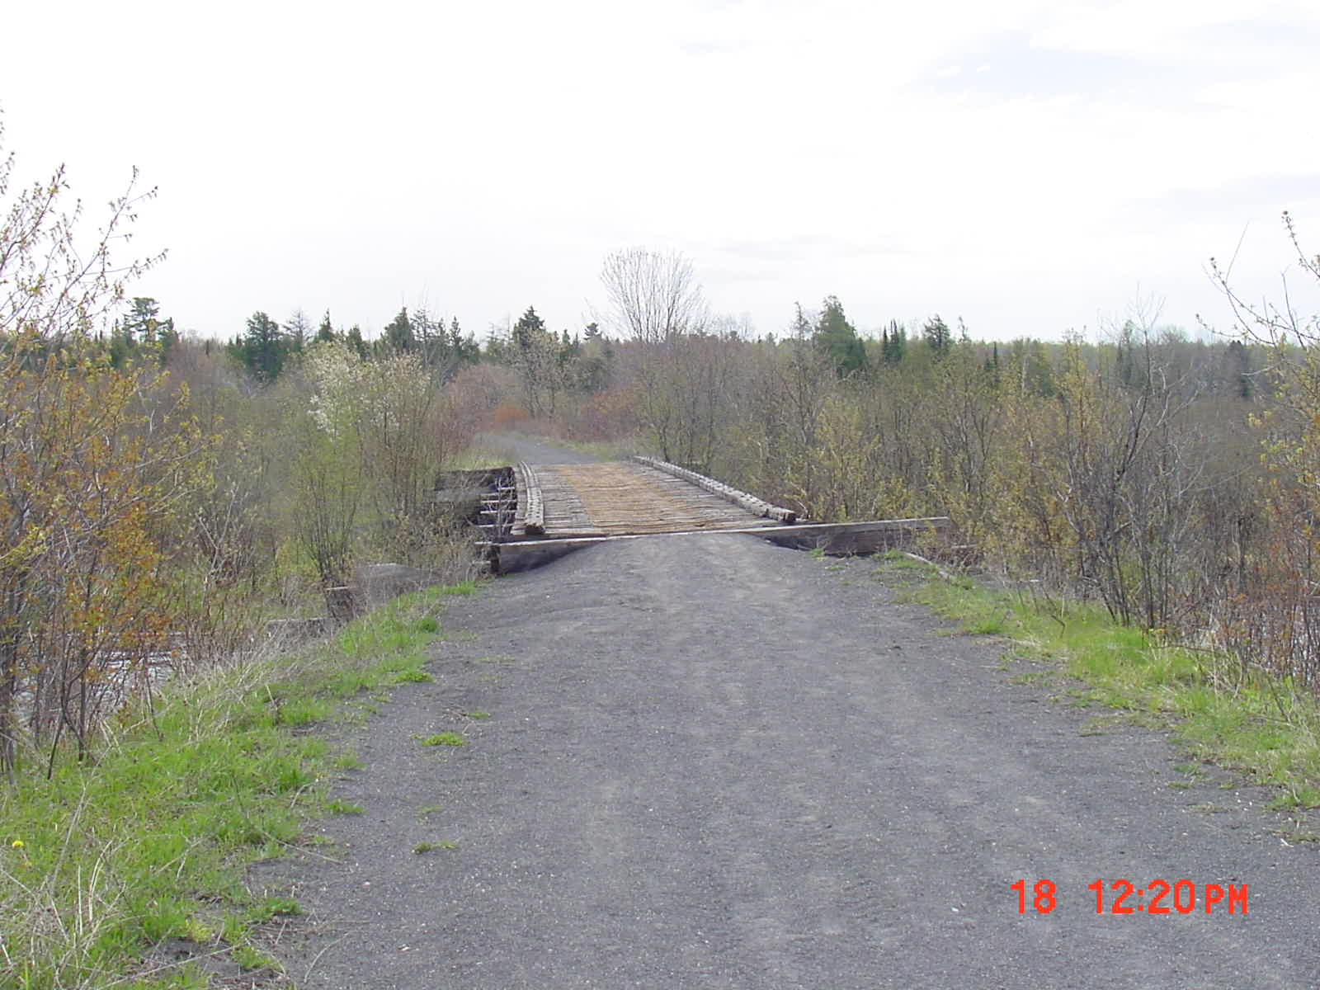
Pike River Bridge
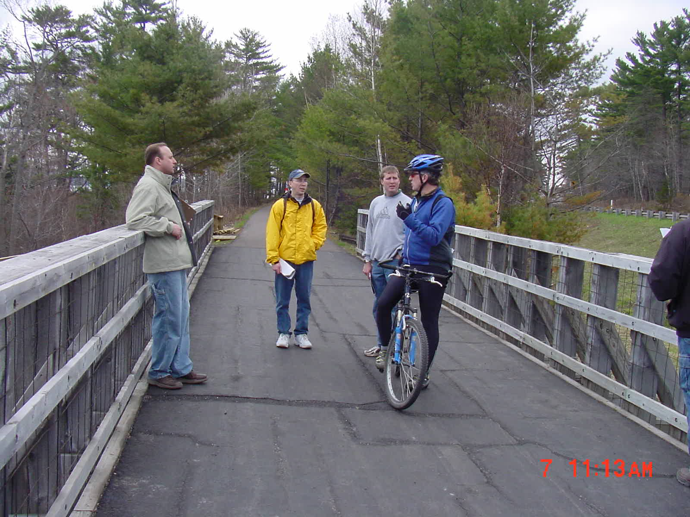
Pilgrim River Bridge
Crossings:
The goal is to maintain a safer trail by limiting trail crossings. Existing crossings should be used for future private access where possible. Crossings allowing access for multiple land owners should be encouraged. New crossings replacing existing access (however poor) should be discouraged. Pedestrian crossings should not be limited. Underground crossings for utilities should be encouraged and allowed. There are instances where crossings are needed to transfer sewage from a dwelling to a septic tank or drain field on the other side of the grade. These underground crossings should also be allowed. No drain fields or septic tanks should be allowed on the State owned land.

Encroachments:
There are numerous encroachments on this grade. There are two options. The first option is to maintain the existing ownership (existing width). This option keeps private structures at the maximum distance from the trail surface. There are numerous existing survey monuments in the area. The task with this option is to identify those survey monuments and to enforce ownership. The second option is to reduce the grade to a constant width. The narrowest width is 20 feet on one side of the center line. A constant width of 40 feet – 20 feet on each side of the center line would work. This option would have the advantage of eliminating many of the encroachments. Disposing of the excess property would be a problem. It is likely that the State ownership will be challenged in court. Because of this, it is not likely that this second option is a good idea,

