Practice1 Determine whether the sequence is geometric. If it is, find the common ratio.

a.

b. .

c.

d.

e.

f.

h

EXAMPLE 2 Finding the Terms of a Geometric Sequence Write the first five terms of the geometric sequence whose first term is and whose common ratio is

Practice 2 write the first five terms of the geometric sequence
a.

b.

c.

d.

Example 3 Find the 15th term of the geometric sequence whose first term is 20 and whose common ratio is 1.05.

Practice 3 find the nth term of the geometric sequence.
a.

b.

c.

Example 4 Find a formula for the nth term of the following geometric sequence. What is the 9th term of the sequence?
5, 15, 45, …..

Practice 5 find the indicated nth term of the geometric sequence.
a. 7th term:

b. 12th term:

Example 5 The fourth term of a geometric sequence is 125, and the 10th term is Find the 14th term. (Assume that the terms of the sequence are positive.)

a.

b.

c.

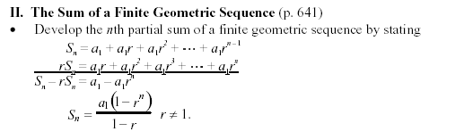
EXAMPLE 6 Find the sum 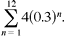

Practice 6 Find the sum

a. 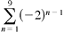

b. 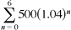

c.

d.

Example 7 Find each sum.

a. 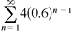

b.

Practice 7
a. 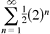

b. 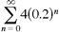

c.

d.

Example 7 A deposit of $50 is made on the first day of each month in a savings account that pays 6% compounded monthly. What is the balance of this annuity at the end of 2 years

Practice 7 Population Growth A city of 350,000 people is growing at a rate of 1.3% per year. Estimate the population of the city 30 years from now

**

