Union County Public Schools

Preschool Program

Parent Handbook
Revised 6/1/2015

UCPS Mission: “Preparing All Students to Succeed”

Program Information

Union County Public Schools
County Wide Preschool Programs
Program Contacts

Exceptional Children’s Director: Janie Webb
Director of Federal Programs: Lisa Gibson
Exceptional Children’s Preschool Coordinator: Donna Brown
Title 1 Program Specialist: Janet Turner
Exceptional Children’s Preschool Data Manager: Rosemary Kmec
Exceptional Children’s Preschool Assessment Team: Paula Simpson, Christine Yurko,
Anita Melton-Gross, Christi Sloop
Exceptional Children’s Preschool Spanish Interpreter: Mercedes Tohala

Contact Information
Exceptional Children’s Director | 704-296-6380
Title 1 Department | 704-296-0152
Exceptional Children’s Preschool Coordinator | 704-296-6376
Exceptional Children’s Preschool Assessment Center | 704-282-6259
Preschool Program Sites
Benton Heights Elementary: Title 1 | Shiloh Elementary: ECPK and Peer Pals
East Elementary: Title 1 | Union Elementary: NCPK and Title 1
Indian Trail Elementary: ECPK and NCPK | Unionville Elementary: ECPK and Peer Pals
Marshville Elementary: Title 1 | Walter Bickett Elementary: Title 1
Marvin Elementary: ECPK and Peer Pals | Walter Bickett Education Center: ECPK and NCPK
New Town Elementary: ECPK and Peer Pals | Waxhaw Elementary: ECPK and NCPK
Porter Ridge Elementary: ECPK and Peer Pals | Weddington Elementary: ECPK and Peer Pals
Rock Rest: ECPK and Title 1 | Wingate Elementary: Title 1
Rocky River: Title 1
Sardis Elementary: ECPK, Title 1 and Peer Pals

Welcome

Welcome! We are glad you are a part of the Union County Public Schools Pre-Kindergarten program. Our goal is to provide a safe learning environment where your child will develop socially, physically and academically as they prepare for Kindergarten and beyond. Parents are welcome to visit the school to enjoy various activities with your child. This handbook should answer most questions you have regarding our program. Please feel free to talk to your child’s teacher or Principal at any time.

Once again, welcome to Pre-K.

Preschool Programs
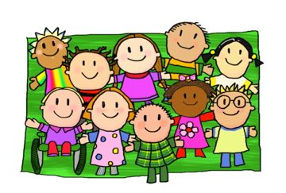

To enroll in one of the following preschool programs offered in Union County Public Schools, children must meet the specific eligibility requirements for the program to which they are applying. Three UCPS Exceptional Children’s preschool sites are Developmental Day certified and are currently located in separate elementary schools. These schools hold a Developmental Day license from the NC Division of Child Development. These classrooms must meet child care licensing requirements, staff education requirements and a 1:6 child to staff ratio. Enrollment in these classes is based on the same requirements as all other EC preschool classes.

- North Carolina Exceptional Children’s Preschool Program
The mission of the Exceptional Children Division of the NC Department of Public Instruction is to ensure that students with disabilities develop intellectually, physically, emotionally, and vocationally through the provision of an appropriate individualized education program in the least restrictive environment.
ncdpi.org
- Peer Pal Program
The EC Preschool Program in Union County Schools reserves a limited number of spaces in some preschool classes for typically developing children for preschool inclusion. Peer Pals must be four years old on or before August 31 of the school year for which they are applying. A monthly tuition rate applies to this program. Please refer to the EC Department website for program and application information.
ecp.ucps.k12.nc.us or 704-282-6259

- North Carolina Pre-Kindergarten Program
The NC Pre-K program is designed to provide high quality educational experiences to enhance school readiness for eligible four year olds. Each classroom provides high quality education using Creative Curriculum, which uses developmentally appropriate methods to prepare children for success in school. Union County Public Schools is a sub-contractor for the NC Pre-K program and offers several
classrooms in different elementary schools. UCPS does not identify students eligible for the program
but provides educational services to those identified as eligible by the Alliance for Children in Union
County.
theAllianceforChildren.org or 704-238-8917

- UCPS Title 1 Pre-Kindergarten
The Title 1 Pre-K is designed to provide a rich, child centered, literacy focused program to ensure that all children enter kindergarten ready to learn. The program provides experiences in the areas of language, early literacy, math, and science. These key experiences lay the groundwork for school success.
fedpro.ucps.k12.nc.us or 704-296-0152

Once your child has been identified as eligible for one of the above programs, enrollment procedures in Union County Public Schools are as follows:

Enrollment Procedures

The following forms must be completed, signed and returned to the school on or before the first day of attendance. This applies to all students enrolled in the EC Preschool, Peer Pal, NC Pre-Kindergarten, or Title 1 Preschool programs.

UCPS Student Enrollment Form
Emergency Contact Form
Birth Certificate
Immunization Record (child must be current on all vaccines)
Health Assessment Form completed by the child’s physician (UCPS uses the Kindergarten Health Form)
Policy Notification and Agreement Form
Photo/Video Form
Inclement Weather/Early Dismissal Procedure Form
Home Language Survey

If applicable:
Medication Consent Form
Peer Pal Application Form
NC Pre-K Application Form
Title 1 Pre-K Application

Note: A 30 day grace period may be granted to allow parents time to obtain the health assessment and immunization record. If a doctor appointment has not been made or kept to complete these forms, the parent will be notified by the principal that the child cannot return until the information is received. Also, the health assessment form must be updated annually.

Exceptional Children’s Preschool

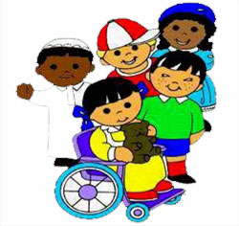

Students in the Exceptional Children’s Preschool Program often have different and varying personal and educational needs. Teachers and staff work hard to provide them with an environment that is as typical as the general school population. All other students, parents, and visitors should be respectful and accept these differences in a welcoming manner.

If your child is in the Exceptional Children’s Program and requires specific items such as diapers, baby wipes, feeding equipment, etc., please be sure the teacher has a supply to keep in the classroom or send them in daily. The school does not have extra supplies of this nature so parents will be called to pick up the child or bring items to the school if your child runs out.

Access to School Buildings



With the exception of the main office entrance at most elementary schools, all exterior school doors are locked at all times. This is for the safety of all students and school personnel. All visitors must go to the main office.

Arrival and Dismissal



Bell Schedules are as follows Monday through Friday:

Marvin Elementary 7:30-2:00
Weddington Elementary 7:30-2:00
Shiloh Elementary 7:30-2:00
Indian Trail Elementary 7:30-2:00
Sardis Elementary 8:15-2:45
Porter Ridge 7:30-2:00
Walter Bickett Education Center 7:00-1:30
New Town Elementary 7:30-2:00
Waxhaw Elementary 7:30-2:00
Unionville Elementary 7:30-2:00

Late Arrivals Will Need To Be Brought To the Front Office To Be Signed In

Bus Riders:

Any student dismissed early must be checked out in the office. All early dismissals must be prior to
15-30 minutes before the dismissal bell, unless there is an emergency. Please notify the school in the morning if your child will need to be dismissed early. By doing this, teachers have an opportunity to prepare your child’s materials before you arrive. Students will not be dismissed to anyone other than parents or a legal guardian unless we receive prior written permission from parents. A form of picture ID is required to pick up the child.

All transportation rules set forth by the Union County School Board and Central office staff will apply to the Preschool department.

When your child is taken home, you or the person responsible for your child must be at the designated bus stop or your child will be returned to the school. If your child is returned, you or a designated adult will be responsible for picking up the child at the school. If someone other than the parent picks up the child a picture ID will be required.

If your child is returned to the school site a second time, a conference will be held with the Principal. Should your child be returned to the school a third time, Central Services’ Staff and other agencies may need to be involved. At this time, school bus transportation is not provided to students enrolled in the NCPK or Peer Pal programs.

The following procedures will be given to each parent for review. Parents are required to acknowledge they understand these procedures by returning the signed Transportation Policies form (attached) to the teacher prior to being transported on a UCPS bus route. All questions should be directed to your child’s teacher.

- When I leave my child at the bus stop they will be with a responsible adult.
- I will give any medication to the bus driver and understand that children cannot transport medication in backpacks, lunch bags, coat pockets, etc.
- I have provided emergency contact information for my child. If I do not provide emergency information, my child will not be transported on a school bus until it is received.
- When the bus arrives at the child’s drop off site, the driver will not allow the preschool children to exit the bus unless the designated responsible adult is there to receive them.
- If no one is at the drop off site to receive the child, the driver will return the child to the school and deliver the child to the Principal or designee.
- Preschool children will never be left on the bus without an adult present.
- I will inform the school staff of any special behavioral, emotional, or physical needs of my child.

Car Riders:

Preschool parents should drop their children off in the car rider line or as specified by the child’s teacher. It is the parent’s responsibility to release their child to a responsible adult on the school campus. Each school has specific procedures that must be followed. A copy can be obtained from your child’s teacher.

Attendance

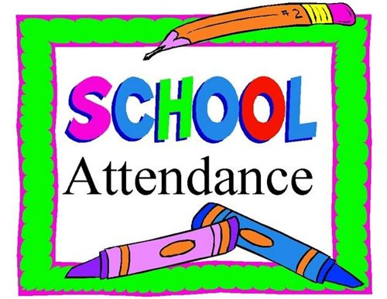

Your child’s success in the program depends on their attendance each day school is in session. Following any absence(s), a student is required to present written documentation from the parent/guardian stating the reason for the absence. Written documentation must be presented within three school days after the student returns to school; otherwise, the absence(s) will be coded as unexcused.

Examples of excused absences are: personal illness, family emergency and religious holidays. It is extremely important that students attend school each day unless they are ill.

Cancellation of School/Delayed Opening



The decision to cancel school is made by the school superintendent. Announcements concerning school closure will be made as early as possible. Connect-Ed calls will be made and announcements will also be communicated by local radio and television. If school is closed and you do not receive a Connect-Ed call, please send a note in your child’s agenda with the current phone numbers. All preschool classes follow the same procedures as upper grades for delayed start, early dismissal and school closure.

Change of Address/Telephone/Emergency Numbers

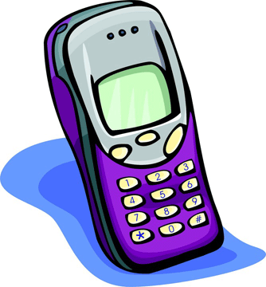

Please notify the school immediately if you have a change of address or telephone number during the school year. It is very important that the school be provided with emergency numbers in case of medical emergency or illness. Please remember that you can never have too many emergency contacts. When a change occurs, it is very important that you let us know so we can update your child’s file.

Dress Code and Items to be Provided by Parent

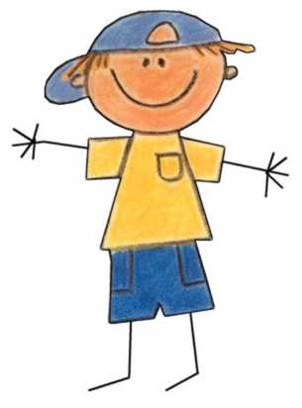
Please send your child in washable play clothes. For safety reasons, we encourage tennis shoes or other shoes with laces; please no flip flops. All students should have an extra set of clothing (appropriate for the season) at school. This should include underwear, pants, socks, and shirt. It is very important for your child to have a warm coat during cold weather. Parents should provide a change of clothes to be maintained daily, a bag or book bag for items to be sent back and forth from home, diapers and wipes if needed for diaper changing and current phone number for contact information.

Health/Medication Policy



Although children are often “contagious” before the onset of fever, the policy below complies with State Regulations governing all childcare facilities and attempts to reduce the widespread infection in our preschool classes. It is vital that your child’s teacher have up to date information on how to contact you or other designated persons in the event of an illness or emergency.

If your child has any of the following symptoms while at school, we will contact you or a designated person to pick up your child as soon as possible after receiving the call. Symptoms include, but are not limited to:
• A temperature of 100 degrees or more.
• 2 or more episodes of diarrhea.
• 2 or more episodes of vomiting.
• Contagious diseases.

MEDICATION AND ONGOING HEALTH CONDITIONS
If your child has a medical condition that could put him or her at risk for a medical emergency at school, the school nurse will contact you to develop a health plan. Examples of conditions include, but are not limited to, asthma, seizures, bee sting allergies, sickle cell anemia or certain heart problems.

A county wide medication policy has been developed to help prevent medication errors in the school. According to this policy, the administration of medication at school is discouraged. However, if you and your doctor decide that it is necessary for your child to receive medication during the school day, the policy below must be followed.

- All children’s prescription medication MUST be sent in an original prescription container with the instruction label attached. Note: Most antibiotics can be given at home. For example, an antibiotic ordered three times daily can be given at home before school, right after school and at bedtime.
- All “over the counter” medicine such as Tylenol, Benadryl, or cough drops MUST be sent in its original container. Please do not send individual doses of such pills in envelopes, plastic baggies, napkins, etc. This is for the safety of your child. Also, the Union County Public Schools policy now requires a physician signature on “over the counter” medication as well as prescription drugs.
- A physician’s written order and parent or guardian authorization is required before medications can be administered at the school. Medication consent forms are available in the school office or from your child’s teacher. After completion, you or your doctor may fax the forms back to the school. Your doctor’s signature is required for any medication that must be taken at school. To ensure the safety of your child, we will not give medication at school unless these measures are followed.

Emergency Procedures

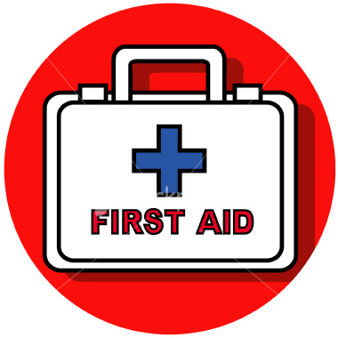

School personnel have received training in first aid and child CPR and have access to an emergency medical kit. First aid equipment is available in the preschool classroom and in the school office. If your child has a medical health care plan in place that was developed with the school nurse, those procedures will be followed as the parent has requested. In case of a suspected contagious disease, the parent will be contacted and asked to take the child home or to a doctor. For more serious incidents or accidents, school personnel will immediately call 911 and then the parent. If necessary, the child will be sent with an accompanying adult to the hospital of the parent’s choice as indicated on the application. If school personnel are unable to reach the parent, the emergency contacts, or the specified physician immediately, the school staff reserves the right to contact another physician, emergency care personnel or medical facility to treat your child.

Reporting Suspected Child Abuse and Neglect



Union County Public Schools is obligated under North Carolina law to report any and all suspected cases of abuse or neglect to the Union County Department of Social Services. North Carolina law states as follows:

§ 7B-301. Duty to report abuse, neglect, dependency, or death due to maltreatment.
(a) Any person or institution who has cause to suspect that any juvenile is abused, neglected, or dependent, as defined by G.S. 7B-101, or has died as the result of maltreatment, shall report the case of that juvenile to the director of the department of social services in the county where the juvenile resides or is found. The report may be made orally, by telephone, or in writing. The report shall include information as is known to the person making it including the name and address of the juvenile; the name and address of the juvenile's parent, guardian, or caretaker; the age of the juvenile; the names and ages of other juveniles in the home; the present whereabouts of the juvenile if not at the home address; the nature and extent of any injury or condition resulting from abuse, neglect, or dependency; and any other information which the person making the report believes might be helpful in establishing the need for protective services or court intervention. If the report is made orally or by telephone, the person making the report shall give the person's name, address, and telephone number. Refusal of the person making the report to give a name shall not preclude the department's assessment of the alleged abuse, neglect, dependency, or death as a result of maltreatment.
Upon receipt of any report of sexual abuse of the juvenile in a child care facility, the director shall notify the State Bureau of Investigation within 24 hours or on the next workday. If sexual abuse in a child care facility is not alleged in the initial report, but during the course of the assessment there is reason to suspect that sexual abuse has occurred, the director shall immediately notify the State Bureau of Investigation. Upon notification that sexual abuse may have occurred in a child care facility, the State Bureau of Investigation may form a task force to investigate the report.
(b) Any person or institution who knowingly or wantonly fails to report the case of a juvenile as required by subsection (a) of this section, or who knowingly or wantonly prevents another person from making a report as required by subsection (a) of this section, is guilty of a Class 1 misdemeanor.
(c) A director of social services who receives a report of sexual abuse of a juvenile in a child care facility and who knowingly fails to notify the State Bureau of Investigation of the report pursuant to subsection (a) of this section is guilty of a Class 1 misdemeanor. (1979, c. 815, s. 1; 1991 (Reg. Sess., 1992), c. 923, s. 2; 1993, c. 516, s. 4; 1997-506, s. 32; 1998-202, s. 6; 1999-456, s. 60; 2005-55, s. 3; 2013-52, s. 7.)

Discipline & Behavior Management Policy

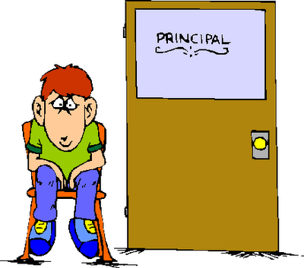

The teachers and staff at each school are committed to helping prepare our children to be responsible citizens. The UCPS Board of Education believes that the welfare of the individual student and of the larger school community is best served when all disciplinary actions and procedures support a positive educational environment.

We expect our students to follow these rules:
- Respect others- no name calling, cursing, teasing, or bullying
- Respect school property and the property of others
- Keep hands and feet and other objects to yourself
- Listen and follow directions
- Refrain from offenses defined in UCPS Board Policy 4-3a Student Discipline -Elementary

Consequences for less serious misbehavior:
- First Offense- Phone call to parent by the Principal
- Second Offense- Conference with parent, teacher and Principal
- Third Offense- Conference with parent, Site Principal and Student Intervention Team

Consistent disruptive behavior may result in suspension from a few hours up to 5 days as documented by the Student Intervention Team. If a student is suspended, a conference must be held with the parent, teacher and Principal.

For students in the Exceptional Children’s Program who have challenging behaviors, the teacher has the option of using an adapted preschool curriculum and/or strategies that focus on dealing with social and emotional behaviors.

Praise and positive reinforcement are effective methods of the behavior management of children. When children receive positive, non-violent, and understanding interactions from adults and others, they develop good self-concepts, problem solving abilities, and self-discipline. Based on this belief of how children learn and develop values, the Preschool Programs will practice a discipline and behavior management policy that is reinforcing, individualized and positive to all students. Depending on the needs of your child, we may, together with the parents, develop individualized behavior modification plans that include more structured reinforcements and consequences. We will be consistent in our behavior management program to provide a positive and successful environment for your child.

WE DO: | WE DO NOT:
Praise, reward, and encourage the children | Spank, shake, bite, pinch, push, pull, slap, or otherwise physically punish the children
Reason with and set limits for the children | Make fun of, yell at, threaten, make sarcastic remarks about, use profanity, or otherwise verbally abuse the children
Model appropriate behavior for the children | Shame or punish the children when bathroom accidents occur
Modify the classroom environment to attempt to prevent problems before they occur | Deny food or rest as punishment
Listen to the children | Relate discipline to eating, resting, or sleeping.
Provide alternatives for inappropriate behavior to the children | Leave the children alone, unattended, or without supervision
Provide the children with natural and logical consequences of their behaviors | Place the children in locked rooms, closets, or boxes as punishment
Treat the children as people and respect their needs, desires, and feelings | Allow discipline of the children by other children.
Ignore minor misbehaviors | Criticize, make fun of, or otherwise belittle children’s parents, families, or ethnic groups
Explain things to children on their levels
Stay consistent in our behavior management program
* Use short supervised periods of “time-out”



*Union County Public School Pre-K programs endorse the SEFEL (Social Emotional Foundations for Early Learning) model for teaching appropriate social emotional development in young children. For young children with challenging behaviors, a “Safe Space” will be provided in every classroom. Safe spaces consist of areas within the classroom with soft pillows, soft music, books on emotions, stress toys, etc. where young children can have a few minutes to calm down and regain control of emotions.
Maintenance of Classrooms and Playgrounds



All classroom and school campus facilities are maintained by the Union County Public Schools maintenance department. Sanitation of classroom toys and materials are completed daily by classroom staff. Sleeping mats are cleaned and sanitized daily by the classroom staff. Bathrooms and changing tables are cleaned and sanitized after each individual child as needed per guidelines of the Union County Health Department. General cleanliness such as sweeping and vacuuming floors, cleaning bathrooms, emptying trash cans, etc. is maintained on a daily basis by the schools’ custodial staff.

Meals and Snacks



Lunch is served at all of the prek classrooms. Breakfast and a snack may be served or may be optional, depending on the school site. You can check with your child’s teacher to determine which meals will be offered. If your child has allergies or you know of any reason that your child cannot try various types of foods, please provide this information to your child’s teacher in writing. If your child needs a specialized meal plan such as pureed food, you will need to provide related medical documentation from your child’s physician. Monthly menus can be obtained from your child’s teacher or from the UCPS website. Families may apply for free/reduced meals by obtaining an application from your child’s teacher or the school office. Students enrolled in the Exceptional Children’s Program, NC Pre-K or Title 1 will not be charged for meals if they qualify for the free/reduced program. Your child’s teacher will inform you if you need to provide the daily snack or if it is provided by the specific preschool program. Since Developmental Day classes follow strict day care licensing nutrition regulations, parents of children attending these classes must complete an “opt-out” form if you wish to send a packed lunch from home. Otherwise, his/her lunch must be supplemented with cafeteria prepared food in order to adhere to nutrition guidelines. This form can be obtained from the classroom teacher. Peer Pals may bring packed meals from home or purchase them in the cafeteria.

Field Trips



Field trips are a way to extend a child’s learning by providing experiences outside the school building. This may include walking trips to observe things in the neighborhood or visiting stores or other places of interest. Some field trips will require riding a school bus. A signed permission form is required for all trips. Teachers will send these forms home prior to each trip. Parents who wish to volunteer to go on field trips must complete the Union County Public Schools volunteer information packet prior to the trip.

Recess
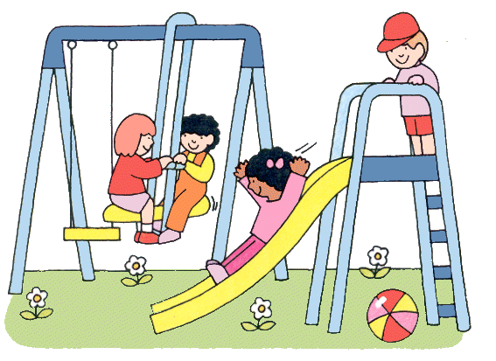

All Pre-K students are required to have recess daily for at least 60 minutes per day. Outside time for Pre-K students is considered an extension of the classroom and promotes development of abilities in motor, cognitive, communication, adaptive and social skills. If your child is too sick to participate in outside time, please make other arrangements for the day since our recess time is considered a part of the Pre-K curriculum.

Quiet Time



All Pre-K students have the opportunity to rest for up to 60 consecutive minutes at a scheduled time of the day. If your child does not sleep, quiet activities will be provided. Rest times can be modified based on your child’s needs during the school day as long as it is not a disruption to the instruction of others in the classroom. A preschool mat will be provided by the school. The parent will be asked to provide a crib sheet and blanket which will be sent home weekly to be washed and returned. You may provide other items from home for rest time upon the discretion of the teacher.

Volunteer Program

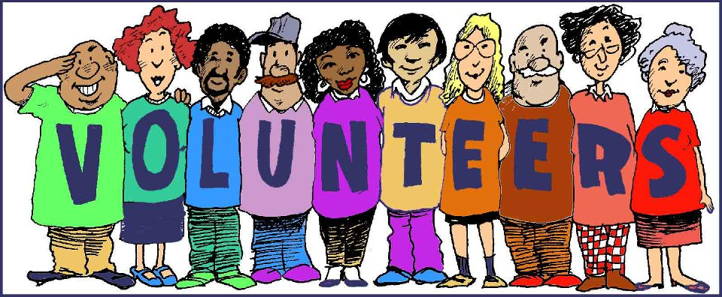

School volunteers perform a valuable service to our school. The additional assistance that volunteers provide directly benefits students by improving and expanding opportunities available to children. Volunteers willing to donate time and talent can help make the learning process more exciting and meaningful. If you are interested in volunteering, please contact your child’s teacher. Volunteer applications are available on-line. For obvious safety reasons, the volunteer application process includes a Criminal Background Check.

Religious Beliefs



Activities, instructions or communications which promote specific religious beliefs are not directed towards students. All classroom curriculums reflect the diversity of cultures around the world.

