River Oaks Academy
1015 Mt. Holly-Huntersville Road
Charlotte, NC 28214
Home of the Bulldogs!
“Empowering Scholars for Academic Success”
Parent-Scholar Handbook
Vision Statement: River Oaks Academy will provide scholars safe environment of rigorous learning, that encourages critical thinking, fosters intellectual curiosity, and provides scholars with opportunities to develop character and excel within our global community.

Mission Statement: To empower scholars to reach their maximum potential to become successful and competitive within the global community!
River Oaks Academy
Welcome to River Oaks Academy, a CMS school in the West Learning Community! We take great pride in our school, and continue our journey of learning and presents “ROA: An Opportunity Culture!” Our staff knows and works hard to see that we are responsive, dedicated, and committed to providing scholars with an education that will truly “Empower them for Academic Success”!
This book is designed to give you information to assist us as we work together in this partnership to ensure the best for your scholar. Please read it carefully and place it in a location where you can reference it from time to time. If you have any questions, please feel free to contact us here at school. We look forward to another fantastic year!

Regards,
Marilyn Tate-Osborne
Marilyn T. Osborne,
Principal

Contact information

School Telephone 980-344-1020
Fax 980-343-1816

Principal Marilyn T. Osborne
Assistant Principal Anika Baker
TD Facilitator JoAnn Grieve
Literacy Facilitator Jennie Green-Morehead
Math Facilitator Victoria Bailey
BMT Craig Maynor
Teaching Assistant Principal Karen Scullion
Nurse Pat Satterfield
West Learning Community TBA
Secretaries Betty Tatum, Sr. Administrative
Kassandra Ottley, Registrar/10 month
Susan Kenley, PT

INTRODUCTION
System Vision: Charlotte Mecklenburg Schools provides all students the best education available anywhere, serving as a beacon to the nation, equipping our children to lead rich and productive lives.
CMS Mission: CMS’s mission is to maximize academic achievement by every student in every school.
School Vision Statement: River Oaks Academy will provide scholars a safe environment of rigorous learning that encourages critical thinking, fosters intellectual curiosity, and provides scholars with opportunities to develop character and excel within our global community.
ROA Mission Statement To empower scholars to reach their maximum potential to become successful and competitive within the global community!

River Oaks Motto: “Empowering Scholars for Academic Success!”

Arrival/Dismissal Information
School Hours!!! 8:30-3:45

DAILY SCHEDULE FOR 2013-2014

8:00-8:10 TEACHERS ARRIVE AT SCHOOL
8:10 BUSES ARRIVE/BREAKFAST PROGRAM STARTS
8:20 SCHOLARS ENTER THE BUILDING
8:45 TARDY BELL RINGS
3:45 DISMISSAL TIME FOR STUDENTS

ROA is a Pre-K-5 elementary school of diverse backgrounds, focusing on educating the total child. We believe that all scholars possess the desire to learn and grow and we are dedicated to giving them the opportunity to achieve academically, while encouraging responsibility and character development. Further, we believe students have a shared responsibility in helping themselves to reach their full potential. Because parents are champions for their scholars, and teachers are facilitators of learning, we must work together as a cooperative team to ensure learning is optimal. Through the implementation of a myriad of programs and strategies, scholars will use multiple intelligences, technology, investigations/research, and self-reflection to attain academic excellence.
Goals:
- To have each scholar responsible, respectful, and receptive to learning
- To have each scholar strive for academic excellence
- To promote community and pride in the school and its’ activities
- To instill character development through school-wide service projects
Expectations for Scholars
- Academic Excellence
- Outstanding Attendance
- Scholarly Attitudes
- Excellent Character
Expectations for Staff
- Regular Attendance
- Knowledge of Content
- Professionalism
- Dedication to provide scholars with meaningful opportunities for learning and growing
Expectations for Parents
- Supporting the school
- Involvement in school/scholar(s) activities
- Respect for school personnel
- Working with staff to make ROA the Best in the West!

Attendance Process

- In order to do well in school, all scholars are expected to be in attendance ... When scholars arrive late, they are missing a vital part of the curriculum. Having them here daily will ensure exposure and instruction needed to give them the academic gains needed for grade level success. If scholars are out for any reason, please send a note explaining their absence on the next day. All absences without notes are documented as ‘unexcused’.
- If a scholar comes in after 12:00 or leaves prior to 12:00 noon, s/he will be counted absent.
- The above includes either excused or unexcused absences.

- Please have your scholars in school on time. When they are late, they are missing an integral part of learning, and instruction on many objectives that will not be repeated. In order to help her/him meet with success, help us by seeing that your scholar is in class at the beginning of the instructional day. After three, six, and nine unexcused absences, parents will receive a letter from the principal and the CMS legal department.

Definition of an Excused Absence:
- Death in the immediate family (1-3 days)
- Court or administrative proceeding
- Current doctor’s note
- Quarantine
- Parent’s note for sickness/illness
(Three consecutive days requires a doctor’s note)
Suspension from school (OSS)
Religious observance (See CMS Approved List)
Approved Administrative educational opportunity

***A student should be marked present for a school-related absence (field trip, In-School Suspension, etc.)***
- A scholar’s excused absence must be documented/recorded as an excused absence.
Parents will be notified via Connect Ed when scholars are absent. Parents may send in written excuses for reasons noted above for the first three single day absences. Beginning with the fourth absence, a doctor’s note will need to be sent in with the scholar. Teachers will document absences for administrative purposes.

B. School Day for Students

1. The Instructional Day is from 8:30-3:45 pm

2. Arrival and Departure Time
    - Arrival Time- Because staff does not report to work until 8:00, scholars should not arrive before 8:20 am, at which time they may report to class. If scholars are eating breakfast, they must arrive by 8:20 am if they are car riders. Scholars are tardy after 8:45 am.
    - Departure Time- Dismissal begins at 3:45 pm. Car riders will be dismissed from the front entrance, and buses will be called three at a time as they arrive. For the first few weeks, scholars may arrive at their bus stops a little late until the routes are worked out. We ask that you work with us as we go through the process. If your scholar is a car rider, please have them picked up no later than 4:00 pm.
    - Early Dismissal- We realize that periodically scholars may have to be picked up early. We ask that you do this in emergency situations only. Cut-off time for early dismissal is 3:00 pm. No scholars will be dismissed after three o’clock. If you know you have a doctor’s appointment or need to get your scholar early, please send a note in to the teacher, or fax or email the information to us so that we have your request in writing before 3:00. We want to refrain from interrupting precious instructional time. There is much to be learned, and reviewed at the end of the day; staff is still instructing, homework is being reviewed, any changes in buses are being relayed to staff, and we want scholars and staff to be focused so that learning is fluid. Also, if someone other than yourself will be picking your scholar up from school, please ensure that the person is listed on the emergency contact list. Also, be prepared to show ID when you arrive to request scholars.
ASEP- Before and after school care will be available for those parents who need to drop their scholars off early, or those who needed extended care at the end of the school day. Hours of operation are 6:45 am-8:20 and 3:45-6:00 pm. You may pick up applications in the office, the website, or from the ASEP office.

Lost and Found
Please label all of your scholars’ personal items such as clothing, lunchboxes, etc…, clearly in indelible ink. The school cannot be responsible for any of these items. Items turned in to the office that are plainly marked will be returned to the owner. Unmarked items will be placed in Lost and Found. Please check with the secretary if you have lost something. Unclaimed items are donated to worthy charities.

Change of Address
One never knows when an emergency may arise during the school day. If this happens, we need to be able to get in touch with you as soon as possible. Please inform the office if you change your address or telephone/cellular numbers. Please inform the office if your emergency contact phone numbers change.

Medication
If your scholar has meds that need to be distributed at school, you will need to obtain the medical release form from the office. This form will need to be taken to your scholar’s doctor for completion and returned to the school filled out completely. Scholars are not allowed to transport meds to school. Parents must bring any medication in its’ original container, count them before the nurse/secretary and initial for documentation.

Dress Code
Scholars are expected to dress in a manner that promotes learning, character development, and is reflective of the mission and vision of the school. Shirts should be tucked in, pants belted and on the waist, and closed in shoes are to be worn daily. All scholars should follow the Uniform Policy for River Oaks Academy. The uniform consists of navy or khaki bottoms (skirts, skorts, pants, jumpers, and white or navy collared shirts. Girls should wear navy or white socks. Leggings ARE NOT a part of the uniform and should not be worn. Girls may wear tights in navy or white. Uniforms may be purchased at Famous Mart, Educational Outfitters, Belks, Penney’s, or Kohls to name a few. Scholars are to wear closed in shoes (black, brown, or white), and sneakers on PE days, though sneakers may be worn daily. No shoes that light up, etc... should be worn. PLEASE ensure that scholars are dressed appropriately daily. River Oaks is special and we want our scholars to look like scholars as well as behave like scholars!

August 24, 2015

To: Parents of Car Riders
From: Marilyn Osborne, Principal/Anika Baker, Assistant Principal
Re: Safety Issues
As school has gotten underway, we realize that we may have more car riders this year as we acclimate to our school campus and new scholars arrive. Because of that and general safety issues, I would like to remind you of the following procedures when it comes to car riders. Please place the construction paper sent home with your scholar’s name on it in the passenger side of your car so that staff will know whom to call. These are color coded by grade level, and we know immediately what grade to call for.
Pre-K-Purple K- Dark Pink 1-Green 2-Yellow 3-Blue 4-Red 5-Orange
- Please remain in your car when you come through the car rider line. The staff on duty will call in to let us know which students to send out. It is very difficult to listen to the radio, the intercom, and parents that appear at the door. In order to help us get your children out as quickly and safely as possible, please remain in your vehicle, and turn your cars off if waiting for a period of time, as indicated by the signage out front.

- You will pick up scholars in the area at the front entrance to the school, that is designated “Student Pick-up”. In order to keep a lane open for thru traffic, please form one single line upon entering the campus, and keep the outer lane open for emergency vehicles or those who are not picking up scholars. Please REFRAIN FROM CUTTING THROUGH THE PARKING SPACES upon entering the parking lot. Please remain in your cars, as we will have scholars in the waiting area, and will send them out as quickly as possible. We want to avoid any accidents!

Thank you for your patience and understanding as we begin this year. Please know that it will take a couple of weeks before traffic flows as smoothly as we want, but it will happen! ☺ We look forward to having a safe and efficient dismissal, and with your support, we will!
Best Wishes for a GREAT year!

Bus and Bus Stop Rules
Students are expected to observe the following rules for safety and courtesy on the bus and at the bus stop.
At the Bus Stop
➔ Arrive at the assigned stop five minutes before bus pickup
➔ Stand on the sidewalk or the edge of the street by the curb
➔ Stay off private property
➔ Do not stand on the traveled part of the road
➔ Be respectful and watchful of traffic
➔ Wait quietly and orderly
When the Bus Arrives
➔ Allow the bus to come to a complete stop
➔ Board bus in a quiet manner
On the Bus
➔ Remain seated at all times
➔ Cooperate with the driver and practice orderly conduct
➔ No profanity or obscene behavior
➔ No smoking
➔ No eating or drinking
➔ No vandalism
➔ No body parts outside bus
➔ No radio, tapes, or electronic audio/video devices
➔ No live animals
➔ No unsafe objects or weapons
➔ No throwing items from the bus or on the bus
Leaving the Bus

➔ Remain seated until the bus comes to a complete stop
➔ Leave in an orderly manner
➔ Leave at your assigned bus stop
➔ Cross in front of the bus

Buses leave campus within 10-15 minutes of arrival. Please know during the first few weeks of school, scholars may arrive home a bit later as the buses work through their routes. Please bear with us as we go through the adjustment period!
Progress Reports
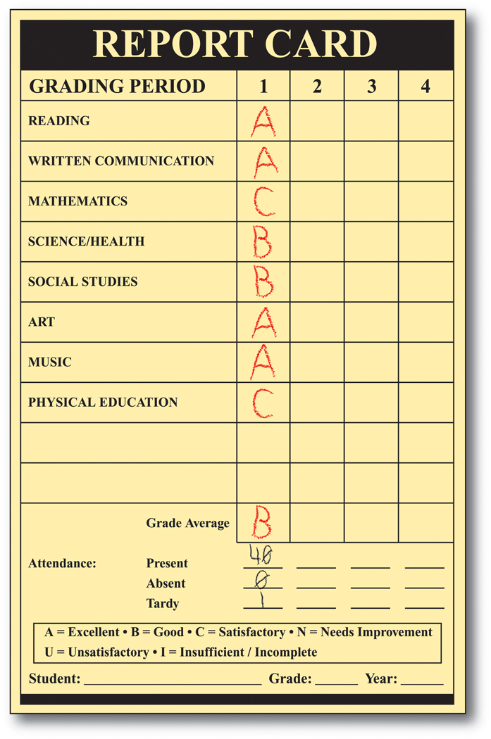
Thursday folders will be sent home with scholars each week. This folder will apprise you of your scholar’s progress throughout the quarter. Please review these papers, sign the form to document your review, and send it back to school the following day. If there is a need for a conference, you may call your scholar’s teacher and set up a time to come in to discuss concerns you may have.
Mid-quarter reports will be sent home 4-1/2 weeks into each quarter, and report cards will be sent home at the end of each quarter. Parents are expected to come in for a conference at the end of the first quarter and as needed thereafter. Please help us help your scholar by keeping in touch and monitoring his/her work as we progress through the year.
Visiting the School
Parental involvement is an integral part of a successful school program. We are excited and honored by your desire to be involved in your scholar’s academic program. While we invite you to visit the school and remain aware of your child’s progress, we ask that you not visit the teachers in the morning as scholars arrive or during the day to discuss your scholar’s progress, and please limit visits to 30 minutes. This prohibits them from monitoring the scholars and interrupts the instructional day. Please call and schedule appointments for conferences.
Discipline
Scholars are expected to behave in a manner that is conducive to the learning environment. Failure to do so results in loss of academic time for all scholars within that classroom. Please review the Rights and Responsibilities Handbook /Code of Conduct with your scholar so that he/she displays those character traits shown to reap success. When scholars fail to follow the set rules and procedures, there are consequences, just as there are rewards for those who display appropriate behaviors. We will be following a Positive Discipline Model (sample on next page). Further, scholars will be awarded with our PAWS-itive Behavior (Positive Behaviors Will Succeed) initiative. Please review this book (R&R) with your scholar and encourage them to do the right thing at all times. Should you receive a call or note (Bulldog Blooper) for your scholar having displayed inappropriate behaviors, please know that we need your assistance in turning it around to reflect the positive behaviors needed for academic and social success. Continued behaviors will result in implementing intervention strategies to address and promote conducive behaviors, up to and including suspension from school.

All-Star Scholarly Expectations
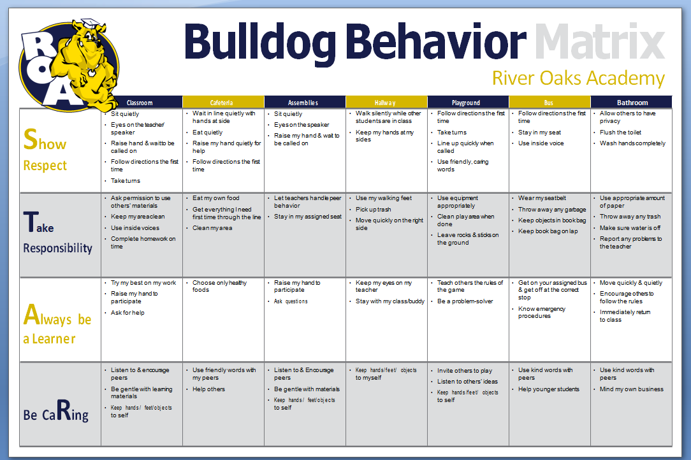

Uniforms
Scholars are expected to be in uniforms each day. As we strive to teach procedures, guidelines, and character education, scholars learn to follow the rules that have been put in place. Just as many of your places of employment require uniforms, our scholars must be acclimated to wearing what is expected each day. That uniform consists of navy or khaki bottoms (skirts, skorts, pants, jumpers), and white or navy polo tops with collars, no emblem, unless it is the ROA emblem, which will be available for purchase through PTA. Scholars should also wear belts, with their shirts tucked in, along with closed toe shoes in white or black (sneakers may be worn). Navy or white sweaters or school sweatshirts may be worn on top of the shirt. During the day, we ask that scholars not wear jackets to special area classes. Sweaters and sweat jackets may be worn in class, but we request that they are school colors (navy or white). Sneakers should be worn on PE days.
Insurance
Regardless of how careful one may be, accidents are prone to happen from time to time. For that reason, insurance is available to you for your scholars. Coverage ranges from “At-School coverage @ $8.25- Basic/$17.50 High option to 24 hour coverage, @$42.50 Basic/$74.50-High Option. It is recommended that you purchase this to cover any unexpected incidents that may occur. Brochures are in the information sent home with your scholar.
Dates to Remember
ROA Calendar of Events for 2013-2014
(This includes dates as of August 1. Dates are Tentative and Subject to Change!! Please refer to updates in School Newsletters☺)
August 21 Open House 5:00-7:00
August 25 First day of School
August 29 Spirit Day
September 1 Labor Day Holiday
September 8 PTA Board Business Meeting 5:30 pm
September 8-19 MAP Testing
September 11 PTA Parent Info Session Night-6:15-8:00/Scout Night-5:45-7:30
September 19 Bulldog Buddies begin 1st/3rd Fridays 8:00 for selected scholars
September 24 Progress Reports distributed
September 26 5th to Duke Explorium/Spirit Day
September 22 SLT@ 4:15
October 1 Fall Pictures
October 9 Donuts for Dad/@7:45-8:30 am/ROA PROS Kick-off
Book Fair Delivery/
October 10 Book Fair Family Night until 6:00 pm
October 13 PTA Board Business Meeting 6:00
October 16 Book Fair Begins
October 15 Grandparent Day
October 20 Cookie Dough Brochure home for sales
October 24 School Spirit Day
October 27 SLT Meeting
October 27 End of Qtr 1
October 30 Bulldog Blast Family Learning Expo Night/Dinner 6:00
October 31 Parent Teacher Conferences/Teacher Workday
November 7 Report Cards go home
November 10 PTA Board Mtg@ 5:30 pm
November 11 Veterans Day Holiday
November 18 Fall Pictures: Make-ups/Holiday Pictures
November 21 ROA Spelling Bee
November 21 Spirit Day
November 25 SLT Meeting @ 4:15
November 26-28 Thanksgiving Holidays
December 4 Holiday PTA Program 6:15/Night of the Arts 3- 5
December 8 PTA Board Business Meeting 5:30 pm
December 18 3rd Annual Holiday Festival Sponsored by Calvary Church 6:00-8:00
December 19 Spirit Day/Holiday Parties
December 22 Teacher Workday
December 23-Jan 4 Winter Break
January 12 PTA Board Meeting@5:30 pm
January 7-17 MAPS Testing
January 9 Group pictures
January 19 Dr. ML King Day Holiday
January 22 Family Game/Curriculum Night
January 23 Teacher Workday/CMS Required
January 20 Quarter Ends
January 24 Qtr 2 Awards Day K-5 (TBA)
January 26 SLT meeting
January 30 Spirit Day/Kate’s Skate Night
February 3 Report Cards go home
February 4 100th Day of School
February 9 PTA Board Business Meeting @6:00 pm
February 10 Group Pictures/Chic-Fil-A Band Night
February 12 ROA Valentine Ball Dance 6:00-8:00
February 13/16 No school: Teacher Workdays
February 23 SLT meeting
February 27 School Spirit Day/Cultural History Day
March 2-6 Read Across America Week
March 3 Read Across America Day: Dress up as favorite book character!
March 5 PTA Night of the Arts K-2 @ 6-7:30/Terrific Parents
March 9 PTA Board Business Meeting
March 10 PTA Chic-Fil –A Night
March 16 Book Fair Delivery
March 19 5th Grade Musical @6:00
March 23 SLT meeting @ 4:15
March 25 Grands Day
March 27 School Spirit Day
April 1-3 5th Grade Trip (Tentative)
April 24 Father/Daughter Dance
April 6-10 Spring Break! No school
April 17 Spring pictures
April 21 PTA Board Business Meeting
April 23 Volunteer Appreciation Program @7:45-8:30
April 23 Beginner’s Night 6-7:30 pm
April 24 Spirit Day
April 27 SLT meeting
May 4-8 Teacher/Staff Appreciation Week
May 7 Muffins for Mom 7:45-8:30/PTA band Concert @6:00
May 11 PTA Board Business Meeting@6:00
May 16 PTA Carnival-10-2 (Tentative)
May 29 School Spirit Day
May 26-29 EOG Testing Week**
June 5 Awards Day 1st/2nd @9:00
June 8 Awards Day 3rd/4th @ 9:00 am
June 9 Kindergarten Promotion Ceremony @ 9:00/Pre-K @1:00
June 10 Fifth Grade Awards Ceremony @10:00 am
June 11 Last Day of School

Report Card Dates
November 6; Feb. 2; April 13; June 9
**To be determined
Just a reminder that we do not celebrate birthday parties at school. If you would like to bring cupcakes on your scholar’s birthday, you may bring them to the cafeteria during their lunch period, where they can be distributed to classmates. Also, any food that is brought in must be purchased from a store and wrapped in its original wrapping. Health regulations prohibit us from giving students any food that is not commercially prepared. This is to keep all students safe from food allergies, etc… Thank you for helping us to abide by the rules by following the guidelines that are in place.
**************************************************************************************
I have read and reviewed the information in the ROA handbook. I understand my responsibilities as a parent and partner in the education of my scholar. I/We will work with the school to ensure that my scholar is present each day, prepared to do his/her best, and engaged in the learning process in order to excel socially, behaviorally and most importantly, academically.
Parent Signature________________________________________________ Date _______________

Student Signature ______________________________________________ Date ______________
Teacher __________________________________________ Grade _________________

