Reading Websites

Pre K-Kindergarten
www.lilfingers.com
www.pbskids.org
http://funschool.kaboose.com

Pre K-Grade 2
www.starfall.com
www.pbskids/org
www.sesamestreet.org

K-6
www.scholastic.com
www.kids321.com
http://lightupyourbrain.com
www.meddybemps.com
www.bedtime-story.com
www.gigglepoetry.com
www.childrenstory.com
www.kidsites.com
http://funschool.kaboose.com
www.learningplanet.com
www.pbskids.org/go

Parent Resource Only
www.mrsjonesroom.com
www.readingresources.net
www.pbs.org/parents
www.dositey.com

**Most of these sites are very kid-friendly. However, parent guidance is need for most children Pre K- Grade 2.

Games to Promote Reading

Scrabble Jr.
Boggle
Taboo
Scattergories
Pictionary
Memory
Bop-It

At Rio Grande Elementary...……………
No Child Is Left Behind



Reading Instruction
at Rio Grande Elementary

Grades K-5



“The more that you read, the more things you will know. The more that you learn, the more places you’ll go.”
- Dr. Suess

Rio Grande Elementary
439 Lake Dr.
Rio Grande, Ohio 45674
740-245-5333

Reading Classroom Goals

Kindergarten 25-35 sounds per minute
1st Grade 40 words per minute
2nd Grade 90 words per minute
3rd Grade 110 words per minute
4th Grade 118 words per minute
5th Grade 128 words per minute

Sight Words
The Dolch Word List is a list of the most common words in the English language. There are 220 words that children need to recognize by the end of first grade in order to achieve reading fluency.

www.dolchsighwords.org

“5 Big Ideas in Reading”
- Phonemic Awareness – the ability to hear and manipulate the sounds in spoken words.
- Alphabetic Principle (Phonics)- matching sounds to letters and use this knowledge in spelling and reading
- Vocabulary – the ability to understand and use words
- Fluency –the ability to read connected text with speed, accuracy, and proper expression
- Reading Comprehension – active and unintentional thinking while reading to understand the meaning of text

Summer Reading Goal

- 5 Books -

Summer Reading Lists
Available at
www.scholastic.com

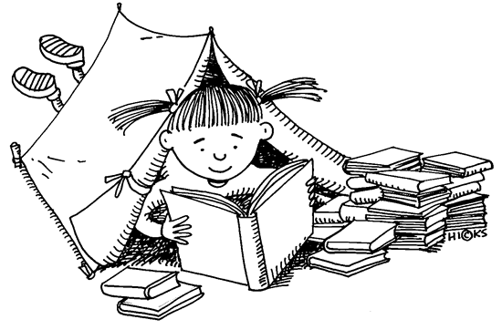

Summer Reading Programs

Family Literacy Nights
Gallipolis City Pool 6:30-8:30PM
June – 1, 3, 8, 10, 15, 17, 22, 24, 29
July – 1, 6, 8, 27, 2 9
August – 3, 5, 10, 12, 17, 19

Bossard Memorial Library
*Summer Reading Reward Program Begins June 1st
*Contact Angie Strait for more details.
Beginning the Week of June 14th
Ages 0-3 Lap Sit Mon. 10AM
Ages 3-6 Story Time Wed. 10 AM
Ages 7-12 Story Time Fri. 10AM
www.bossard.lib.oh.us
740-446-7323 (READ)
Youth Services Ext. 229
straitan@oplin.org

Ways to Increase
Reading Fluency
- Books on Tape
- Use Closed Captioning
on Your TV
- Magazines
- Comics
- Poems
- Songs
- Recipes

How does my child become a
better reader?

Read, Read, Read, Read, Read, Read, Read, Read, Read, Read, Read, Read!!!
- Knowing Rhyming Words
- Sight Word Recognition
- Reading Every Night
- Ask Questions...
Ask: about what is happening in the story
Ask: Open Ended Questions, Not Yes or No Questions
Ask: Who, What, Where, When,
and How

