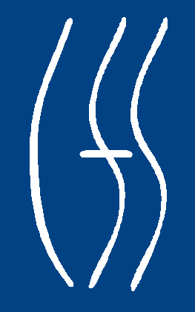
NEW YORK STATE
OFFICE OF CHILDREN
AND FAMILY SERVICES

Division of Juvenile Justice and Opportunities for Youth

PROGRAM DESCRIPTION

Andrew Cuomo

Governor
Sheila J. Poole, Acting
Acting Commissioner

HIGHLAND RESIDENTIAL CENTER

LOCATION 629 North Chodikee Lake Road, Highland, NY 12528

TELEPHONE 845-691-6006

FAX NUMBER 845-691-6042

YOUTH SERVED Male juvenile delinquents between the ages of 13 and 18 placed with OCFS by New York State Family Courts.

BUDGETED CAPACITY 80

PHYSICAL PLANT Campus design -- ten residential buildings and four educational buildings.

SERVICES PROVIDED Counseling

The counseling program's philosophy/methodology are based on a cognitive-moral approach utilizing psycho-educational curriculums like:

Moral Reconation Therapy (MRT)
- Anger Replacement Training (ART)
- Victim Awareness
- Independent Living (IL)

Additionally, behavioral modification approaches utilizing skill building and therapy are used:

- Dialectical Behavior Therapy (DBT)

Each youth engages in specific group counseling based on the treatment team identification of needs.

Education
Programs offer remedial, special education, academic and vocational instruction: individualized and in small groups. Instruction is in:

- Math
- Reading
- Science
- Social Studies
- English
- Health
- Physical Education

GED and all levels from pre-K to college prep are available. Regents exams in all subjects are being phased in each year by NYS standards.

Vocational
Vocational offerings include:

- Technology
- Computer Lab
- Keyboarding
- Print Shop
- Building and Grounds Maintenance
- Food Service

Health Services
The facility employs a Physician, Physician's Assistant and four Registered Nurses, full time, covering days and evenings, seven days per week. Additionally, the services of one part-time Psychiatrist and one part-time Optometrist are provided. A Dentist and Registered Hygienist utilize the facility’s dental unit five days per week. Local hospitals are used for emergencies. Ambulance service is available when necessary.

Recreational
Full-service recreation facilities include gymnasium, athletic fields, outdoor basketball and handball courts and recreational/game building. There is a specialized building for canteen purchases and leisure time recreation.

Religious Services
Youth attend religious services on site. Religious counseling and education are offered through the facility Chaplain and community volunteers.

SPECIAL PROGRAMS Orientation and Assessment Unit (OAU)
All admissions will first be assigned to OAU to prepare them for facility living and allow for the creation of the initial treatment plan. Wide batteries of assessments are assembled and orientation on drug prevention and HIV are accomplished.

Sex Offender Units

Discrete Living Units/Programs have been designated for predatory/exploitative sex offenders. Specific/targeted interventions are designed into these program offerings.

Chemical Dependency Unit
The Discrete Unit is licensed by New York OASAS; a drug-free residential treatment facility.

Mental Health Unit
Discrete Living Unit and program for court placed youth with multiple DSM IV diagnoses. This is a cooperative program with the NYS Office of Mental Health (OMH).

Community Involvement

Volunteers are used for cultural, recreational and educational activities. Highland has an active Community Advisory Board.

PRE-RELEASE Youth preparing for release address relapse
ORIENTATION prevention issues. Curriculums such as “Beat the Streets” and HIV Prevention are also provided.

Revised 3/2012

