
Leeton R-X School District
500 N. Main St.  Leeton, MO 64761

Central Office 660-653-2301  Elementary 660-653-4731
High School 660-653-4314  Fax 660-653-4315
Online Application for Substitute Teaching
EQUAL OPPORTUNITY IN EDUCATION AND EMPLOYMENT
Leeton R-X School District does not discriminate on the basis of race, color, national origin, sex or disability.
All complaints of discrimination should be filed with the Superintendent of Schools, Title IX Section 504 Coordinator, 500 North Main, Leeton, MO 64761, Telephone 660-653-2301.

APPLICANT MUST HAVE A MINIMUM 2.5 GPA TO BE CONSIDERED

Days Available: M Tu W Th F All
Grades: Pre-K Elem MS/HS Any
(Please circle all that apply)

Date:
Support Staff Position applying for: |  |  |  |  |  |  |  |  | Substitute Teaching
(last name) (first name) (middle initial)
Home Address:
Work Address:
Home Telephone Number:
Work Telephone Number:
Social Security Number:
Name and address of a person who will always know your address (do not list husband/wife):
GENERAL INFORMATION:
Are you legally authorized to work in the US on a full-time basis?
Yes |  | No
Are you currently employed?
Yes |  | No
May we contact you at your place of employment?
Yes |  | No
Skills required in your present position?
Indicate special skills you possess for the position(s) you are seeking:
If employed, when could you begin your duties if hired?
Have you even been asked to resign or been discharged from a job?
If yes, please explain.
Yes |  | No
Have you ever been arrested for, or charged with, or convicted of a felony or misdemeanor? (exclude traffic offenses for which you were not sentenced to jail or for which the fine was less than $100)
Yes |  | No
Have you ever plead guilty or nolo contender (no contest) to a felony or misdemeanor? (exclude traffic offenses for which you were not sentenced to jail or for which the fine was less than $100)
Yes |  | No
Has the Missouri Department of Family Services or a similar agency in any other state or jurisdiction ever issued a determination or finding of cause or reason to believe or suspect that you had engaged in the physical, emotional, psychological or sexual abuse or neglect of a child?
Yes |  | No
If the answer to any of the foregoing questions is “yes”, please explain.
If you are applying to be a substitute teacher in the Leeton R-X School District and need the district to apply for your substitute certificate, it is necessary to have your date of birth.
Date of Birth:
EDUCATION AND PROFESSIONAL TRAINING:
Type of School |  |  | Name of School |  |  |  |  | Major |  |  |  | Semester Hours in Major | Degree |  | Date |  | Total Semester Hours in Each School & GPA
High School
Trade, Technical Business or other School
College/ University
Graduate Work
WORK EXPERIENCE:
Name & Address of Employer |  |  |  |  | Date  From To |  |  |  |  |  | Name & Phone of Immediate Supervisor |  |  |  |  | Reason for Leaving
REFERENCES:
List name and addresses of three persons – do not include relatives. (lnclude your most recent employer.)
Name |  |  |  |  |  |  | Address and Telephone |  |  |  |  |  |  | Position/Employer
If you have confidential papers with a committee, bureau or college, give name, address and telephone number:
Any further information that may strengthen your application, include as an attachment.
STATEMENT:
I hereby authorize the Leeton R-X School District to contact past and/or present employers to verify employment, attendance, work habits and complete background check of all records related to arrests, criminal convictions and child abuse or neglect reports. In addition, I hereby authorize investigation of all statements in this application and understand that misrepresentation or omission of facts is cause for dismissal anytime during my employment period.
I understand that employment with the Leeton R-X School District is contingent upon the satisfactory outcome of a report from the Missouri Division of Family Services and the Missouri Highway Patrol or other authorized agency acceptable to the Board of Education. I understand that an unsatisfactory criminal records history or child abuse/neglect history is grounds for termination of my employment with the Leeton R-X School District. I understand that the Board of Education will make the ultimate decision as to whether a particular applicant or employee’s criminal record or child abuse/neglect history is unsatisfactory.

I understand a Tuberculin test is required for Food Service employees.

I understand the Board of Education shall not tolerate the unlawful manufacture, use, possession, sale, distribution, or being under the influence of drugs or controlled substances; nor shall the Board tolerate the unlawful use, or being under the influence of alcohol by an on-duty employee. Any employee who violates this policy will be subject to disciplinary action, which may include employment termination and referral or prosecution. As a condition of employment, the employee must abide by the terms of this policy and will notify the superintendent of any criminal drug statute conviction for a violation occurring in or on the premises of this school district or while engaged in regular employment.
Should the Leeton R-X School District employ me, I will support the education program and follow all rules and regulations of the District. I agree to promptly notify the District of any change of address during my employment.

Signature of Applicant: |  |  |  |  |  |  |  |  |  |  |  |  |  | Date:

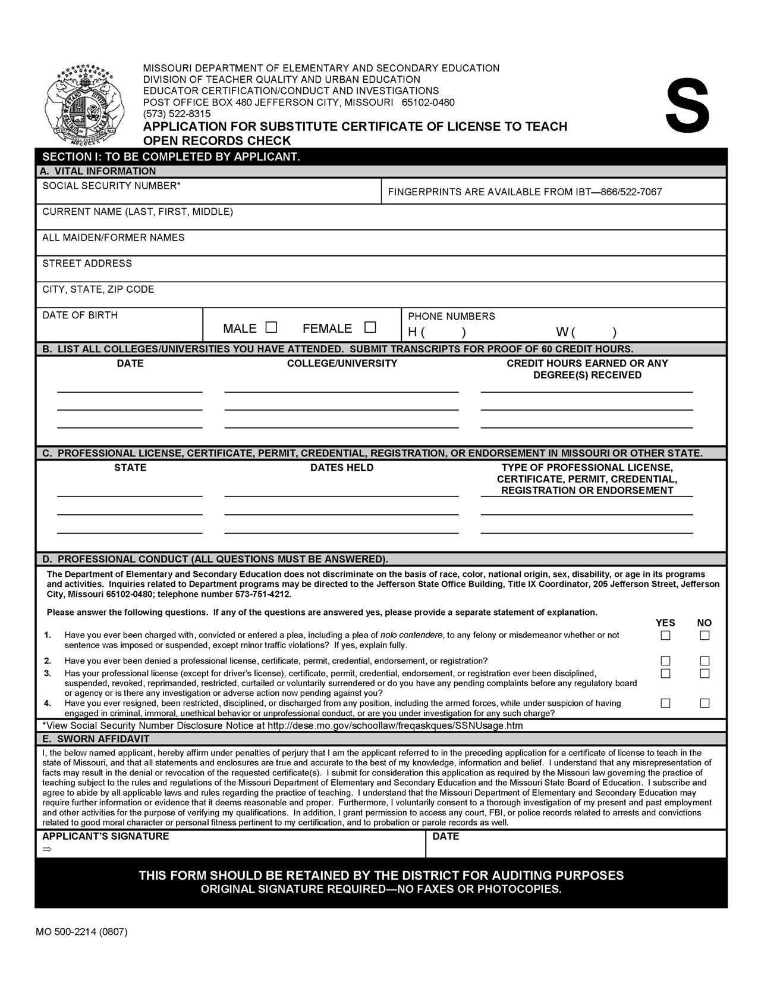

jhj

FBI/Highway Patrol Background Check Procedures
Scheduling an Appointment (Missouri residents)
To be fingerprinted for the Department of Elementary and Secondary Education through 3M/Cogent, you must first register with MACHS, which is located at www.machs.mo.gov. Individuals without access to the Internet may contact the fingerprint processing company, 3M/Cogent, directly at 1-877-862-2425 to have a Fingerprint Services Representative conduct this registration on their behalf. To register with the Missouri Automated Criminal History Site (MACHS) for a fingerprint, you must have a 4-digit registration code. This code ties all agency-identifying information together to ensure that your background check response is returned to the correct agency. Below are the codes to use for Leeton R-X School:
1128 Certified Teachers
1129 Substitutes
1130 Uncertified employees (i.e. custodians, secretaries)
1131 Bus Drivers

Fingerprinting Fee
The fee for the fingerprinting process is $44.80. You will have the option to make this payment online at the time of registration or at your appointment.

Scheduling an Appointment (Non-Missouri residents)
If you live outside the state of Missouri and cannot make an appointment for fingerprinting in Missouri, you may mail fingerprint cards directly to 3M/COGENT. You will need to contact the fingerprint processing company, 3M/Cogent, at 1-877-862-2425 to make sure all information is recorded on the FBI fingerprint cards correctly before mailing them. The fee for this process is $44.80. A check or money order must be made payable to 3M/Cogent.

Fingerprint Results
If you are an educator, substitute teacher, or student teacher, your fingerprint information will be recorded automatically on your profile page in the online Educator Certification System. If you are an uncertified staff member or a bus driver, your results will be forwarded to the school district based upon the registration code you provided. Results of fingerprints are generally reported to the Educator Certification within 2-3 weeks from the date of appointment.

Additional information about the fingerprinting process may be viewed at the following website: http://dese.mo.gov/eq/cert/eq-cert-fingerprint-background.htm
http://dese.mo.gov/forms/documents/ApplicantsPrivacyRights.pdf

