Pre-calculus Chapter 1 Test Form A

Calculators are allowed
Each problem 3 points –Perfect
2 points—a little mistake
1 point--- a little right
0 point----total wrong or blank

Name: I.D.: Period:

1. Determine whether the function is one-to-one. If it is

Find the inverse of the function

Determine whether the function is even, odd, or neither
2a 2b. 2c

3. Use the graph of the function f to complete the table and sketch the graph of
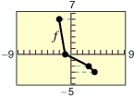
x
-3
-2
0

4. Determine the intervals over which the function is increasing, decreasing, or
constant
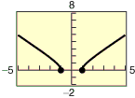

5a. Does the table describe a function?
Input value | a | b | c | a | d
Output value | -8 | -1 | 0 | 1 | 8

5b.

5c.
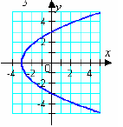
6. Sketch the piecewise-defined function.
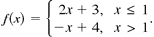

7. Find the domain of the inverses of the function

8. Given

9. Specify the sequence of transformations that will yield the graph of the given function from the graph of the function f(x)

11. Write the height h of the rectangle as a function of x.
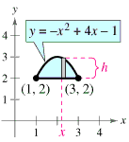

Use the graphs of f and g to evaluate the functions.
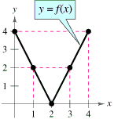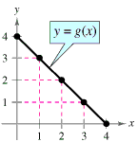

12.

13. Evaluate the function at each specified value of the independent variable and simplify

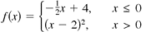 (a) (b) (c)

14. . Find the difference quotient and simplify your answer

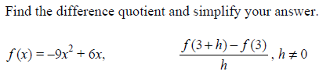

15.Use function notation to write g in terms of the common function

16. A manufacturer cuts squares from the corners of 20” by 20” piece of cardboard and then folds the card board to make an open top box. What is length of the corners, cut to the nearest tenth, that is maximize the volume?

17. Automobile Aerodynamics The number of horse- power H required to overcome wind drag on a certain automobile is approximated by where x is the speed of the car in miles per hour.
(a) Use a graphing utility to graph the power function.
(b) Rewrite the power function so that x represents the speed in kilometers per hour. [Find
(c) Identify the type of transformation applied to the graph of the power function.

18.Find two functions f and g such that (There are many correct answers.) No g(x)=x

19.. A rancher has 800 feet of fencing to enclose 4 adjacent rectangular corrals. Find the maximum possible enclosed area to the nearest square foot

