Elizabeth City-Pasquotank Public Schools
Parent Instructions

Accessing the Parent Portal

Getting to the login screen

The recommended browsers for this application are Google Chrome and Firefox

Navigate to:

http://ecpps.powerschool.com/public
You will be prompted for your login and password.

If this is your first time navigating to this site, click Create an Account at the bottom of the screen.

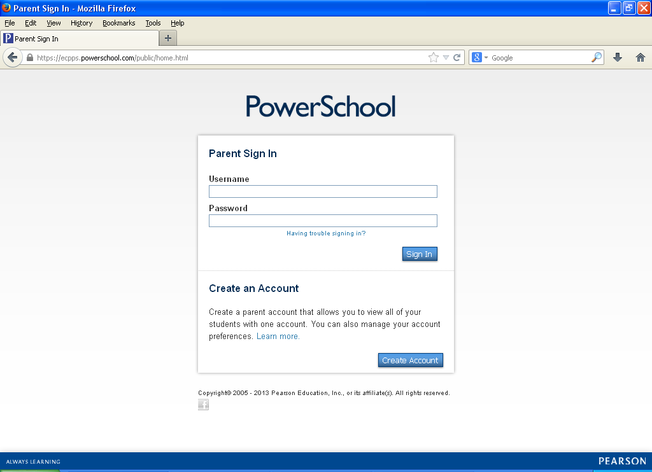

Type in Parent/Guardian first name and last name, email address, your desired
username, your desired password, and re-enter password. Please make note of password requirements.
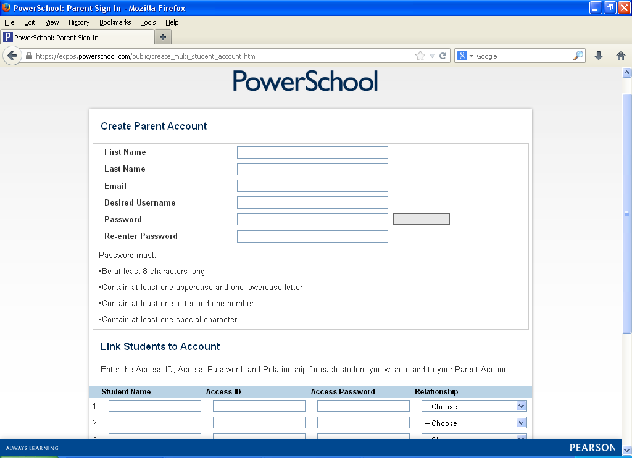

Next scroll down and list all children in the same family to link your students to your account.

Use your Parent Access ID and Parent Access Password for each child exactly as they are listed on the information you received from your child’s school. They are case sensitive and each child will have their own code that needs to be entered.

It is recommended that you keep your username and password secure and not share it with anyone else.

Options in Portal
· Once logged on the system, parents will see a variety of options along the side of the screen.

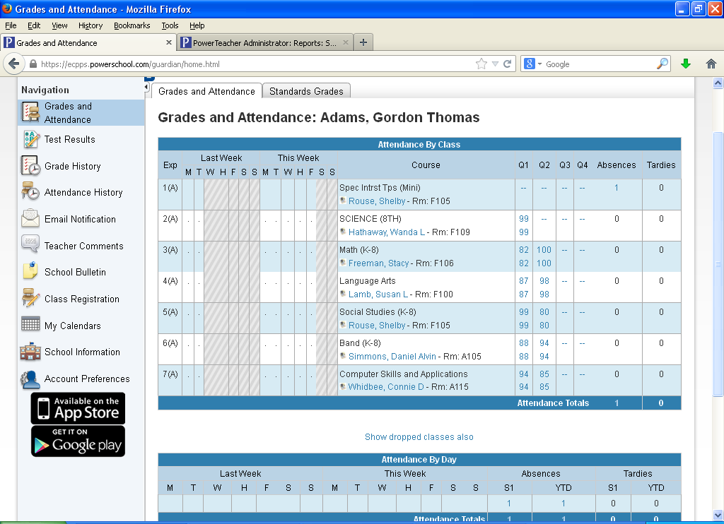

· The page that initially appears (as the default) is called the Grades and Attendance Screen.

Attendance
The Grades and Attendance page displays a “real time” view of the previous and current week’s attendance, as well as total absences for the current semester/year.

These absent and tardy totals are clickable and will reveal additional information about an absence.

Grades
The Grades and Attendance screen also displays the cumulative grade for each course in which the student is currently enrolled.

This view provides a quick summary detailing exactly where a student stands in each course or subject area for the current semester.

These are the grades as they exist in the teacher’s grade books at that particular time and will be updated as grades are entered.

Updates will be weekly.

The grades in blue are clickable and will reveal details about the grade

Email Notification
Parents can receive email notification of certain situations or events that might require their intervention, such as poor scores on recent assignments, unexcused absences, etc.

These emails can be scheduled as frequently as daily, and can be sent to multiple email addresses (to include other parents, etc.)

Click on the Email Notification link under the Navigation on the left of the screen

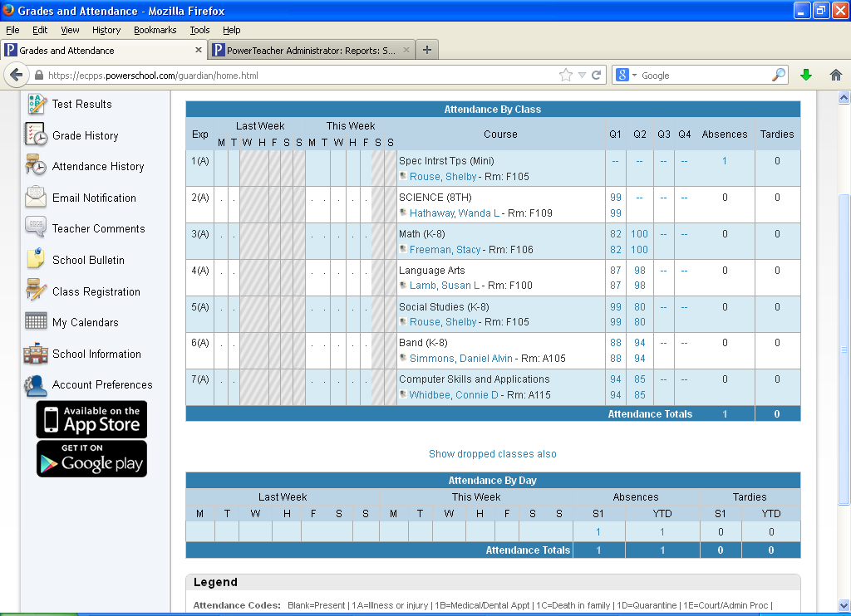

Check the box for the information you’d like to receive, choose how often you’d like to receive this information and provide your email address(es).

If multiple email addresses are entered, separate each with a comma.

Click the Submit button to save these settings.

To stop receiving these automatic emails, return to the Email Notification screen, uncheck the boxes and click the Submit button.

Important Note: When you receive these reports via email, replying back is not a valid option as the email will be sent back to the System Administrator. If you need to contact the Teacher, you can e-mail them directly through their ECPPS e-mail address or contact them at the school.

Printing a Page
Parents can print any page displayed in PowerSchool by clicking on the icon.
This icon is found at the top right of every page

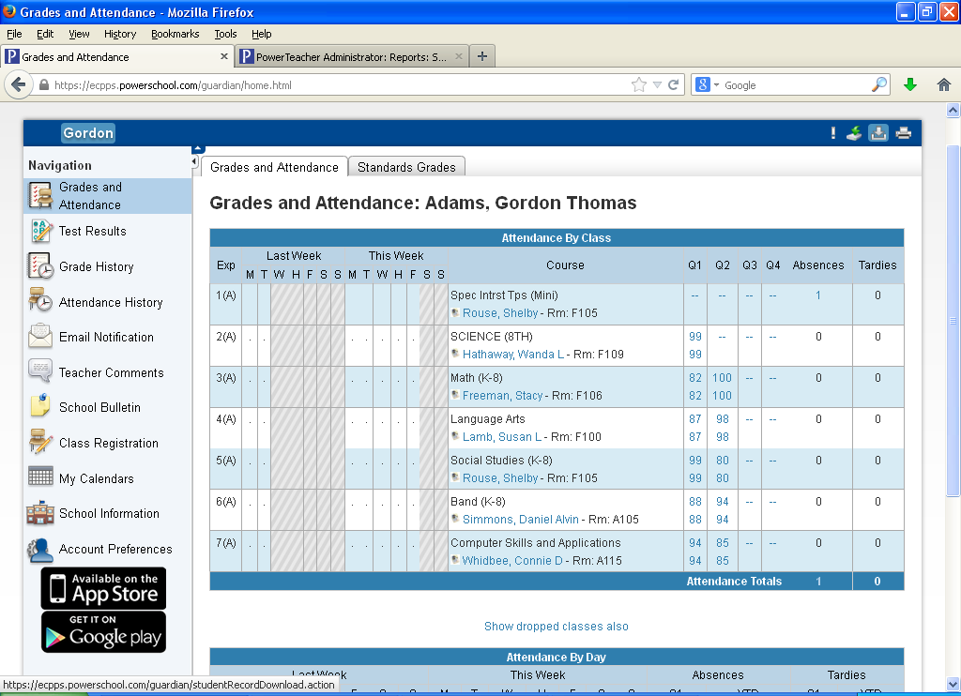

Other Navigation Links
There are additional links listed down the left side of the main page that will provide additional student information. Please click on the icons to see those screens.

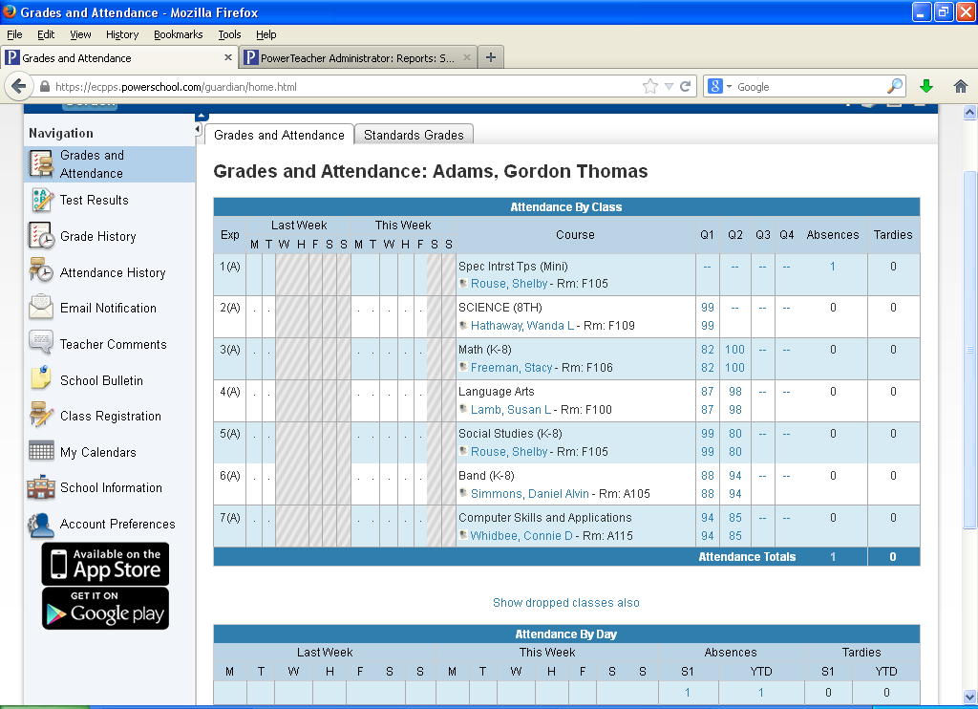

Logging Out
To end your session and exit the system, please click the blue “Sign Out” in the upper right corner of the PowerSchool window.

