September 8, 2020

Principals and Teachers:

Fire prevention week is upon us once again, during Fire Prevention Week (October 4th-10th) the Dothan Fire Prevention Division will hold a Fire Prevention Poster Contest for grades K thru 4 in all elementary schools city-wide. The Fire Prevention theme for this year is:
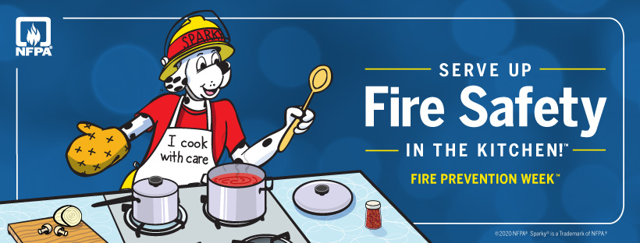
All classrooms are urged to participate. With this year’s campaign we are focusing on Fire Safety in the Kitchen.

Did you know?
Cooking is the #1 cause of home fires and home fire injuries. Unattended cooking is the leading cause of fires in the kitchen.

The guidelines for the poster contest are listed below:

- Each entry should follow the Fire Prevention theme of “Serve Up Fire Safety in the Kitchen.”
- Posters need to be developed by individual students in each grade level, K thru 4.
- Teachers and/or School officials at each school will pick ONE poster to represent the school in the overall competition.
- The representing poster from each school MUST compete against the other schools, city-wide, for an overall first, second, third and fourth place.
- Members of the Dothan Fire Department will judge the representing posters submitted from each school and choose the overall winners.
- First place overall will receive, a first place ribbon, a first place certificate, a T-shirt and a ride in the National Peanut Festival Parade. Provided parade is not cancelled due to Covid-19.
- Second place overall will receive a second place ribbon, a second place certificate, a T-shirt and a ride in the National Peanut Festival Parade. Provided parade is not cancelled due to Covid-19.
- Third place overall will receive a third place ribbon, a third place certificate, a T-shirt and a ride in the National Peanut Festival Parade. Provided parade is not cancelled due to Covid-19.
- Fourth place overall will receive a fourth place ribbon, a fourth place certificate, a T-shirt and a ride in the National Peanut Festival Parade. Provided parade is not cancelled due to Covid-19.
- Posters must be completed by Wednesday the 30th of September.
- Personnel from the Fire Prevention Division will pick up posters on Thursday the 1st of October.
- The poster selected by your school will be on display at the Dothan Fire Department Administration building during Fire Prevention Week.

Additional poster guidelines:

- Posters must be 22 inches by 28 inches (Full Sized Posterboard)
- On the BACK of each poster, in the TOP RIGHT HAND CORNER, please attach the following information using the provided information sheet:

1. Students name, age and home address
2. Grade level
2. Teacher’s name
3. Name of the school he/ she is attending
4. Parent or Guardian’s Name and Phone number.
5. Student’s T-Shirt Size.

Each school is asked to select One Junior Fire Marshal from the 5th grade. Each Junior Fire Marshal will receive a T-shirt, a medallion, and a ride on the Fire Truck in the National Peanut Festival Parade. Provided parade is not cancelled due to Covid-19.

Selections for Junior Fire Marshals must be complete by Friday the 2nd of October. Once these selections are made, the following information should be submitted to the Fire Prevention office, for each Junior Fire Marshal, by e-mail or by phone:
Students name, age, School name, Home address, Parent/guardian, Phone number and (T-Shirt Size).
This letter will be sent out as an email attachment to each of the elementary schools. You may also request a hard copy of this letter be delivered directly to your school. The information for e-mail & phone communication is listed below. I have included an information sheet for parents/guardians to read over prior to parade day. Please contact us with any questions or concerns you may have.

Thank you,

Captain Garrett Crow Captain Bill Sullivan
gcrow@dothan.org wasullivan@dothan.org
Office: 334-615-4577 Office: 334-615-4588
Cell: 334-701-0710 Cell: 334-796-9816

Information for Parade Day, provide it is not cancelled:

- The Poster Winners and the Junior Fire Marshals should arrive at Fire Station # 1, 510 Columbia Highway, by 7:00 a.m. on November 14, 2020.

- We will have limited time for parents/guardians to sign waiver forms, sign in, and arrange for accountability and seating for the children, so please be prompt!

- Children will be seated on the fire apparatus and will be transported directly to the parking lot located at 3106 Ross Clark Circle, in front of McAlister’s Deli following the parade.

- Parents/guardians must sign out and pick up their children at the parking lot located at 3106 Ross Clark Circle, in front of McAlister’s Deli no later than 11:00 am following the parade.

Please Fill out completely and attach to the back of each poster in the top right hand corner.

Name:___________________________________ Age:____________

Home Address:____________________________________________

_________________________________________________________

Teachers Name:_______________________________ Grade:_______

School Attending:___________________________________________

Parent/ Guardians Name:______________________________________

Phone Number (s):___________________________________________

Students T-Shirt Size:_________________________________________

