Physics Practice Problems

Use your physics formulas to answer the word problems below. Remember, when solving word problems ask yourself the following questions:
- What is the problem asking for?
- What information is provided?
- Can I use a physics equation or should I use vector addition?
- If a formula is required, plug in variables and do the math.
Formulas:
V = d/t Slope = (y₂-y₁)/ (x₂-x₁) Pythagorean Theorem a² + b² = c² a = (V_{f} – V_{i})/t F = ma gravity = 9.8 m/s² toward the center of the earth

Velocity:

Position & Velocity
- How are speed & velocity different?

- The world record for the 50 meter dash was 4.98 seconds. What was the runner’s average speed?

- A planes average speed between two cities is 600 km/hr. If the trip takes 2.5 hours, how far does the plane fly?
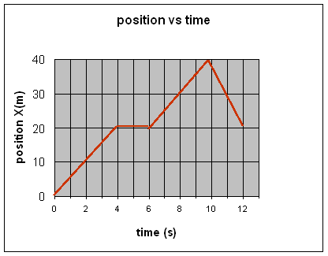

- According to the graph above when does the object have the highest velocity?

- What will happen to an object with positive velocity and negative acceleration?

- What will happen to an object with negative velocity and positive acceleration?

- For the Position-Time graphs below, be able to do the following:
  - Calculate Velocity.
  - Determine where the object is not moving.
  - Determine where the object is changing direction.
  - Determine how far an object has moved in a given amount of time.
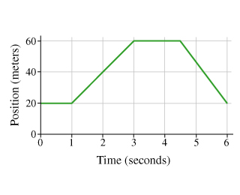

Calculate Velocity between 1 & 3 seconds

Calculate velocity between 4.5 & 6 seconds.

What is the objects’ total Displacement? (How far did it end from where it started?)

How much total ground did the object cover?

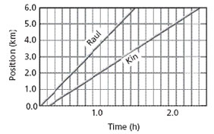
Calculate the velocity of each runner.

Who wins the race?

Velocity & Acceleration:

- What units is acceleration measured in?

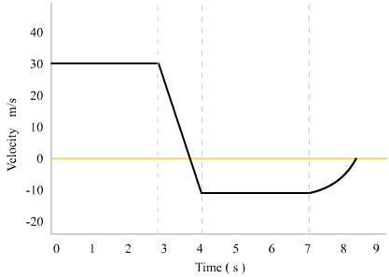

- According to the graph above, at what rate does the object accelerate between three and four seconds?

- According to the graph above, when does the object begin slowing down? When does it stop and turn around? When does it start going the opposite direction?

- According to the graph above, what is the object’s maximum velocity?

- A car is traveling at 28 meters per second north; 10 seconds later the car is traveling 15 meters per second north. What is the car’s acceleration?

- A car with a mass of 2150 kg is traveling at west 70 m/s, two minutes later the car is traveling west at 100 m/s. What is the car’s acceleration?

Vector Addition:
- A person runs on a treadmill. The treadmill is set at 5 meters per second. How fast must the person run to stay on the treadmill?

- A man runs through the airport at 3 meters per second; he jumps on a moving walkway going 2 meters per second in the same direction. What is the man’s net velocity?

- A student runs through an abandoned mall at 4 meters per second from blood-thirsty zombies; she runs down an escalator only to find that the escalator is moving up at 2.5 meters per second!! What is the student’s net velocity?

- A person walks north at .5 km/hr across a train car moving east at 25 km/hr. What is the person’s net velocity?

- A student trying to cross a river swims north at 2 m/s. The stream flows east at 5 m/s. What is the student’s net velocity?

