Project Modern Physics, Netherlands

Ed van den Berg, Dick Hoekzema
Centre for Science and Mathematics Education
University of Utrecht, Utrecht, Netherlands

The home base for the Dutch Project Modern Physics is the Centre for Science and Mathematics Education which is part of the Faculty of Physics and Astronomy of the University of Utrecht. The Centre is the leading Centre for Science Education Research and Development in the Netherlands. The Faculty of Physics and Astronomy hosts a wide range of research activities in the different branches of Physics and Astronomy including nanophysics. Nobel Prize winner Professor Gerard ‘t Hooft is one of its professors. However, as the Project is a national project the developers are also linking with physicists at other Dutch universities.

Background: In 1996 a new curriculum was formulated for the pre-university stream of secondary education in the Netherlands. The Science Committee felt that Modern Physics did not get sufficient attention and requested a special project to explore alternatives and develop lesson materials for teaching and learning Modern Physics.

During the period 1996 – 2002 lesson materials were developed and tested through several cycles of piloting in schools and revision. Currently the course consists of a package of materials for about 40 lessons. The package was used in 13 schools in 2002-2003 and in 24 schools in 2003-2004.

The objectives for the Modern Physics package are that it should:
- give a valid impression of present day Physics;
- be conceptually interesting and challenging but mathematically limited;
- provide opportunities for in-depth study as well as for bridges to applications;
- be testable in National Secondary School Exams;
- be interesting to Physics teachers and be “teachable”.

A special characteristic of the materials, which is immediately noticed by the students, is the representation of Physics as a subject that is very much in development, with many uncertainties in interpretation, even in topics where predictions and measurements can have a high degree of accuracy. Another characteristic is the thinking in terms of simple quantitative models, and evaluating their benefits and limitations. For example, in the atomic physics chapter the students learn about the particle-in-a-box model and about possible refinements; in astrophysics students use simple secondary school physics to investigate alternatives for the energy generation in the Sun, such as burning or gravitational contraction and then evaluate whether these models are possible or not.

Topics are:
- What is Modern Physics?
- Photons and electrons, wave-particle dualism, probability
- Atoms and molecules; particle-in-a-box model and applications of the model to explain spectra, strength of materials, and some other phenomena;
- Reactions of atoms, nuclei, and elementary particles; conservation laws and symmetries;
- Astrophysics with an emphasis on the use of models and on some main observational methods, like the use of spectra for determining temperatures, compositions and velocities.

Time required: Most participating teachers devote about 40 lessons of 45 – 50 minutes to Modern Physics.

Target population: The top 10% students of Dutch secondary schools who may be inclined to choose careers in Engineering or Science.

Grade level: 12

Teaching methods: Typical lessons of participating teachers consist of short plenary 10 – 15 minute introductions to the theory or plenary discussions of assignments followed by student activities such as small group discussions of conceptual questions, solving problems, doing computer simulations, searching for additional information on internet or CDs, etc.

Excursions: Most students/schools participate in an annual excursion to one of the big European Modern Physics facilities such as CERN, DESY (accelerator), or JET (nuclear fusion).

Outreach: The project also conducts outreach activities with regard to the teaching of modern physics through national workshops and seminars for teachers who are not directly involved in the project. Recently the project produced several sample modules, which can be used to assist teachers who are not participating in the project.

Future Development: Early 2004 decisions will be made about curriculum changes for the pre-university science stream in Dutch secondary schools. Our Modern Physics materials might be incorporated in a new Advanced Science course and we would like to add alternative modules on different aspects of nano-physics.

Contacts: Through our excursion program, we have contacts with the large European research centres in addition to having good contacts with Dutch Physics research at several universities.
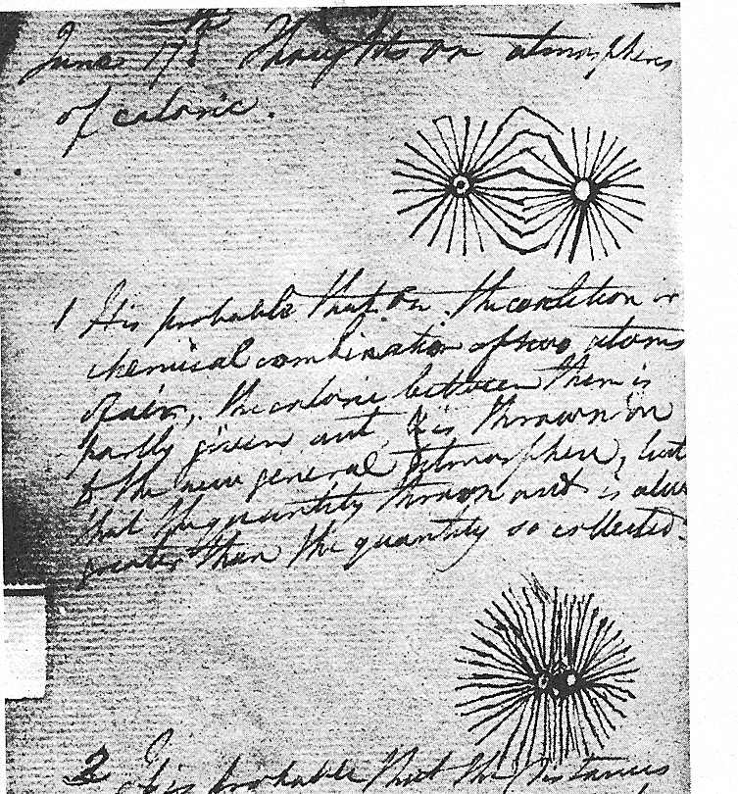
Molecules according to Dalton
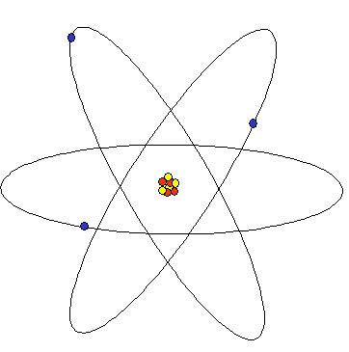
Bohr

Atomic models, Quantum models and Student’s models

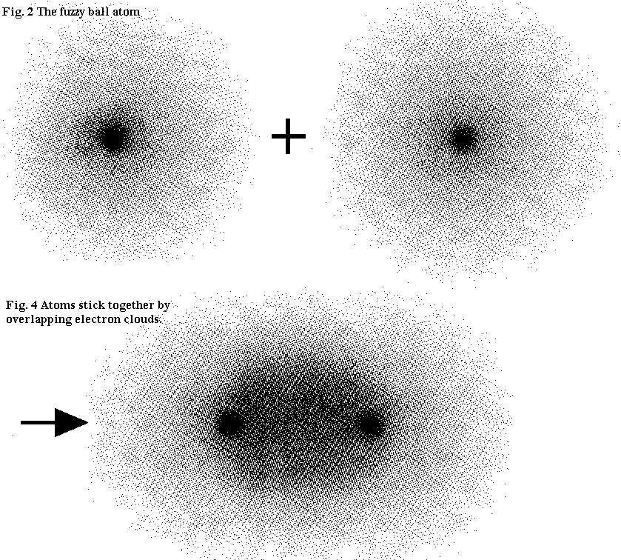
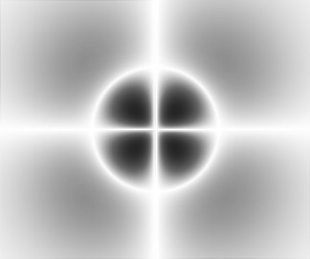
4dxy orbital

Fuzzy ball molecules

d.j.hoekzema
e. van den berg
g.j. schooten

project

Modern Physics

www.phys.uu.nl/~wwwpmn
Visualizations of Atoms

The image students have of atoms rarely goes beyond the Bohr-atom: Electrons move around the nucleus like planets around the sun, but miraculously their orbits are quantized, so only specific distances are allowed.
In Holland, the Modern Physics Project provides a deeper and more up-to-date understanding of the atom, but it is an experimental program. Trying to attract also teachers who do not, or do not yet want to be fully involved project, we have tried to provide two series of about three introductory lessons each about quantum physics and particle physics.

Preknowledge

We assume that teaching most of the standard curriculum is finished. In particular knowledge about waves, kinetic theory of gases, photoelectric effect, energy diagrams and spectral lines, electron diffraction and De Broglie-wavelength should be sufficiently well understood.

Lessons

In a classical introduction a more or less historical overview is given of a sequence of atomic models. It is noted that each model is designed to solve specific problems, and each has its own problems. Subsequently, the excersises of the worksheet about atomic models are made. The central topics are on the one hand the relation between microscopic and macroscopifc models, and on the other hand the limitations of these models and their intended domain of applicability. As homework, the students read some pages of the project material, which is not available in translation.

Probability plays an important role in relating theory and experiment in quantum physics. Motto:

If the position of a particle is measured, then the probability of finding it at a given position is given by the square of the amplitude of the quantum wavefunction at that position..

Two applets serve to illustrate this point:
the foto-applet (www.phys.uu.nl/~wwwpmn/03-04/foto.htm)
and the psi-applet (www.phys.uu.nl/~wwwpmn/03-04/psi.htm)

The lesson proceeds with the exercises of the worksheet: Understanding probabilities and wave functions through fast feedback

As homework, the students can exercise with the psi-applet, using worksheets available on the internet.

After doing exercises with classical probability, we return to quantum physics and to the specific peculiarities involved in it. In a class discussion two aspects highlighted:

The minima in an interference-pattern originate from destructive interference of quantum waves, i.e.: the particle cannot reach certain position, because it can reach that position in different ways.

The reduction of the wave-packet demonstrates in a very conclusive way that quantum particles are not only waves; they also have a particle-aspect. When the position of a quantum-object is measured, one finds it at one single location (from which it may then further propagate as a wave again).

After this discussion there are again some exersises using fast feedback, with the waves and particles worksheet, and the subject is concluded with a class discussion about what has been achieved.

Fast feedback
If we learned anything about learning from the misconception research of the 1980s, it is that there has to be a continuous interaction between teacher and students to check on students’ conceptual progress (or lack thereof) and to provide constructive feedback (White & Gunstone, 1992). The importance of feedback also comes from a completely different line of studies. Black and William (1998) recently analyzed hundreds of studies on formative evaluation and concluded that formative feedback, -that is constructive reactions to student work- is one of the most powerful tools in teaching and learning, particularly if it is not graded (no marks given). Indeed, interaction and feedback are the consistent ingredients of the interactive-engagement methods promoted by PER researchers (Hake, 1998; Mazur, 1997; Meltzer & Manivannan, 2002). Now the problem: how can teachers provide this feedback without spending all evenings until midnight checking student work and writing in feedback comments? The answer is the use of student responses in graphical form combined with fast feedback by the teacher.
Fast feedback is a whole class method in which students work individually but at the same pace through a series of questions that require answers in the form of a sketch, a graph, or a drawing. The questions are given one by one. After each question, the teacher walks around and looks at student work, asks a question here and there. After completing the question, students compare and discuss answers. When most are finished, the teacher returns to the front and discusses the one or two most frequent errors based on the work he just saw in the classroom and launches the next question. It is important to keep up the pace. A question and the individual student work could take 2 or 3 minutes. The plenary discussion might take 1 or 2 minutes and then: next question. The fast feedback method works well in topics where students are known to hold strong misconceptions such as forces (force diagrams), kinematics (graphs), and electric circuits. Over a series of 6 – 8 questions, progress is very visible. At any time the teacher has a good idea what students understand and what not yet and further teaching is based on that information. It is necessary that the teacher keeps going around and bases the short plenary discussions on actual observations of student work or even short interviews with students while they are working. That way the teacher gets immediate feedback on what students do and do not understand, while students get feedback on their actual work. The fast feedback method can be used with any topic in physics which allows responses in the form of graphs, diagrams, sketches, and drawings. For example, force diagrams, optics diagrams, graphs in any branch of physics, etc. A complete example in kinematics can be found in Berg et al (2000) and an overview of fast feedback and possibilities in different branches of Physics and Chemistry is contained in Berg (2003). Mazur’s peer teaching methods (Mazur, 1997; Crouch & Mazur, 2001; Meltzer & Manivannan, 2002) are in essence fast feedback methods. Students respond to multiple-choice questions after a mini-lecture. Responses can be tallied quickly through use of cards or a pushbutton system. If the tally indicates serious problems in understanding, the class will discuss the multiple-choice problems in small group or peer discussions while the lecturer listens around and interacts. On the other hand, if most students answer correctly, the lecturer proceeds with the next mini-lecture.
Student’s models

Images of atoms: As Heisenberg seems to have said (Beiser, 1995, p110): Any picture of the atom that our imagination is able to invent is for that very reason defective. Dean Zollman, who is in charge of the American Visual Quantum Mechanics said that in all his work on visualisation he avoids visualisation of the atom itself. Wavefunctions are visualized, energydiagrams, spectra, but not atoms. Nevertheless, the topic is hard to avoid when dealing with pupils. One way or another, we must provide some representation of atoms. What can we do?

Wright wrote a nice article about the representation of atoms in science education at secondary schools. The following diagrams (from Wright, 2003) contain some popular images of atoms:

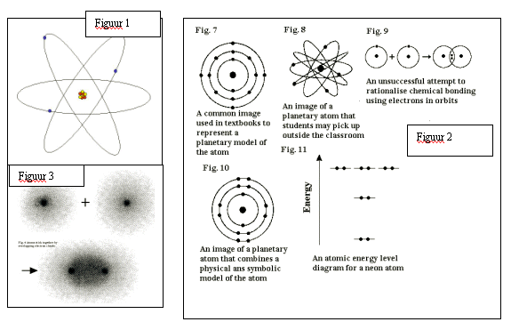
Each of these pictures is used for explaining some particular feature. Figure 1 can be used to explain the resultats of Rutherford’s experiment: the empty atom with the tiny nucleus. The pictures in figure 2 are chemistry illustrations, used for depicting electronic orbitals. Figure 3 shows fuzzy ball atoms in a reaction in which a molecule is formed. From figure 3 one could move to a more quantum mechanical atom, like in figure 4, where the probability distribution for electrons in a 2p-orbital is shown.
Figuur 3

Figure 4  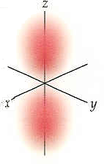 | A problem is that some pictures tend to lead to rather persistent misconceptions. The famous Bohr picture in figure 1 suggests very strongly a particle model with sharply defined electron orbits. But these do not exist. The quantum model yields probability-densities for the electrons in diferent states, such as the 2p state in figure 4.  Wright (2003) argues very strongly against representations like figure 2 en in favour of figure 3. Figures 1 and 2 are too classical and too particle-like. They do not provide a step towards a quantum model, but rather stimulate the students into the wrong direction. Wright has been using the fuzzy ball model in his chemistry lessons for over 20 years now.

Visualising the atom by means of the wave-function is used here as a didactical model, offering some counterweight, for balancing the misconceptions that are generated by the more common pictures. This is not strictly related to the question of what the physical meaning of the wave-function is supposed to be, a problem which still divides the opinions very strongly. For some, ψ*ψ merely represents a probability-density. For others, ψ itself is a physical entity in its own right. In Budde, Niedderer, Scott en Leach (2002), e.g., ψ*ψ gives the density of a sort of liquid they call electronium. This also yields the physical charge- and mass-density, in a way closely resembling Schrödinger’s original interpretation of ψ. One may debate these matters at length, but this is not strictly related to visualisations of ψ as a didactical instrument.

Images of Atoms: Models and Explanation
If you think
Atoms can stop their course, refrain from movement,
And by cessation cause new kinds of motion,
You are far astray indeed. Since there is void
Through which’they move, all fundamental motes
Must be impelled, either by their own weight
Or by some force outside them. When they strike
Each other, they bounce off; no wonder, either,
Since they are absolute solid, all compact,
With nothing back of them to block their path.
no atom ever rests
Coming through void, but always drives, is driven
In various ways, and their collisions cause,
As the case may be, greater or less rebound.
When they are held in thickest combination,
At closer intervals, with the space between
More hindered by their interlock of figure,
These give us rock, or adamant, or iron,
Things of that nature. (Not very many kinds
Go wandering little and lonely through the void.)
There are some whose alternate meetings, partings, are
At greater intervals; from these we are given
Thin air, the shining sunlight .
It’s no wonder
That while the atoms are in constant motion,
Their total seems to be at total rest,
Save here and there some individual stir.
Their nature lies beyond our range of sense,
Far, far beyond. Since you can’t get to see
The things themselves, they’re bound to hide their moves,
Especially since things we can see, often
Conceal their movements, too, when at a distance.
Take grazing sheep on a hill, you know they move,
The woolly creatures, to crop the lovely grass
Wherever it may call each one, with dew
Still sparkling it with jewels, and the lambs,
Fed full, play little games, flash in the sunlight,
Yet all this, far away, is just a blue,
A whiteness resting on a hill of green.
Or when great armies sweep across great plains
In mimic warfare, and their shining goes
Up to the sky, and all the world around
Is brilliant with their bronze, and trampled earth
Trembles under the cadence of their tread,
White mountains echo the uproar to the stars,
The horsemen gallop and shake the very ground,
And yet high in the hills there is a place
From which the watcher sees a host at rest,
And only a brightness resting on the plain.

[translated from the Latin by Rolfe Humphries]

The idea that matter consists of atoms and that the properties of these atoms determine ther macroscopic properties of matter goes back to the Greek philosophers Leucippus en Demokrites (around 450 BC). Much later (around 70 BC) the Roman poet Lucretius wrote the poem printed at the left.
(Project Physics, 1970, Vol 5, p3).

Question

List the properties of these Greek atoms, and note the similarities and differences with our 21st century atoms.

Image | Subject | Model
See poem | Philosophy of Nature | Leucippus, Demokritus, Lucretius  Atoms are undivisible units of matter.
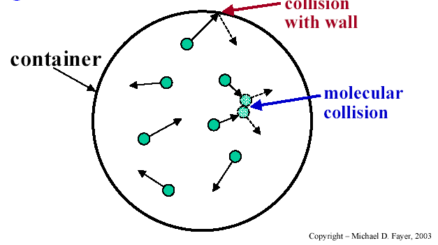 | Gasses  Kinetic theorie  of gasses | Halliday-Resnick, 4de edition, p512:  A gas consists of particles we call molecules.  - The molecules move randomly, obeying Newton’s laws.  - The number of molecules is very large.  - The volume of the molecules is negligible, compared to the volume of the gas.  - Forces between the molecules are negligible, except during collisions.  - Collisions are elastic, and the duration of a collision is negligible.  In short, molecules are very little balls, moving at large speeds, transferring momentum by collisions that take negligible time, and otherwise there are no mutual forces.
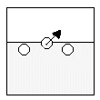 | Solid state, melting,  liquid, vaporization, boiling | Compared to the de kinetic theory of gasses:  - Movement is restricted by mutual attraction. In a solid, random movement at a fixed location. In liquid movement through the entire liquid, but:  - The density is much higher than in gas.  - The volume of the molecules is no longer negligible but essential.  - Mutual attraction is important.  - Collisions can be inelastic.  Melting: The kinetic energy becomes large enough to break up the molecular bonds.  Vaporization: Some of the molecules at the surface have enough kinetic energy to escape.  Boiling: The kinetic energic of the molecules in the fluid exceeds the binding energy due to mutual attraction.

Image | Subject | Model
The Harvard Project Physics Course,  part 5, p13 | Chemistry  Elements | Dalton (A new system of chemical philosophy, 1808, 1810)  - Matter consists of indivisible atoms.  - Every element has its own characteristic type of atoms, i.e. there are as many types of atoms as elements. The atoms of an element are perfectly identical, in mass, shape, etc.  - Atoms are unchangeable.  - When different elements combine to create a substance, the smallest part of this substance consists of a molecule, with a fixed number of atoms of each element.  - In chemical reactions, atoms are not created or annihilated, but merely rearranged.  The figure comes from Dalton’s notebook. It shows 2 atoms (top) forming a molecule (bottom).
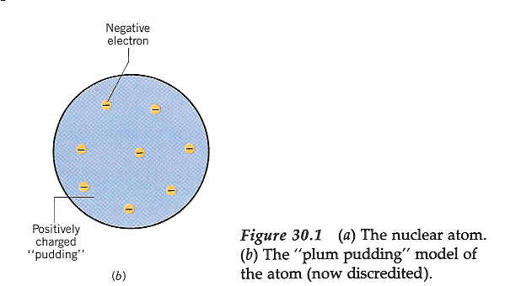  Cutnell/Johnson | Atoms 1897 | Thomson: e/m ratio is fixed, so the electron is a particle, and not an X-ray or some other form of EM-radiation.  From this arose the “plumpudding” model, with electrons as raisins in the pudding of the atom.
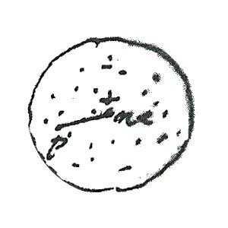 | Rutherford (Geiger-Marsden) | Rutherford arrived at the conclusion that the atomic mass is concentrated in a small nucleus.  He proved that electrons, with their tiny mass could not be responsible for the deflection of alpha-particles. Whether electrons moved within the atom was a point he left blank.  The figure comes from Rutherford’s collected works.

Image | Subject | Model
 | Bohr | Electrons move in planet-like orbits, but quantized: only very specific orbits are allowed.  Figure: Internet
screenshot  from applet psi  www.phys.uu.nl/~wwwpmn/03-04/psi.htm | Present day  QM  and  chemistry | “Fuzzy ball” atoms In the figure, the amplitude of an electron-wave in a hydrogen atom is shown.  The electron-wave is smeared out in space. The position of the electron is indeterminate, so we cannot really regard is as a particle.
 | Chemistry | An electron in an excited state of the hydrogen atom. The picture represents  p-orbital.  Figure from Brown, LeMay, Chemistry (8ste editie)
 | Chemistry | 'Fuzzy ball' atoms in a chemical reaction. Two hydrogen atoms sharing electron to form a molecule.  Figure: Wright, 2003

Literature
Brown, T.L., LeMay, H.E., Bursten, B.E. (2000). Chemistry (8ste editie). Prentice Hall.
Cutnell, J.D., Johnson, K.W. (1995). Physics (3rd edition). Wiley.
Holton, G., Rutherford, F.J., Watson, F.G. (1970). The Project Physics Course. Text and Handbook (deel 5).
Rutherford, E., Chadwick, J. (1962-1965). The collected papers of Lord Rutherford of Nelson. Allen and Unwin.
Wright, T. (2003). Images of Atoms. The Australian Science Teacher Journal, January 2003.

Worksheet Atomic models

1. Half the air is sucked from an erlenmeyer flask. Assume we have magic spectacles enabling us to see the air-molecules. Draw the image we can see  a) before the air is sucked out;  b) after half the air is removed.  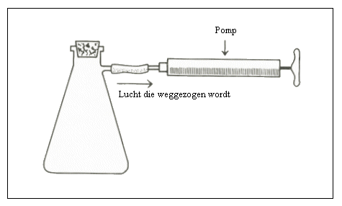 | before after
2. Water is made to boil in a test tube with a balloon attached to it. The balloon will expand.  a) Explain this, using a particle theory.  b) In the spherical balloon on the right, draw the particles.  c) Explain what kind of particles they are.  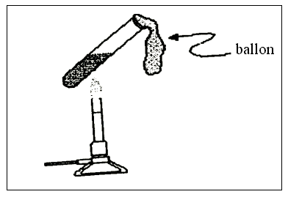 | 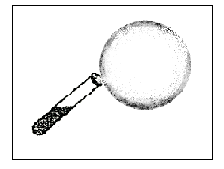
3. Compare the particle model for explaining the theory of gases with the model used to explain vaporization. A particle at the surface is going to escape from the liquid, but it still experiences the forces exerted by the other particles.
- In the diagram on the left, draw the forces on the particle.
- In the diagram on the right, draw the velocity of the particle.
- List the differences with the kinetic theory of gases.

4. List the features that must be added to the molecular theory in order to explain chemical reactions.
Try to give your answer in the form of a diagram.

5. What features must be added to explain also radioactive decay?

Again, try to answer with a diagram.

6.  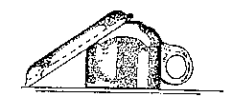  A wet cup and saucer are laid to dry on the draining board. After a while, they are indeed dry.  What happens to the water? | Some answers of other students:  - The water is absorbed in the cup and the saucer.  - The water dries up and does not exist anymore.  - The water changes into hydrogen and oxygen.  - Small water particles mix with the air.  Explain your answer:

Understanding probabilities and wave functions through fast feedback

Students, but also Einstein and other physicists, have (had) problems with the probability aspects of quantum physics. There are at least three kinds of problems:
- using probabilities and getting used to the idea that probability plays a role in Physics;
- using and interpreting wave functions and related phenomena such as interference.
- problems relating to entangled states.
At the grammar school level, typically all problems of type 3, concerned with entanglement, are too complex to even start any serious attempt at explanation. Perhaps it is preferable to avoid mentioning them at all, although this may become increasingly difficult as more students start asking about these mysterious quantum computers they may read about in the newspapers.

Even at an introductory level, however, problems of type 1 and 2 can mix and confuse. One way to do something about it is to clearly separate the different problems and find experiences and exercises to match. Whenever there are problems in understanding, it is important to build in ample opportunities for interaction and feedback. This can be done realistically with big classes when we use graphical presentations with so fast feedback methods.

Wave functions

Wave functions are functions from which one could extract information about particles such as momentum, energy, position, and other variables. Wave functions are usually complex, but the product Ψ*.Ψ is real. The product Ψ*(x,y,z).Ψ(x,y,z) provides the probability per unit volume, that is the probability density f(x,y,z) to find an electron, proton, or other particle at a particular place. First we will teach the classical concept of probability.

The teacher sketches figure 1 on the board and says:

figure 1

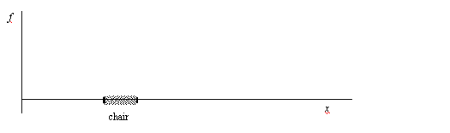

Teacher: I have an x-axis (delineates an x-axis in front of the room) and on that x-axis I put a chair (puts a chair). I put a ballpoint under a piece of cloth “somewhere” on the chair (puts cloth or handkerchief on chair and puts ballpoint somewhere under it). I sketch the x-axis on the board and the gray area between the bars is the chair (draws figure 1 on the board).
The probability (in this 1-dimensional case per cm) to find the ballpoint is f(x).
Question 1: Sketch the probability f(x) as function of x. There are several acceptable solutions, so later compare with your neighbor.

While the students are making their sketches, the teacher goes around the room, looks at student work, and asks an interpretation here and there: What does your graph mean? Where is the greatest probability to find the ballpoint in your graph? How do you see that in the graph?

Some possible solutions are as follows (figure 2a,b):

figure 2a figure 2b
Everywhere on the chair the probability is the same. In the middle of the chair the probability is greatest.
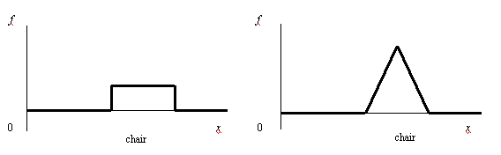
In figure 2a the probability of finding the ballpoint anywhere on the chair is the same. In figure 2b it is more probable that the ballpoint is found in the middle of the chair. There could be a real physical reason for that, for example, when the chair is a little bit deeper in the middle as compared to the sides.

Teacher: Now I have 4 chairs at some distance from each other (puts 4 chairs or tells students to imagine them). The ballpoint could be on any of these chairs and anywhere on their surface.
Question 2: Draw the probability.

figure 3
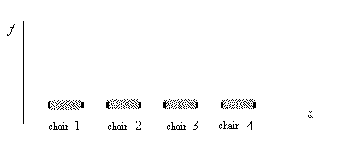
An answer can be found in figure 4. The sum of the areas in the graph should be 1 as that is the chance to find the ballpoint somewhere in the universe. Also here one could think of different solutions such as in figure 2b or an opposite solution where the probability of finding the ballpoint is greater on the sides of the chair (figure 7b).

figure 4

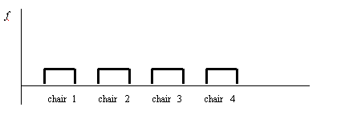

Teacher: Suppose that sat on chair 4 so that the chance to find my ballpoint there is greater than on chairs 1 – 3.
Question 3: How does the graph look? Sketch.

figure 5
The area under the graph is greater for the location of chair 4.

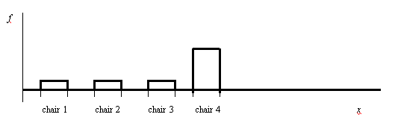

Teacher: The area under the graph shows the probability to find the particle somewhere. The total probability should be 1.
Question 4: Should anything be adjusted in your graph of figure 5 in comparison to figure 3 to achieve a total area under the graph of 1?

Now sketch on the board a map of your class and roughly indicate the location of tables and chairs.
Teacher: There are places in the class where I often pass and there are places where I don’t.
Question 5: Indicate through pencil marks where the probability is high to find the teacher. Areas where that probability is zero, remain white.

figure 6
A classroom situation where students can pencil in the probability for finding the teacher.

Probably all benches will remain white as most teachers do not dance on top of student tables. Although, many teachers sometimes sit on one of the benches… In front of the room we usually find the most black area, but who knows, perhaps you are the kind of teacher who moves around a lot to unexpected parts of the classroom!

From here the jump to a probability density picture of an orbital is not that big (?)anymore.

If students need more exercise yet, one could still reverse the process and give graphs to the students and let them write a short interpretation (figures 7a, 7b)

figure 7a figure 7b

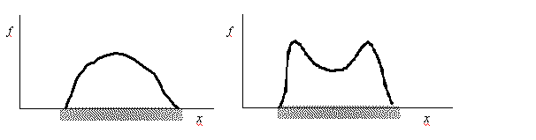
Teacher: In figure 7a I have drawn the probability to find a ballpoint on the chair.
Question 6: Does this mean that the ballpoint is unlikely to be found on the side of the chair? Explain.
Question 7: Where on the chair is the probability greatest to find the ballpoint in figure 7b?

Figure 8 shows a golf course. There is the start, the target hole, a little hill, a pond, and there are bush. We forgot the sand traps. We do an experiment in which 10,000 amateur golf players hit the ball at the start. Then we put a pencil dot where the ball lands. So we get a picture with 10,000 pencil dots. As a result we obtain a map showing light and dark places. The dark places have a high probability to find balls. Here one can let the students draw their golf ball probability plot. The resulting plot already looks like an orbital plot!

figure 8

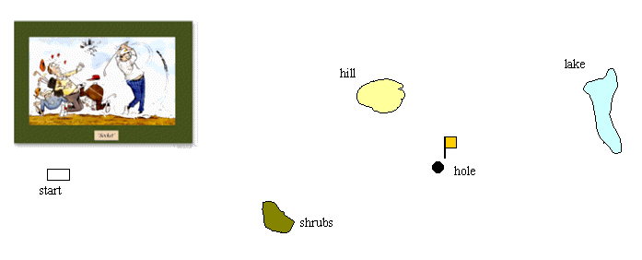

The next step is to start wondering about the difference between classical probabilities and the meaning of probability in quantum theory.

Probability in quantum physics

Once students understand the work with probabilities, it is time to pay attention to the peculiarities that are added by quantum physics. The normal, classical probabilities are often interpreted as lack of knowledge. The ballpoint on the chair has a very fixed location, except we do not know yet. Perhaps somebody, in this case the teacher, knows the exact location already. However, in quantum physics the probability is fundamental. The general interpretation is that the uncertainty cannot be reduced by additional knowledge. Quantum objects such as electrons, protons, and other particles cannot be located with absolute certainty.

An important difference between the probabilities of finding golf balls somewhere in the field and the probability of electrons to hit a particular place on a screen, is that with electrons the probabilities have to do with wave functions. The behavior of waves leads to strange phenomena, which we do not encounter with golf balls. Waves can extinguish each other through interference. On a screen we could find interference patters with dark lines or rings. These are places that electrons cannot come because they can get there in different ways and interfere! Such patterns are also found when particles are shot at rather large time intervals, thus one by one. So even individual particles exhibit wave behavior, not just groups of particles. One possible point of view is to take distance from the idea that quantum physics describes individual systems or particles, but that the quantum theory only deals with ensembles of similar systems. In the words of Muller & Wiesner (2002):

“As we have mentioned, a basic observation in an interference experiment with single photons is that the pattern on the screen builds up from the “hits” of single photons. It is legitimate to ask whether these positions are predetermined as in classical physics and can be predicted from the initial conditions. In this stage of the course, the students learn that one cannot predict the position of a single hit, but that it is nevertheless possible to make accurate predictions for the statistical distribution of many hits. This observation is generalized to the following important statement: Quantum mechanics makes statistical predictions about the results of repeated measurements on an ensemble of identically prepared quantum objects. This preliminary version of the probability interpretation is later, in the context of electrons, formulated more precisely in terms of the wave function.” (Muller & Wiesner, 2002).

The question whether and how individual systems can be described disappears then into the background. That is unfortunate, but such is nature. What can be done is to exercise with differences between classic and quantum probabilities and particularly with interference phenomena.

Literature
Berg, E and R van den, N. Capistrano, A. Sicam (2000). Kinematics graphs and instant feedback. School Science Review, 82(299), 104-106.
Berg, E. van den (2003). Teaching, Learning, and Quick Feedback Methods. The Australian Science Teaching Journal, June 2003, 28-34.
Black, P., William, D (1998). Assessment and classroom learning. Assessment in Education: Principles, Policy & Practice, 5(1), 7 – 75.
Crouch, C.H., Mazur, E. (2001). Peer Instruction: Ten years of experience and results. American Journal of Physics, 69(9), 970-977.
Hake, R.R. (1998). Interactive-engagement vs. Traditional methods: A six-thousand-student survey of mechanics test data for introductory physics courses. American Journal of Physics, 66 (1), 64-74.
Mazur, E. (1997). Peer Instruction: A user’s Manual. Prentice-Hall.
Meltzer, D.E., Manivannan, K. (2002). Transforming the lecture-hall environment: The flly interactive physics lecture. American Journal of Physics, 70(6), 639-654.
M. Muller, H. Wiesner (2002). Teaching quantum mechanics on an introductory level. American Journal of Physics, 70(3), 200-209.

Worksheet Particles and Waves

In figure 1a a beam of particles, or waves, or in any case ‘quantum things’, is fired at a double slit screen. Figure 1d shows a possible result: a screen hit by 70 000 electrons.

figure 1
Double slit experiment.

What appears on the screen depends among other things on the distance between the slits and the type of objects being fired. The pattern in figure 2A was made by firing small bullets through a two-slit metal plate; figure 2B is a result from Young’s experiment, with light falling through a two-slit diaphragm.

figure 2
Particles and waves

2A: bullets | 2B: waves

Questions | Answers
- Is figure 1d more like 2A or like 2B? Explain your answer.

- Which of the two figures 2A of 2B shows interference?  Circle one of the answers a)...d) and explain. | - A  - B | - A en B  - None
In the following questions, different objects are fired at slits in different ways. The distance d between the slits is called big if it is large compared to the De Broglie-wavelength and small if it is of the same order of magnitude.
Explain in each case whether the screen image is more like 2A or like 2B.

- A beam of red light is pointed at two slits with small d.

- Beam intensity is decreased until photons pass the slits one by one. A screen pattern is obtained by recording single photon hits with a very sensitive CCD-plate, and waiting a few days.

- A beam of electrons is pointed at two slits with small d.

- Beam intensity is decreased until electrons pass the slits one by one. A screen pattern is obtained by recording single electron hits.

- An electron beam is pointed at two slits with large d.

- A beam of red light is pointed at two slits with large d.

- Summarize your answers.

With the following questions we aim to get a clearer picture of what it means for d to be small or large. Each time, the distance between diaphragm and screen is 1,0 m, but wavelength and slit-distance d will vary.
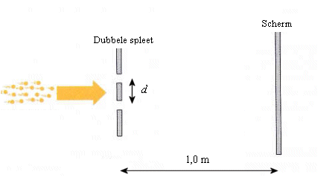
Calculate the distance between the 0th- and 1th-order maximum on the screen.

- A beam of red light hits a diaphragm with d = 1 mm.

- A beam of electrons with an energy of 10 eV hits a diaphragm with d = 1 mm.
- A beam of electrons with an energy of 10 keV hits a diaphragm with d = 1 mm.
- A beam of electrons with an energy of 10 keV hits a diaphragm with d = 1 nm.
- A beam of red light hits a diaphragm with d = 1 nm.

The particle in a box

The quantum physics part of the Project Modern Physics does not involve solving Schrödinger equations. The pupil’s knowledge of standing waves is used to introduce the model of a quantum particle in a box. The advantage is that the level of mathematical complexity is very low, but there are nevertheless some interesting applications, and can be used for showing physical principles without getting lost in details. A disadvantage is of course that that the model is very limited.

Equations:

Applications:

- rough size and energy estimates
- attractive forces and binding energies (by sharing electrons)
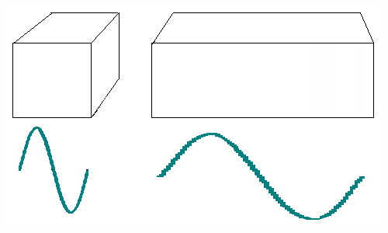
- repulsive forces (by electron pressure and exclusion principle)
- calculating the colour of organic dyes

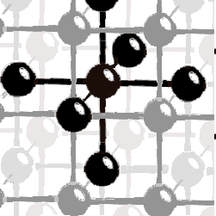
- atomic bonds in crystals
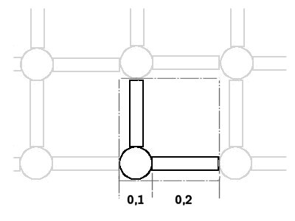

- minimising energies in atomic bond models
- order of magnitude calculations of stiffness in models of crystals

The particle in a box

Worksheet
- A quantum particle is captured in a box. Draw the shape of the ground state.

- The figure on the right shows a wave crest in a chord, moving from left to right.  In the same figure, draw the shape of the chord 0.5 T later. | 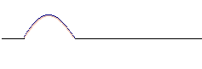
- The figure on the right shows the wave function of a quantum particle in a box. Indicate where the probability of finding the particle if one were to measure its position is largest. | 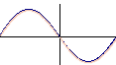
- The diagram below shows the potential energy of a quantum particle in a stair-like well as a function of x.  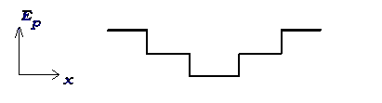  Which of the wave functions in the diagram on the right shows a possible wave function of the particle? | 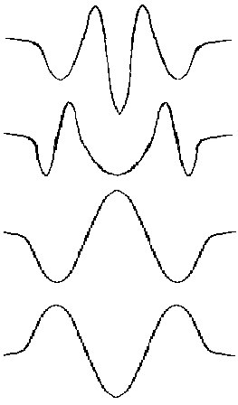 |  | (a)  (b)  (c)  (d)
- A beam of electrons hits a two slit diaphragm with small slit distance. Behind the diaphragm, a photographic plate is attached to the screen. The intensity of the beam is set to 1 electron per second.
In a sequence of four pictures, draw an animation of what the photographic plate will show after 10, 20, 30 and 40 s.

Symmetries and Elementary Particles

Dick Hoekzema, Gert Schooten, Ed van den Berg, Piet Lijnse
Centre for Science and Mathematics Education
Universiteit Utrecht, Utrecht
Netherlands

Introduction
The following student text on conservation laws, symmetries, and elementary particles was developed in a Dutch project for teaching Modern Physics to the top stream of the 6th year of secondary education (age ~17-18). In a series of 35 lessons of 45 – 50 minutes each, students study particle-wave duality, the Heisenberg principle, probability models for properties of particles, the particle in a box and applications, elementary particles, and astrophysics (www.phys.uu.nl/~wwwpmn). In this article we focus on particle physics and the key concepts of this chapter are: transformation, reaction equation, conservation laws and symmetry. For recent literature regarding the teaching about symmetries and/or elementary particles we refer to articles by Hill & Lederman [1], Pascolini & Pietroni [2], Kalmus [3], O’Connell [4], and Hanley [5].

Instead of discussing a multitude of particles and reactions, the core of the elementary particle chapter is formed by a discussion of conservation laws and symmetries. Before getting to this point students have encountered reaction equations, nuclear reactions with a few examples, energy and mass, binding energy and mass defect and some computations, quarks and leptons, and accelerators and detectors. In the following we present the student text as an example of how to deal with elementary particles at the secondary level and as a handy background article for teachers.
The reasons for our focus on conservation laws and symmetries are:
- The conservation laws provide a nice connection with the classical physics background of students.
- A focus on conservation laws and symmetries matches the current emphasis in elementary particle physics and is useful in other branches of physics as well.
- Using the laws and symmetries in reaction diagrams provides an opportunity for reasoning with main principles while an approach with lots of different particles (particle zoo) and reactions may present too many details, which will be forgotten anyway.
The use of the term conservation laws and symmetries might generate some expectations that we cannot fulfill. We expect our students to be able to apply symmetry principles in reaction diagrams and use these as a tool to determine whether or not reactions are possible and to predict alternative reactions. We do not expect students to fully understand the connection between symmetry and a conservation law [1].
Because in an earlier Dutch project the use of Feynman diagrams in secondary Physics courses was not successful, we use simplified diagrams and call them reaction diagrams rather than Feynman diagrams. The diagrams are only used to describe and predict reactions. They are not used to infer the probability of reactions or look deeper into the nature of the interactions.

The Student Text
Conservation principles are at the core of reaction equations and in different walks of life one uses different terminology. In daily life one can say that house keys do not dissolve when it rains. In Physics one could say that the number of keys is conserved in interactions with raindrops.

In many kinds of reactions the number of electrons is conserved. However, there is no absolute conservation law, because in nuclear reactions and in reactions of sub-atomic particles the number of electrons can change. For example, β-decay produces an electron that was not there before:

This is why instead of the number of electrons we introduce another number: the lepton number. Leptons (light particles) are electron-like particles and neutrinos specific for each kind and labeled ν_{e}, ν_{μ}, and ν_{τ}. The lepton number is defined as:

lepton number = number of leptons minus the number of anti-leptons

Because there is no known reaction in which the lepton number changes, we can say that lepton number is conserved. As far as we know, this is an absolute conservation law, comparable to the conservation of charge.
Long before the theory of quarks it was already noticed that a similar conservation law could be applied to particles like protons, neutrons, and other similar particles jointly called baryons. The conservation law applies to the so-called baryon number:

baryon number = number of baryons minus number of anti-baryons

Quark number can be defined as the number of quarks minus the number of anti-quarks. What Conservation of baryon number really boils down to conservation of quark number. At present we know that all baryons consist of three quarks, so their quark number is three, whereas mesons consist of a quark and an antiquark and have zero quark number. In all known reactions involving mesons and baryons, both baryon and quark numbers are conserved. Baryon number, however, is the more usual term, also because we already know it from nuclear physics. The mass number of a nucleus is actually the baryon number. The atomic number (Z), the number of protons in a nucleus expresses the amount of positive charge and is sometimes called charge number.

Symmetries
Earlier in this chapter we have already seen that conservation laws are important in analyzing reactions. Another closely related and convenient way of analyzing reactions is the use of symmetries. What is symmetry?

Figure 1

The crystal lattice of graphite provides a clear example of symmetry (see figure 1). It is symmetric with respect to rotation over 60º. The principle of symmetry is that there is a property, the pattern of the crystal lattice, which does not change under certain operations, in this case a rotation over 60º. Such a property is called a symmetry property and the operation is called a symmetry transformation.

We will deal with symmetry transformations for particle reactions. The symmetry property we study is whether a reaction is possible. We then look at some different symmetry transformations, each time following the same principle: We take an existing reaction equation, change something, and ask whether the result can also occur in nature.

Time reversal and charge reversal symmetry
Time reversal (T ) is an operation which reverses a process in time (as distinguished from space). In other words, the arrow in the reaction equation is reversed. A reaction is symmetric under time reversal if the reverse reaction is also possible. The creation of an electron-positron pair is the reverse of the annihilation that occurs when an electron and a positron meet. Time reversal symmetry means that the arrow in the equation can be reversed.

Example:
Thorium-232 decays into Radium-228 while emitting an alpha particle.

Collisions between radium and α-particles of the proper energy can result in the production of Thorium:

The macroscopic world is clearly not time symmetric. When viewing a videotape you will notice within seconds whether it is run forward or backward. However, on a microscopic scale most reactions can be reversed. For a long time physicist thought that on a microscopic scale the world is indeed rigorously symmetric. The reversibility of time and the physics and philosophical questions related to that, constitute an interesting problem with many questions remaining.

A second and closely related symmetry is symmetry under charge reversal (C: Charge conjugation). With this we mean that particles are being replaced with their anti-particles. Symmetry under C means that the reaction equation remains valid if all particles are replaced by their anti-particles.

Example:
A proton and an electron together form a Hydrogen atom:

Based on this one would expect that an antiproton and a positron together would form an anti-Hydrogen atom:

Since 2002 such anti-atoms can be produced in considerable quantities at CERN in Geneva.

Diagrams

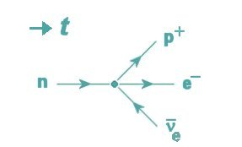
Figure 2

Particle reactions can be visualized using diagrams which we will call reaction diagrams. In the diagram in figure 2 time is going from left to right. The lines stand for particles; points where the lines come together (called: vertex) visualize interactions; the diagram express a conservation law: conservation of baryon number in the case of the proton and conservation of lepton number in the case of the electron and the anti-neutrino. The fact that in the diagram in figure 2 the arrow of the anti-neutrino points to the left means that the lepton number (-1) is opposite to that of the electron (+1). Also with a positron the arrow would be to the left (lepton number –1), just like with the antiproton (baryon number –1).
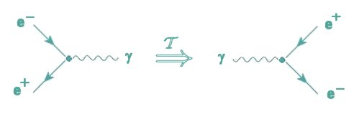
Figure 3

The diagrams of figure 3 visualize a pair creation reaction equation and its time-reversed annihilation reaction. The symmetries can be formulated as rules for operations on diagrams. T-symmetry means that the diagram can be flipped around (figure 3).

Electron capture and β⁺- decay
β⁻-decay occurs in nuclei with a surplus of neutrons. In the nucleus a neutron is converted into a proton, see figure 2.

In nuclei with a relative shortage of neutrons, the reverse reaction can occur in which a proton is converted into a neutron. This result can be achieved through two different reactions.

The first of these reactions is called electron-capture: a proton and an electron can react with as result a neutron and a neutrino (figure 4).

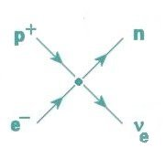
Figure 4
This reaction takes place primarily in heavy nuclei. The inner electrons are then close to the nucleus, which increases the chances of electron capture.

If electron capture is not possible or has a low probability, then it is still possible that a proton decays into a neutron while emitting a positron and a neutrino:
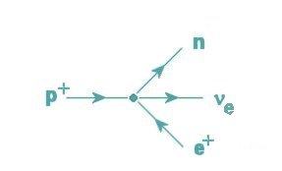
Figure 5

This reaction cannot take place in a free proton as the reaction requires energy. Within a nucleus such energy might be available if there is a surplus of protons. In the nucleusneutronsexperience only attractive nuclear forces of other neutrons and protons. However, protons experience attractive nuclear forces as well as repulsive electrostatic forces of other protons. If there are too many protons the nucleus might become unstable due to the electrostatic potential energy. Some of the electrostatic potential energy is used to create mass when a proton decays into a neutron and a positron plus a neutrino (figure 5). The last two will be ejected from the nucleus. The reaction is called β⁺-decay. On the other hand the decay of a neutron into a proton plus an electron and neutrino is called β⁻- decay.

Crossing
Time reversal means that the reaction arrow is reversed. Charge reversal, also called charge conjugation, means that all particles that participate in the reaction are changed into their anti-particles. A comparison of the diagrams for β⁻-decay, β⁺- decay, and electron capture (figures 2, 4, and 5), suggests yet another symmetry which could be applied to the individual particles in a reaction. The operation that is needed to relate the different reactions is a combination of T and C for the separate lines in a diagram.
The symmetry operation in which an individual particle is taken from one side of the reaction arrow to the other side and then is converted in its antiparticle is called crossing.
We will use the symbol X for this operation. It turns out that crossing-symmetry is indeed valid for every kind of particle reaction. In a reaction diagram this means that any line can be flipped over to the other side (or mirrored with respect to a vertical mirror) in which the arrow still points in the same way with respect to the vertex (toward vertex or away). Figure 6 shows this more clearly. In the reaction on the left, a neutron decays into a proton, an electron, and an anti-neutrino. In the reaction on the right a neutron reacting with a neutrino produces a proton and an electron.
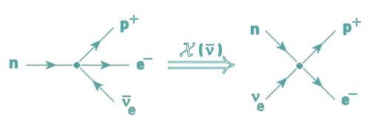
Figure 6

The reactions for β⁺-decay and for electron capture can be deduced from the reaction for β⁻-capture through a combination of crossing and time symmetry:

and

Many other reactions can be obtained in a similar way, such as:

All these reactions are indeed possible if the energy is available. The reaction on the right hand side in figure 6, for example, means that neutrinos can cause nuclear reactions. This is the basis for the detection of neutrinos!

For physicists, diagrams have a deeper meaning than the mere representation of reaction equations. Particle physicists use so called Feynman diagrams which are constructed according to certain rules so that every line, and every point has a mathematical meaning. From these diagrams they can compute the probability of a certain reaction taking place.
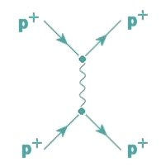
Figure 7

Feynman diagrams are also be used to compute forces. Figure 7 gives a first approximation of the electrical force between two protons. Two protons approach each other from the left. They exchange a photon as part of the repulsion process. The angle between the incoming and outgoing proton can be used to compute the electric repulsion force.

For a long time, particle theories encountered major problems. Many of these problems originated from infinities in the computations based on the diagrams. For several decades beautiful results were followed by incomprehensible riddles and vice-versa. Only towards the end of the 20th century some of these problems were solved which led to the “Standard Model” of elementary particles. The Dutch physicists Gerard ’t Hooft and Martinus Veltman received a Nobel Prize for their contributions to solving the infinities.

The formulation of the Standard Model does not mean that all problems have been solved. Although the predictions of the model match spectacularly with the experimental results the theory still has some characteristics which physicists do not like. Also some important elements are still lacking, such as a good description of gravity. So far physicists have not been able to integrate quantum physics and gravity in one theory in spite of major efforts, although a tentative hypothesis called “string theory” has made encouraging progress in this direction.

The student text then ends the particle chapter with a paragraph about hadrons and quarks and of course there are exercises (not included here). The pion problem (figure 8) shows the “style” of examination problems common at the pre-university level in the Netherlands.

Experiences
The student text has been used for 2 years now. The teachers are generally happy with the approach and the topic conservations laws/symmetries is considered one of the easier topics of the rather demanding modern physics course. Teachers, who had tried the previous Dutch approach with Feynman diagrams and many more particles, feel that the current approach with the simplified diagrams gives them a much better understanding and confidence. Some students are able to understand the topic by reading the text only, however, most students and teachers need a few additional examples and exercises and then get the motivating experience of recognizing how neatly the diagrams can represent the reaction equations and how one can predict new reactions by applying the symmetries. Teachers typically spend 2 lessons on the topic. We suspect that some teachers now find the topic easy and go too fast with too little exercise as other topics in the course are considered more demanding. On the Pion-problem (figure 8) 75 students from 7 classes/teachers scored 52% on the first question, 87% on the second, 68% on the third, and 54% on the 4th. The performance on the 4th question on diagrams ranged from 25% - 83% for different teachers. That range may show the difference between classes that include sufficient exercises and those that do not.

References
- C.T. Hill, L.M. Lederman (2000). Teaching symmetry in the introductory physics curriculum. The Physics Teacher, 38, 348-353.
- A. Pascolini, M. Pietroni (2002). Feynman diagrams as metaphors: borrowing the particle physicist’s imagery for science communication purposes. Physics Education, 37(4), 324-328.
- P.I.P.Kalmus (1999). Empty matter and the full physical vacuum. Physics Education 34(4), 205-208.
- J. O’Connell (1998). Comparison of the four fundamental interactions of physics. The Physics Teacher, 36(1), 27.
- P. Hanley (2000). Teaching particle physics. Physics Education, 35(5), 332-338.

Teaching conservation laws, symmetries, and elementary particles with fast feedback

Ed van den Berg, Dick Hoekzema
Centre for Science and Mathematics Education
University of Utrecht, Netherlands

Will you teach about elementary particles this year in your upper secondary Physics class? No time? An overloaded program? Do you feel you either have to spend lots of time and many lessons, or better skip the topic? It is possible to spend just 3 lessons on the topic in a very meaningful way, as we will show you. Of course it is nicer if you have more time, but in this article we present a sequence of 3 lessons focussing on conservation laws and symmetries.

Lessons about elementary particles easily degenerate into listing a zoo of particles and reactions, resulting in disorganized and rather meaningless knowledge. A more powerful way is to focus on conservation laws, symmetries, and reaction diagrams. The conservation laws and symmetries provide generalizing power which enables the students to predict whether or not certain reactions are possible and to derive new reactions from given ones by applying the symmetries. In a previous article [1] we supplied the rationale and a complete student text for this approach. In this article we present a teaching method and worksheet. For “content” please refer back to [1].

Fast feedback method
Fast feedback is a “whole class” teaching method in which the teacher gives a series of short tasks to be done by students individually but at a collective pace. The tasks can be answered in the form of a diagram, a sketch, a drawing or a few words. Tasks are given one by one. With each task the teacher goes around and looks at student work. Here and there (s)he asks students to clarify their answer. In one or two minutes the teacher can check a representative sample of 10 – 20 students. That way the teacher gets immediate feedback on whether students understand and what kind of misunderstandings are there. The students get immediate feedback as the teacher can respond during the lesson to the common errors and misunderstanding (s)he observed. The teacher has to keep pace to keep the lesson moving. Not every single student error is discussed in plenary, only one or two of the most common errors before the class moves to the next task. If we count 2 or 3 minutes for each task and 2 minutes for plenary discussion, then in one lesson the teacher can go through 6 – 8 tasks.
Fast feedback methods are a common element in so-called interactive engagement teaching methods [2,3]. For example, the peer teaching method described by Mazur [4,5] uses concept-focused multiple-choice questions. A quick vote on answers provides a good indication of prevalent student misconceptions. Subsequent small group discussion of answers triggers student engagement and provides more feedback for students and teachers. Berg [6] outlined different formats for fast feedback in the classroom in “real time” and Berg et al [7]) contains a worked out example for kinematics.

Three lessons
Lesson 1: The teacher introduces the standard model and the particle families of leptons, mesons, and baryons. Introducing the first generation only might be sufficient. The result will be tables 1 and 2 or just the first generation parts of table 1. Any extra time could be spent on detection methods.
Lesson 2: In a short class discussion the teacher and students recall the conservation laws they have encountered so far (linear momentum, energy-mass, charge, and possibly angular momentum). Then the lesson proceeds in the following steps:
- (Teacher) We start with the reaction equation: and give an example of C-symmetry [1] by replacing particles by anti-particles: . The resulting anti-Hydrogen was made at CERN, Geneva. Since 2002 it is even made there in considerable quantities, so this reaction with anti-particles can indeed take place.
- Students answer exercise 1a and 1b from the worksheet and perhaps an additional exercise added by the teacher. The teacher walks around and identifies any problems students may have with the exercise.
- (Teacher) The teacher discusses the answer to 1a and 1b and perhaps one or two problems (s)he encountered when looking at the answers of students. Then the teacher gives an example of time symmetry using the ionization of Hydrogen. . Reversing the arrow (time symmetry) also shows a possible reaction.
- Students do exercise 1c and the teacher goes around and looks at answers.
- The teacher discusses the answer of exercise 1c or skips that part altogether if everyone got it right. Then the teacher gives an example of the crossing operation in which every particle in the equation can be moved to the other side of the arrow if replaced by its anti-particle. For example: . It turns out that we can move particles to the right or left of the arrow if we replace them by their antiparticle. For example, the reaction is possible but we are now dealing with an anti-neutrino. Whenever we apply the crossing operation to a valid and possible reaction, the particle has to be replaced by its anti-particle and we have another valid and possible reaction.
- Students do exercises 1d and 1e and the teacher goes around to observe.
- Teacher discusses 1d and 1e.
- In the same way the class proceeds with exercises 2a-f.

Lesson 3:
- Lesson 3 starts with an example of reaction diagrams (Figure 1).
On the left of the vertex are reactants and on the right are products. An arrow to the right stands for a particle and an arrow to the left stands for an anti-particle. For further details of these simplified Feynman diagrams we refer to our earlier article [1]. Then problems 3a-c are with fast feedback just like problems 1a-e and 2a-f in the previous lesson.
After every 1 or 2 exercises, the teacher interrupts, discusses the answers and the class moves on to the following exercise.
Figure 1

- Exercises 4 – 6 are done by students individually or in small groups at their own pace and no longer in fast feedback format as these exercises take more thinking time. Thanks to the format of the worksheet, it is still possible for the teacher to very quickly assess the work of individual students and interact to find out the students’ reasons for alternative answers and to engage in individual or small group discussions.

Worksheet Symmetries and Reaction Diagrams with Answers

- Beta decay
(1)

Question | Answer
- Check for baryon, lepton, and charge conservation.  - Apply C-symmetry to (1) and write the resulting equation  - Apply T-symmetry to (1) and write the resulting equation.  - Apply X()-symmetry to (1)  - Apply X()-symmetry to (1) | - Baryon: 1 = 1  Lepton: 0 = 1 – 1  Charge: 0 = +1 -1  Please note that n consists of while consists of quarks, so neutron and anti-neutron are different.

- Reactions with pions
(2)

Question 2 | Answer 2
- Check for baryon and charge conservation.  - Apply C-symmetry to (2), where π⁺ is taken as the anti-particle of π – .  - Apply T-symmetry to (2)  - Apply X(n) to (2)  - Why is the last reaction rather unlikely?  - The π ⁰ deeltje consists of an up quark and its anti-particle ( ) or a down quark and its antiparticle (). Will the particle last long? Explain. | - Baryon: 0 + 1 = 0 + 1  Charge: -1 + 1 = 0 + 0  - It is rather unlikely to find these three particles within 1 fm (10⁻¹⁵ m) from each other.  - Annihilation can take place between and or and but not between quarks of different flavor such as and and and .

  - Muon decay
The reaction for muon decay is:
(3)

The reaction diagram can be drawn as follows (the teacher will introduce reaction diagrams and then the students continue with questions 3a-3c using the fast feedback method, thus the teacher discusses the answer to 3a before students proceed to 3b, etc.).
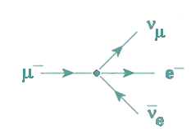

Question 3 | Answer 3
- Check for lepton conservation  - Apply C symmetry to (3)  - Apply X(ν_{μ}) to (3)  - Apply X( ) to (3) | - μ-leptons: +1 = +1  e-leptons: 0 = +1 -1

Draw the reaction diagrams.
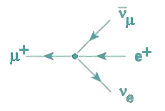 | 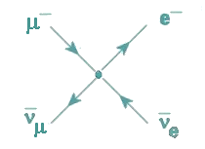
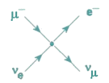

  - Once again beta decay
We return to equation (1):
(1)

Question 4 | Answer 4
- Use symmetries to derive an equation for beta decay, which results in the emission of a positron.  - Show that it is not possible to derive a reaction from (1) using symmetries in which amongst others a positron is produced from a neutron..  - Use the symmetries and try to derive an equation in which an electron is absorbed into the nucleus. (In nature this can happen spontaneously in nuclei with high Z. It can also be contrived by shooting electrons at nuclei).  - Look at the equations once again. Which process could be used to detect electron neutrinos and electron anti-neutrinos?  - Reaction (1) can take place in a free neutron but it is much more likely to occur in a neutron which is part of a nucleus such as . Write reaction (1) for Chlorine-35.  - By crossing the reaction in Chlorine 35 we can get a reaction which makes it possible to discover neutrinos when they collide with a Chlorine nucleus. Write the reaction and add a reaction diagram. | - X() would produce a positron on the left of the arrow. Then we apply T symmetry and reverse the arrow:  - Using crossing symmetry with the particles of (1) only, we would always end up with a positron and a neutron on the same side of the arrow and not on opposite sides.  - As input we need an electron. So we apply Time symmetry on (1) and then move the anti-neutrino to the right using crossing:  We can also get this by applying time symmetry to the answer of 1c.  - We can detect electron neutrino’s through collisions with neutrons  and anti-neutrinos through collisions with protons:  or

5. Collisions
Check whether the following reactions are possible or not and indicate why.

Question 5 | Answer 5
a)  b) | 4a) Baryon conservation is okay:  0 + 1 = 1 + 1 –1.  Also charge conservation is okay.  4b) No baryon conservation as: 2 ≠ 3

6. What kind of particles?
Question 6 | Answer 6
A reaction is as follows:  X is an unknown particle.  - Is it a meson or a baryon? Why?  - Does X have charge or not, why?  - Can X be a lepton?  - Answer a), b), and c) in case two particles are formed (X and Y). | - X cannot be a baryon or anti-baryon as then baryon number would not be conserved. It could be a neutral meson.  - X cannot have charge as then there would be no charge conservation.  - If X would be a lepton, there would not be conservation of lepton number.  - A baryon and an anti-baryon would be possible if X and Y would both be neutral or would have opposite charge. Leptons would be possible, but then it would have to be a lepton and its anti-lepton.

Table 1: Elementary Particles

Elementary Particles: Fermions
Quarks¹ |  |  |  |  | Leptons²
Generation |  | Particle/flavor | Mass (GeV/c²) | Charge (e) | Generation |  | Particle/flavor | Mass (GeV/c²) | Charge (e)
1 |  | u up quark | 0.003 | 2/3 | 1 |  | ν_{e} electron neutrino | <1. 10⁻⁵ | 0
 |  | d down quark | 0.006 | -1/3 |  |  | e⁻ electron | 0.000511 | -1
2 |  | c charm quark | 1.3 | 2/3 | 2 |  | ν_{μ} muon neutrino | <0.0002 | 0
 |  | s strange quark | 0.1 | -1/3 |  |  | μ⁻ muon | 0.106 | -1
3 |  | t top quark | 175 | 2/3 | 3 |  | ν_{τ} tau neutrino | <0.02 | 0
 |  | b bottom quark | 4.3 | -1/3 |  |  | τ tau | 1.7771 | -1

Elementary Particles: Bosons
Strong interaction |  |  |  |  |  | Electro-weak interaction
 | g gluon |  | 0 | 0 |  | γ photon |  | 0 | 0
 |  |  |  |  |  | W minus boson |  | 80.4 | -1
Gravitation |  |  |  |  |  | W plus boson |  | 80.4 | +1
 | graviton  (hypothetical) |  |  |  |  | Z boson |  | 91.2 | 0
  - For every quark there is a anti-quark with the same mass, opposite charge and baryon number –1.
  - For every lepton there is an anti-lepton with the same mass, opposite charge, and lepton number –1.
  - Conservation of lepton number is considered separate for electron and electron neutrino, muon and muon neutrino, and tau particle and tau neutrino.
Table 2: Some compound particles

Several compound particles
particle | composition | Baryon number
p⁺ proton | uud | 1
p– anti-proton |  | -1
n neutron | udd | 1
anti-neutron |  | -1
pi minus meson |  | 0
pi plus meson |  | 0
π ⁰ pi meson | of | 0

References
[1] Hoekzema, D., Schooten, G.J., Berg, E. van den, Lijnse, P.L. (2004). Conservation laws, symmetries, and elementary particles. The Physics Teacher, in press.
[2] Hake, R. R. (1998). Interactive engagement versus traditional methods: A six-thousand-student survey of mechanics test data for introductory physics courses. American Journal of Physics, 66(1), 64-74.
[3] Meltzer, D.E., K. Manivannan (2002). Transforming the lecture-hall environment: The fully interactive physics lecture. American Journal of Physics, 70(6), 639-654.
[4] Mazur. E. (1997). Peer Teaching. Prentice Hall.
[5] Crouch, C.H., E. Mazur, (2001). Peer instruction: ten years of experience and results. American Journal of Physics, 69, 970-977.
[6] Berg, E. van den (2003). Teaching, Learning, and Quick Feedback Methods. The Australian Science Teaching Journal, June 2003, 28-34.
[7] Berg, E and R van den, N. Capistrano, A. Sicam (2000). Kinematics graphs and instant feedback. School Science Review, 82(299), 104-106.

Remember Einstein’s saying that God does not play dice.
Although the word probability is used, from the context it will be clear that we usually mean probability density, per cm, or per cm², or per cm³.
In this case we graph probability density per cm². Wave functions in quantum physics usually concern probability density per volume as we are dealing with three-dimensional space.
In advanced particle physics, physicists do not only look at whether a reaction is possible, but also compute the probability that it takes place.
Pair creation only takes place near heavy nuclei which absorb part of the momentum of a photon. Otherwise there would be no simultaneous conservation of energy-mass and momentum. For example, consider a photon that has just enough energy to create the mass of a positron and an electron. If energy is just enough, then the photon has momentum but the positron and electron will be at rest. Momentum conservation in this reaction is only possible if a nucleus nearby absorbs the momentum of the photon. Therefore pair creation cannot take place in vacuum.
At extremely short distance, nuclear forces are repulsive to prevent collapse of the nucleus.
The student version should have a blank second column!
Strictly speaking all anti-particles should be written with a bar (), however, it is a custom to just write p⁻ and e⁺ rather than and .
The reaction diagrams used here are simplified Feynman diagrams, which provide a graphical analysis of the reaction equation without the mathematical meaning of these diagrams and without specifying the meaning of the interactions. The arrows do indicate a relationship with conservation laws: Arrows of normal particles point roughly towards the right while arrows of anti-particles point left. A photon just gets a line without arrow, as it is its own anti-particle.
Obviously the answer diagrams should not be given in the student version of the worksheet.
From now on students work either in small groups or alone at their own pace and no longer with fast feedback.
With questions 4a and 4b things get interesting. We can derive all forms of beta decay from just one equation (1). We can also immediately judge whether a certain variation is possible or not. For example, we can immediately judge whether a certain variation is possible or not. So we can predict that absorbing an electron in a heavy nucleus. However, such an electron cannot remain an electron as its typical wavelength (10⁻¹⁰ m) would not fit the nucleus (10⁻¹⁵ m).
This question once again shows how the use of symmetries can lead to important predictions. It is indeed possible to detect neutrinos using these reactions.
The reaction with Chlorine was used by Nobel laureate Davis (2002) to detect and count neutrinos emitted by the Sun.

