CONCEPTUAL PHYSICS FINAL REVIEW PACKET

EXAM BREAKDOWN

TOPIC # OF QUESTIONS

FORCES 10

CIRCULAR MOTION/GRAVITY 10

WORK/ENERGY 10

CENTER OF MASS/COLLISIONS 10

WAVES 20

TOTAL 60

DATE: ________________
TIME: ________________
ROOM: ________________
PROCTOR: ________________

YOU ARE REQUIRED TO BRING: 1. CALCULATOR (YOUR OWN…NO SHARING)
2. PENCIL WITH ERASER.

YOU WILL BE GIVEN: 1. FORMULA SHEET
2. SCRAP PAPER
3. EXAM BOOKLETS

FORCES

- Find the acceleration and determine the tension in the rope of:
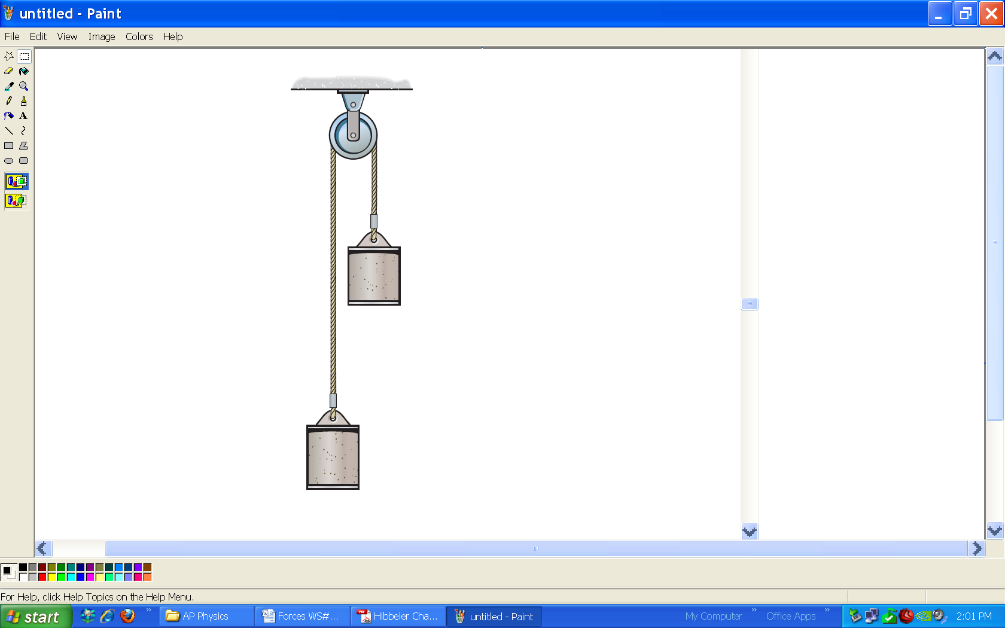

13 kg

7 kg

[a = 3 m/s², T = 91 N]

- For the Atwood machine, what number can the acceleration never exceed?

- The heavier side of the Atwood machine will always travel___________.

- The tension in the rope/string will always be ____________ on both sides of the pulley.

- Determine the acceleration and the tension in the string of the following:

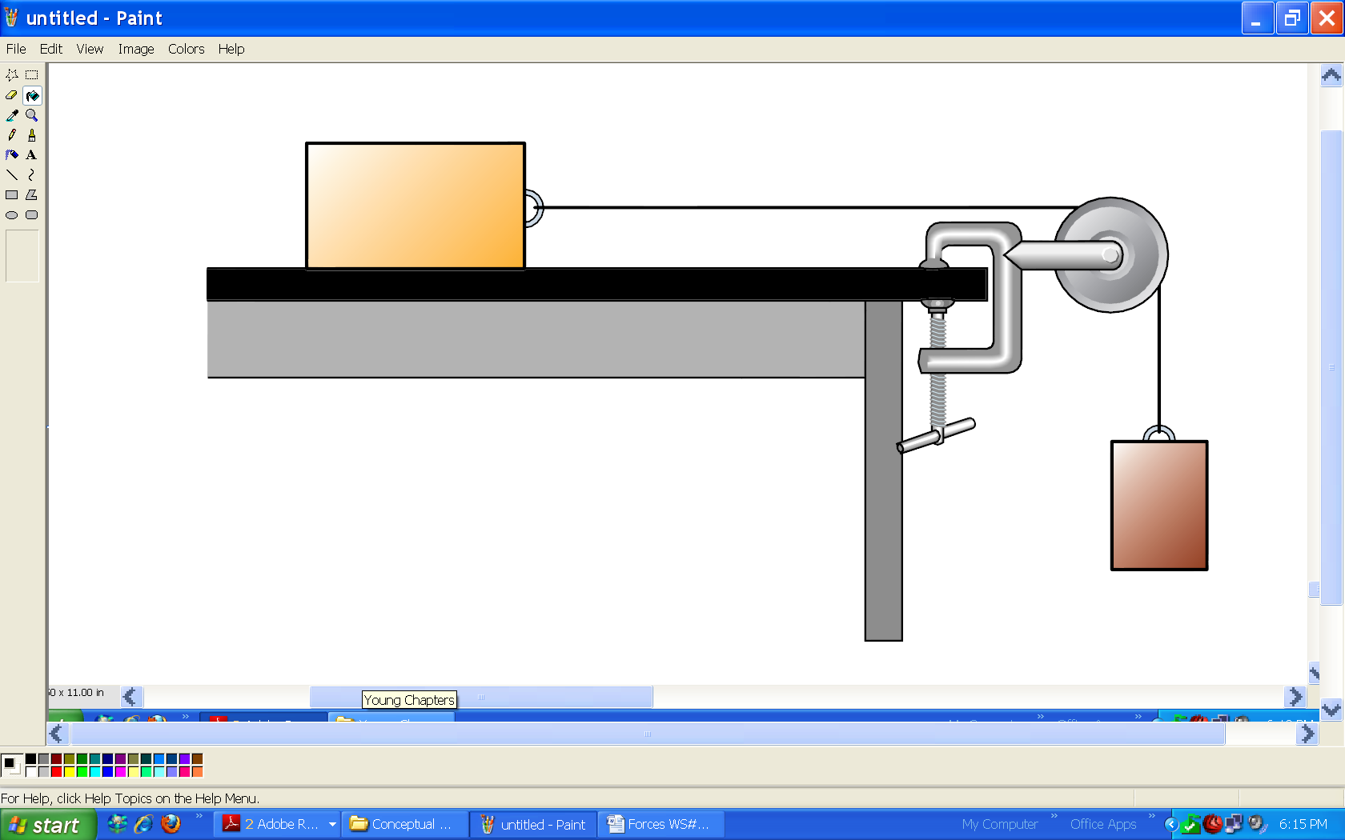
15 kg

9 kg

[a = 3.75 m/s², T = 56 N]

- Determine the acceleration of the following:
7 kg
7 kg
μ_{K} = 0.5

[2.5 m/s²]

CIRCLUAR MOTION/GRAVITY
- A gymnast is swinging around a bar. He makes 10 revolutions in 4 seconds.
  - How long does it take for him to go around once? [0.4 s]
  - What is the velocity of his feet (radius = 2.5 m)? [39 m/s]
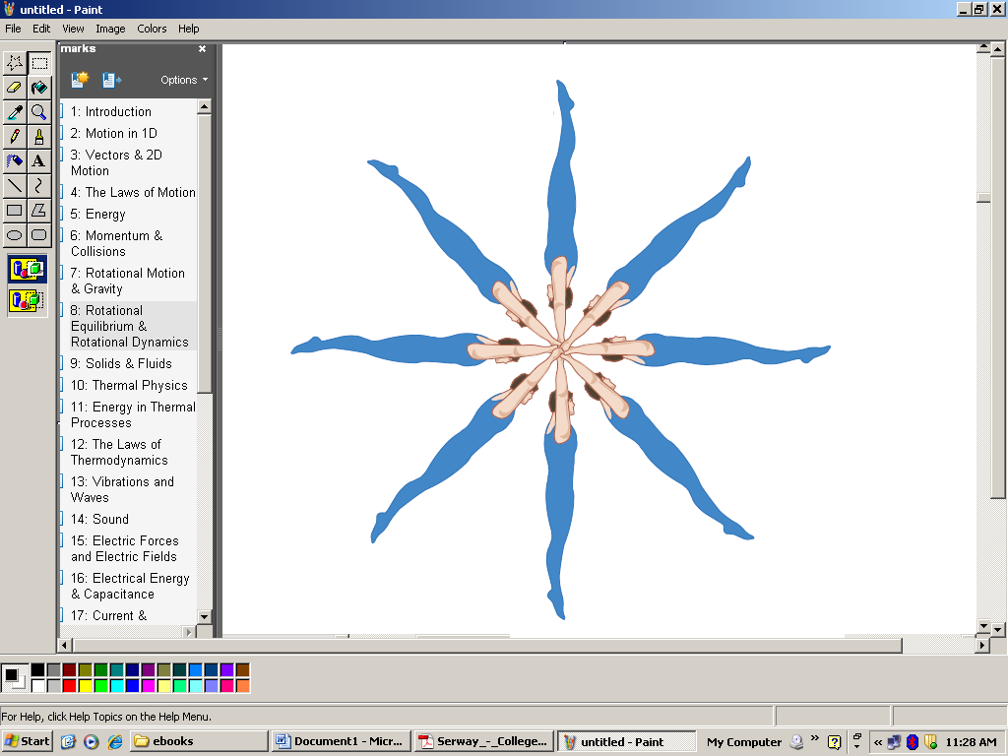
  - What is the velocity of his head (radius = 0.25 m)? [3.9 m/s]

- A person is out riding their bike in a circle at a speed of 8 m/s. What must be the radius of the circle if they are to make 20 laps in 350 seconds?
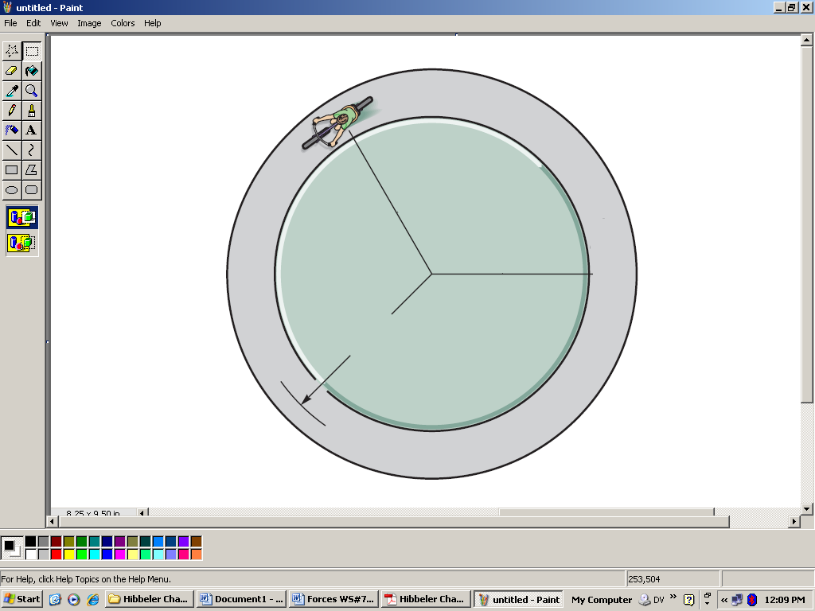

[22.3 m]

- A 2 kg puck is spun in a circle by a string.
  - If the tension in the string is 64 N, what is the acceleration of the puck? [32 m/s²]
  - What must be the velocity of the puck? [4 m/s]
  - How long does it take for the puck to make 1 revolution? [0.79 s]
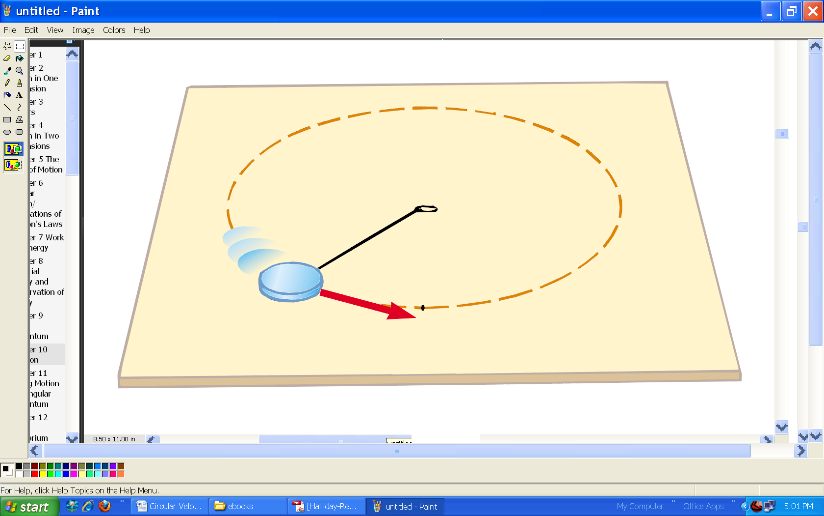

0.5 m

- What is the force between two objects that are 5,000,000 kg and 3,000,000 kg and are separated by 100 m?
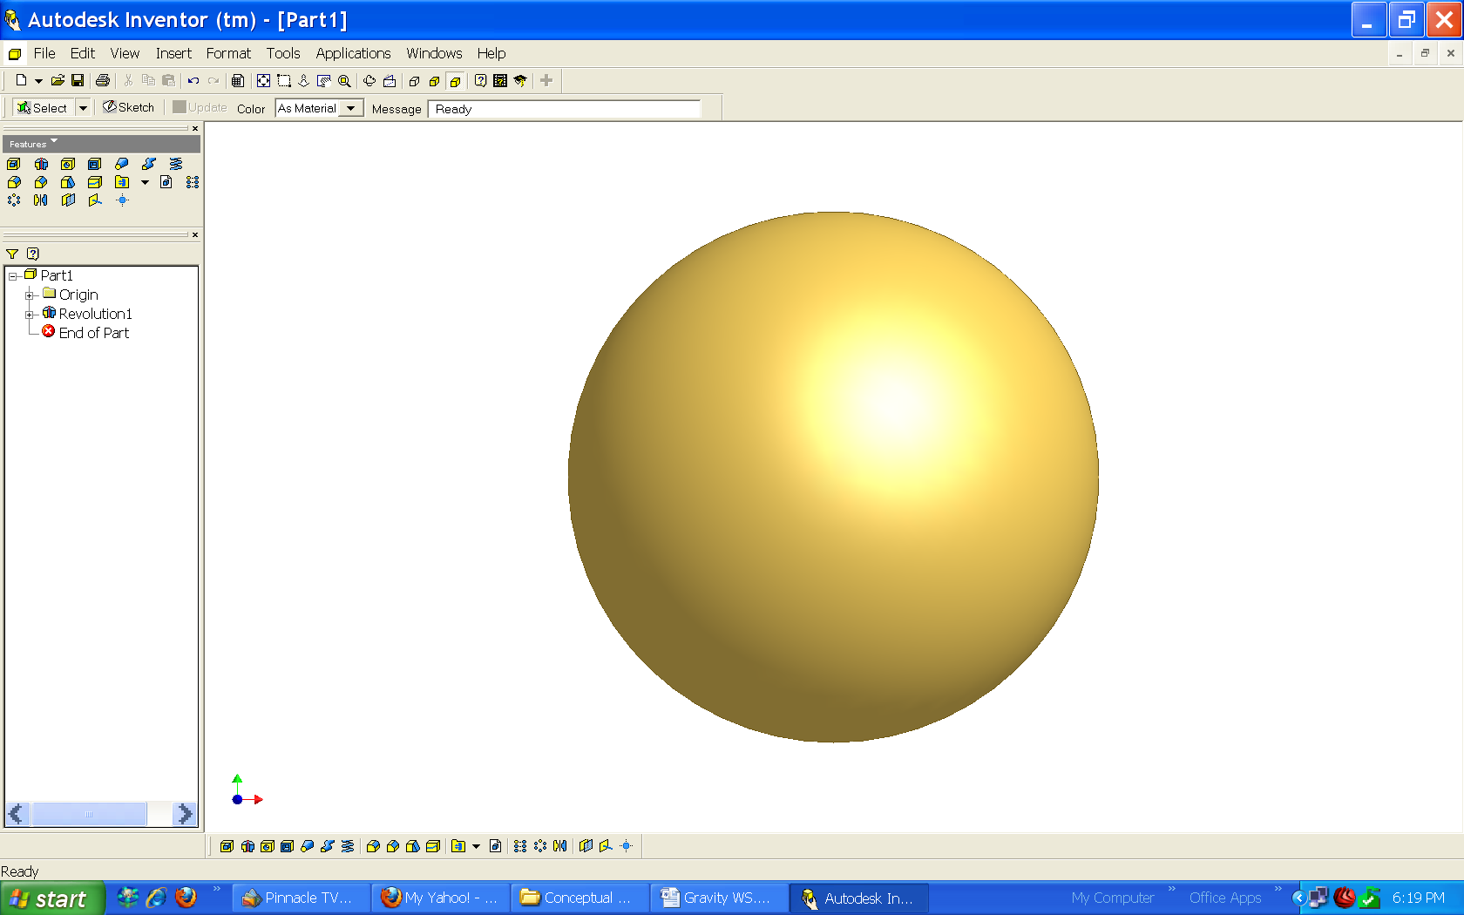
100 m

5,000,000 kg
3,000,000 kg

[0.10 N]

- Two objects pull each other with a force of 250 N. They are separated by 5 m. If one mass is 500,000 kg, what is the mass of the other object?

5 m

500,000 kg
?

[190,000,000 kg]
WROK/ENERGY

- State whether the work done by force F in the following situations is (+positive, - negative, or 0 zero)

moves
moves
moves
F
F

F

F
moves
F

moves
moves

F

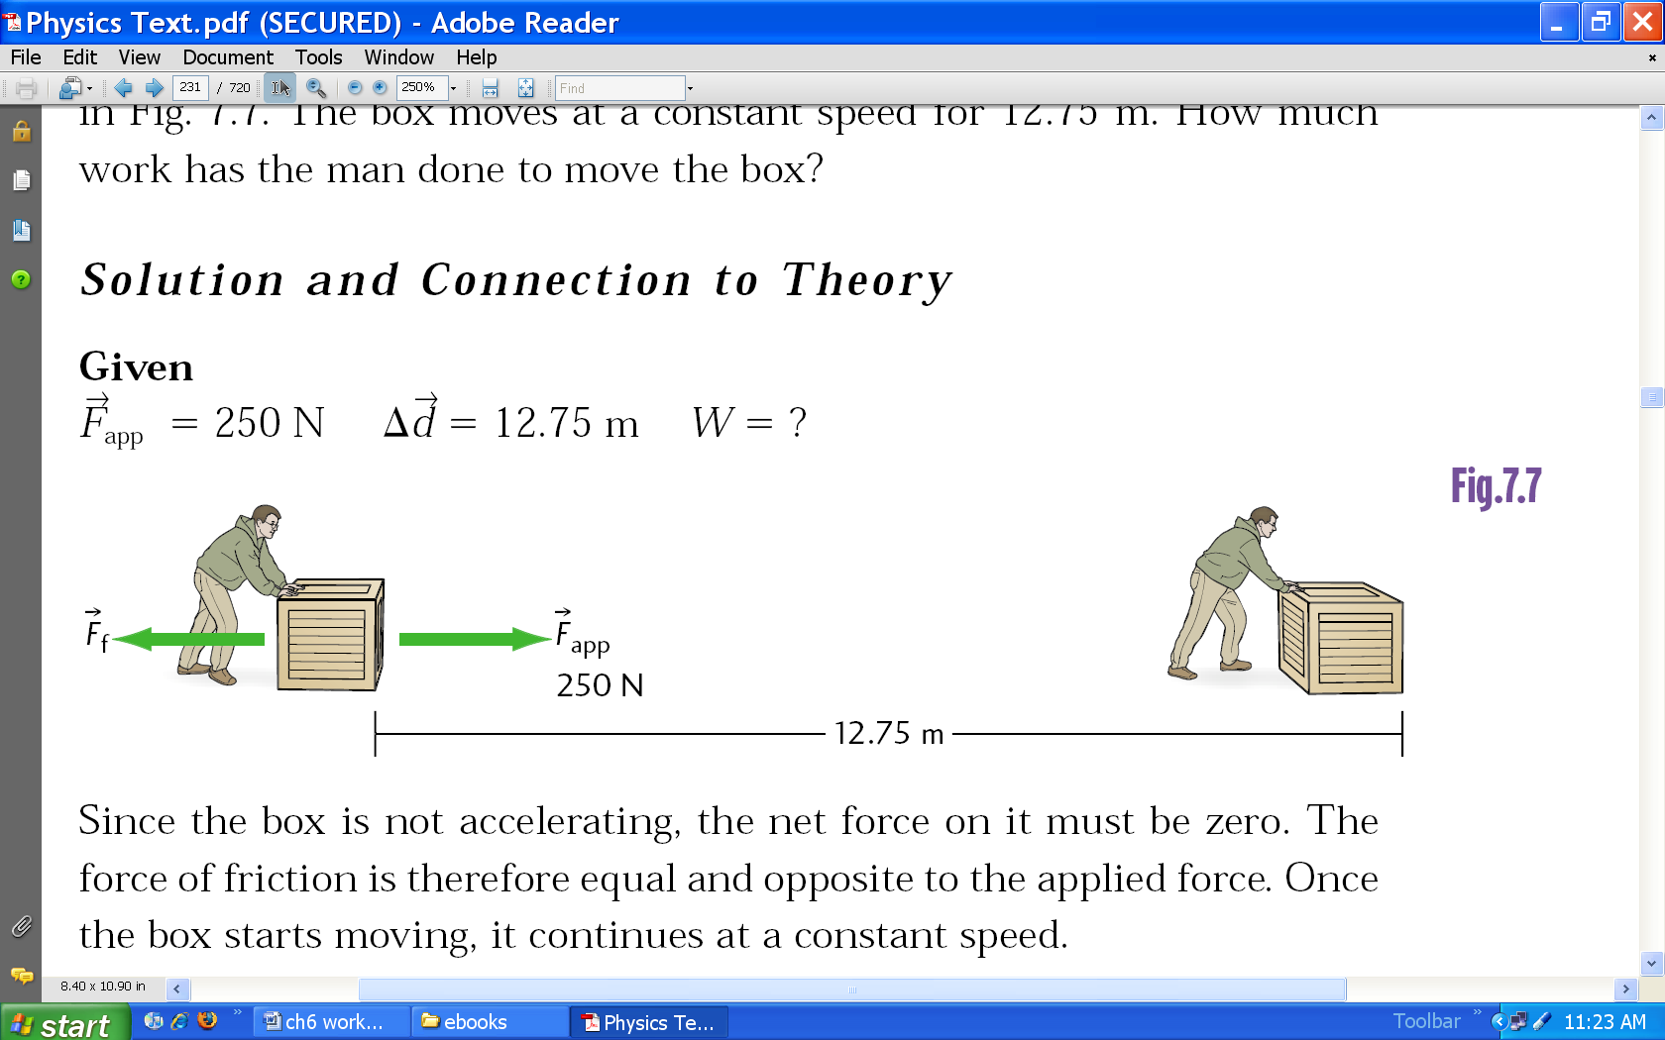
- A man pushes a crate across the floor by applying a force of 250 N. The crate move at a constant velocity and travels 12.75 m.
  - How much work does the man do?
  - How much work does friction do?
  - How much work does gravity do?

A. +3190 J
B. -3190 J
C. 0 J

- Four books, each is 0.05 m thick and has a mass of 1.5 kg are lying flat on a table. Which book would require the most amount of work to stack? The least? How much work is required to stack them one on top of another?
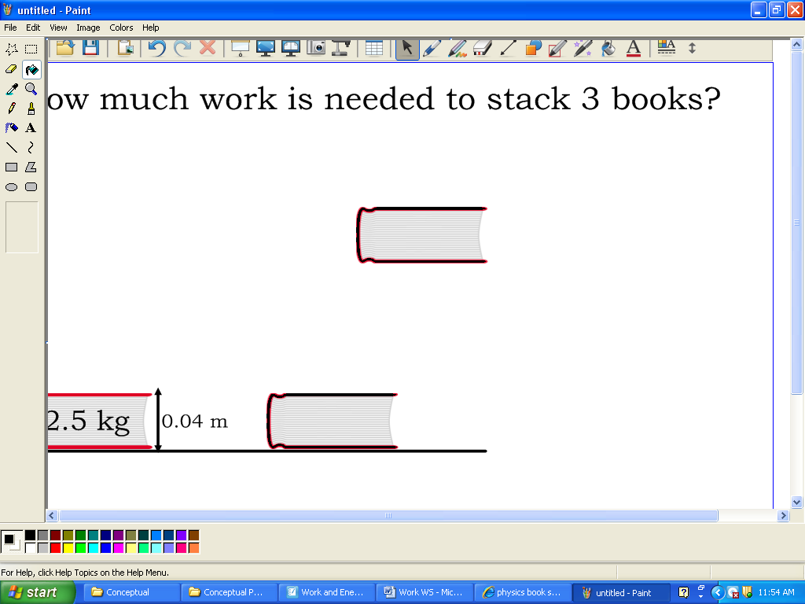

4.5 J

- A 250 W motor must do a job that requires 145,000 J. How long will it take to do this job? [580 s]

- If an engine does 1500 J of work in 120 s, what is its power in Watts? [12.5 W]
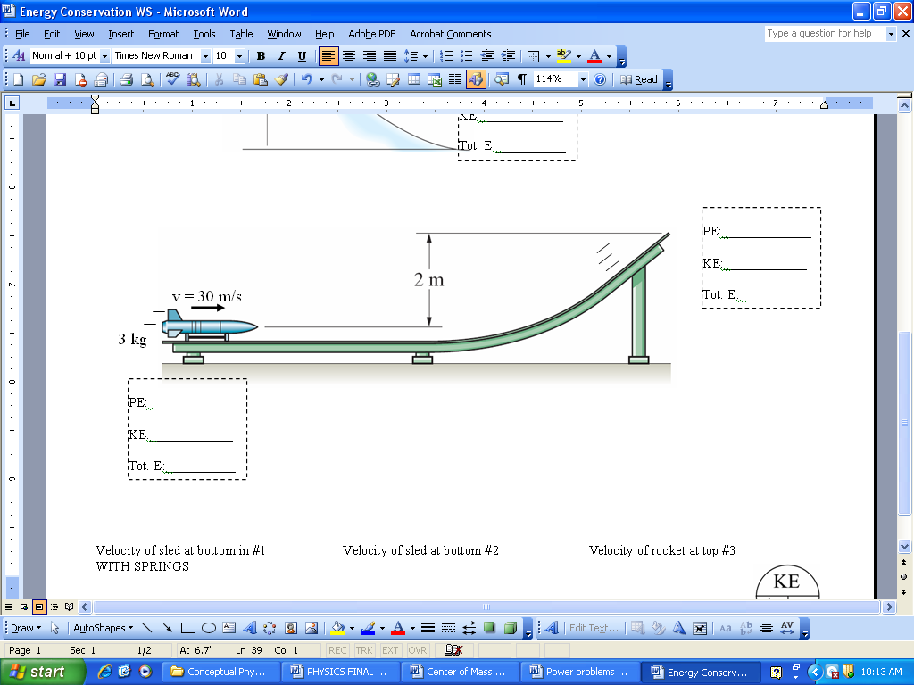
- Fill in the blanks:

Center of Mass/ Collisions

- Find the X_{CM} of the following:

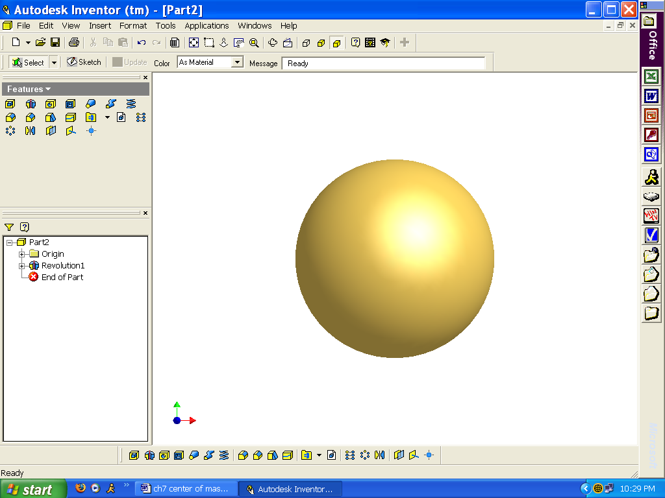
2 m
3 m
10 kg
2 kg
5 kg

[1.76 m]

- Find the V_{CM} of the following:

2 m/s
3 m/s
10 kg
2 kg

[-1.2 m/s]

- Determine the velocity of all vehicles after the following occurs……
BUMP!
1500 kg
500 kg
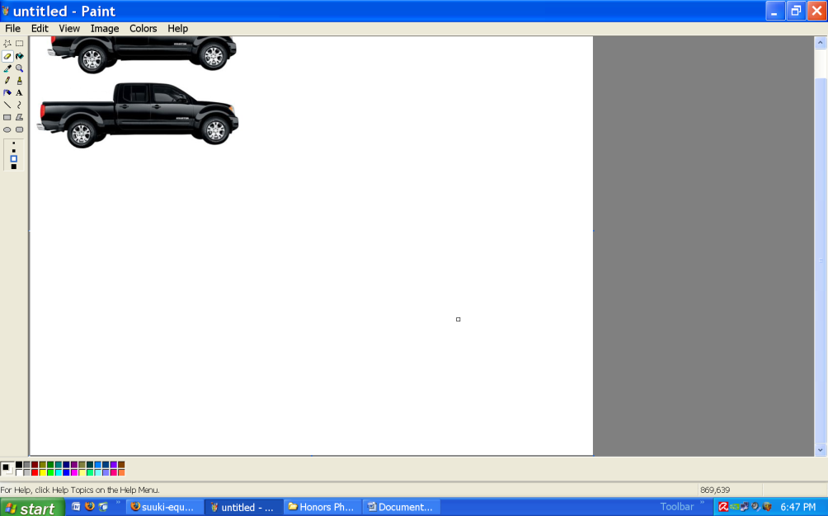
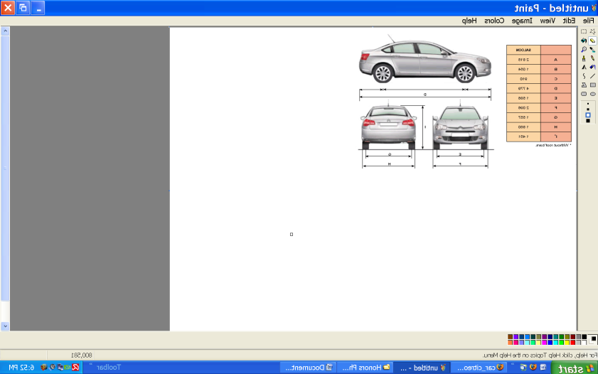
12 m/s
2 m/s

- What is the same both before and after all collisions?

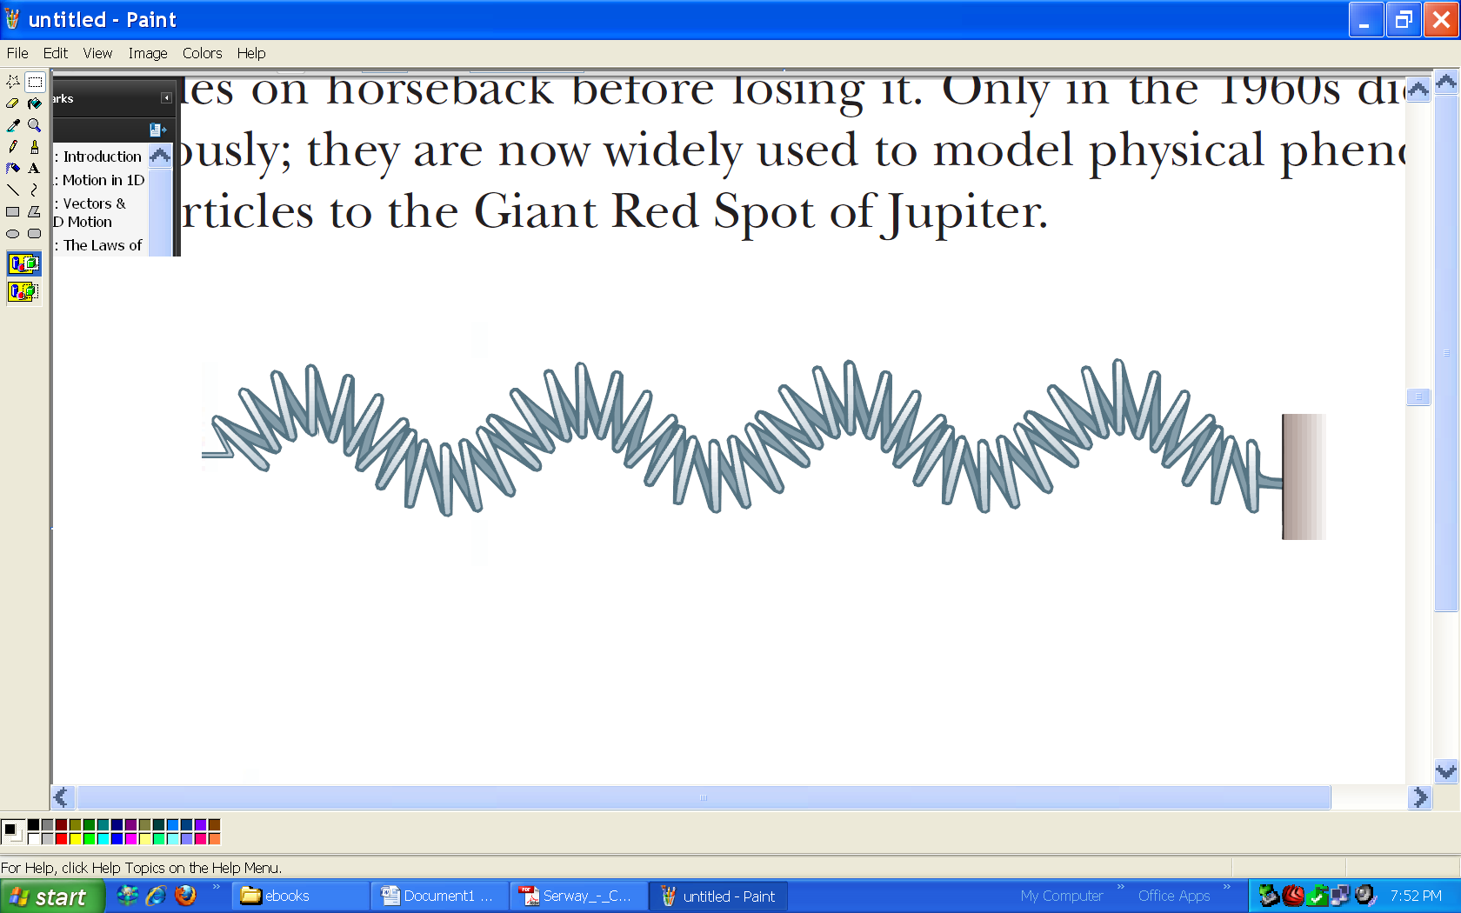
WAVES
- What is the name of the following wave?

- What are the names of waves that travel at the speed of light? Name as many as you can….

- What are the names of the waves that need a medium to travel through?

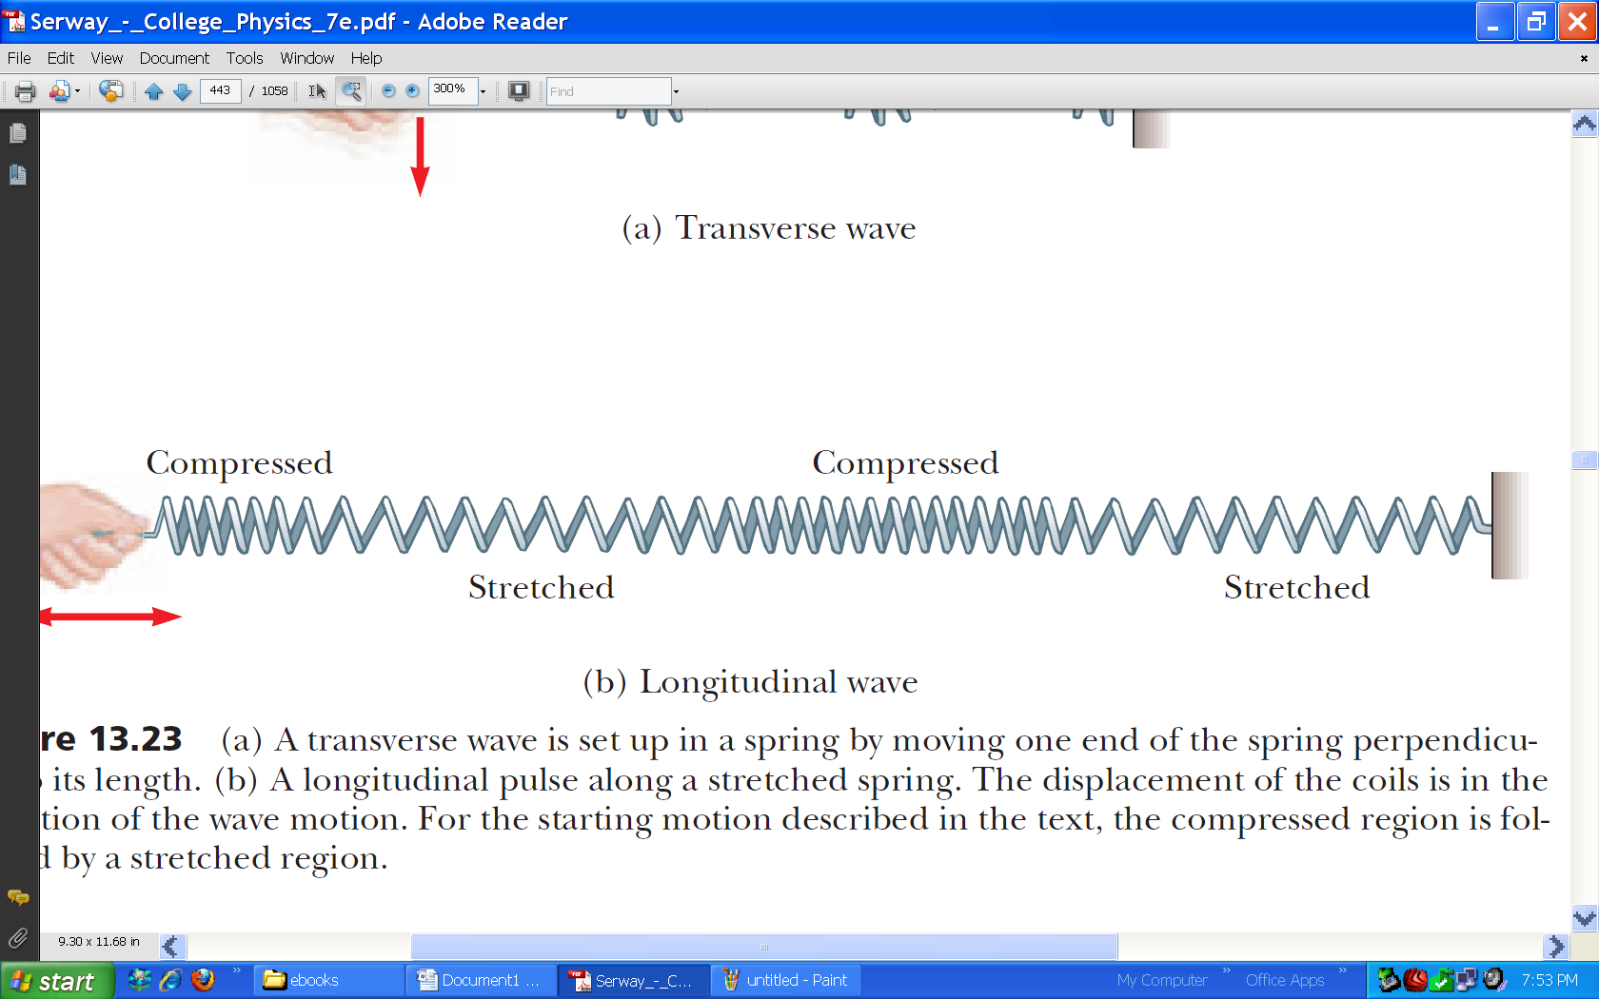
- What is the name of this wave?

- Which wave will travel faster? (same tension for both)
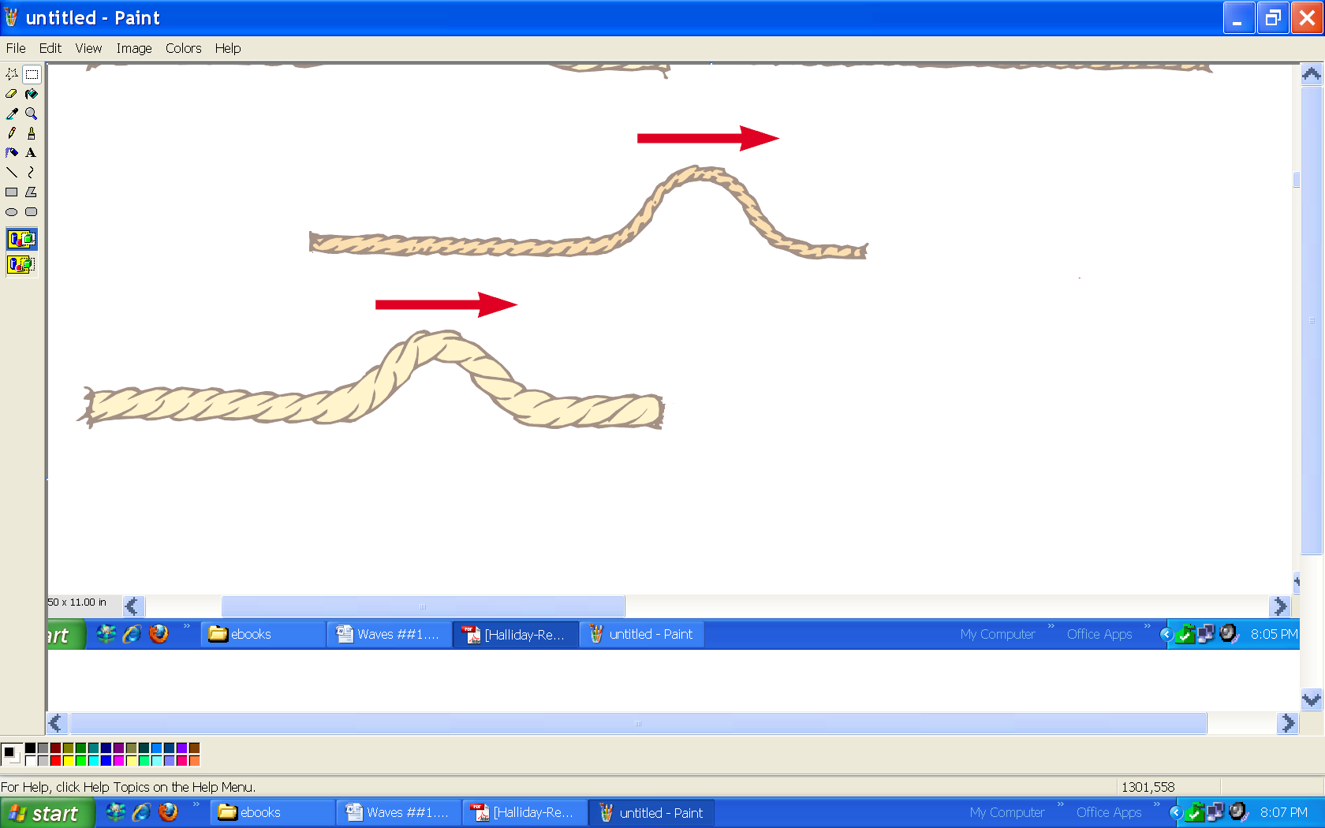

- Sketch what will happen after the wave reaches the free end…

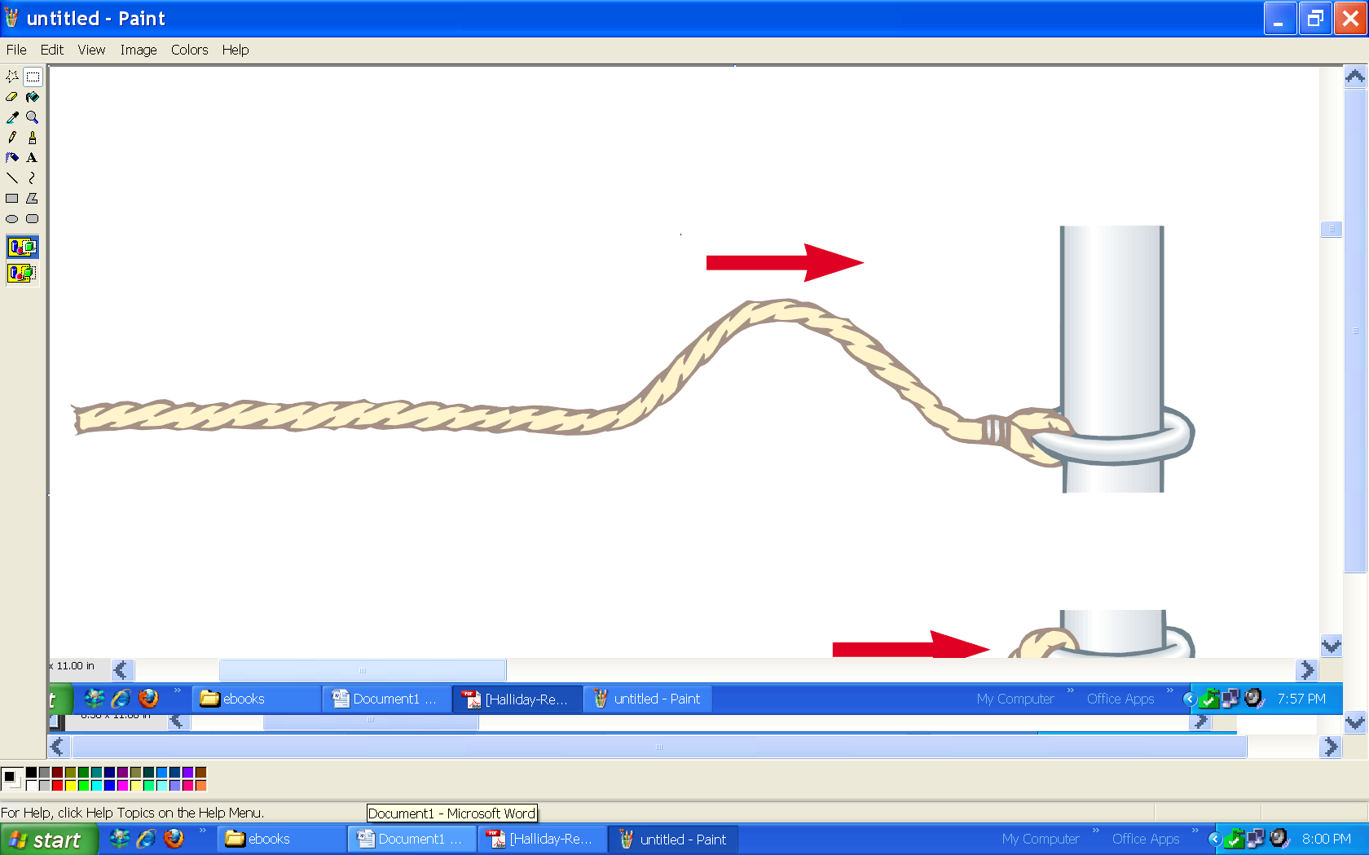

- Sketch what will happen after the wave reaches the fixed end….
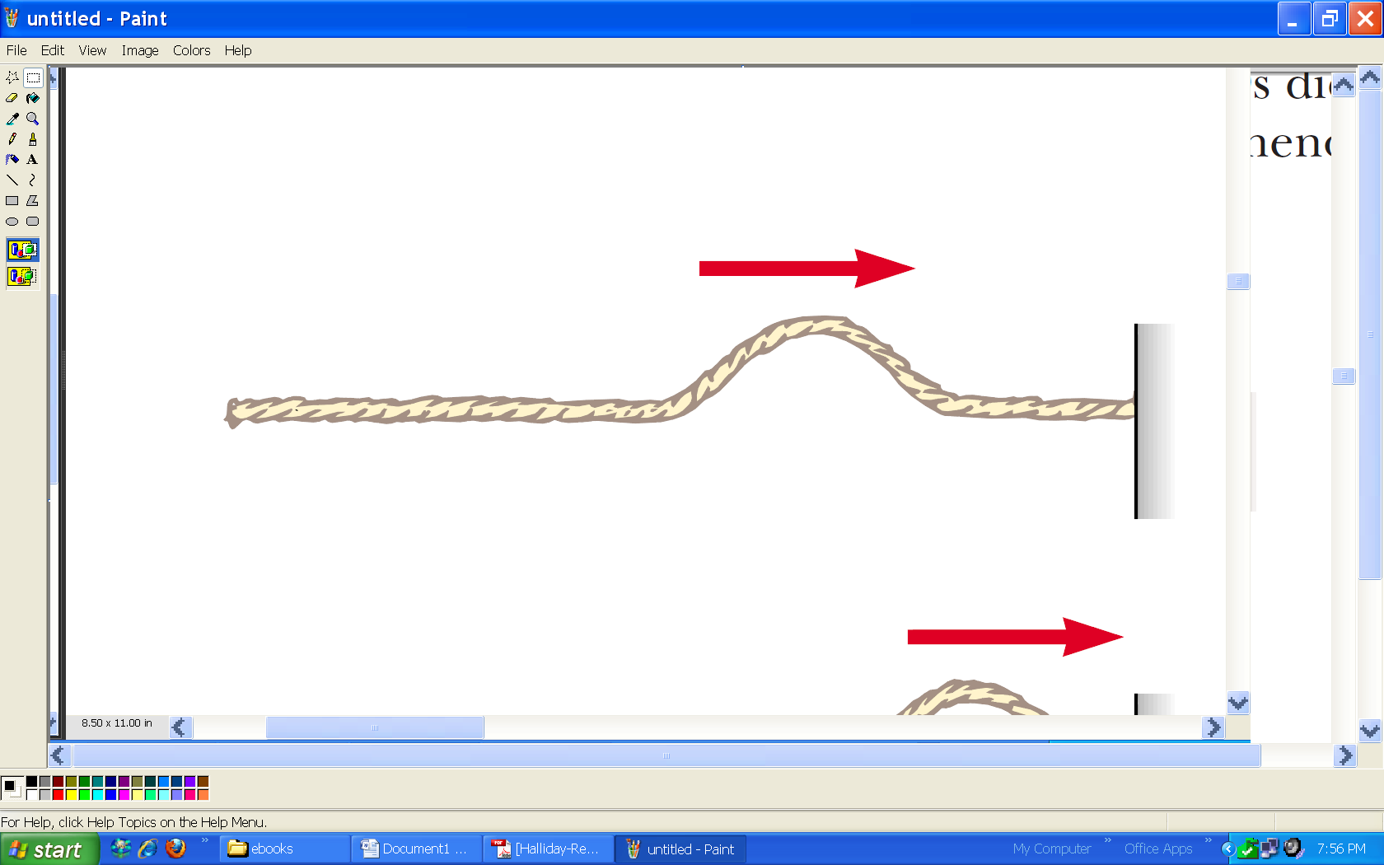

- Sketch what will happen when: The waves meet, and after the waves meet.

Before Meet After
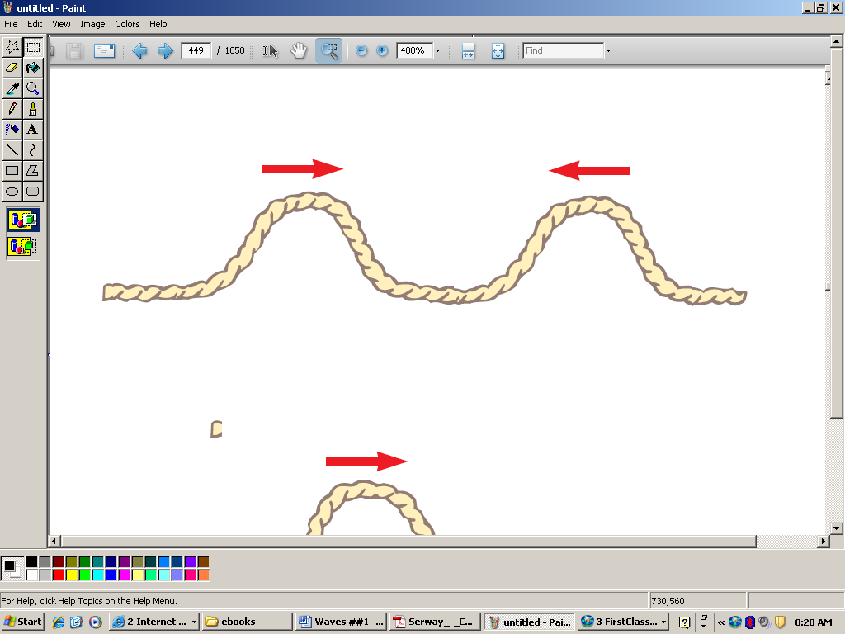

4
4

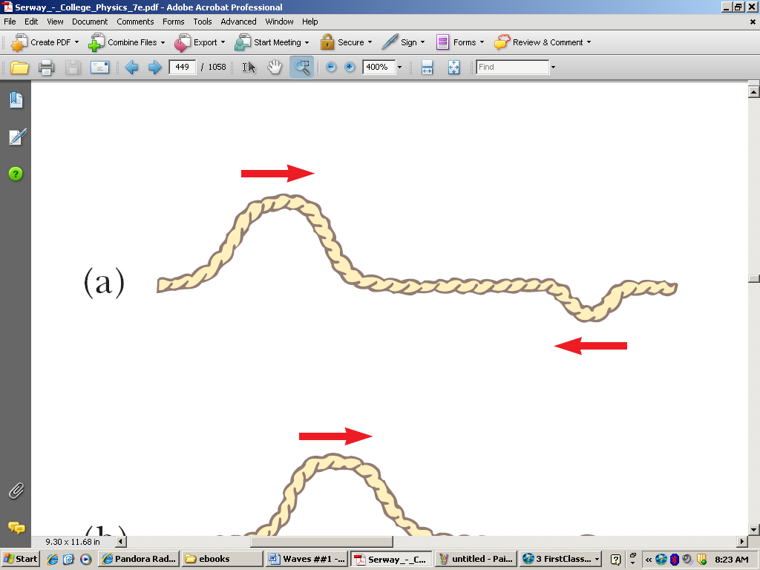

6
2

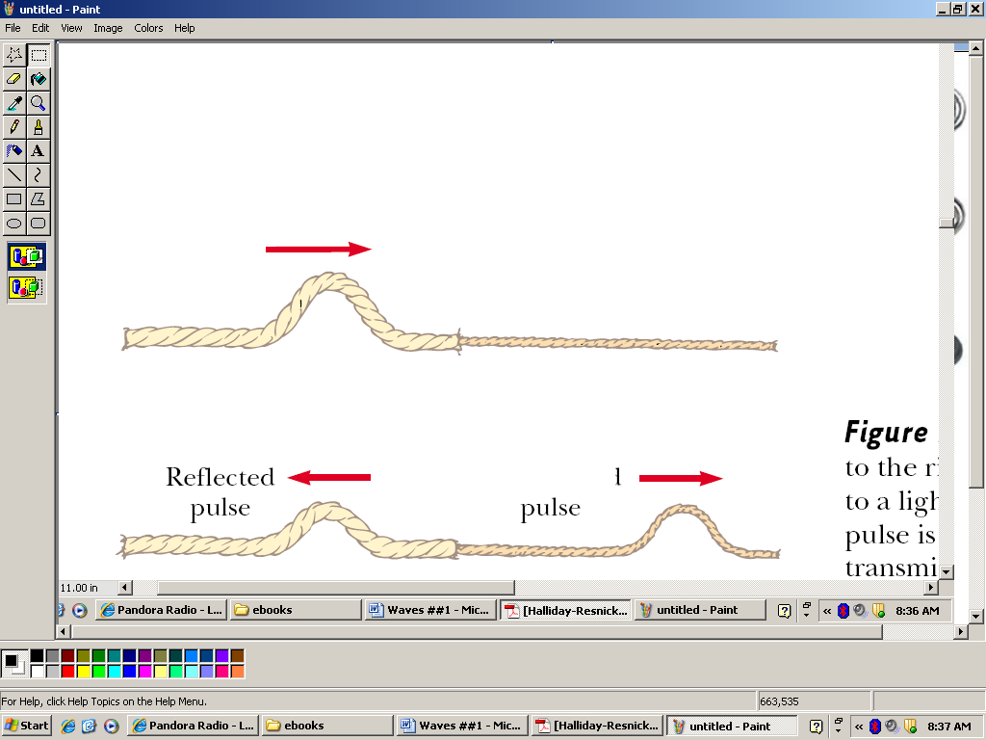
- Sketch the wave after it reaches the string. Both in the rope and the string.

- Light wave, f = 950,000,000 Hz find λ

- A car horn beeping at 1250 Hz. Find its wavelength.

- The police use radar that operates with a λ = 0.0050 m. What is its frequency?
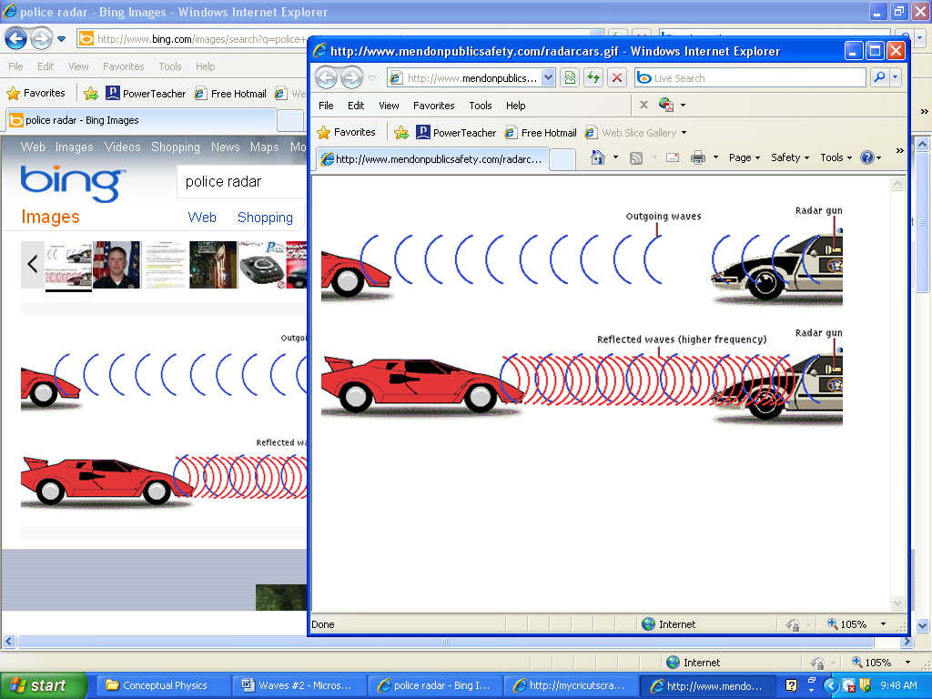

- Bats can hear sounds that are as high as 120,000 Hz. What is the wavelength of those waves?

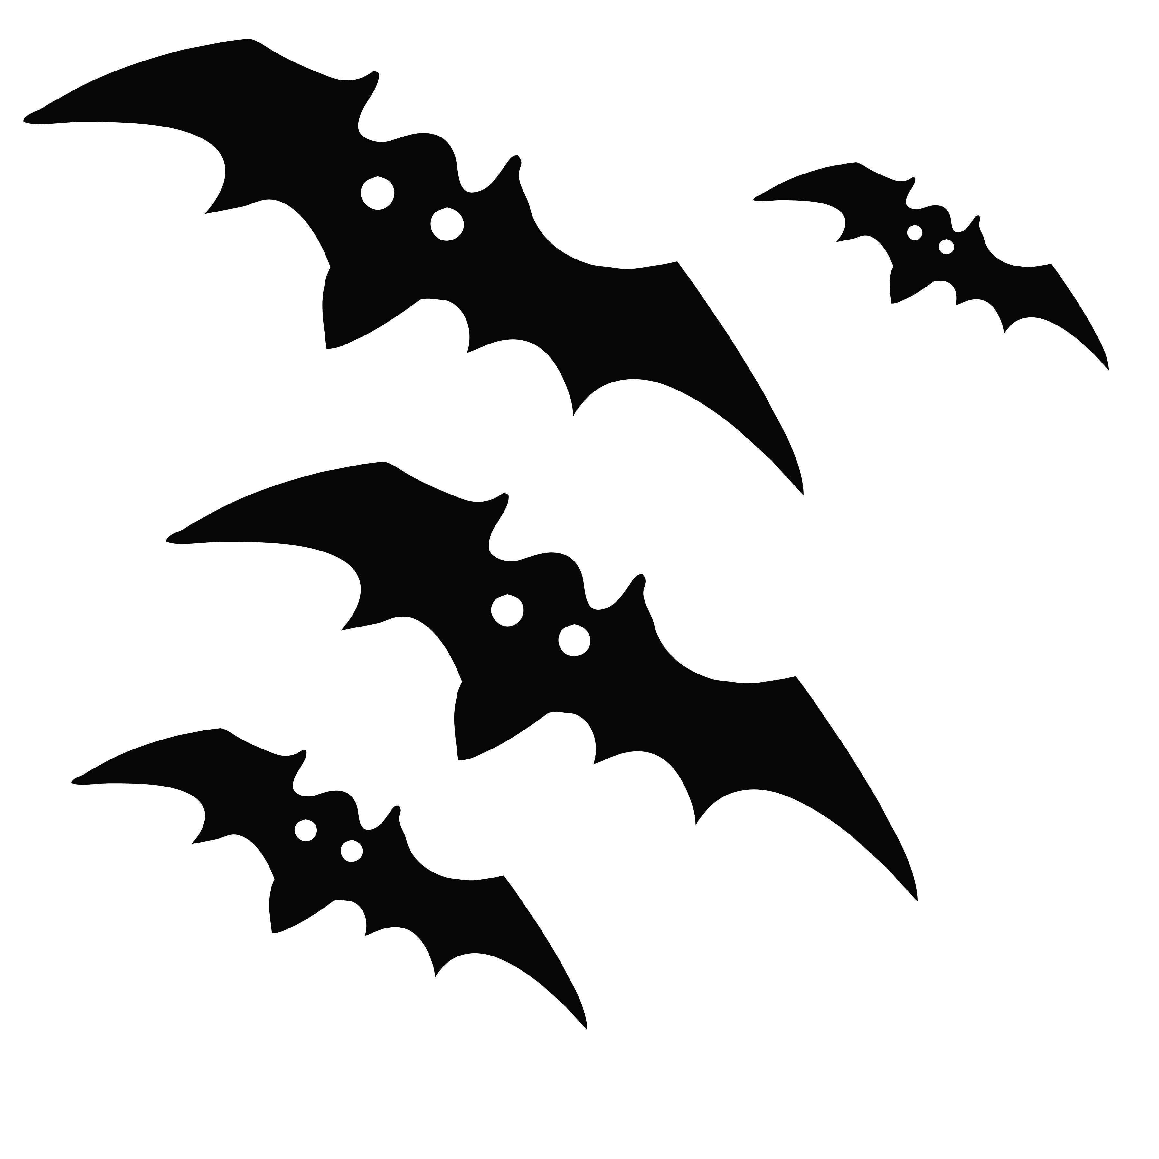

- A certain water wave has a λ = 2.0 m and a frequency of 7.0 Hz. What is the velocity of the waves?

- A tuning fork vibrates 250 times in 2 seconds.
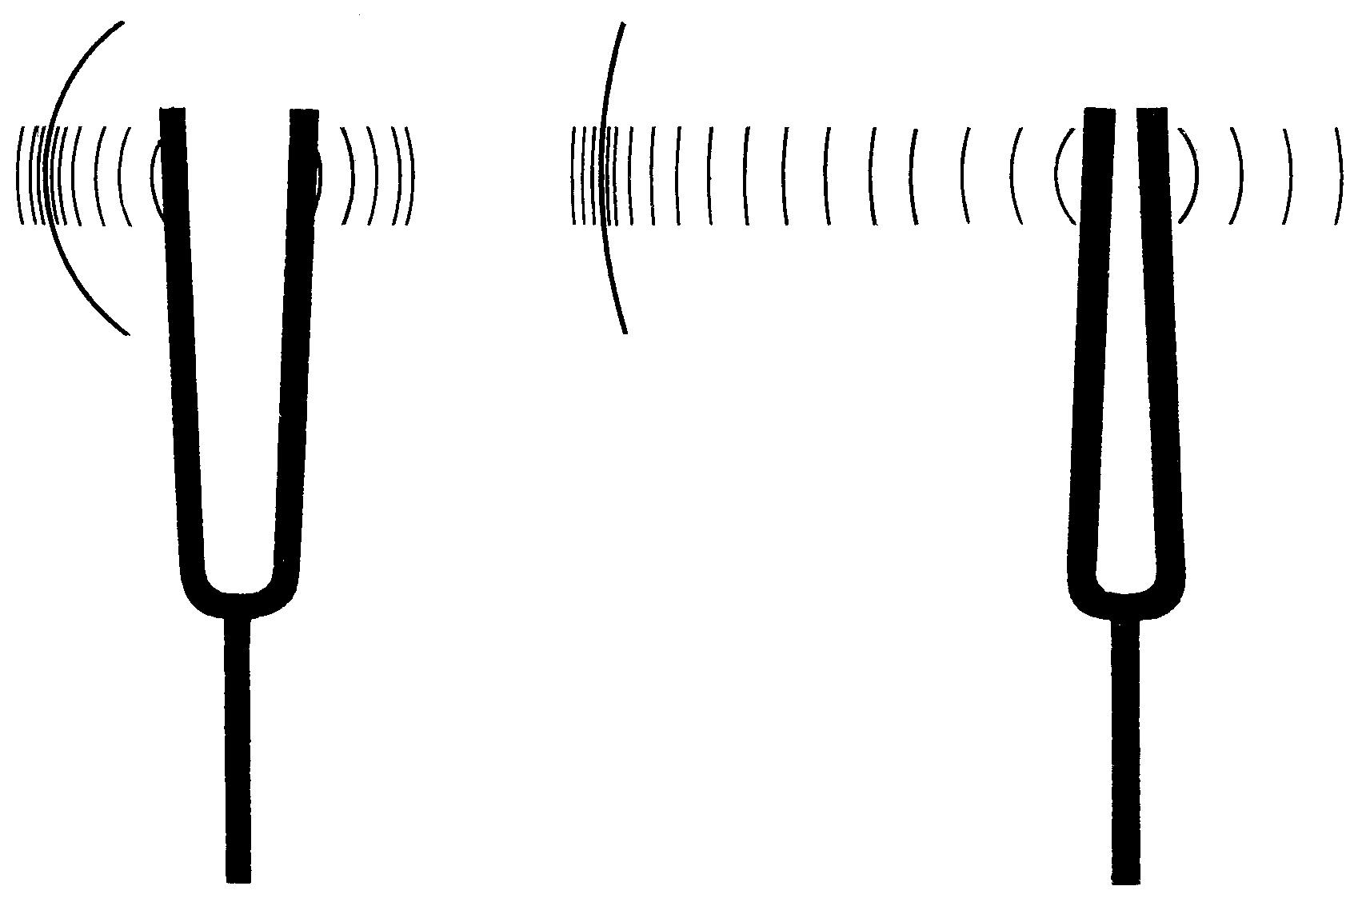
  - What is the frequency?
  - What will be the wavelength of the sound produced?

- A person on the beach sees waves that are 3.0 m apart approaching the shore. They hear the waves crash 30 times every 60 seconds. What is the frequency and velocity of the water waves?

- A radio tower emits signals at frequency of 103,500,000. What is the wavelength of the waves?


F
m
a
w
m
g
f
μ
N
Forces

2πR
v
t
v²
a_{C}
R
F
m
a
Circular
Motion

Gm₁m₂
F_{G}
d²
Gravity
G = 6.7x10⁻¹¹

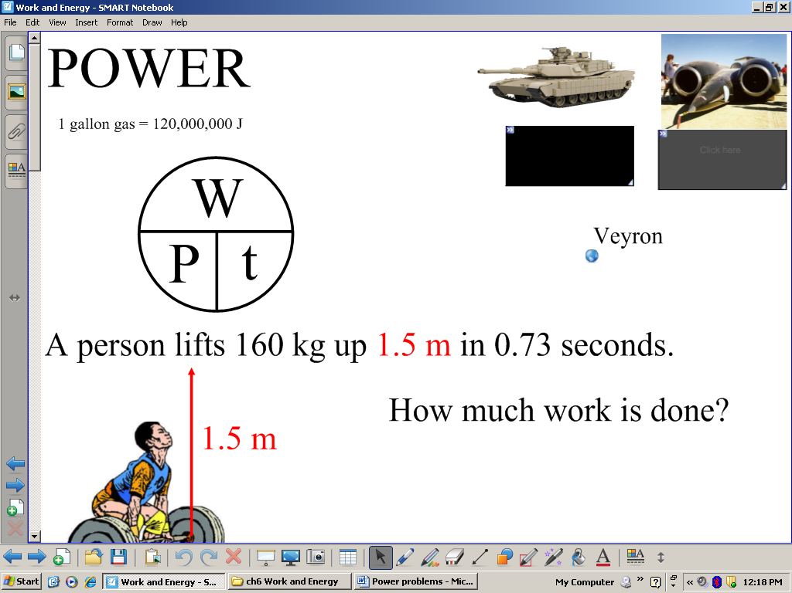
Work and
Power
W
F
d

Energy
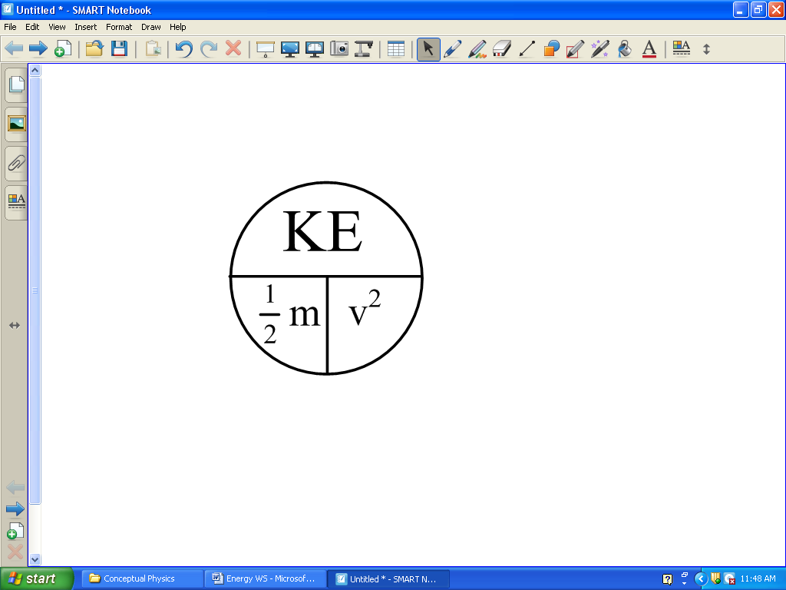
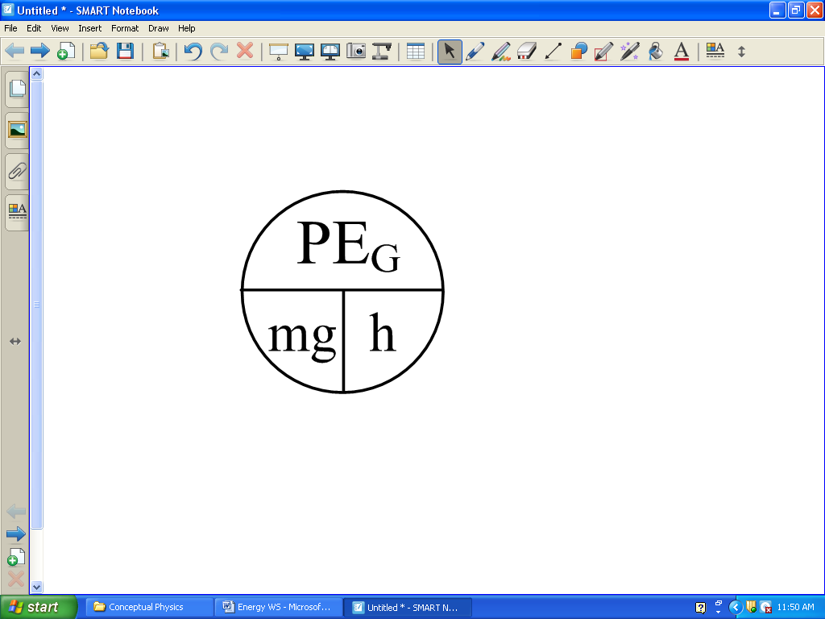
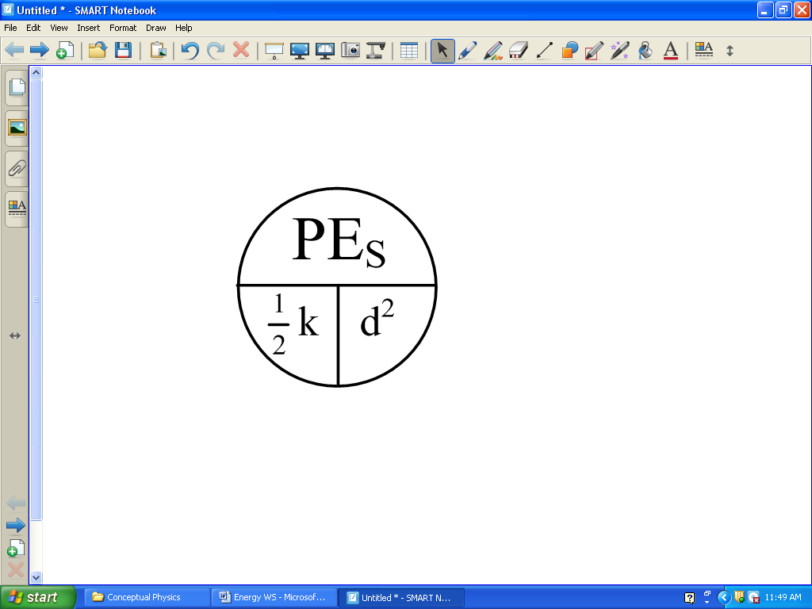

p
m
v
Center of
Mass/
Momentum
$X_{\text{CM}}=\frac{m_{1}x_{1}+m_{2}x_{2}+\text{.}\text{.}\text{.}}{m_{\text{total}}}$

Waves
v
f
λ
V_{SOUND} = 340 m/s

V_{E&M} = 300,000,000 m/s

