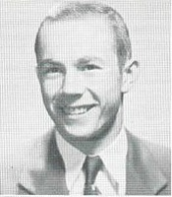
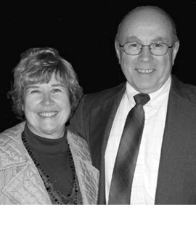

George W. Rohrbaugh, Jr.
Alexandria, Pa.

EHS classmates George Rohrbaugh and Doris Manahan have been a couple since senior-prom month of 1954. They married in 1957 and have two well-educated redheaded daughters, an IBM son, and four active grandchildren. George is a physicist/inventor and Doris is a professional artist. They’ve lived in Gettysburg, Lancaster, State College (ten years), and Alexandria PA (thirty-three years).

George appreciates Ray Gray and all the EHS teachers who helped him receive the first Glatfelter four-year college scholarship. At Gettysburg he majored in physics and math and graduated Phi Beta Kappa in 1958. He won a three-year nuclear-physics fellowship to Notre Dame but left South Bend after the first semester for “the real world.”

He started work at Hamilton Watch Company in Lancaster where he developed safing and arming devices for small rockets. In 1961 George moved his family to State College where he bought his first house and joined HRB-Singer as a research physicist. Specializing in acoustics, he patented an Ultrasonic Yarn Trimmer, the Shaft Spider Tracking Arrow, and an Automatic Gunnery Shock Wave Scoring System.

In 1971 George and Doris found a dream house in the country and began their ongoing project of restoration. George commuted for two years, then started his own company, Accubar Engineering, around the electronic scoring devices he’d developed for HRB. He added patents on supersonic curved-rod sensors and expanded Accubar into the field of military rifle marksmanship training. He’s equipped many ranges in the US and Canada (most recently for the Marine Corps in Hawaii and California), and a few abroad, with live-fire computerized target scoring systems.

Currently George has a licensing and consulting contract with ATA Defense Systems and “can never retire.” He stays fit by skiing, keeping up with the grandchildren, and working on “The Munster House.” He thinks our generation is very fortunate to have grown up through these fast-paced, high-tech times, but wishes he’d kept his low-tech ‘32 Chevy.

