AP Physics 1 Name __________________________

Summer Assignment 2015 Period _____
Log into the edmodo account “gph72e” to get any additional information
Summer Assignments turned in the FIRST DAY of school will receive extra credit. All others will be due the Monday of the second week of school.
- This summer packet will allow us to start on the Physics subject matter immediately when school begins. This packet is a math review to brush up on valuable skills, and a brief introduction into some of the topics covered in AP Physics 1
- Physics, and AP Physics in particular, requires a proficiency in algebra, trigonometry, and geometry. In addition to the science concepts Physics often seems like a course in applied mathematics. The following assignment includes math skills that we will use and continue to build upon throughout the year. It is hoped that combined with your previous math knowledge this assignment is merely a review and a means to brush up before school begins in the fall. Please read the text and instructions throughout.
- Complete the TWO graphing activities. These will require Internet access. Please get this done early in the summer so you do not have to worry about it on that last weekend of the summer.
- What is due?
Read all of the information included in this document.
  - Complete the math problems section.
  - Completed Cornell notes on chapter 1 all sections, and 2.1, 2.2, 2.4.
  - Self-Propelled Car Project build and ready for lab.
  - Completed Distance vs. Time and the Velocity vs. Time activities (walking man PHET).
Extra Credit: if completed on first day of school, however it will be considered due on the Monday of the second week of school. The first day we will be using the self-propelled cars in a lab.

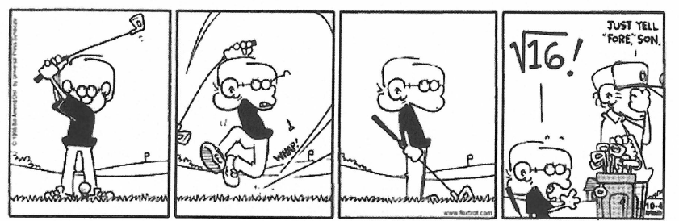

Self-Propelled Car Project:

- Groups will be 3-people, and must be from the same period.
- Groups can be found and organized on edmodo.
- Project: Build a self-propelled car from scratch. (Force ideas, rubber bands, mouse trap, balloon, etc.) Gravity cannot be used as your accelerating force.
- On the first day of class we will complete three test runs using your car and will measure the distance and recording the time. This data will be used to calculate the average speed.

Summer Work
Since physics is the study of relationships in nature, and these relationships are often expressed in the form of mathematical equations, we are requiring you to spend time this summer learning (memorizing) some equations and units to get started first semester. Expect a quiz over variables and units in the first couple of days! We will be adding to this list as the course goes on. I suggest making note cards for each one.
Units:
Variable | Symbol | SI unit | “Dead Scientists Society”
Mass | m | kg
Length/displacement | L or x | m
Time | t | sec
Velocity | v | m/s
Acceleration | a | m/s/s
Force | F | kg⋅m/s² | Newton (N)
Kinetic energy | K_{E} | kg⋅m²/s² | Joule (J)
Potential energy | U | kg⋅m²/s² | Joule (J)
Torque | τ | N⋅m
Work | W | N⋅m | Joule
Momentum | p | kg⋅m/s
Power | P | J/s | Watt (W)
Spring constant | k | N/m

Geometry Review
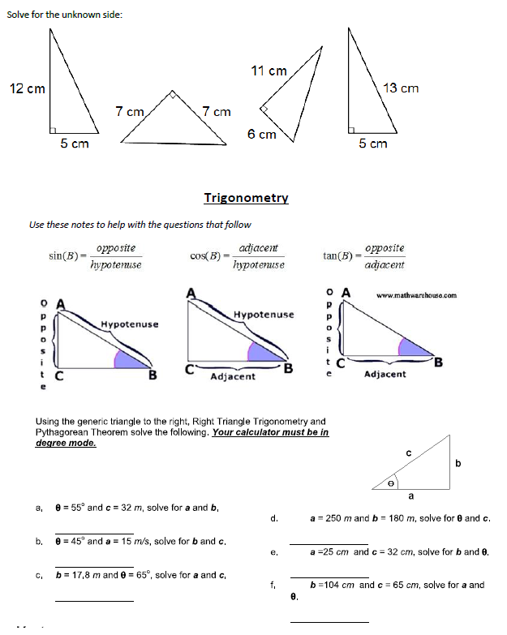
Often problems on the AP exam are done with variables only. Solve for the variable indicated. Don’t let the different letters confuse you. Manipulate them algebraically as though they were numbers.

  - $v^{2}=v_{o^{2}}+2a\left(s−s_{o}\right) ,a=$ _______________
  - _______________
  - _______________
  - _______________
  - _______________
  - _______________

Kinematics Introduction (This goes along with your notes from Chapter 2)
Speed
Speed is a scalar. It only has magnitude (numerical value).
v_{s} = 10 m/s means that an object is going 10 meters every second. But, we do not know where it is going.
Velocity
Velocity is a vector. It is composed of both magnitude and direction. Speed is a part (numerical value) of velocity.
v = 10 m/s north, or v = 10 m/s in the +x direction, etc.
There are three types of speed and three types of velocity
Instantaneous speed / velocity: The speed or velocity at an instant in time. You look down at your speedometer and it says 20 m/s. You are traveling at 20 m/s at that instant. Your speed or velocity could be changing, but at that moment it is 20 m/s.
Average speed / velocity: If you take a trip you might go slow part of the way and fast at other times. If you take the total distance traveled divided by the time traveled you get the average speed over the whole trip. If you looked at your speedometer from time to time you would have recorded a variety of instantaneous speeds. You could go 0 m/s in a gas station, or at a light. You could go
30 m/s on the highway, and only go 10 m/s on surface streets. But, while there are many instantaneous speeds there is only one average speed for the whole trip.
Constant speed / velocity: If you have cruise control you might travel the whole time at one constant speed. If this is the case then your average speed will equal this constant speed.
A trick question
Will an object traveling at a constant speed of 10 m/s also always have constant velocity?
Answer before you keep reading.
Not always. If the object is turning around a curve or moving in a circle it can have a constant speed of 10 m/s, but since it is turning, its direction is changing. And if direction is changing then velocity must change, since velocity is made up of speed and direction.
Constant velocity must have both constant magnitude and constant direction.
Rate
Speed and velocity are rates. A rate is a way to quantify anything that takes place during a time interval. Rates are easily recognized. They always have time in the denominator.
10 m/s 10 meters / second
The very first Physics Equation
Velocity and Speed both share the same equation. Remember speed is the numerical (magnitude) part of velocity. Velocity only differs from speed in that it specifies a direction.
$v=\frac{Δx}{Δt}$ v stands for velocity; Δx stands for displacement (change in position); Δt stands for time
Displacement is a vector for distance traveled in a straight line. It goes with velocity. Distance is a scalar and goes with speed. Displacement is measured from the origin. It is a value of how far away from the origin you are at the end of the problem. The direction of a displacement is the shortest straight line from the location at the beginning of the problem to the location at the end of the problem.
How do distance and displacement differ? Supposes you walk 20 meters down the + x axis and turn around and walk 10 meters down the – x axis.
The distance traveled does not depend on direction since it is a scalar, so you walked 20 + 10 = 30 meter.
Displacement only cares about your distance from the origin at the end of the problem. +20 – 10 = 10 meter.
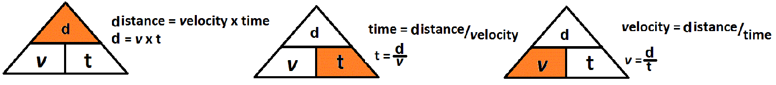
Kinematics Intro Wkst
Attempt to solve the following problems. Take heed of the following.
Always use the KMS system: Units must be in kilograms, meters, seconds.
On the all tests, Quizzes, and assignments, including the AP exam you must:
1. List known and unknown information and verify unit agreement.
2. List the original equation used.
3. Show correct substitution.
4. Arrive at the correct answer with correct units.
Distance and displacement are measured in meters (m)
Speed and velocity are measured in meters per second (m/s)
Time is measured in seconds (s)
Example: A car travels 1000 meters in 10 seconds. What is its velocity?
v =x
m = 1000m
t = 10s
  - A car travels 35 km west and 75 km east. What distance did it travel?
  - A car travels 35 km west and 75 km east. What is its displacement?
  - A car travels 35 km west, 90 km north. What distance did it travel?
  - A car travels 35 km west, 90 km north. What is its displacement?
  - A bicyclist pedals at 10 m/s in 20 s. What distance was traveled?
  - An airplane flies 250.0 km at 300 m/s. How long does this take?
  - A skydiver falls 3 km in 15 s. How fast are they going?
  - A car travels 35 km west, 90 km north in two hours. What is its average speed?
Moving Man – Distance vs. Time Graphs
Background – Graphs are not just an evil thing your teacher makes you create, they are a means of communication. In this activity you will learn to speak and read “graph”.
Learning Goals – The students will:
- Develop a general knowledge of distance time graphs.
  - What a graph of a person standing still would look like
  - What a graph of a person moving away from an observer would look like.
  - What a graph of a person moving towards an observer would look like.
  - How differences in speed appear on the graph
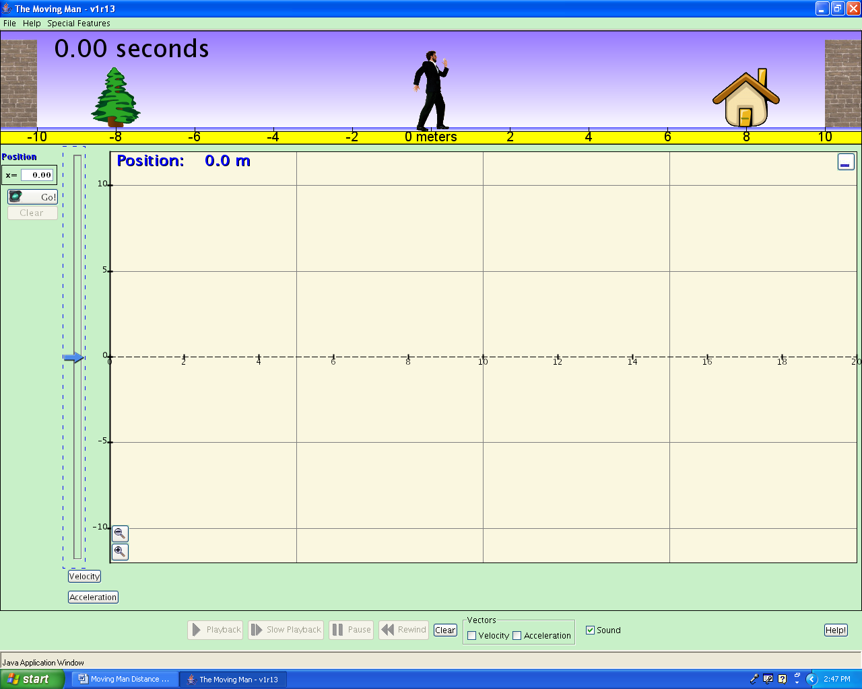
Procedure – Go to the class Edmodo page and in the AP Summer folder open the Moving Man link or go to http://phet.colorado.edu/en/simulation/moving-man
Screen 1
Then click on “The Moving Man”

- Getting started. After “Moving Man” is open leave the position graph open but close all of the other graphs, velocity and acceleration. You will do this from the Charts tab. Your screen should look like screen 1.
- Making observations. By either clicking on the man or the slider cause the man to move back and forth and observe what shows up on the graph. Using the axes provided below make a sketch of the graph that is produced by each action described next to each axis.

A man standing still at 5 m.
-5
-10
5
0
10
Time
(s)

Distance (m)
A man moving from 0 m to 10 m at a fast pace.

-5
-10
5
0
10
Time
(s)

Distance (m)
A man moving from 0 m to 10 m at a slow steady pace.

-5
-10
5
0
10
Time
(s)

Distance (m)

Apply what you learned. Look at the graph below and for the different parts of the graph that are marked write a statement about what is happening. Be sure to include the direction of motion and the speed of motion.
A man moving from 0 m to -10 m at a slow steady pace.

-5
-10
5
0
10
Time
(s)

Distance (m)
A man moving from 0 m to 5 m at a slow steady pace, then moving back to 0 m at a slow steady pace.

-5
-10
5
0
10
Time
(s)

Distance (m)
A man moving from 0 m to 10 m at a slow steady pace, then moving back to 0 m at a fast pace.

-5
-10
5
0
10
Time
(s)

Distance (m)

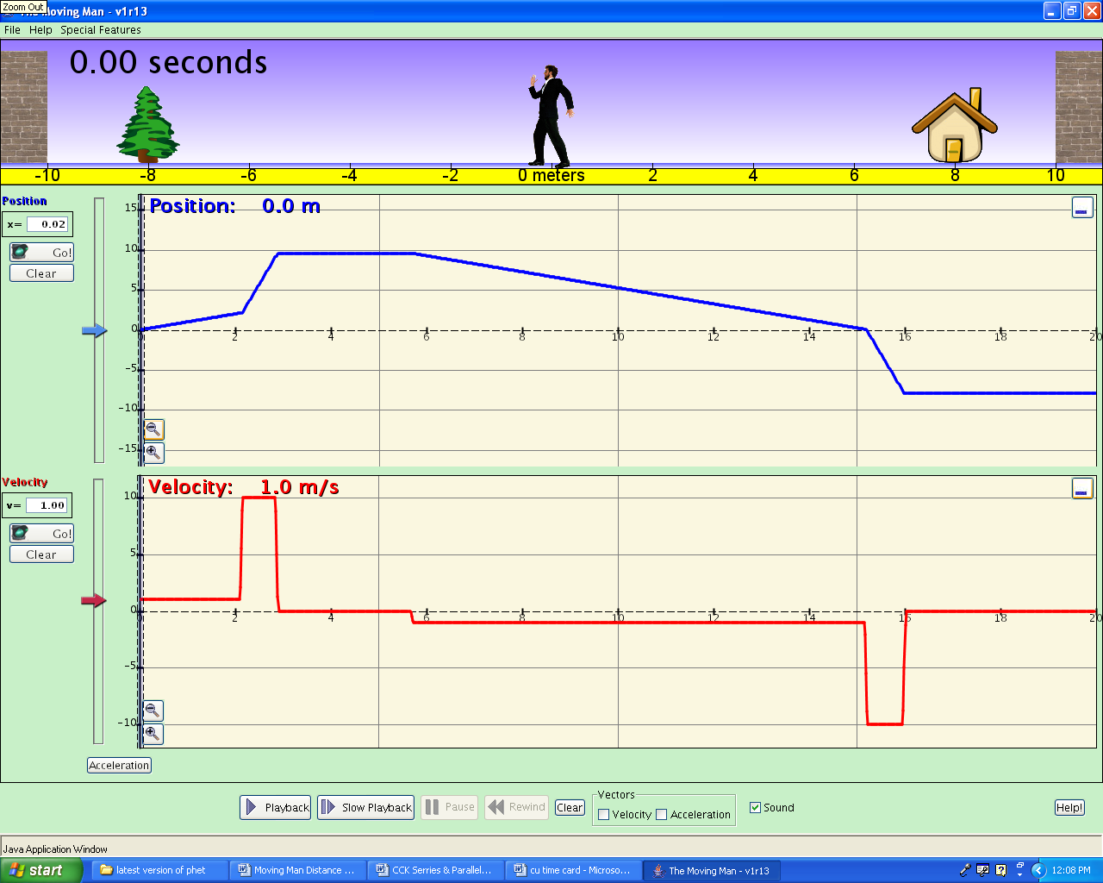
Part A
Part B
Part C
Part D
Part F
Part E

Part | Description of direction and speed

Moving Man – Velocity vs. Time Graphs

Background – Remember graphs are not just an evil thing your teacher makes you create, they are a means of communication. Graphs are a way of communicating by using pictures and since a picture is worth a thousand words knowing how to make and interpret graphs will save you a lot of writing.
Learning Goals – The students will:
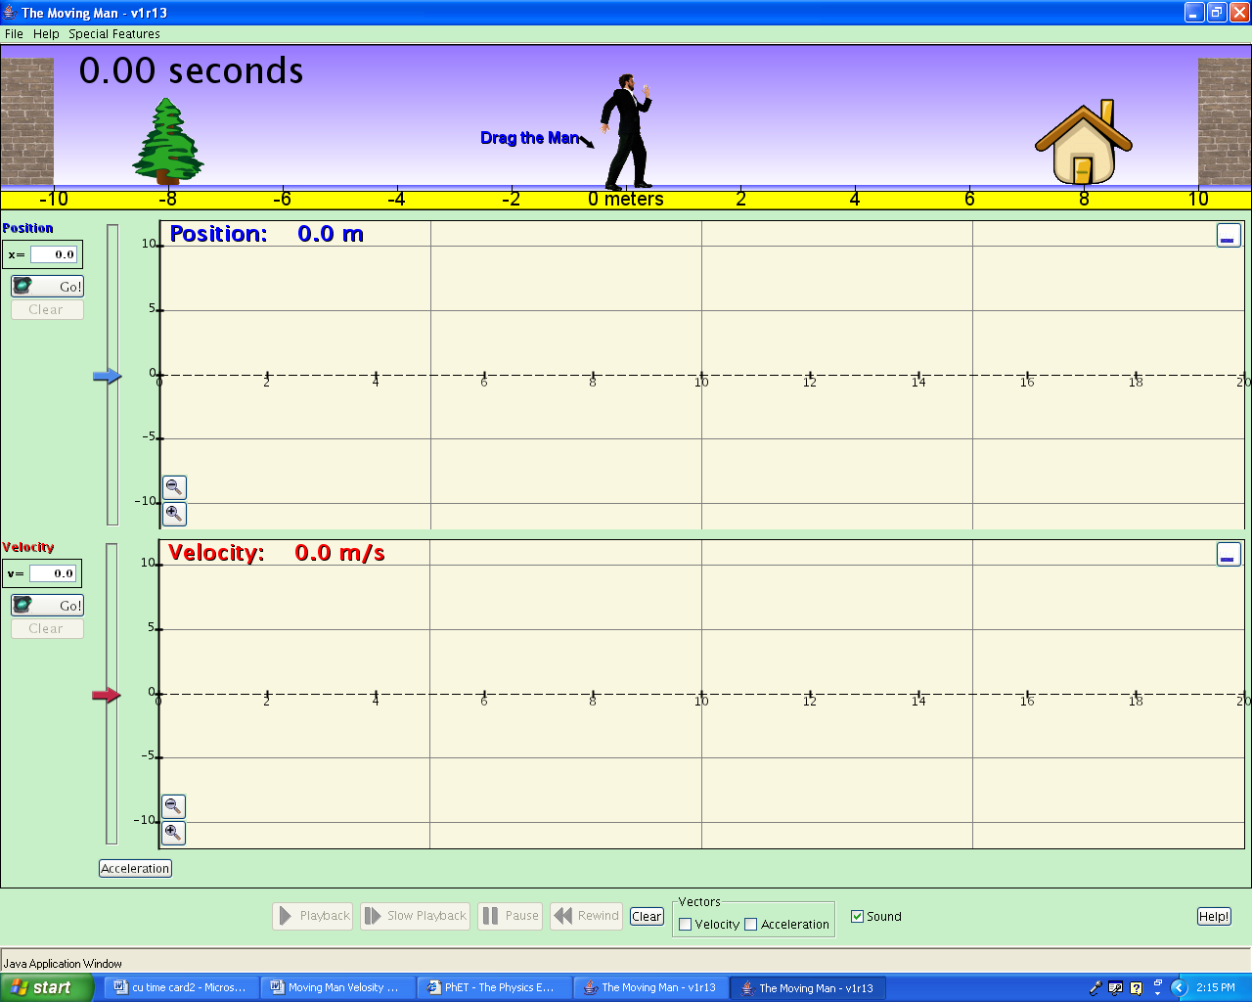
- Develop a general knowledge of “Velocity vs. Time” graphs and “Distance vs. Time” graphs
Screen 1
  - What graphs of a person standing still would look like
  - What graphs of a person moving away from an observer at a constant speed would look like.
  - What graphs of a person moving towards an observer at a constant speed would look like.
  - How differences in speed appear on the graphs

Procedure – Do the following activity using this web site
http://phet.colorado.edu/simulations/index.php?cat=Motion

Then click on “The Moving Man”

- Getting started. After “The Moving Man” is open leave the position graph and the velocity graph open but close the acceleration graph. Your screen should look like screen 1.
- Making observations. By either clicking on the man or the slider cause the man to move back and forth and observe what shows up on the graphs. Using the axis provided below make sketches of Distance vs. Time and Velocity vs. Time graphs for the actions described next to each axis.
A man moving from 0 to 10 at a slow steady pace.
-5
-10
5
0
10
Distance (m)
Time
(s)
-5
-10
5
0
10
Velocity (m/s)
Time
(s)

A man moving from 0 to 10 at a fast pace.

-5
-10
5
0
10
Distance (m)
Time
(s)

-5
-10
5
0
10
Velocity (m/s)
Time
(s)

A man standing still at 4 m
-5
-10
5
0
10
Distance (m)
Time
(s)

-5
-10
5
0
10
Velocity (m/s)
Time
(s)

A man moving from 0 to 10 at a fast pace the moving back to 0 at a slow pace.
10
Distance (m)
Time
(s)

-5
-10
0
Velocity (m/s)
Time
(s)

A man moving from 0 to -10 at a fast pace the moving back to 0 at a slow pace.

-5
-10
Distance (m)
Time
(s)

-5
-10
5
0
10
Velocity (m/s)
Time
(s)

A man moving from 10 to 0 at a fast pace.

-5
-10
5
0
10
Distance (m)
Time
(s)

-5
-10
5
0
10
Velocity (m/s)
Time
(s)

Apply what you learned. Look at the Distance vs. Time graph below and for the different parts of the graph that are marked by the dotted lines make the corresponding Velocity vs. Time graph directly below each part.
-5
-10
5
0
10
Velocity
Time
-5
-10
5
0
10
Velocity
Time
Distance
Time

