Energy “I Can” Statements
Physical Science Learning Target #1:
I can…investigate how matter changes forms but the total amount of matter stays the same.
Physical Science Learning Target #2:
I can . . . describe how an object can have potential energy because of its chemical make-up and can have kinetic energy because of its motion.
Physical Science Learning Target #3:
I can . . .identify how electrical, chemical, thermal nuclear, radiant, and acoustic energy change form.
Physical Science Learning Target #4:
I can . . . explain how matter can change form but total amount is same.
Physical Science Learning Target #5:
I can . . . trace how energy changes from one form to another.
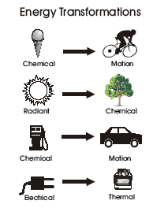
Shansgen2011

