Chemistry - Lab Safety Poster

Hi! My name is Mr. Snowman. I am your semi-official chemistry lab safety mascot. Whenever you see my picture, I want you to remember to be safe in the science classroom.
Catchy Slogan
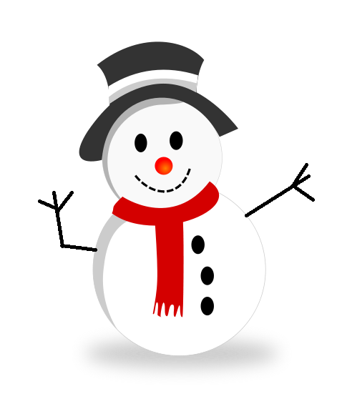
“Good Mr. Snowman” drawing
“Bad Mr. Snowman” drawing
Captions

Your assignment is to draw a cartoon in landscape orientation with me as the star!
- Choose a science safety rule from the safety contract or your book.
- On the left half of your cartoon, draw me demonstrating your safety rule.
- Then, on the right half, show what happens when I don’t follow the lab safety rules (Ouch! It hurts already!).
- Develop a slogan that illustrates your safety rule and write it REALLY BIG at the top of your poster.
Example: Rule #10 – “If you let your chair get in the way, you are sure to
have a very bad day.”
- Make sure you use the whole page and write captions for the “Good/Bad Snowman” describing what I’m doing below the pictures you drew of me.

Make sure that when you draw and color me that you do your very best.

Turn in your cartoon on Block Day, August 22/23, 2018.

