General Physical Science Syllabus 2012-13

Teacher: Ted Cramer
Room: K-01
Periods: 3,5 (Prep: Period 1, Period 6)
Welcome to General Physical Science (GPS). GPS is focused on introductory Earth & Space Science, Chemistry, and Physics. The goal of the course is to help students gain content knowledge and think scientifically, develop critical thinking skills and learn laboratory techniques. Approximately 50% of our class time will be used conducting laboratory investigations and hands on activities. Students will be encouraged throughout the year to develop a number of original scientific procedures and questions. At HRVHS our mission is to educate and support every student, every day, for success now and in the future.

Topics

Semester 1: Earth Science, Astronomy, Water Cycle

Semester 2: Properties of Matter, Changes in Matter (Chemistry), Force & Motion, Work & Energy

These topics reflect the 2011-12 State of Oregon Curriculum Goals and Standards:
- Understand structure and properties of matter.
- Understand chemical and physical changes.
- Understand fundamental forces, their forms and their effects on motion.
- Understand energy, its transformations, and interactions with matter.
- Understand the properties and limited availability of the materials which make up the Earth.
- Understand changes occurring within the lithosphere, hydrosphere, and atmosphere of the Earth.
- Understand the Earth’s place in the solar system and the universe.
- The process of scientific inquiry will be continually stressed.
In addition the course will reflect teaching and learning goals outlined in the Common Core State Standards (CCSS) in the area of English Language Arts and Literacy.

Materials
Textbook: Foundation of Physical Science with Earth and Space Science, CPO Science, 2003. Each student will be issued a textbook or a CD copy of a textbook. Students will need to bring these textbooks to class each day. Replacement cost = $70.

What to bring to class: You must have notebook and pencil everyday. It will also be necessary to have access to a calculator, either a stand-alone calculator or a phone with a good calculator application.

Expectations
You will be very successful if you meet the following expectations:
1. Attend class every day and show up on time.
2. Complete and turn in your own work, not the work of others.
3. Show respect for others – you will be treated with respect in return.
4. If you have a problem in class or about the class, speak with me privately either during class or after class if you wish.
5. MP3 players, iPods and the like are not allowed in class.
6. Cell phones are not allowed in class. If yours is a distraction during class, I will deliver it to the office where you can retrieve it at the end of the school day.

Discipline
Step 1.
You will receive two verbal warnings if you are either disrupting me from teaching or other students from learning. If further disruptive behavior continues the following may occur:
-you will be asked to leave the room
-you will be assigned in class duties and/or lunchtime detention with me in my room.
-parents will be contacted
Step 2.
If disruptive behavior continues, you will be asked to leave the classroom and earn a written referral to speak with an administrator if you continue to display disruptive behavior.

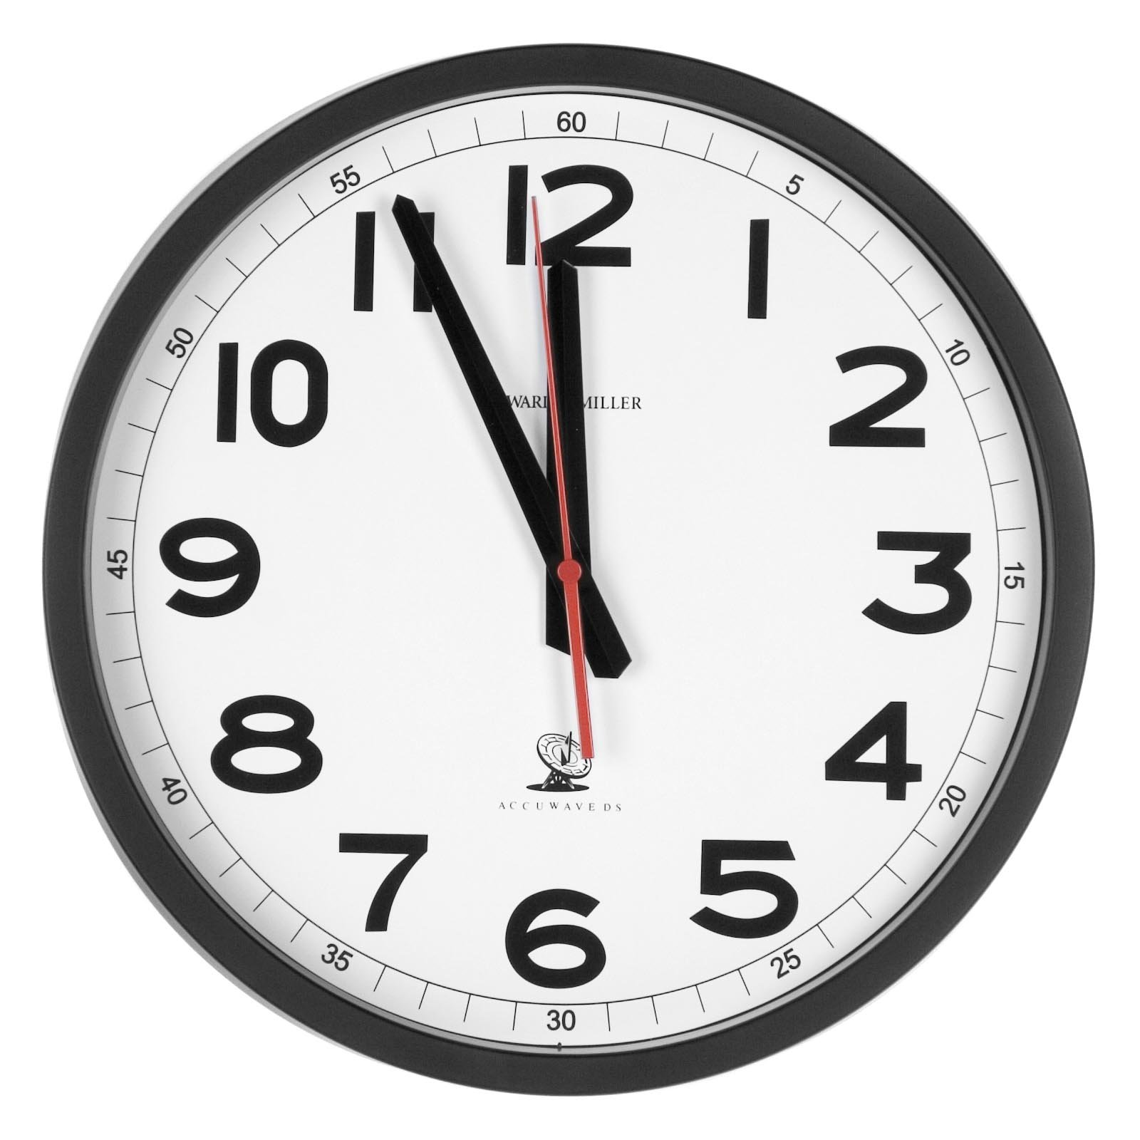
Tardiness: *Come to class on time. A letter will be sent home to parents from the main office when a student receives a 3rd tardy per semester, classroom consequences will occur after the 4th and you will speak with the Dean of Students after the 5th

Grading
The grading system is proficiency based which means you need to show what you know in order to pass. This is different from a strictly points based system where you earn enough points to pass.

90% Unit Tests (proficiency)
10% Lab reports and Projects (points)

Unit Tests: There will be 5 Unit Tests per semester. There are 2 sections in each test: “Meets” and “Exceeds”. You must pass every Unit test with at least a 75% on the “Meets” section in order to pass the class. In order to earn an 81% or higher, you need to earn credit in the “Exceeds” section of the test.

What if I fail a test? You will have the opportunity to retake the exam after you complete a review session at a scheduled time. You must attend the review session and complete make up practice work in order to be allowed to retake the exam. If you have failed a test (if your grade was lower than 75% on the “Meets” section) your test grade will be scored as 0 until you pass the exam on retake.

Lab reports and Projects: These are worth a total of 10% of the grade.

Homework: Homework is assigned weekly and will be checked. Completion will be tracked online, but it will not impact the final grade.



Progress reports
Progress reports will be posted about once a month, and danger of failure notices will go out mid-quarter and near the end of the semester. Students are strongly encouraged to keep track of their own grades online through our TAC and HAC system.

Communication for Parents
I am available at HRVHS on school days from 7:45-3:45. Please feel free to come in, email (ted.cramer@hoodriver.k12.or.us) or call (386-4500 ext. 4604) and leave a message for me to return your call. Email is most effective for me. Morning or evening visits are possible to discuss the progress of your student in my class.

It is the students responsibility to read and understand the syllabus for each and every class.

