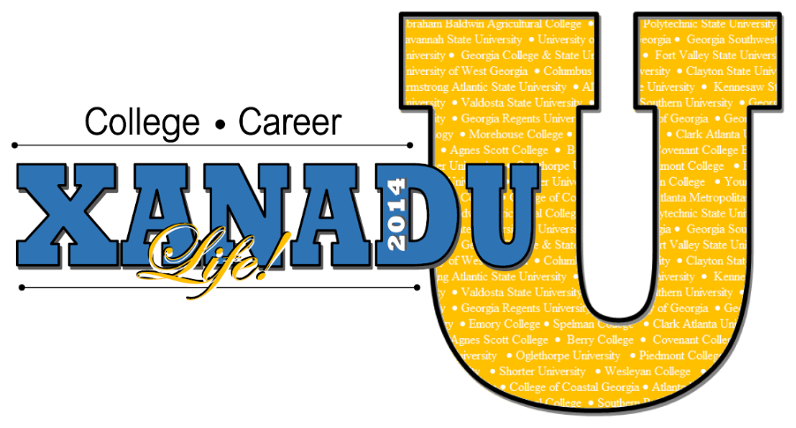

NOTE: All courses in yellow are full.

ENGL: Poppin’ Poetry
Students will embark on a crash course in poetry that will prepare them for understanding nuances in poetry, literature, and other multi-modal texts. They will study poetry through vocabulary, writing, reading, reciting, and various activities!

MATH: Money, Money, Money!
Come one, come all as we work to develop our own monetary system. Calling all artists, accountants and mathematicians of all stripes. We will brainstorm, develop and create each unit of our new system. This is the time for all enthusiastic artists and doodlers to shine. We need a governor, a bank manager and many regular townspeople and we will print and use our new currency in our very own marketplace!

HIST: God, Gold, & Glory: The Story of the Aztecs
Close your eyes and imagine this: A city of millions, floating on water, with people dripping in gold and beautiful gems. Can you see it? No, you’re not dreaming, this place really existed, and it is fun to say as well. This magical place was the capital city of the Aztec and it was known as Tenochtitlan. Come on this adventure as we explore the myths and stories of the Aztec and their demise at the hands of the Spanish!

CHEM: Fizz, Bubble, & Flash
Like to play with chemicals like Bill Nye the Science Guy? Are you good at making observations? Then join Fizz, Bubble and Flash! Learn the difference between physical and chemical changes as you become a quality assurance chemist for a major international cosmetics company. KABOOM!

COMM: Let’s Talk Change!
Are you a problem solver? Do you enjoy giving advice? If so, “Let’s Talk Change” is the show for you! We are currently filming for our pilot episode. See you there!

HIST: A Love Unfilfilled
Have you ever been separated from a loved one due to circumstances? How did you deal with the separation. Imagine being separated for 26 years? Bring construction paper, copy paper, and colored pencils, and be prepared to explore/write about an historical love that was unfulfilled.

ANTH: Explore the Land Down Under
G'day mate! Come along as we travel through the Outback of Australia. Dead-cert you will love it! That's Aussie talk. Explore the culture of the Aborigines, construct and throw a boomerang, prepare some tasty Australian cuisine, create Aboriginal art, and listen to the sounds of Dreamtime. Pack your bag, let's throw a shrimp on the barbie and create our own passport through the culture and history of Australia.

PLAN: Party Made Perfect
“Party, Party, Party, Let’s All Get Together”…It’s time to get ready and party! Come and register for the “Party Planner Class” where you will plan the most elaborate, exciting, and “crunk” party of all times. Using various math and language arts skills, you will create a balanced budget, intriguing invites and a marvelous menu and we can’t forget the energizing entertainment. You won’t want to miss this planning!

ART HIST: In Living Color
History through the eyes of an artist. In Living Color will allow students to study various historical events throughout history and create murals, portraits, and paintings that depict history through an artist’s lens.

ANAT: The Human Body is a Wonderland
The human body is fascinating! Have you ever wondered how your body does all the things that it does? Our bodies contain 206 bones and over 600 muscles, all coordinated by one central organ, the brain. In this course, you will learn how your body's components work together as one, to keep you going each day. This exciting hands-on course will provide an opportunity to answer your questions about the human body. You will investigate the skeletal, muscular, cardiovascular, and nervous systems by performing both virtual and hands-on dissections of various animal organs.

HLTH: Let’s Move, Move Your Body!
“If you did what you always did, you will get what you always got.” Are you ready for a change in how you feel, how you look, and your overall health in general? Well this would be the right class for you! Let’s Move! Move your body class is all about being a better you. Come join me because working out doesn’t have to be a chore, it can be fun!

ALG: Show Me the NUMBERS!

Do you like to explore number facts and relationships, as well as draw? Well great, because this is the course for you. We will cultivate prior mathematical knowledge, as well as spring forth new knowledge of ratio and proportion, scaling, and scientific notation. Then, if you add that to your thirst to orchestrate dynamic drawings, you can create a masterpiece!

ARCH: Do You Remember the Time?
Calling all explorers! The Age of Discovery Network is looking for highly intellectual students to produce a game show on the benefits of early exploration. For example, Christopher Columbus discovered goods and services that we utilize today. So if you enjoy the benefits of the past, log on to www.exploration.com and complete an application to become a member of our exclusive team.

ENV SCI: XANADU Troup 1000 vs. EPA
Do you wonder what it would be like to be a scientist, a lawyer, and an environmentalist all at once? Join me this summer as we use science to conduct labs to help solve a Supreme Court case. Will justice be served? Will science prove innocence or guilt? Be a part of Science Court Work on the case of Girl Scout Troup 1000 vs. the Environmental Protection Agency!

WRIT: Tales from my HOOD
Have you ever wondered what are the BEST Atlanta neighborhoods for kids? How did those neighborhoods come about? Well, now you will have the opportunity to tell us about your NeighborHOOD by creating a Picture Book showcasing various points of interests for kids.

SOCI: Freedom Fighters
Is there a cause you are willing to die for? If so, join the Freedom Fighters for a wonderful journey on how to create your own movement to change the world!
PLAN: Party Made Perfect
“Party, Party, Party, Let’s All Get Together”…It’s time to get ready and party! Come and register for the “Party Planner Class” where you will plan the most elaborate, exciting, and “crunk” party of all times. Using various math and language arts skills, you will create a balanced budget, intriguing invites and a marvelous menu and we can’t forget the energizing entertainment. You won’t want to miss this planning!

ART HIST: In Living Color
History through the eyes of an artist. In Living Color will allow students to study various historical events throughout history and create murals, portraits, and paintings that depict history through an artist’s lens.

ANAT: The Human Body is a Wonderland
The human body is fascinating! Have you ever wondered how your body does all the things that it does? Our bodies contain 206 bones and over 600 muscles, all coordinated by one central organ, the brain. In this course, you will learn how your body's components work together as one, to keep you going each day. This exciting hands-on course will provide an opportunity to answer your questions about the human body. You will investigate the skeletal, muscular, cardiovascular, and nervous systems by performing both virtual and hands-on dissections of various animal organs.

HLTH: Let’s Move, Move Your Body!
“If you did what you always did, you will get what you always got.” Are you ready for a change in how you feel, how you look, and your overall health in general? Well this would be the right class for you! Let’s Move! Move your body class is all about being a better you. Come join me because working out doesn’t have to be a chore, it can be fun!

JOUR: The DigiZine Tribune
The DigiZine Tribune needs you! Yes, you! Future journalists, sports writers, fashionistas, bloggers, DIY'ers, food critics, gamers and more...take your future career or favorite hobby and bring it to life through the creation of a live digital magazine! Be the creator, feature writer and the graphic designer of your own magazine. If two or three heads are better than one, gather your friends and come along as you create a magazine that showcases what makes you great friends and unique individuals! The DigiZine Tribune...the digital magazine made by you and (of course) for you!



SYST: Gaming with Systems
Are your peers bored in math class? Do you enjoy playing games? Do you wish math class incorporated more math games? Have you ever wished you were a game designer? If you answer yes for all of the questions, “That Game Company” needs you. “That Game Company” is looking for innovative students to join their team to create math games that involve solving systems of equations/inequalities. If you enjoy math and enjoy creating games, complete an application to become a member of “That Game Company”.

MYTH: Religion or Mythology?
Zeus, Poseidon, Apollo, Aphrodite, and more! Fact or Fiction? Religion or Myth? Learn about the amazing lives of the Gods and Goddesses of Ancient Greece. Real or Imaginary? You Decide!

WRIT: Yes, you're a poet; but did you know it?
Hone the creative side of you by perfecting the poetic form-Haiku! Or if that doesn't fit your creative mode, try something different like an Ode. If all this sounds a bit rehearsed, then extricate yourself and write Free Verse, Idylls, Sonnets, Limericks, Ballads... All types of poems for your artistic palette!

CHEM: It’s Just a Chemical Reaction!
Welcome to the world of Chemistry. Let us see what makes the leaves change color, raise the dough to bake your cookies, the fizzing of soda when you open the can of soda, and many more exciting things that happens every second and minute around us. Let us connect the everyday life around us to the real world of chemistry. The power inside the atoms and the nucleus causing great destruction - atomic and nuclear bombs. The chemical bond that binds the atoms together making up the material world around us.Let us also explore the table of elements that contains the world that you live in. Come and enjoy the chemistry in and around you during this two weeks.

FORS: Who Dunnit?
Who stole your pencil at school? Who took a bite out of the candy? Why are there missing clothes from your closet? Answering these questions is what forensics is all about. In this course, you will learn how to be a crime solver by exploring the world of forensics scientist. You will learn how to identify handwriting traits, read a lie detector and solve a real life school mystery.

SPAN: Todo Acerca de Mi:
All About Me Interactive E-Book
¿Te gusta la tecnología? ¿Te gusta escribir? ¿Te gusta el español? Did you understand the questions? Do you like technology, writing and Spanish? If the answer is yes, this is the class for you to become a self-published author! Who will you write about? The best person in the world to write about; YOU! The Xansa Publishing Company in Quito, Ecuador is looking for young children from the United States of America to publish books about themselves. They are very interested in the hobbies, families, likes and dislikes of American youth. The magazine will be published online using cutting edge Website tools and Social Media. Hurry up and be one of the first young authors to publish a multimedia book about you.

FINC: What's Your Interest?
Do you want more money? I know I do! In this course, you will learn how to take the money you have and make more money through investments. You will explore the banking world and discover the different types of interests available when you decide to invest money, obtain a loan or apply for a credit card. You will discover what seemed so complicated is actually very simple.

JOUR: The DigiZine Tribune
The DigiZine Tribune needs you! Yes, you! Future The DigiZine Tribune needs you! Yes, you! Future journalists, sports writers, fashionistas, bloggers, DIY'ers, food critics, gamers and more...take your future career or favorite hobby and bring it to life through the creation of a live digital magazine! Be the creator, feature writer and the graphic designer of your own magazine. If two or three heads are better than one, gather your friends and come along as you create a magazine that showcases what makes you great friends and unique individuals! The DigiZine Tribune...the digital magazine made by you and (of course) for you!

EQUA: Figure it out!
Equations are all around us. Some may even believe that life is an equation! Well what’s the easiest thing to do to an equation: SOLVE IT. Come join this course as we figure out how to solve all of life’s equations.

CVL RGHTS: Who Dat Say We Free?
Calling all historians!!! Jim Crow, racial violence, segregation & discrimination…it is clear that the “Deep South” in the 20th century is no place for African Americans. Come learn about the people, the struggles and the day-to-day life of black and white Americans during the Jim Crow Era.

CULT: Every day is a HOLIDAY – SOMEWHERE!
Every day is a holiday…SOMEWHERE! It’s Time to Celebrate! Join our daily celebrations as we discover both traditional and bizarre holidays from around the world. Each day we will explore the music, foods, games, dress, oral/written traditions, and history of various cultures (religious and secular). Be ready to eat, drink and be merry!

BIOL: What is that THING?!
A call to all biologists interested in learning about the diversity of life and going on a local safari! Have you ever wondered why living things are the way they are? In this course you will investigate the characteristics of all living things. The culminating activity will allow you to survey the local population of organisms and create a field guide of various organisms found here in Georgia.

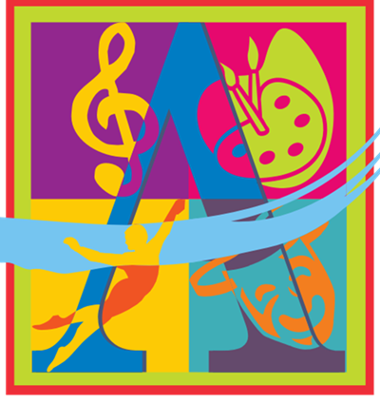

ART: Visual Art Studio
Tired of drawing stick figures? Take your drawing skills to the next level. Learn to see in a new and exciting way. This intensive drawing and painting studio class will teach your child to expand his/ her creativity and engage in techniques to developing technical skill through activities that further their seeing and drawing skills. This course will culminate in a final painting that exhibits visual storytelling, and the skills and knowledge learned throughout the session.

MUS THTR: Bright LIGHTS!
The curtain is going up...on a summer filled with the excitement and magic of theater! This class is for those who love theater and the performing arts. This class is for those who dream of standing in the spotlight on opening night, of seeing yourself on television or in the movies, of hearing the applause of an audience? Students will learn how to dissect monologues and analyze characters for audition(s) and performance purposes.

VOCL: The Joy of Singing My Voice, My Instrument
Develop your voice, train your ear, sight read music with finesse, and obtain skills to help when auditioning for All State Chorus or Governor’s Honors.

DRAM: Curtain Call for Thespians!

Now Casting! Are you ready to audition for your next role on stage or for the cinema? Join us as we explore the fascinating world of drama. Develop the skills that true thespians possess. We'll examine expression, emotions, character and play analysis, stage directions, improvisation as well as theater history and the cinema. To "be" here or not to "be" here. Come showcase your artistic flair!

ORCH: Hanging on STRINGS
In this course, students will develop technique, interpretive skills, and musical expression through intense engagement with a variety of compositions. Students discover the joys that result from a dedication, persistence, and hard work as their musical development is guided by a master orchestra educator towards a culminating performance.

BAND: Leaders of the BAND
Students will develop a proficiency by studying with a master band director. Instruction includes rehearsals, supervised practice, individualized instruction, and a culminating performance.

DANCE: Save the Last Dance
In this course, students will be introduced to a variety of dance genres, develop and hone dance technique, and explore individual expression through dance choreography.

