

May 15, 2017

To: ALL “The Little Mermaid” Cast Members and Parents/Guardians

Welcome to Brea’s Youth Theatre production of “The Little Mermaid”. Sponsored by the City of Brea, this popular program encourages teamwork while teaching children and teens the fundamentals of the performing arts. For over 25 years, Stagelight Productions, under the leadership of Janice Kraus, has served as the City’s producing partner for this popular program.

Truly a community program, Brea’s Youth Theatre depends upon the support of parent/guardian volunteers to assist backstage, work on committees, and participate with their children. We count on everyone to take on some small part of the production. Sign-up sheets are available at tonight’s Parent Meeting, at auditions, and during the first week of rehearsals. Please sign-up to help with at least one committee. The show could not go on without you!

Communication is essential to a successful theatrical production. Enclosed you will find important details about auditions, casting, ticket sales, rehearsal schedules and, of course, the performance itself. We also encourage you to log onto www.stagelightproductions.com for updated information. If you have a question at any time during auditions, rehearsals and the production, do not hesitate to ask Curtis Theatre staff, or a member of the Stagelight Productions staff. The Producer, Janice Kraus, will also be available at every rehearsal.

We want your experience with us to be a positive one. If you have any questions or concerns regarding Brea’s Youth Theatre, please feel free to contact me at (714) 990-7723. On behalf of the Curtis Theatre, thank you for joining us!

Sincerely,

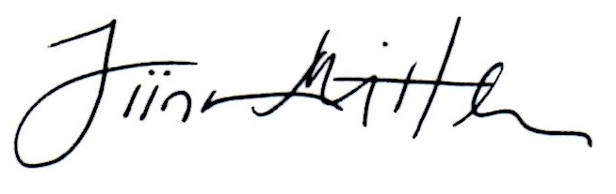

Tiina C. Mittler
Theatre Managing Director


FREQUENTLY ASKED QUESTIONS
What if my child cannot attend auditions?
If your child cannot make it to auditions, he or she will automatically be cast in the ensemble.

When do we begin rehearsals?
Rehearsals begin the Friday after auditions.

I heard the children are split into two casts—how will I know what cast my child is in?
Cast assignments will be assigned the weekend after auditions. The producer needs this time to take into account participant scheduling conflicts.

How do I get updates about rehearsals, deadlines, and other key information?
A detailed list of rehearsals and deadlines will be distributed within the first two weeks of rehearsal. Please visit Stagelight Production’s website at www.stagelightproductions.com for up-to-date rehearsal schedules, forms, deadlines, and other important information. You may also sign-up to receive periodic production updates through this website.

How often does my child have to attend rehearsals?
Typically, each participant is required to rehearse two times per week. Approximately three weeks before the show, rehearsals will increase. Please note any conflicts (other activities, family vacations, etc.) at the time of auditions. This information will be helpful in scheduling your child.

What if my five year old can’t keep up with the older children?
Auditions and rehearsals are broken down by age range. About three weeks before the show’s opening, the entire cast comes together to ready the show for the performances.

When do tickets go on sale?
Special Priority Sale Days on June 26-29, 2017, will be open to parents/guardians of Brea’s Youth Theatre participants only. Tickets will go on sale to the general public July 5, 2017 at 12pm. Details about ticket sales are enclosed in this packet. For questions, please contact Box Office Staff at 714-990-7722.

What if my child cannot attend rehearsal?
Cast members will be given the name and phone number of the contact parent/guardian assigned to their group. Please call the assigned contact person prior to rehearsal to report all absences that are not listed on your child’s conflict sheet.

What if I have a question?
Please do not hesitate to ask. Coordinators, are available at every rehearsal, and will be able to answer your questions. In addition, contact phone numbers will be distributed the first weekend of rehearsals. A member of the Curtis Theatre’s staff will also be present at every rehearsal. If a question arises during normal business hours, you may also call Theatre Managing Director, Tiina Mittler, at (714) 990-7723.

AUDITION & REHEARSAL SCHEDULE
The following schedule is for Pre-Auditions through the first weekend of rehearsals.

Pre-Audition Workshop- Friday, May 26th
- Group A (ages 5-8): Brea Senior Center - 6 to 7 pm

- Group B (ages 9-12): Brea Senior Center -7:15 to 8:15 pm

Group C (ages 13-Adult): Brea Senior Center - 8:30 to 9:30 pm

Auditions – Saturday, May 27th
- Group A (ages 5-8): Brea Senior Center – 12:30 to 1:30 pm

- Group B (ages 9-12): Brea Senior Center - 1:45 to 2:45 pm

Group C (ages 13-Adult): Brea Senior Center – 3:00 to 4:00 pm

Rehearsals – Beginning Friday, June 2nd
- Group A (ages 5-8): Brea Senior Center, Fridays 6 to 7 pm; Saturdays 12:30 to 1:30 pm

- Group B (ages 9-12): Brea Senior Center, Fridays, 7:15 to 8:15 pm; Saturdays
1:45 to 2:45 pm

Group C (ages 13-Adult): Brea Senior Center, Fridays, 8:30 to 9:30 pm; Saturdays,

3:00 to 4:00 pm

Invitational Callbacks will be held Sunday, May 28th, 2017 at 1 pm, at Pioneer Hall. Rehearsals will be held on some Sundays for Lead Cast Members. A detailed schedule will be distributed stating who is needed for Sunday rehearsals.

Rehearsals will take place at the Brea Senior Center located at 500 Sievers Avenue, Brea. We ask that all parents/guardians, regardless of the age of your child, park at the Brea Senior Center or legally on the street to drop off/pick up your child. Beginning Monday, June 26th, all rehearsals will take place at the Curtis Theatre. Additional rehearsals will be added during this period.

PERFORMANCE DATES
Mark your calendars! Disney’s The Little Mermaid performs Thursday, July 13, 2017 through Sunday, July 30, 2017. Performance times are Thursdays at 7:30 pm, Fridays at 7:30 pm, Saturdays 2 & 7:30 pm and Sundays 2 & 7:30 pm. All performances take place at the Curtis Theatre. Please calendar these dates and note any conflicts at the time of your child’s audition. Participants will be divided into two casts, with each group alternating performances.

Ticket Information & PROGRAM COSTS
Priority Ticket Sale:
Priority Ticket Sale will be held on June 26-29, 2017. Each participant will be given an order form with a priority number and assigned time. The Priority Sale Day is the earliest you can purchase tickets. Your assigned priority number ensures that you will have an opportunity to purchase tickets within your scheduled time. Therefore, there will be no need to line up prior to your scheduled time. If you cannot make it to the Priority Sale Day, you may give your order form to someone who can purchase tickets on your behalf or to a Curtis Theatre staff member. Your order will then be processed when your number comes up. All tickets are $15 each. Children ages 2 years and older must have a ticket. Priority Numbers are drawn at random, and order forms will be passed out the weekends of June 16th – 25th, 2017.

Due to the popularity of this program, the Curtis Theatre cannot guarantee tickets to opening and closing night performances. For the Priority Sale Day only, ticket purchase limits will be enforced for each participant, and parents/guardians may only purchase tickets for the cast that their child is assigned. Please be sure of your child’s cast and performance prior to purchasing tickets.
There are no refunds or exchanges on any tickets.

General Public Ticket Sales:
Tickets go on sale to the General Public on Wednesday, July 5th at 12:00 p.m. Tickets can be purchased in person, at the Curtis Theatre Box Office, by calling 714-990-7722, AND online at www.curtistheatre.com.
On General Public sale day, the quickest way to purchase tickets is online. Please note that there is a $4.00 transaction charge and a $1.00 per ticket convenience fee.
The Curtis Theatre Box Office is located at 1 Civic Center Circle, Brea, on the Plaza Level. Box Office Hours are 12 p.m. to 3 p.m., Tuesday through Friday, and one hour prior to performance.
Box Office Staff at (714) 990-7722, can assist with ticket orders and inquiries, Tuesday through Friday, 12 p.m. to 3 p.m.
Please buy your tickets early. Brea’s Youth Theatre regularly sells out.

PARENT VOLUNTEER COMMITTEES
During this production, we will need help from everyone! Please share your talent with us and become one of the many parent/guardian volunteers needed to orchestrate this production. This is truly your opportunity to take part in the excitement. A brief description of the committees is outlined below. Please review the list and sign-up wherever you can assist. Your participation will allow you to be more involved with your child on a truly memorable project. The following are ways you can volunteer:

PARENT/GUARDIAN SUPERVISION:
The Parent Supervision Committee ensures that cast members are supervised during tech week and performances. Therefore, we need as many volunteers as possible. The Committee Chair schedules the volunteers for Cast Check-In and Backstage Supervision. Volunteers select the show or shows they are able to work.

Men and Moms in Back (M.I.B.’s):
This Committee serves as the Running Crew for each performance. The Men and Moms in Back work backstage to move set pieces, change scenery, and organize props during each performance.

COSTUME COMMITTEE:
Although Stagelight Productions offers costume rentals, assistance is needed with sewing and costume organization.

GALA COMMITTEE:
The Gala Committee will organize Opening Night festivities.

CAST PARTY COMMITTEE:
The Cast Party Committee will organize the Cast Party.

BALLOON & GIFT SALES COMMITTEE:
This Committee will coordinate balloon and gift sales during the performance run.

T-SHIRT COMMITTEE:
This committee organizes the distribution of the cast t-shirts.

CAST LUNCH COMMITTEE:
This committee organizes the ordering, pick-up, and delivery of the cast lunch.

SILENT AUCTION COMMITTEE:
This committee organizes and runs the Silent Auction during each Opening Night Gala.

VOLUNTEER SIGN-UP
We ask that every parent/guardian participate on at least one committee. Please fill out a Volunteer Application and bring it with you to a rehearsal. Siblings may also volunteer as theatre ushers! It’s a great way to earn community service hours. For safety purposes, every volunteer usher must attend a short orientation and submit a volunteer application, prior to their first volunteer date. For questions or comments, please contact Lottie Frick at (714) 990-7729.

VOLUNTEER GUIDELINES
All Volunteers, Staff and Contractors for Brea’s Youth Theatre and Stagelight Productions shall follow the guidelines of supervision as follows:

- Two-deep Leadership: Two (2) registered, adult volunteers and/or parent/guardians of a participant will supervise the children in the cast at all times. Any adult and/or parent/guardian in the Backstage Area of the Theatre must be either a paid staff member of Stagelight Productions, the City of Brea, or a registered Volunteer. (Please note: Registered volunteers must have a completed and signed volunteer application on file with the City of Brea.). At no time shall an adult and child be alone together without the presence of another adult. One-on-one contact between adults and children is not permitted. This includes the Theatre’s Backstage Area (i.e. Restrooms, Green Room, Cement Room, Dressing Rooms, etc.), as well as areas inside the Brea Senior Center and Civic Center. In the event that a Personal Conference is necessary, the meeting is to be conducted in view of other adults and children.

- Respect Privacy: Adult Supervisors and Volunteers must respect the privacy of youth cast members in situations such as, but not limited to, changing clothes or using the restrooms. Adult Supervisors and Volunteers should intrude only in the event that health and safety are at risk. Adults are responsible to protect their own privacy in similar situations.

PARTICIPANT BEHAVIOR GUIDELINES
Constructive and Progressive Discipline: Discipline used should be constructive, progressive, and at all times shall reflect the highest standard of values. Corporal punishment is never permitted. To provide a positive theatrical experience and ensure the safety of all participants, the following steps will be taken for children who exhibit unacceptable behavior:

- Disruptive behavior will be reported to the Producer, Janice Kraus. From there, Janice will conduct a Discipline Conference with the participant. At this time, the participant in question will be asked to sign and date a Discipline Conference Report. Stagelight Productions staff will notify parent/guardians.

- If the disruptive behavior continues, the participant’s parent/guardians will be notified. Producer, Janice Kraus, will have a conference with the cast member and his/her parent/guardian(s). Both the participant and his/her parent/guardian(s) will be asked to sign and date a second Discipline Conference Report. (Please note: The parent/guardian and child’s signature indicates only that the conference took place and does not indicate agreement with the Producer.)

- If the disruptive behavior continues, the participant’s parent/guardian(s) will be asked to attend all remaining rehearsals and remain Backstage during performances to monitor their child’s behavior.

- If the previous interventions are not successful, the participant will be dismissed from the production. Participation in future productions will be at the discretion of Stagelight Productions and the Curtis Theatre.
PROGRAM COSTS

Program Costs:
Registration and the costume rentals are the only two required costs associated with the Brea’s Youth Theatre Program. Throughout the program, you will have the option to purchase additional items (photos, balloons, etc.). We strive to create the scale and scope of Broadway in a welcoming environment that is fun for the entire family. The sale of items like balloons, candy, rehearsal lunch etc. helps support the costs associated with producing the Brea’s Youth Theatre Program.
The following is a list of optional items and their approximate cost:
- Rehearsal Lunch - $6
- Break-a-Leg Ads - $6
- Tickets - $15 each
- Photos – $4 - $40
- Program ads - $25
- Sponsor Ads - $25 - $200

Map to Curtis Theatre at the Civic Center: Map to Brea Senior Center:
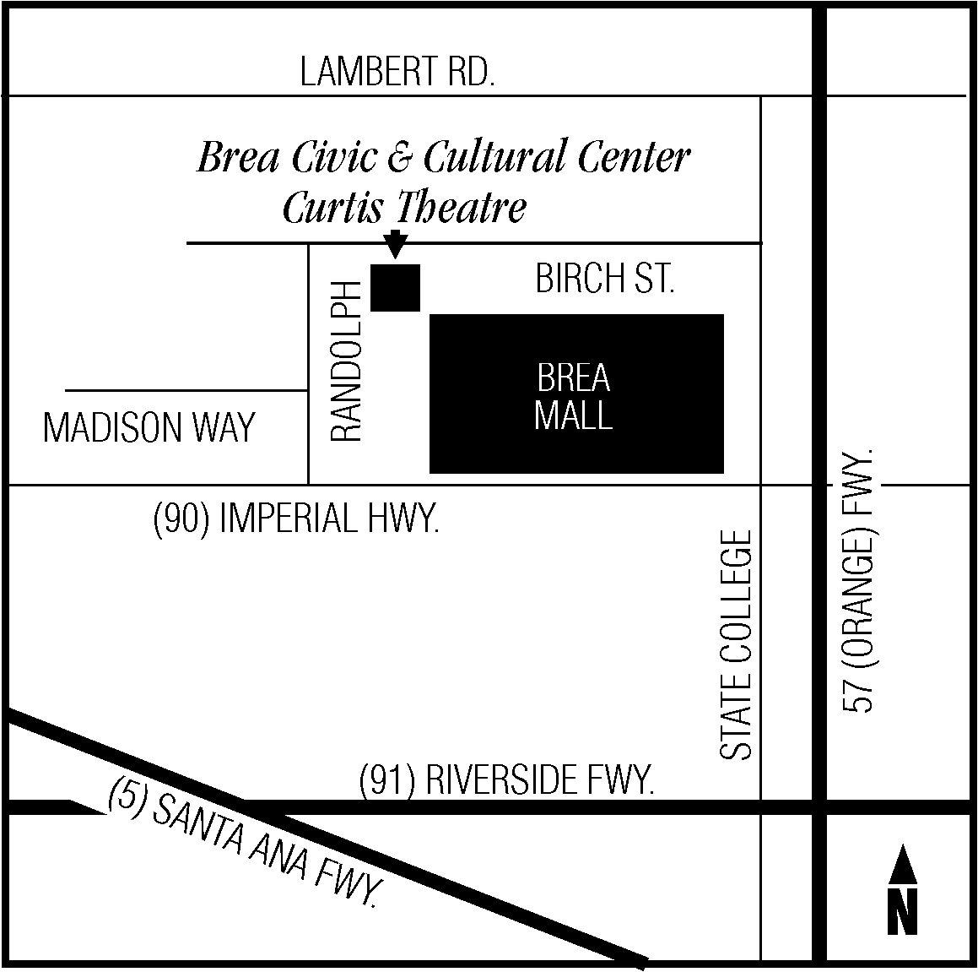

Stay Connected & Share about the Show

- Want to stay in the loop? Join the group! Stay connected by joining the Facebook group, Brea Stagelight Family Productions.
- Keep up with behind the scenes photos & exclusive show information on the Curtis Theatre’s social media pages –

 /curtistheatre  @curtisthtr


