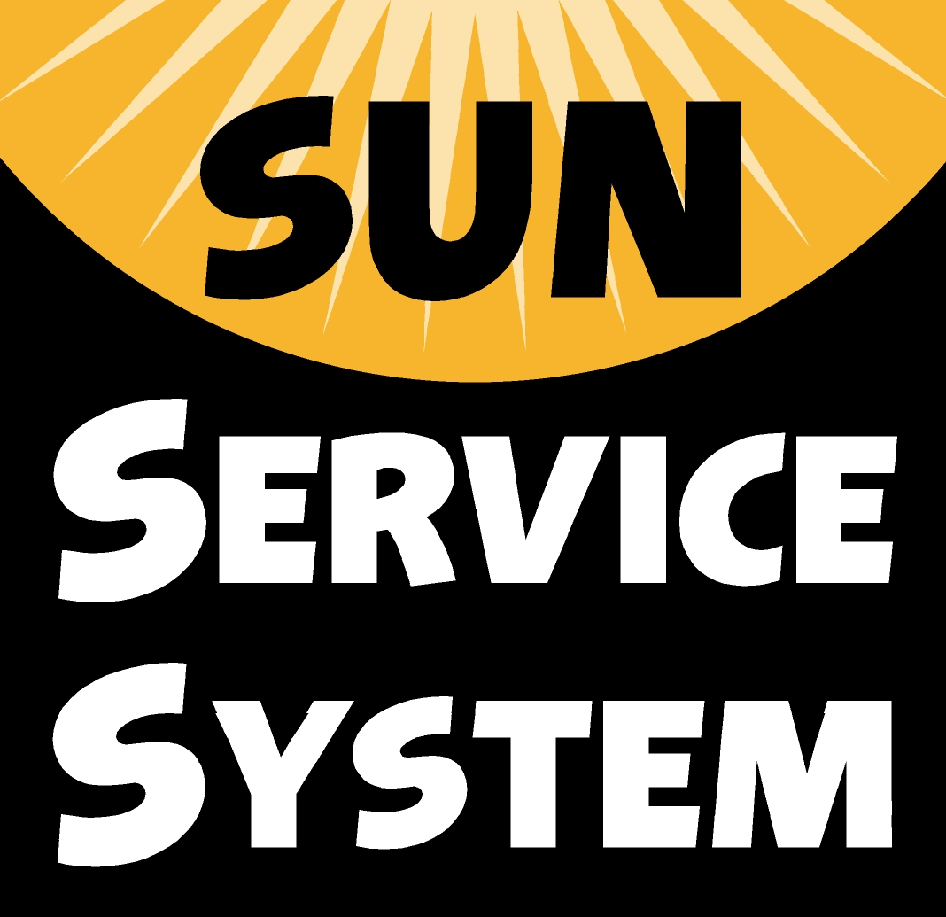
Local Community Schools
Past and Current Financing Examples
May 2011

Education/School Sources

- Alder Elementary
The School Specialist Team have flexed hours, working 8:30am to 4:30pm to enable them to offer academic support to students in the extended-day program.

- Centennial School District
Title I funds support supplemental academically focused programming at Lynch View, Oliver, Parklane and Lynch Wood Elementary Schools ($15,000 per site).

- Clear Creek Middle
Faced with the possible loss of competitive sports, funds were blended to run intramural sports through the Community School.

- Earl Boyles Elementary
Title 1 teachers and assistants lead an extended-day computer-based literacy and math enrichment/remediation class four days a week for students just below benchmark in grades 3-5.

- George Middle
Through building-based and central Title I funding, this Community School served 300 students each term by providing safe transportation home for approximately 40 students a day ($6,000), supported summer programming for 60 students ($20,000 each summer), and provided snacks and meals for SUN CS events ($2,000).

- Kelly Elementary
$1200 of Title I Parent Involvement funds have supported food for SUN CS celebrations.

- Kelly, Lane, Lent, Woodmere
A PPS 21st CCLC grant provides funding for certified teachers to teach in the extended-day program during the school year and summer ($20,000 school year/$12,000 summer per site)

- Lane Middle
Title I funds pay for an activity bus, on average $3800 per SUN CS session.

- Marshall High
All three principals contributed a total of $4800 in Title I Family Involvement funds to support SUN CS family events, including Multicultural Night, Bike Fix-it Fair, College Preparation Event, Harvest Party, and Translations.

- Marysville K-8
Title I Family Involvement funds support events such as Family Write Night, Math Night, Multicultural Night, and Parent Teas. Family Write Night and monthly Parent Teas are written into both the SUN CS Annual Plan and School Improvement Plan.

- Roosevelt High
Educational funding sources ($30,000 Title I, SES funding) are aligned to provide extended-day tutoring and credit retrieval.

- Scott K-8
A Spanish family literacy event with 136 attendees was funded through a blending of Title I and SUN CS dollars.

- Shaver Elementary
School-day educational assistants worked an adjusted schedule to allow them to teach extended-day academic classes. $18,900 of Title I funds also supported six additional educational assistants in the extended-day program this year.

- Whitman and Woodmere Elementary Schools
PPS Title I funded a 3-week Parent/Child Early Kindergarten Transition program at both schools that served 35 children ($17,000 per site).

PTA Sources

- Markham Elementary
The PTA provides $1000 each year to support a SUN CS choir class.

- Rigler K-8
SUN CS partnered with the PTA to sponsor the Rigler School Carnival where a silent auction was held that raised $6,000. Half of the funds will support a year-long family nutrition program through the Community School.

- Roseway Heights K-8
The PTA donates $2,000 annually to support extended-day performing arts classes.

Higher Education Sources

- Faubion K-8
A partnership with Concordia University provides tutors in the extended-day.

- Lane Middle
A partnership with Reed College have brought mentorship and internship programs to Lane SUN CS.

- Markham Elementary
A Partnership with PCC’s America Reads program provides up to ten year-long work study staff to support SUN CS services and activities.

Faith-based Sources

- East Gresham Grade School
Through a partnership with Grace Community Church, a food backpack program was established that sent 15 bags of food home to families each week.

- Roosevelt High
Southlake Church donated 150 summer survival kits and 300 giving tree bags to the school.

- Woodmere Elementary
A partnership with Mt Scott Church sends home backpacks with food to 12 families a week.

