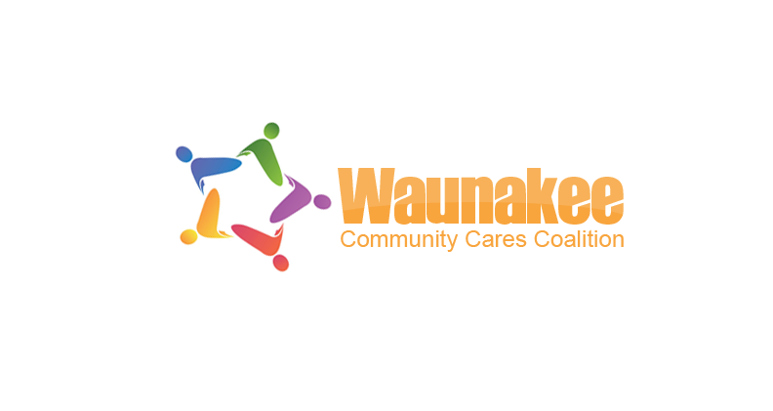
Our Mission: Creating conditions and opportunities that promote positive youth development
Our Vision: Waunakee community youth are healthy and resilient

If you are interested in getting involved or receiving information about the Waunakee Community Cares Coalition, please either email us at waunakeecares@gmail.com or follow us on Facebook at https://www.facebook.com/WaunakeeCares/

Events

Hope over Addiction
Waunakee Community Cares Coalition is sponsoring a Town Hall Meeting to be held on Wednesday, February, 21st 2018 at the Waunakee Community High School Performing Arts Center at 301 Community Drive. The evening will start at 6:00 pm with booths providing informational materials and our panel of FIVE presenters will start at 6:30 pm. Their focus will be on prevention, risk factors, stigma, statistics/trends in Waunakee, recovery, treatment, law enforcement trends in Waunakee and HOPE! There will also be a questions/answer session to follow the presentations with questions submitted by those present. All are welcome for a night that we hope those in attendance will leave with a better understanding about prevention, the risk factors, breaking the stigma about addiction and hopefully giving us all HOPE that we can see an end to this epidemic!

