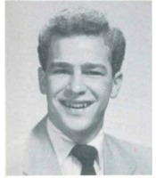
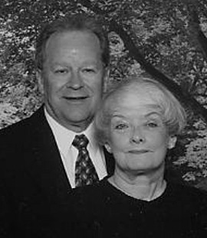

Fern L. Reindollar
Lancaster, Pa.

Moon and his wife, Shirley, live in Lancaster. “Soon after leaving the Navy, I was taking my sister back to school. On the way, we picked up her roommate in New Holland. My sister, of course, introduced us, and I knew immediately she was ‘THE ONE.’” They have four children, twelve grandchildren, and one great granddaughter! Their two daughters are teachers. One son is a plant manager, and the other is president of his own small business. Moon retired after 35 years with the U.S.P.S as Postmaster of Mountville, Pa. Shirley retired after 30 years in Nursing Administration, but she still sees patients for Hospice of Lancaster County. They both enjoy golf and traveling to visit children, relatives and siblings. They also sing in several choirs and are involved in many church activities. Moon has been an active member of Lion’s Club, and has also worked with Habitat for Humanity.

They have traveled extensively to all but ten states in the US, and to Canada, Central America, Europe, Asia, Africa, Israel, and the Caribbean. They enjoy attending a wide range of events. They have season tickets to performances of the Lancaster Symphony Orchestra and the Lancaster Community Concert Series. Sometimes they take their grandchildren to the Eichelberger Performing Arts Center.

He sometimes thinks about the good old days … “It was fun to hang out with friends after school. Life was more relaxed and ‘laid back’ and gas was 13 cents/gal.” But, he loves being retired, “We can do things on the spur of the moment.”

Moon is proud of, “I am most proud of my family, my wife of 45 years, four wonderful children, thirteen very active grandchildren and one beautiful great granddaughter.”

His message to his classmates is … “I have many wonderful memories from our days at EHS. I am looking forward to our 50th Reunion in 2004, and I encourage everyone to attend.”

Fern served in the US Navy from 1954 through 1958. He attended Elizabethtown College and the Penn State Extension. Shirley received her BSN from Millersville University and her RN from Lancaster General Hospital Nursing School.

