Masterpiece: Yellow Cactus, 1940

by Georgia O’Keeffe
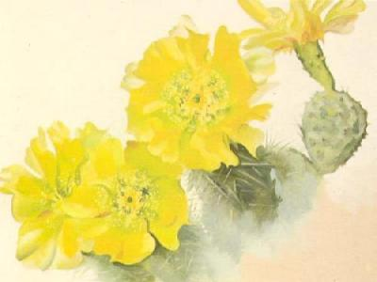

Keywords: Vantage Point, Balance and Shading
Grade: 4th Grade
Month: September/October
Activity: The Art of Nature: Flower Study
TIME: 1.25 hours

Meet The Artist:
- O’Keeffe was born in 1887 on a Wisconsin farm, she was the second of seven children. (She was born about the same time the telephone and light bulb were invented.)
- Her parents believed in the education of women so, O’Keeffe and her sisters were given art lessons which were uncommon for girls at that time.
- By age 13, she was very independent and knew she wanted to be an artist. She had a strong personality, liked to be different and rebelled against being like anybody else.
- As a young woman, she moved first to Chicago and then to New York to study art. While in New York, she met photographer and gallery owner by the name of Alfred Stieglitz. They were married in 1924 and he encouraged her to paint fulltime.
- O’Keeffe’s work from this period included many oversized paintings of flowers. She once said that since we often ignore them in life, she decided to make her flowers too large to be ignored.
- In these early paintings, she reduced nature to its simplest, abstract form by using a very close-up view.
- Beginning in her 40s, she was drawn to New Mexico, which inspired her later paintings. Fascinated by the beautiful New Mexico landscape, she began painting images of the desert and animal bones.
- Over 900 paintings are to her credit.
- She retired in Abiquiu (AB i Q), NM, and painted until her eye sight failed.
- She died in 1986 at the age of 99.
Discussion:
What is the artist’s vantage point? The vantage point is where you think the artist seems to have been standing when the art was created. In this picture, O’Keeffe took a bee’s eye view in order to study the detail.
Why is shading used? Artists use darker colors when they are trying to create a three-dimensional appearance on the object. This technique gives the object depth and helps it to be more real….as you would see it.
Possible Questions:
- What do you see in the painting? What is missing?
- What kind of flower is it?
- How big do you think this flower is in real life?
- Does this flower look delicate or strong? (O'Keeffe often made her paintings simple but strong. The size of the flower makes it seem more powerful.)
- Does this painting looked balanced to you?
- Is the picture symmetrical or asymmetrical?
- Why do you think the artist used dark colors towards the center of each flower? (This technique is called shading)
- What's missing? No Signature, Georgia O'Keeffe chose not to sign her paintings. She felt that the painting itself was a personal signature.
Note to Grade Coordinator or Art Guide: To get the real effect of this activity, bring in real flowers for the students to examine in order for them to see the intricate details of nature.
Activity: The Art of Nature: Flower Study
Materials Needed: 9”x12” watercolor paper, watercolor pencils, water bowls, #6 paint brushes, clean sponges, real or silk flowers or plant, mats for desks. Optional: magnifying glass -pass these out on an as-needed basis.
Process:
- For each student, place a mat, watercolor paper, set of watercolor pencils, brush, bowl of water, small sponge, and flower or plant on each desk.
- Have student label the back of the paper with their name.
- Before you begin, instruct students to select an analogous (i.e. either warm or cool colors) color scheme from their watercolor pencils. The colors may or may not need to be the same color as their flower or plant.
- Tell them to pretend they are looking at their flower or plant as if they were a hovering bee or hummingbird. Encourage them to study the texture, color, variegations and to think about the size of their flower from that vantage point. They may use a magnifying glass.
- Once they have a feel for their flower, lightly sketch it on the paper at that large scale with the darkest watercolor pencil of their color scheme. Have the edges of their flower or plant sketch drop off the sides of the paper so that the item looks very large and close up.
- When the outline of the flower or plant is complete, have them select a lighter color and loosely fill in the petal shapes. They can use their darker colored pencil to add the shading or detail.
- Now the fun part….with their wet paintbrush, wash over each of the petals and see how the colors mix. They don’t need a lot of water to do this. Continue to do this to their flower until they are satisfied. Dab off extra water with the clean sponge.
- Once the watercolor is somewhat dry, they can go back to their darker colors to continue adding the shading or detail…but stop the water usage.
- For the background, have students use the complimentary color of the predominant color they used for the flower to fill in the background. In other words, if Orange was predominantly used, the background will be Blue. Complimentary colors: Blue & Orange, Yellow & Purple, Green & Red.
- Use the water technique to blend in the background and dab off any extra water with a clean sponge.

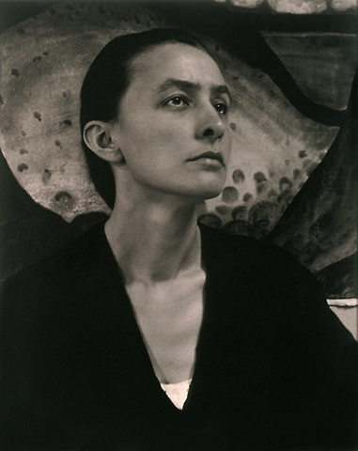
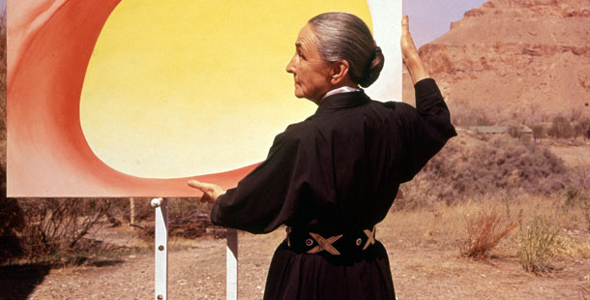
Portrait of Georgia O’Keeffe and other Works
O’Keeffe in New Mexico, 1960

the artist taken by Alfred Stieglitz
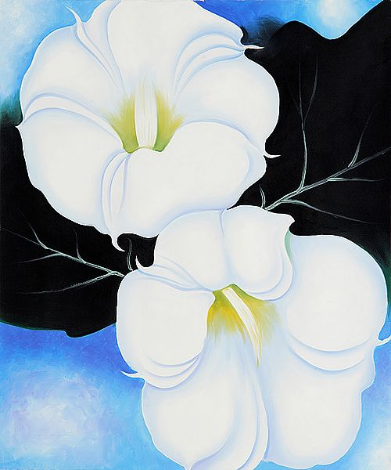

Two Jimson Weeds with Green Leaves and Blue Sky, 1939

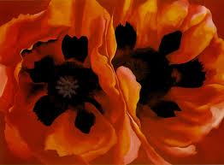
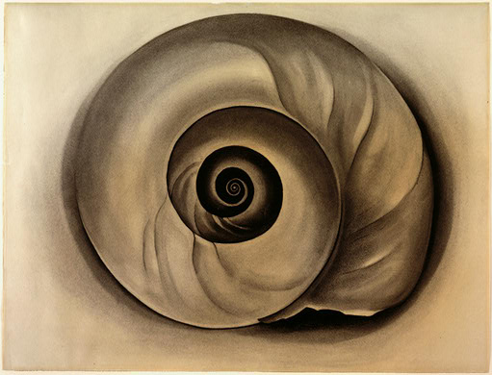
Poppies

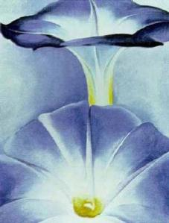
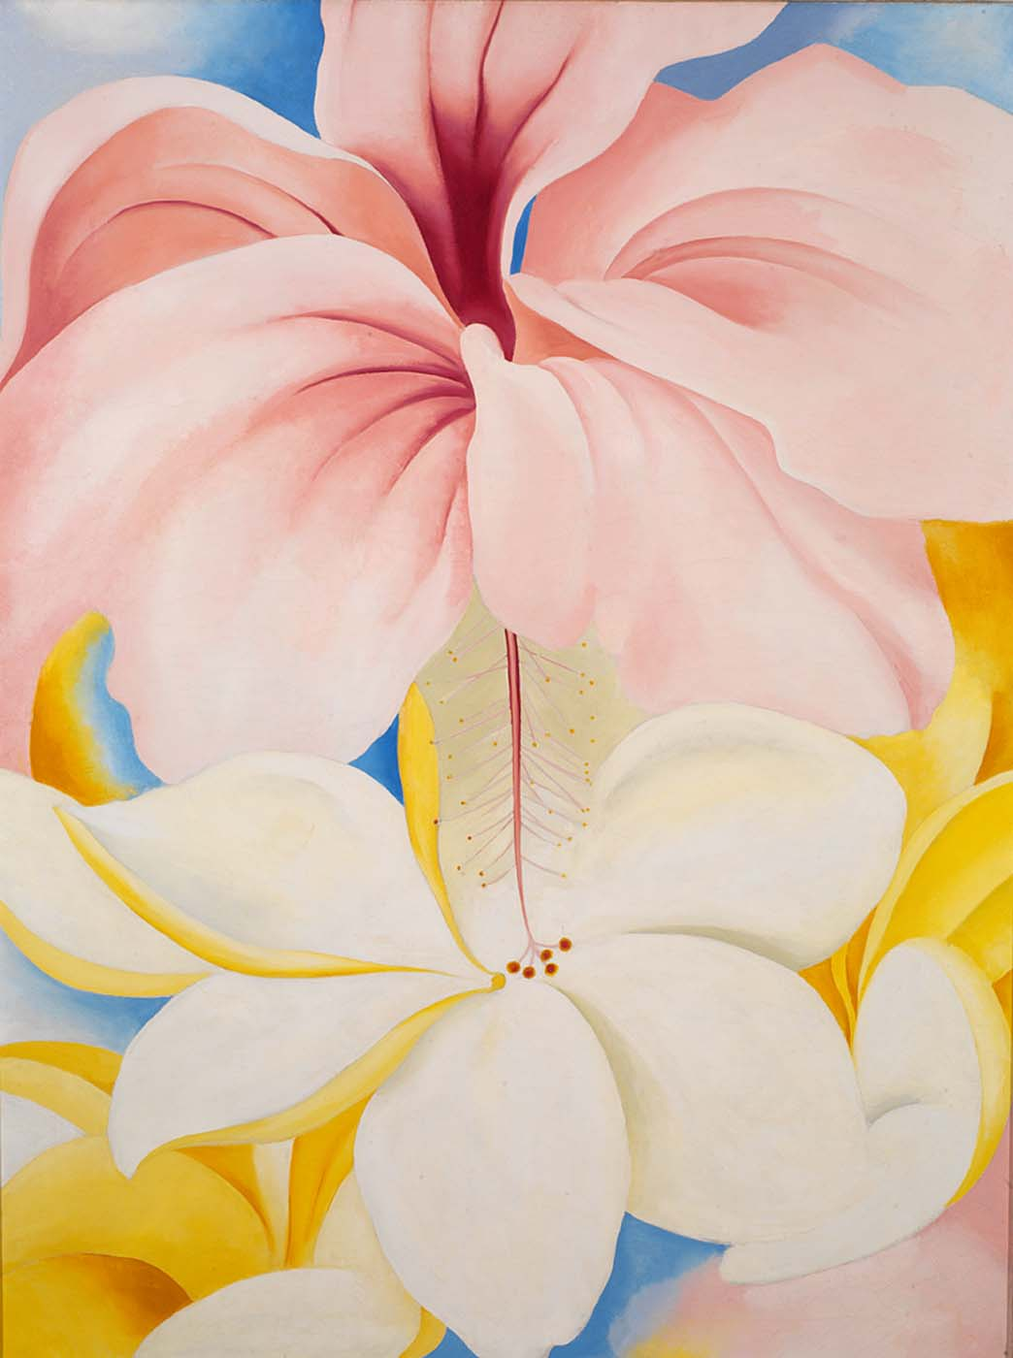
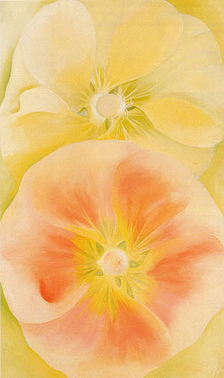
Pink & Yellow Hollyhocks, 1952 Blue Morning Glories, 1935 Hibiscus with Plumeria, 1939
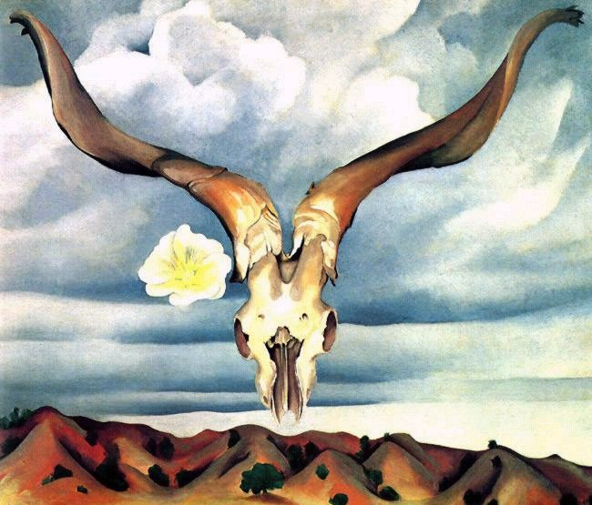

Rams Head White Hollyhock Hills, 1935

