Freshman Honors English: Semester 2 Replacement Assignment (Optional)

Hard Copy Due: __________________________________

Turnitin.com Due: _________________________________

Value: Replaces ONE assignment, up to 100 pts

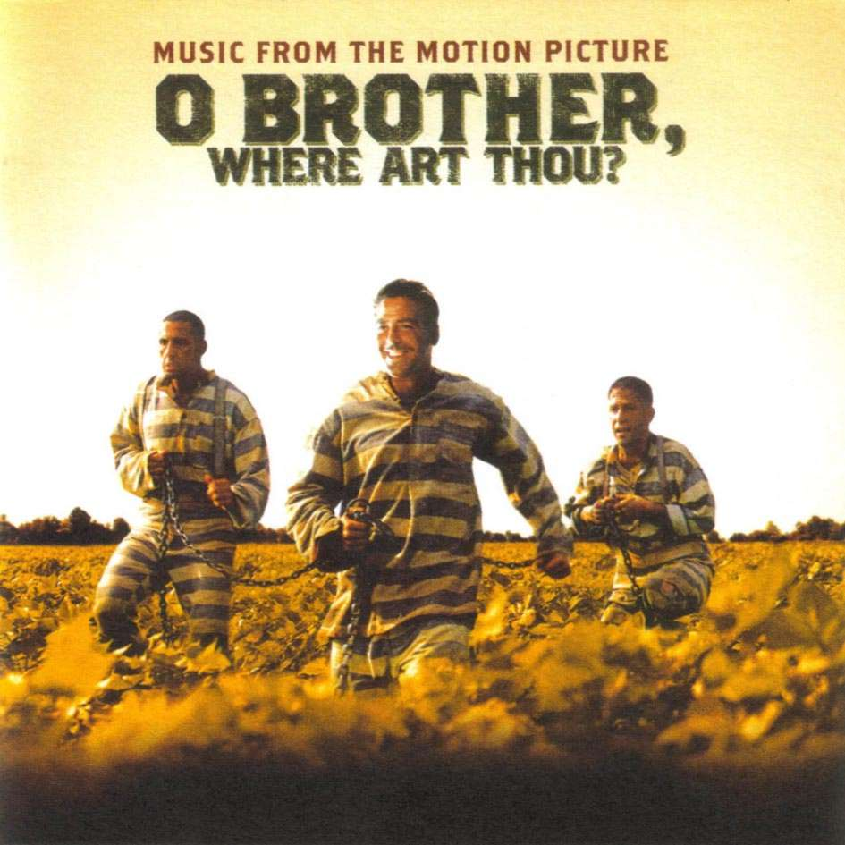

The Assignment
After viewing the film Oh Brother, Where Art Thou (and discovering the many similarities and differences this film has with Homer’s The Odyssey) please select one of the writing prompts below to explore in a multi-paragraph essay:

Prompt A:
How effective is the film Oh Brother, Where Art Thou as a contemporized retelling of The Odyssey? What elements are consistent between the two works, and which are different? Have the changes made by the Coen brothers in the story of The Odyssey affected the message of Homer’s work? In what ways?

Prompt B:
Compare and contrast Odysseus (from The Odyssey) and Ulysses Everett McGill (from Oh Brother, Where Art Thou). Identify the unique heroic/character traits that these characters possessed and decide which you think is more heroic.

Format:
Your final essay must be typed (MLA FORMAT). The TITLE Of your essay must be one of the following:

Prompt A: (Type in the EXACT name of the assignment you are trying to replace with your grade on this essay)
OR
Prompt B: (Type in the EXACT name of the assignment you are trying to replace with your grade on this essay)

***Your title must show which prompt you responded to, as well as the name of the assignment you are trying to replace***
Requirements:
- Your essay must be a minimum of 4 paragraphs long
- Your essay must contain textual evidence from The Odyssey, and specific/descriptive references to the film Oh Brother, Where Art Thou (minimum of 2 pieces of textual evidence per body paragraph)
- Your essay may use the first person (but please limit this to the conclusion of your essay)
- Your essay must adhere to MLA format rules (think about how your format titles of films/larger works)
- Your essay must be POLISHED! Please fix/avoid spelling and grammatical errors!

Grading:
Your essay will be graded based upon the Holistic rubric on the back of these guidelines. You will not receive partial credit for any late work/ essays that are not submitted to turnitin.com.

