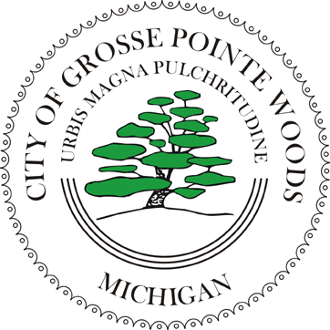

CITY OF GROSSE POINTE WOODS
(313) 343-2440
Fax (313) 343-2785
20025 Mack Plaza Drive
Grosse Pointe Woods, Michigan 48236-2397

NOTICE OF MEETING

COMMISSIONS: |  | COMMITTEES: |  | BOARDS:
Beautification Advisory |  | Building Authority |  | Board of Canvassers
Citizens' Recreation |  | Compensation & Evaluation |  | Board of Review
Community Tree |  | Construction |  | Construction Board of Appeals
Election |  | Finance |  | Downspout Board of Appeals
Historical |  | Community Events Committee |  | Pension
Local Officers Compensation |  | Mack Ave Business Study
Planning |  | Public Relations

Senior Citizens'

PUBLIC INVITED: IN ACCORDANCE WITH PUBLIC ACT 267 OF 1976 (OPEN MEETINGS ACT), ALL MEMBERS OF THE GROUP SELECTED ABOVE, AS WELL AS THE GENERAL PUBLIC, ARE INVITED TO ATTEND THE FOLLOWING MEETING ON Day, Date AT Time IN THE Place GROSSE POINTE WOODS.

AGENDA OF MEETING

- Call to Order
- Roll Call

cc:

(Members)
Fincham
Hathaway
File
Post

Submitted by: Office Held: Telephone:

