Purpose
Setup Standard Notes Job Aid
Use this procedure to setup Note Types and Standard Notes. Note Types are used to categorize standard notes. Standard Notes are used to allow note text to default in on the bill when a standard note code is selected. Standard Notes can be associated with customers or individual bills. Note Types and Standard Notes have been configured as part of the Billing Implementation. Billing Processors are responsible for adding new Note Types and Standard Notes and maintaining existing Note Types and Standard Notes.
To edit an existing Note Type or Standard Note Code, click or click to add a new row and update the appropriate field information after searching for and selecting the value.
To discontinue using a Note Type or Standard Note Code, click or click to add a new row and select Inactive using the Status drop down list after searching for and selecting the value.
Procedure
Setup Note Types
1. Begin by selecting Set Up Financials/Supply Chain ➔ Common Definitions ➔ Notes ➔ Note Types to display the Notes Type Search page.
2. Complete the Find an Existing Value or Add a New Value tab. Enter the SetID and Note Type to display the Notes Type page. The SetID is your Business Unit. If you are adding a new value, ensure that you enter a Note Type ID that will easily identify the Note Type.
Note Types
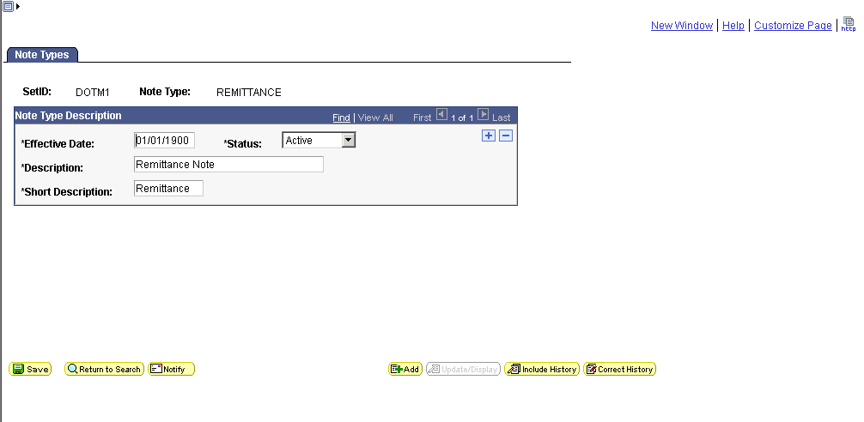
3. Type 01/01/1900 in the Effective Date field.
4. Leave the default of Active in the Status field.
5. Type a Description.
6. Type a Short Description.
7. Click . You have setup a Note Type. This Note Type can now be selected on the Standard Notes page when setting up a Standard Note. Use the procedure below to setup a Standard Note Code.
Setup Standard Notes
1. Select Set Up Financials/Supply Chain ➔ Common Definitions ➔ Notes ➔ Standard Note to display the Standard Note Search page.
2. Complete the Find an Existing Value or Add a New Value tab. Enter the SetID and Standard Note Code to display the Standard Note page. The SetID is your Business Unit. If you are adding a new value, ensure that you enter a Standard Note Code that will easily identify the Standard Note.
Standard Notes
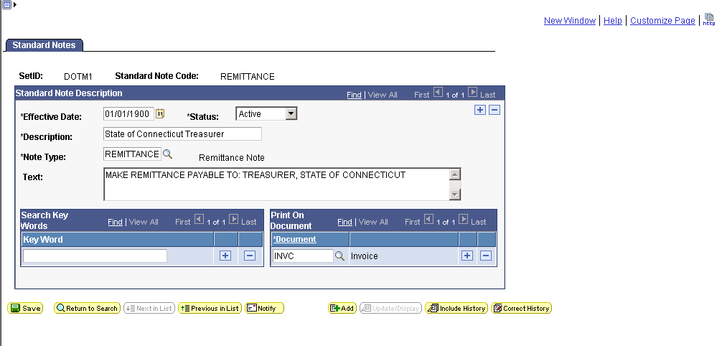
3. Type 01/01/1900 in the Effective Date field.
4. Leave the default of Active in the Status field.
5. Type a Description.
6. Select a Note Type.
7. Type the note text in the Text box. This note will display on the customer invoice when the standard note code is attached to a customer or the individual invoice.
8. Select Invoice (INVC) in the Document field if you want the note to print on the invoice when it is finalized and printed.
9. Click . You have setup a Standard Note code. You may now use this code when entering customer information on the Notes page, when entering bill header information on the Header - Note page, or when entering bill line information on the Line - Note page.

