Chapter 3
Book O

The Nature of Light

Name _______Teacher’s Copy___________________________
Class __________________________________
Test: March 25, 2014 – Next Tuesday!

Chapter 3 –The Nature of Light Outline
Section 1-What is Light? p. 60 - 65

- Light: An Electromagnetic Wave

*Note-An electromagnetic wave is a wave that consists of changing _electric_____________ and ____magnetic________ fields.

A. Electric and Magnetic Fields

- How EM (Electromagnetic) Waves Are Produced

II. The Speed of Light

Note-Light travels at 300,000,000 m/s (meters per second) or 186,000 m/s (miles per second)
That’s 880,000 times faster than sound waves!
Light could travel 7.5 times around the earth in 1 second.

III. Light From the Sun

*Note-The major source of energy on Earth originates from the ____sun______.

Chapter 3 –The Nature of Light Outline
Section 2-The Electromagnetic Spectrum
- Characteristics of EM Waves

*Note-Electromagnetic (EM) waves are arranged in a chart called the Electromagnetic Spectrum by their ____wavelengths_______. The Electromagnetic Spectrum is arranged from long to short waves.
***Electromagnetic Spectrum p. 66-67***

L
E
F
T

___radio__ _microwave __Infrared__ _Visible__ _ultraviolet__ ___X rays_ __Gamma_
R
I
G
H
T
Heat ROY G. BIV
low frequency high frequency
long wavelength short wavelength
“All right, I’ll say Hi to my short Gramma!”
- Radio Waves
    - Broadcasting Radio Signals
    - Comparing AM and FM Radio Waves
    - Radio Waves and Television
*Note-Radio Waves are used to broadcast ______television_____ signals.
*Radio waves have the longest wavelength and the lowest frequency.

- Microwaves
    - Microwaves and Communication
*Note-Microwaves are used by _______cellular phones________ to send and receive signals.

    - Radar

- Infrared Waves
*Note-___Infrared_____________ waves make things warm.

- Visible Light
    - Visible Light From the Sun
*Note-___Visible_______ light is white light the can come from the sun. It contains all the colors that people can see.
B. Colors of Light
Note-Name the colors of light people can see. ROY G. BIV
__red____ __orange____ ___yellow_ ___green__ ___blue___ __indigo____ __violet_______
Left side
Long wavelength
Low frequency
Right side
short wavelength
high frequency
**Say, “Hi” to my short Gramma Violet.
- Ultraviolet Light
    - Bad Effects
*Note-UV (Ultraviolet) light is produced by the sun and can cause a __sun burn_ or ___cancer____________.

- X Rays and Gamma Rays
    - X Rays
*Note-__X Rays_____________ are used to see inside containers without opening them for security purposes at airports.

    - Gamma Rays
*Note-____Gamma Rays____________ are used to treat some forms of cancer.

Chapter 3 –The Nature of Light Outline
Section 3 Interactions of Light Waves p. 74 - 81

- Reflection
*Note-___Reflection______________ is a wave interaction in which a ray of light, sound, or heat bounces off a surface that it does not go through.

- The Law of Reflection
- Types of Reflection
- Light Source or Reflection?
*Note-Objects that produce their own light are called ___Luminous____________.

- Absorption and Scattering
- Absorption of Light
*Note-____Absorption____________ is a wave interaction in which the energy carried by light waves is transferred to particles of matter.

- Scattering of Light
*Note-_____Scattering___________ is a wave interaction with matter that causes light to change its energy, direction of motion, or both.

- Refraction
- Refraction and Material
*Note-__Refraction________ is a wave interaction in which a wave bends as it passes between two substances in which the speed of the wave differs.

- Refraction and Optical Illusions
- Refraction and Color Separation
*Note-When white light is refracted, the amount that the light bends depends on the light’s __wavelength__________________.

- Diffraction
*Note-_____Diffraction____ is a wave interaction in which a wave encounters an obstacle or an edge and changes direction.

- Diffraction and Wavelength

- Interference
- Constructive Interference
*Note-Constructive Interference is a wave interaction that happens when two or more waves overlap and the resulting wave has a greater __amplitude_________________.

- Destructive Interference
*Note-Destructive Interference is a wave interaction that happens when two or more waves overlap and the resulting wave has a smaller ____amplitude___________________.

Chapter 3 –The Nature of Light Outline
Section 4-Light and Color
- Light and Matter
    - Types of Matter
      - Transparent
      - Translucent
      - Opaque
- Colors of Objects
    - Colors of Opaque Objects
*Note-The color of an opaque object is determined by the color that is _____reflected_________.
B. Colors of Transparent and Translucent Objects
*Note-The color of a transparent object depends on the color of light that is _______transmitted_______.

- Mixing Colors of Light
    - Color Addition -- “When the center is WHITE, you’re adding LIGHT”.
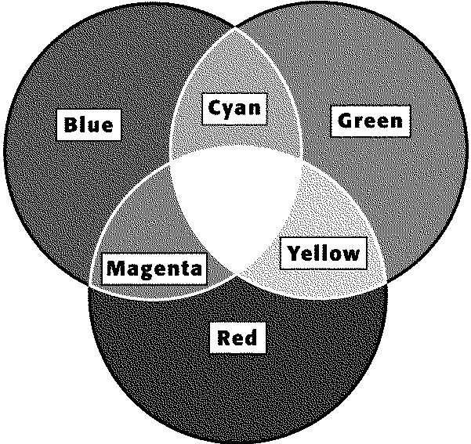
*Note-Primary colors of light combine to produce white light. This is ___Color ____ _____Addition__________.
    - Light and Color Television

- Mixing Colors of Pigment
    - Pigments and Color
    - Color Subtraction- “When colors subtract, you’re left with BLACK.”
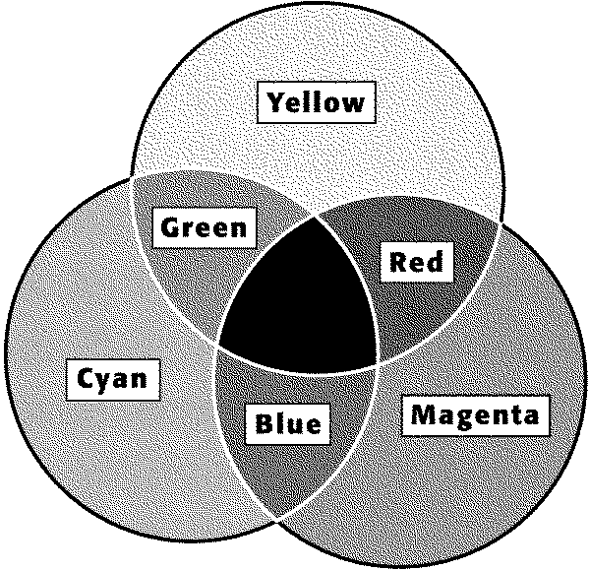 *ON Test*

