LESSON 4: NOTES, RESTS AND SYMBOLS
The Basics
Here is a chart representing the majority of notes, rests and symbols. Note how many counts each is worth when the quarter note gets a beat. (4/4 time, 2/4 time, etc.)
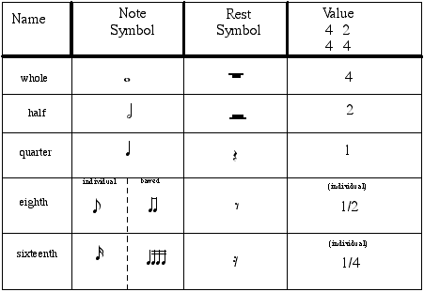

Counting
To count exercises, we use one of two methods. We could use "ta" "ti-ti" and so forth. Or, we could subdivide each beat (1, 2 and[+], 3 ee[e] + a, etc.). Each of the following exercises has both. Use whichever method works best for you first, then try the other.
Example A.1
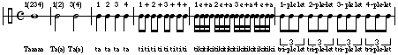
Example A.2
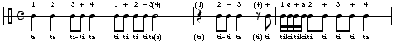
Example A.3
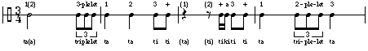
Ties and Dots
If we want to connect two notes to make its value longer, we use a tie. Sometimes, an abbreviation for a tie is used by adding a dot to a note. A dot adds 1/2 the value of the note it follows.
For instance, a half note is worth 2 counts. If we add a dot to it, we add half its' value. Half of 2 is 1. The orginal 2 beats plus the added half-value (1) gives us a total of 3 beats. So, a dotted half note is worth 3 beats.
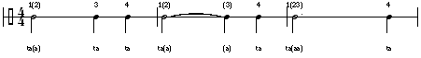
The same can be applied to a quarter note. A quarter note is worth 1 count. Adding a dot adds half its' value. (Half of 1 is 1/2). So, one count plus 1/2 count = 1 1/2 counts for a dotted quarter note.
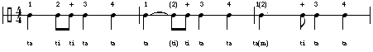
See again how this can also be applied to eighth notes:
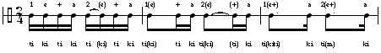
Counting Revisited
Now, apply the same counting exercises with dotted rhythms and ties.
Example A.4
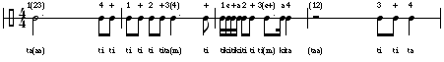
Example A.5
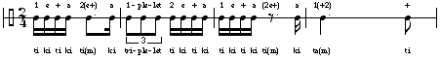
Example A.6
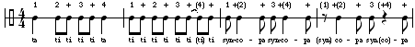
Other time signatures
As we have discussed before (Chapter I), there are more possibilities for time signatures other than a quarter note getting a beat. Here is a modified chart adding in the values for each note in x/8 time signatures (eighth note getting a beat) and x/2 time signatures (half note getting a beat). Notice how the relationships between notes change uniformly across the chart (i.e. 2 eighth notes will always equal 1 quarter note, and so forth).
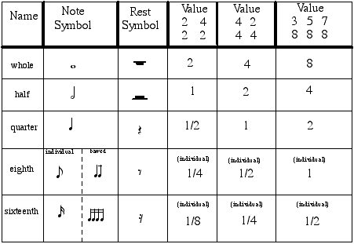
Now, try some of these counting exercises in the other time signatures. When we use more complex time signatures, we use only the subdivision method of counting.
Example B.1
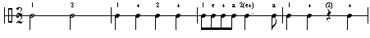
Example B.2
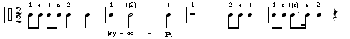
Example B.3
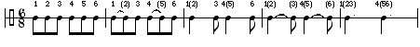
Example B.4
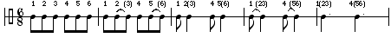
Example B.5
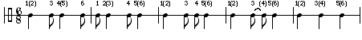
Example B.6
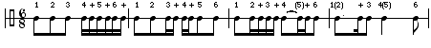
Back to: Theory Help

