Scatter Plot and Linear Regression

Entering and Formatting the Data in Excel
Open Excel.
Your data will go in the first two columns in the spreadsheet (see Figure 1a).
Title the spreadsheet page in cell A1
Label Column A as the name you will give your x values in cell A3. Label cell A4 as “x values”
Label Column B as the name you will give your y values in cell B3. Label cell B4 as “y values”
Enter the data from your worksheet table into the appropriate columns for x and y beginning at cells A5 and B5.

Creating the Initial Scatter Plot
With the data you want graphed, start the chart wizard
Choose the Chart Wizard icon from the tool bar (Figure 3). If the Chart Wizard is not visible, you can also choose Insert > Chart...
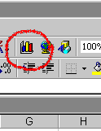
The first dialogue of the wizard comes up
Choose XY (Scatter) and the unconnected points icon for the Chart sub-type (Figure 4a)
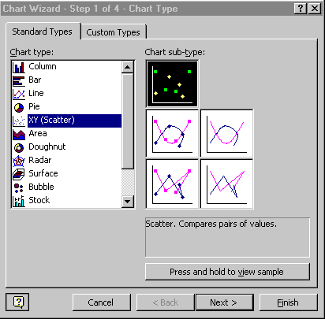

Click Next >
The Data Range box should reflect the data you highlighted in the spreadsheet. The Series option should be set to Columns, which is how your data is organized (see Figure 4b).
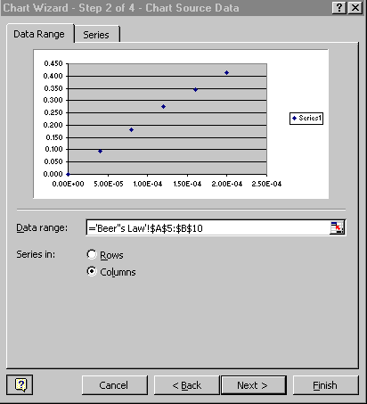
Click Next >
The next dialogue in the wizard is where you label your chart (Figure 4c)
Enter An appropriate title for the Chart Title
Enter the name of the x values for the Value X Axis
Enter the name of the y values for the Value Y Axis

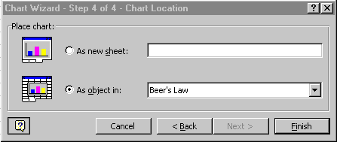
Click Next >
Keep the chart as an object in the current sheet (Figure 4e). Note: Your current sheet is probably named with the default name of "Sheet 1".
Click Finish
Your chart should now appear. If it was done correctly the points should appear to form a line. In order for this line to appear on your graph you need to follow the following steps.
When the chart window is highlighted, besides having the chart floating palette appear, a Chart menu also appears. From the Chart menu, you can add a regression line to the chart.
- Choose Chart > Add trendline...
A dialogue box appears (Figure 6a).
- Select the Linear Trend/Regression type
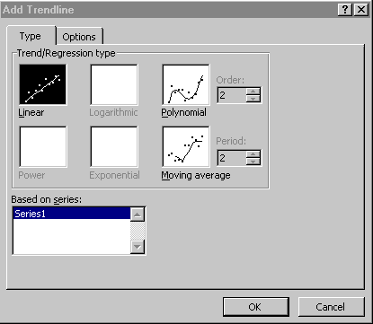

- Choose the Options tab and select Display equation on chart (Figure 6b)
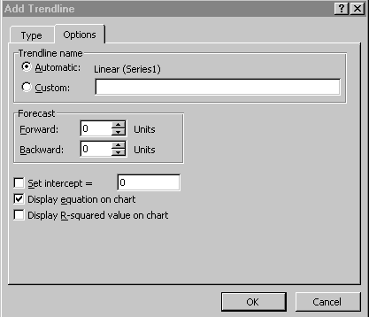
Figure 6b.
- In the forecast section by forward click on the up areas to increase the range in which you will see your linear equation.
The chart now displays the line (Figure 7)
In order to get rid of the legend (that displays series 1, etc.) click on it and hit delete.

