Activity 2.1.2 – Calculating Properties of Shapes Answer Key

Introduction
If you were given the responsibility of painting a room, how would you know how much paint to purchase for the job? If you were told to purchase enough carpet to cover all the bedroom floors in your home, how would you communicate the amount of carpet needed to the salesperson? If you had to place an order for new shingles for the roof of your home, how would you determine the number of shingles needed? Aside from the fact that each of these questions deals with home improvement issues, they all center on the concept of area.

Area describes the measure of a two-dimensional surface. One example of how area is used in engineering is the calculation of stress that develops in an object that is subjected to an external load. If you have ever stretched a rubberband to the point that it breaks, then you have applied an external load to an object that has a constant cross-sectional area. In doing so, you caused stress to build up inside the rubberband until it broke. Another example of how area is used in engineering is the calculation of beam deflection. If you have ever walked across a fallen tree in an effort to cross a creek, then you have experienced the concept of deflection. If the tree had a small diameter, then the amount of deflection would be significant and noticeable. If the tree had a large trunk, then the amount of deflection was probably too small to feel or notice.

Equipment
- Number 2 pencil
- Calculator
- Engineer’s notebook

Procedure
In this activity, you will broaden your knowledge of shapes and your ability to sketch them. You will also learn how to calculate the dimensions and area of a shape. Use points, construction lines, and object lines to sketch the shapes described in the first seven word problems. Use the notes contained in your engineer’s notebook to help you perform the necessary calculations. Calculator use is encouraged, but you must show all of your work.

- Use the sketch below to calculate the area of the square. Add all linear dimensions to the sketch that were used in the calculations. Note: each grid unit = 1 inch
A = bh
b = 8 inches
h = 8 inches
A = 8 * 8
A = 64 in²

- Complete the sketch of the rectangle. It must have an area of 2.25 in². Prove the geometry by dimensioning the sketch and showing the area calculation. Show only those dimensions needed for the area calculation. Note: each grid unit = .25 inch.

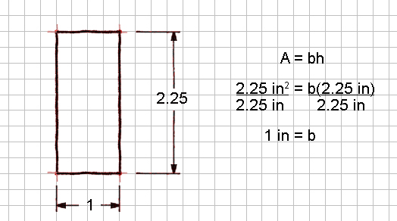

- Use the sketch below to calculate the area of the rhomboid. Add linear dimensions to the sketch that were used in the area calculation. Note: each grid unit = 1 inch
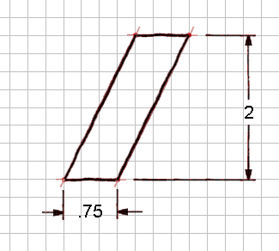
3
8
A = bh
b = 3 inches
h = 8 inches
A = 3 * 8
= 24 in²

- Complete the sketch of the obtuse triangle. It must have an area of 1.75 in². Prove the geometry by dimensioning the sketch and showing the area calculation. Show only those dimensions needed for the area calculation. Note: each grid unit = .25 inch

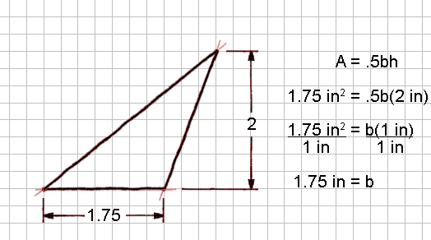

- Use the sketch below to calculate the area of the circle. Dimension sketch, show calculations and label. Note: each grid unit = .25 inch

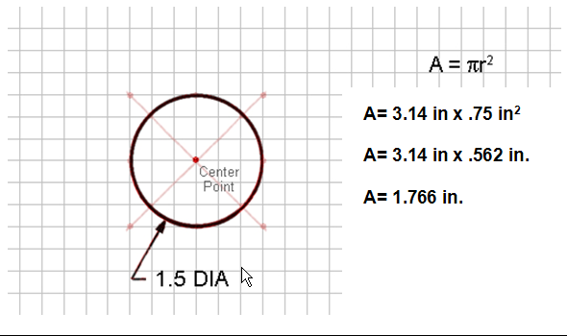

6. A circle has an area of 50.24 in². Solve for the radius and then draw the circle below. Use 3.14 for π. Indicate your grid spacing. Show work.
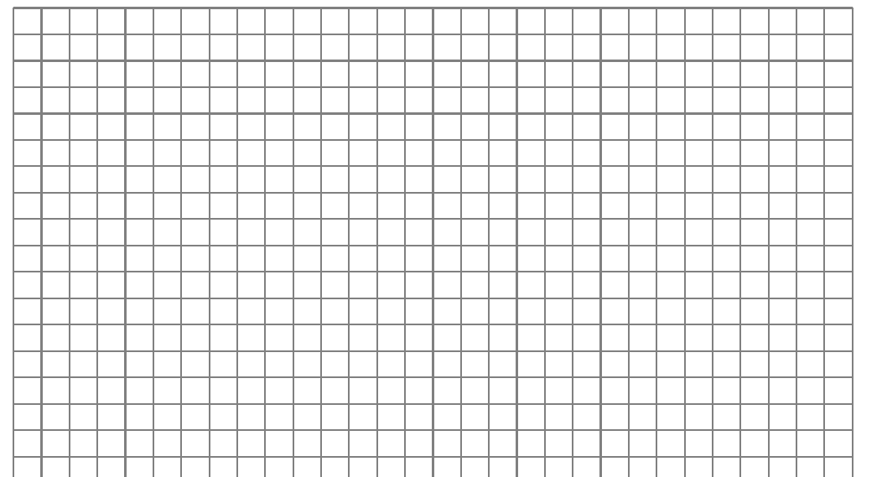
Grid unit = 1inch

$$A=3\text{.}\text{14}r^{2}$$

$$\text{50}\text{.}\text{24}=3\text{.}\text{14}r^{2}$$

$$\frac{\text{50}\text{.}\text{24}}{3\text{.}\text{14}}=\frac{3\text{.}\text{14}r^{2}}{3\text{.}\text{14}}$$
$\begin{aligned}\text{16}=r^{2} \\ \sqrt{\text{16}}=\sqrt{r^{2}} \\ 4=r\end{aligned}$

- You are given a sheet of cardboard that is 8.0 in. x 11.0 in. How many full circles with a diameter of 3.0 inches can you cut from the cardboard? What is the percentage of waste if the excess cardboard (outside the circles) is thrown away? Note: each grid unit = 1 inch Draw a picture and show your work.
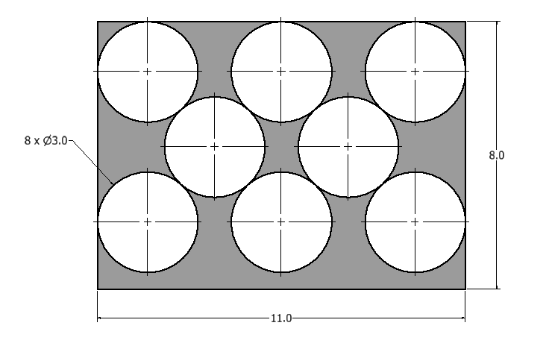 | 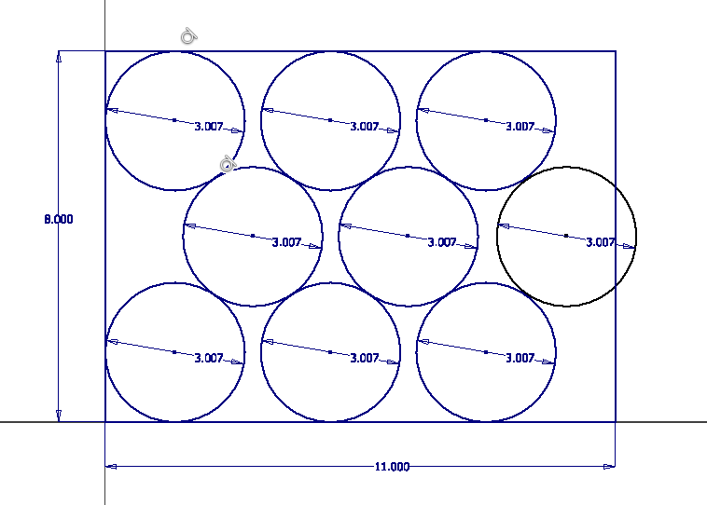
Eight circles can be cut from an 8.0 in. x 11.0 in. sheet, but nine circles will not fit.

Area of eight circles is .
Total area of cardboard = (8.0 in.)(11.0 in.) = 88.0 in.²
Area of Waste = 88.0 in.² - 56.55 in.² = 31.35 in.²
Percent waste =

- Draw a right triangle with a height of 4 meters and base of 9 meters. Calculate the area, the hypotenuse and the perimeter. Show all work and label.

A = .5bh
A = .5(9)(4)
A =18 m²

$a^{2}+b^{2}=c^{2}$
$4^{2}+9^{2}=c^{2}$
$\text{16}+\text{81}=c^{2}$
$\text{87}=c^{2}$
$\sqrt{\text{87}}=\sqrt{c^{2}}$
$\sqrt{\text{87}}=\sqrt{c^{2}}$
9.33 = c = hypotenuse
Perimeter = 9 +4 + 9.33 = 22.33 in

- The trapezoid below has bases of 5 meters and 11 meters and a height of 6 meters. Calculate the area in feet.

$$\frac{5m}{1}⋅\frac{3\text{.}\text{28}\text{ft}}{1m}=\text{16}\text{.}\text{25}\text{ft}$$
$$\frac{\text{11}m}{1}⋅\frac{3\text{.}\text{28}\text{ft}}{1m}=\text{36}\text{.}\text{08}\text{ft}$$
$$\frac{6m}{1}⋅\frac{3\text{.}\text{28}\text{ft}}{1m}=\text{19}\text{.}\text{68}\text{ft}$$

$$A=\text{.}5(a+b)⋅h$$
$$A=\text{.}5(\text{16}\text{.}\text{25}+\text{36}\text{.}\text{08})⋅\text{19}\text{.}\text{68}$$
$$A=\text{514}\text{.}\text{93}\text{ft}$$

- The sketch shown below is of a commercial sign, and was drawn with an area of 10% of the real commercial sign. What is the area of the actual sign? Prove your answer by showing all calculations. Note: each grid unit = 1 inch.
Area 1 = ½ bh = ½ *4 * 3 = 6

Area 2 = Area 3 = ½ bh = ½ * 2*2=2

Area 4 = bh = 7 *4 = 28

Area 5 = ½ πr² = ½ * 3.14 * 2² = ½ * 3.14 * 4 = 6.28

Total Area = Area 1 + Area 2 + Area 3 + Area 4 + Area 5 =
6 + 2 + 2 + 28 + 6.28 = 44.28

Scale of actual figure = 44.28 * 10 = 442.8 in²

Conclusion

- What is the difference between an inscribed polygon and a circumscribed polygon? Draw pictures.

In inscribed polygon is one that has vertices of the polygon coincident with the circle. The polygon would be contained within the circle. A circumscribed polygon is one that has the midpoint of each side coincident with the circle. The circle is contained within the polygon.

