Biology Unit 8 Review: Evolution Name: _____________________

Part One: Construct an original sentence that accurately conveys the meaning of the following terms:

adaptation
analogous structures
directional selection
disruptive selection
evolution
fitness
geographic isolation
gradualism
homologous structures
natural selection
punctuated equilibrium
reproductive isolation
speciation
stabilizing selection
vestigial structure

Part Two: Elaborate on the following:

1. Spontaneous Generation vs. Redi, Needham, Spallanzani, Pasteur

2. Conditions needed for natural selection to occur

3. Three types of natural selection

4. Charles Darwin, HMS Beagle

5. Evidence of biological evolution (fossils, biochemical, comparative anatomy)

6. Geographic isolation vs. Reproductive isolation

7. Allopatric vs. sympatric speciation

8. Catastrophism, gradualism, punctuated equilibrium

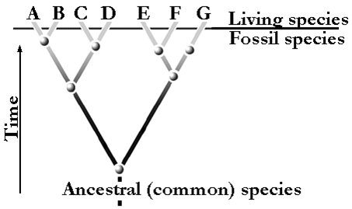

9. Discuss how the figure above displays speciation.

10. Which of the following conclusions is best supported by the data given in the chart?
a. Modern bears evolved from species that are now extinct.
b. The short-faced bear was the ancestor of the Asiatic black bear.
c. Present day bear species are more closely related than their ancestors were.
d. Natural selection favored the brown bear over the American black bear.

