What is a widget?
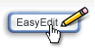
Widgets are web-based tools and gadgets from other web sites that you can embed directly on your page. Like any application on the Web, you should only use those developed by trusted sources.
Widgets are placed on any editable page. To add a widget:
- Click on the "EasyEdit" button and the toolbar will appear.
- Place your cursor where you'd like to display your widget, and click on the "Widget" button in the toolbar.
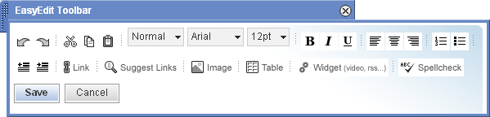
The "Add Widget" dialog will appear.
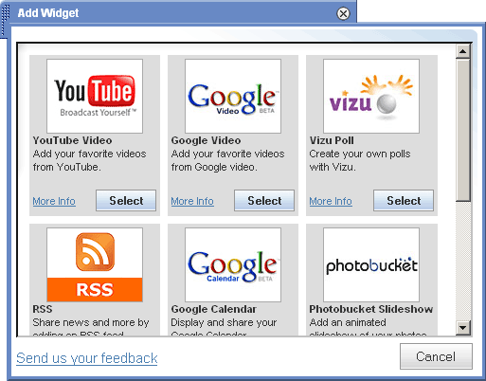
- Select the widget you want to add and follow the instructions for that widget from there.


How do I add a slideshow?
Wetpaint has partnered with Photobucket™ to bring you the best slideshow features on the web. For more information on creating and embedding slideshows from Photobucket, visit their tutorials.
- Once you've created your free slideshow on Photobucket it takes only seconds to add it to your Wetpaint site. To add a slideshow to a Wetpaint page, click on the "EasyEdit" button and the toolbar will appear.
- Place your cursor where you'd like to display your slideshow, and click on the "Widget" button in the toolbar.
The "Add Widget" dialog will appear.
- Select the Photobucket Slideshow widget. The "Add Slidehow" dialog will appear.
- Paste in the “Tag” code from your Photobucket slideshow into the open text field and click “Add Slideshow.”
- After you've added your slideshow, an "Edit Slideshow" dialog will appear. You can change the size of your slideshow by using the (-) or (+) options. You can also change where your slideshow appears in relationship to the copy on the page by using the layout icons. When you're satisfied with the size and layout of your slideshow image, click on the "Done" button.
Note: You cannot view a widget while editing a page; at that time, you will see an icon that represents your widget. Your widget will be viewable after you save the page.

How do I add music?

You can add music player to a page. You can add a single song, use a preexisting playlist, or create your own playlist. For more information on how to use music from imeem, visit their help section.

- To add a music player to a page, click on the "EasyEdit" button and the toolbar will appear.
- Place your cursor where you'd like to display your music player, and click on the "Widget" button in the toolbar.
- The "Add Widget" dialog will appear. Select the Imeem Music widget. The "Add Player" dialog will appear.
- Select your music and enter the code to "embed in your blog, website, etc" from Imeem into the open text field and click "Add Imeem Music."
- After you've added your music, an "Edit Player" dialog will appear. You can change the size of your player by using the (-) or (+) options. You can also change where your player appears in relationship to the copy on the page by using the layout icons. When you're satisfied with the size and layout of your player image, click on the "Done" button.
It is best not to resize the Imeem Music player. The features are easier to use and more visible if you leave the widget the original size.

How do I add video?

- Select either YouTube Video or Google Video. The "Add Video" dialog will appear.
- Paste in the URL or the Embed code from the video into the open text field and click "Add Video." For more information on uploading videos visit the YouTube help center or the Google help center.
- After you've added your video, an "Edit Video" dialog will appear. You can change the size of your video by using the (-) or (+) options. You can also change where your video appears in relationship to the copy on the page by using the layout icons. When you're satisfied with the size and layout of your video image, click on the "Done" button.

How do I add a poll?


- Select the Visu Poll widget. The "Add Poll" dialog will appear.
- Export your poll and copy the code from Vizu into the open text field and click "Add Poll."
- After you've added your poll, an "Edit Poll" dialog will appear. You can change the size of your poll by using the (-) or (+) options. You can also change where your poll appears in relationship to the copy on the page by using the layout icons. When you're satisfied with the size and layout of your poll image, click on the "Done".

Reference source:
http:// wetpaint.com/help#top

