LESSON 2: MUSICAL ALPHABET, SCALE DEGREES AND SOLFEGGIO

The Musical Alphabet
The Musical Alphabet consists of the letters A-G, then it repeats.

A-B-C-D-E-F-G - A-B-C-D-E-F-G - A-B, etc.

Scale Degree Numbers
Since there are seven letters in the Musical Alphabet, there are also 7 scale degrees in a major scale.

1-2-3-4-5-6-7 - 1-2-3-4-5-6-7 - 1-2, etc.

Solfege
For our purposes, we will use solfege (or solfa) for sight singing. These syllables relate directly to the scale degree numbers.

DO (1) - RE (2) - MI (3) - FA (4) - SO (5) - LA (6) - TI (7) - DO (1)
One popular song, which you might recognize, is "Do-Re-Mi," from The Sound of Music.

"Circle of Scales"
This diagram shows the relationship of scale degrees, solfa and note names in a "C Major" scale. If you were to play only the white notes on a piano, this is the scale that would be played.

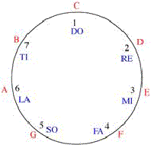

How music moves

Music moves in three different ways:

Up:
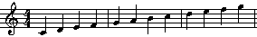

Down:

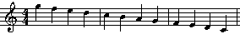

or,

Same:

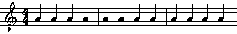

Intervals

As music moves up or down, it either moves by step or skip. The distance between notes is called an interval.

This example moves by step:

This example moves by skip:

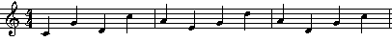

Using numbers, count the lines and spaces in between the two notes including the note you start on and the note you end on. This is how we "count" intervals.

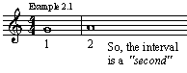

Next, see how other intervals are counted:

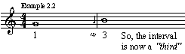

Here are the intervals included within an octave (eight notes apart):

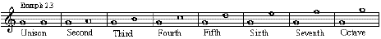
Back to: Theory Help

