Name: ____________________________ No. ____ Date: _______________________________
__
24
__
10
Math Test – Topic E – Equivalent Fractions
Read each question. Circle the correct answer. Show your work.
1. Which pair of squares has the same fraction shaded? 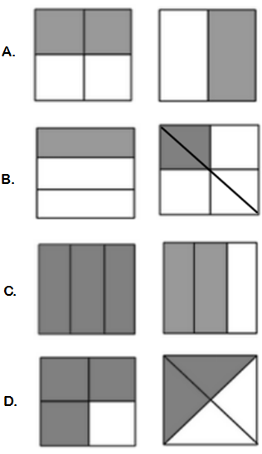

2. Look at the figures below. Circle the figure that is equivalent to 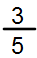 ?
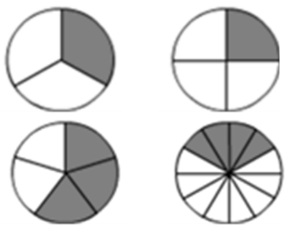
3. What figure is not equivalent to ¼?
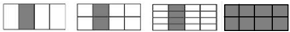
4. What fraction is equal to the marked part of the picture shown below?
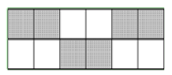
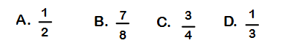
5. Explain your answer to question 4?
_______________________________________________
____________________________________________________________________________________________________________________________________________________________________________________________

6. Fill in the blanks and answer the following question.

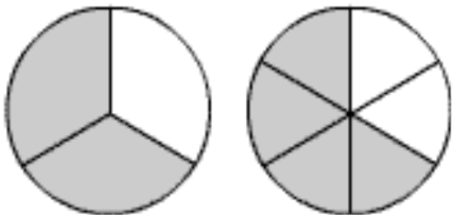

4 sixths is equal to _____ thirds
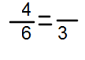
7. Fill in each square to complete the number sentence. Use the area models to help. (4 points)
