Module 5 Topic D Quiz Lessons 14-18 Fractions on the Number Line

Name_____________________ #_____ Date__________
1. Tyler wants to share $1 (100 cents) equally with 9 other friends. What fraction of a dollar will each person receive?

- 1 B. 9
10 10

- 1 D. 1
9 100

2. How much money did each of Tyler’s friends receive?

- 9 cents
- 100 cents
- 10 cents
- 20 cents

3. Bobby covered of a cupcake with frosting. He marked a point on a number line to show how much of the cupcake he covered with frosting. Which number line shows the point Bobby marked?

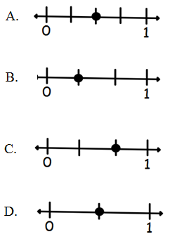

2
4
4. Reagan ate of a candy bar. She marked a point on a number line to show how much of the candy bar that she ate. Which number line shows the point Reagan marked?

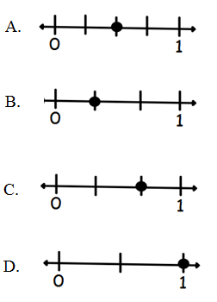

5. Which fraction will correctly complete the number line below?

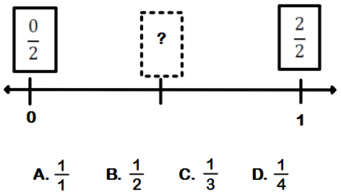

2
3
Page 2

6. Which fraction will correctly complete the number line below?
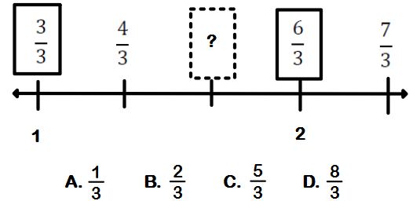

7. Place the two fractions on the number line. Which symbol correctly compares the two fractions?

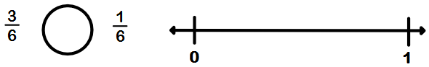

A.

B.

C. =

Constructed Response

In math class, students measured the lengths of their pencils. Jenna’s measured inches long. Craig’s pencil was 2 inches long. Riley’s pencil is inches long. Partition the number line below into ¼ units. Label the fractions under each line and circle the fraction that matches Jenna’s, Craig’s and Riley’s pencils.

- Complete the number line below to help prove your answer.

- Whose pencil is the longest? ________________________________

- List the fractions in order from greatest to smallest.

0 1 2 3
Page 3

For number 9 and 10, Write number bonds. Partition the fraction strip to show the unit fractions of the number bond. Use the fraction strip to help you label the unit fractions on the number line. Include 0 unit fractions.

9. thirds
1
0 1
0 1

10. fourths
1

11. Partition the number line equally to place each of these fractions on the number line: 2 sixths, 4 sixths, and 6 sixths.

Page 4
Constructed Response

Directions: Write your answer to the questions in the spaces provided. This question has more than one part. Be sure to show all of the work you do to find your answer. Even if you cannot answer all parts, answer as many as you can. You may get points for answering part of a question. Write your answers clearly.

Liz and Jay each have a piece of string. Liz’s sting is 4 sixths of a yard long, and Jay’s string is 5 sevenths yard long. Whose sting is longer? Draw a number line to model the length of both strings. Explain the comparison using pictures, numbers, and words.

