
Module 5 Topic C Quiz Lessons 10-13
Name__________________ #_____ Date__________
1. Bill used cup of raisins and cup of
Banana chips to make a snack. Which statement correctly compares the fractions?

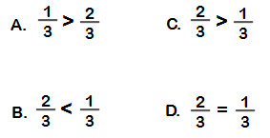

2. Carlos found that ½ of the apples in one basket are Granny Smith apples and of the apples in another basket are Granny Smith apples. The baskets are the same size. Which statement correctly compares the fractions?

- 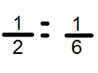 C. 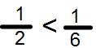

- 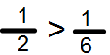 D. 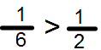

3. Dan and David are on the track team. Dan runs mile each day. David runs mile each day. Which statement is correct?

- David runs farther than Dan each day.
- David runs more than 2 mile each day.
- David runs the same distance as Dan each day
- David runs farther than David each day.

Label the unit fraction. In each blank draw and label the same whole with a shaded unit fraction that makes the sentence true. There is more than 1 correct way to make the sentence true.

4.    Label: _________ | is less than
5.    Label:_________ | is greater than
6.  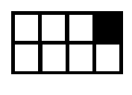  Label: ________ | is greater than

7. Choose the symbol that compares the shape correctly.
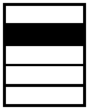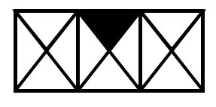

A. <

B. >

C.=

