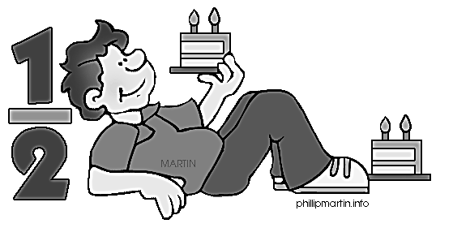
Module 5 Topic B Quiz
Unit Fractions and their Relation to the Whole
Name_____________________#_____ Date_________________
Directions:
Circle the letter to the correct answer. Read the questions carefully. Think and work out the problem before marking your answer choice.

1) George and his 3 friends baked a pizza during his sleepover. They want to share the pizza equally. Show how George can slice the pizza so that he and his 3 friends can each get an equal amount with none leftover.

A. C.

B. D.
4. What fraction is shaded?

- _7 C. _3_
8 4

- _1 D. _6_
7 7

- Tom bought 9 balloons for a party. His friends popped 1 balloon. What fraction of the balloons did his guests pop?

- _1 C. _9_
9 1
- _1 D. _2_
2 8

6. What is the perimeter of a rectangle that is 4 inches long and 3 inches wide?

A. 7 inches
B. 14 inches
C. 21 inches
D. 28 inches

3. What fraction of the balloons were left?

- _7 C. _9_
8 1

- _1 D. _8_
9 9

5. What fraction is NOT shaded?

- _2 C. _3_
4 4

- _1 D. _2_
4 3

Module 5 Topic B Quiz
Lessons 5-9
1

8. Complete the number bond.

A. _7 C. _1_
9 8

B. _1 D. _5_
2 7

- Jerry cooks 8 cups of soup for his family. They eat 7 eighths of the soup. What fraction of the soup is uneaten?
A _7 C. _1_
8 8

B _1 D. _3_
2 4

Constructed Response Question
Directions: Write your answer to the questions in the spaces provided. This question has more than one part. Be sure to show all of the work you do to find your answer. Even if you cannot answer all parts, answer as many as you can. You may get points for answering part of a question. Write your answers clearly.

Jimmy bought 2 ice cream sandwiches. Draw the ice cream sandwiches and estimate to partition each sandwich into 4 equal pieces.

a. Jimmy ate 7 pieces. Shade the amount that was eaten.

b. Write a fraction to show how many pieces of the ice cream sandwiches Jimmy ate.

