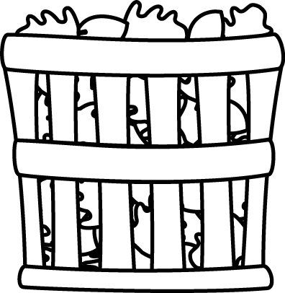
Module 3 Topic A Quiz
The Properties of Multiplication and Division

Name____________________#_____ Date_________
Directions:
Circle the letter to the correct answer. Read the questions carefully. Think and work out the problem before marking your answer choice.

1) Complete the chart. Each bag contains 6 hot dog buns.

Number of bags | 2 |  | 4 | 5
Number of Buns |  | 18 |  |  | 36

2) Use the array to write two different multiplication sentences.

__________= ______ x __________

_________= _______x ___________

2) There are 4 pepperoni slices on each personal pizza. How many pepperoni slices are on 9 personal pizzas?

A. 13
B. 36
C. 4
D. 32

3) What is the total number of sides on 8 triangles?

A. 24
B. 3
C. 16
D. 8

3) Fill in the blanks.

8 x 4 = 5 fours + ______ fours

=________
4) Fill in the blanks.

_____ x 7 = 7 x _____

= 28
For numbers 5 and 6 there are TWO answer choices. Page 2
5) Reagan eats 9 pieces of chocolate a week. After 7 weeks, how many chocolates has she eaten?

A. 16
B. 63
C. 6 tens and 3 ones
D. 5 tens and 4 ones

6) Mrs. Hidalgo bought 32 flags for her neighbors. She gives 8 flags to each neighbor. How many neighbors does she have?

A. 4
B. 26
C. 2 + 2
D. 2 x 0

Use the information below to answer questions 7 and 8.

Mrs. Landry makes 7 flipcharts a day.

7) If she works for 6 days how many flipcharts has she created? Choose the answer that is NOT correct.

A. 42
B. 4 tens and 2 ones
C. 30 + 12
D. 36
8) Why is your answer choice for number 7 incorrect?
__________________________________________________________________________________________________________________________________________________________________________________________
Page 3
Constructed Response Question
Directions: Write your answer to the questions in the spaces provided. This question has more than one part. Be sure to show all of the work you do to find your answer. Even if you cannot answer all parts, answer as many as you can. You may get points for answering part of a question. Write your answers clearly.

Sasha buys 4 dolls for $8 each.

Part A: Write an equation using the letter d to represent the total amount Sasha spent on dolls.

Part B: Solve the equation. What is d equal to?

Part C: Sasha hands the cashier 4 $10 bills. How much money did she give the cashier?

Part D: How much change should Sasha receive? Use the letter c to represent the unknown and then solve.

