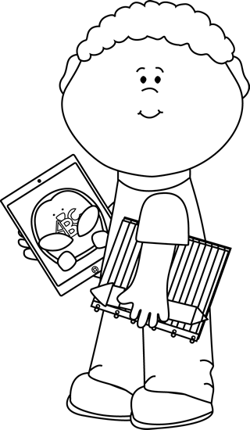
Module 2 Topic E Quiz
Two and Three-Digit Measurement Subtraction Using the Standard Algorithm

Name____________________#_____ Date_________
Directions:
Circle the letter to the correct answer. Read the questions carefully. Think and work out the problem before marking your answer choice.

1) Solve the subtraction problems below. Make sure to show your work.

A) 307g - 130g = B) 452m - 234m= C) 2 km 770m – 1 km 455m =

___________ ____________ ______________
2) The total weight of three candles is 405g. If two of the books weigh 233 grams, how much does the third book weigh?

A) 182 grams
B) 192 grams
C) 638 grams
D) 132 grams
3) The total length of a jump rope is 408cm. Chloe cuts the jump rope into three pieces. The first two pieces are 187 centimeters altogether. How long is the third section?

A) 321 centimeters
B) 572 centimeters
C) 582 centimeters
D) 221 centimeters
2) There are 4 pepperoni slices on each personal pizza. How many pepperoni slices are on 9 personal pizzas?

A. 13
B. 36
C. 4
D. 32

3) What is the total number of sides on 8 triangles?

A. 24
B. 3
C. 16
D. 8

Page 2
4) During recess Jessica and Tammy were jumping rope. The total number of minutes each girl jumped is found below. Jessica says that she jumped 16 minutes longer than Tammy. Tammy says that Jessica jumped only 4 minutes longer. Whose calculation is correct? Explain the mistake of the other person.

______________________________________________________________________________________________________________________________________________________________________________________________________________________________________________________________________________

0sa+++++++++++++++++++++++++++++++++++++++++++++++++++
Person | Minutes
Jessica | 33 minutes
Tammy | 29 minutes

Use the information below to answer questions 5 and 6. There are two answers for each question.

Samuel feeds his dog 156 kg of dog food a month. So far this month he has fed his dog 48kg of dog food.

5) How many more kg of dog food does Samuel have left?

A) 10 tens 8 ones
B) 108
C) 204
D) 20 tens 4 ones
6) How many kgs of dog food does Samuels does eat in two months?

A) 3 hundreds 12 ones
B) 2 hundreds 12 ones
C) 312
D) 212
Page 3
Constructed Response Question
Directions: Write your answer to the questions in the spaces provided. This question has more than one part. Be sure to show all of the work you do to find your answer. Even if you cannot answer all parts, answer as many as you can. You may get points for answering part of a question. Write your answers clearly.

Baggage handlers lift heavy luggage into a plane. The weight of one bag is 65 kg.

Part A) One baggage lifts 3 bags of the same weight. Round to estimate the total weight he lifts. Then, calculate the exact weight.

Estimate________ Actual________

Part B) Another baggage handler lifts luggage that weights a total of 200 kilograms. Write and solve an equation to show how much more weight he lifts than the first handler in Part (a).

Part C) They load luggage for 18 minutes. If they start at 10:25p.m., what time do they finish?

Page 4
Constructed Response Question
Directions: Write your answer to the questions in the spaces provided. This question has more than one part. Be sure to show all of the work you do to find your answer. Even if you cannot answer all parts, answer as many as you can. You may get points for answering part of a question. Write your answers clearly.

A large couch weighs 395 kg. A small couch weighs 239kg.

Part A) Round to the nearest ten to determine the difference in weight between the two couches.

Part B) Find the actual difference between the two couches.

Part C) Round to the nearest hundred to estimate the total weight of the couches.

Part D) Find the actual weight of the two couches.

