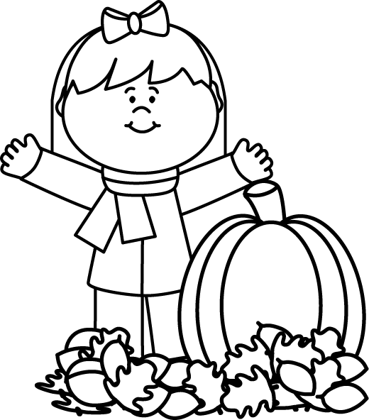
Module 2 Topic C Quiz
Rounding to the nearest ten and hundred

Name____________________#_____ Date_________
Directions:
Circle the letter to the correct answer. Read the questions carefully. Think and work out the problem before marking your answer choice.

For numbers 1 and 2 round to the nearest ten. Label the number line and solve the problem.

2) 157 ≈ ____

A) 160
B) 150
C) 100
D) 200

1) 43 ≈ _____

A) 50
B) 45
C) 40
D) 43

For numbers 3 and 4 round to the nearest hundred. Label the number line and solve the problem.
3) 564 ≈ ______

A) 500
B) 600
C) 650
D) 550
4) 1214 ≈ _______

A) 1000
B) 1300
C) 1250
D) 1200

Page 2
5) Erin gets off of the bus at 3:47 p.m. Round the time to the nearest ten minutes.

A) 3:50
B) 3:40
C) 3:45
D) 4:00
6) Circle the NUMBERS that round to 600.

678
579
523
612
1,624
1,678
7) Emily weighs her dog. The weight of the dog is shown on the scale. What is the weight of the dog rounded to the nearest 10 kilograms?
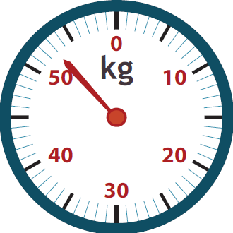

A) 50 kg
B) 55 kg
C) 60 kg
Page 3
Constructed Response Question
Directions: Write your answer to the questions in the spaces provided. This question has more than one part. Be sure to show all of the work you do to find your answer. Even if you cannot answer all parts, answer as many as you can. You may get points for answering part of a question. Write your answers clearly.

Jessica rounded the number 457 to the nearest ten. She says the answer is 460. Is she correct?

Part A: Draw a number line that shows how Jessica rounded.

Part B: Is Jessica’s answer correct? Explain why or why not.
_______________________________________________________________________________________________________________________________________________________________________________________

Part C: Jessica then took the number 457 and rounded it to the nearest hundred. Draw a number line to show how 457 can be rounded to the nearest hundred.

Part D: Jessica said the answer is 400. Is she correct? Why or why not?
_______________________________________________________________________________________________________________________________________________________________________________________

Page 4
Constructed Response Question
Directions: Write your answer to the questions in the spaces provided. This question has more than one part. Be sure to show all of the work you do to find your answer. Even if you cannot answer all parts, answer as many as you can. You may get points for answering part of a question. Write your answers clearly.

The teacher asks students to round 468 to the nearest ten. Jamie says that it is four hundred seventy. Alex disagrees and says it is 47 tens. Who is correct? Explain your thinking. Write using complete sentences.

_________________________________________________________________________________________________________________________________________________________________________________________________________________________________________________________________________________________________________________

