
Module 1 Topic F Quiz
Distributive Property and Problem Solving Using Units 2-5 and 10

Name____________________#_____ Date_________
Directions:
Circle the letter to the correct answer. Read the questions carefully. Think and work out the problem before marking your answer choice.

1) How many toes are on 6 babies?

Ⓐ 6
Ⓑ 10
Ⓒ 16
Ⓓ 60

4) Fill in the blanks to complete the equation.

2) There are 4 pepperonis on each personal pizza. How many pepperonis are on 9 personal pizzas?

Ⓐ 13
Ⓑ 36
Ⓒ 4
Ⓓ 32

3) What is the total number of sides on 8 triangles?

Ⓐ 24
Ⓑ 3
Ⓒ 16
Ⓓ 8

Page 2
5) Solve the equation.

27÷3=

Ⓐ 3
Ⓑ 9
Ⓒ 11
Ⓓ 27
8) Sam has 18 marbles. He has an equal number of red, blue, and green. If Sam gives all of his red marbles to his sister, how many marbles does he have left?

Ⓐ 3
Ⓑ 6
Ⓒ 12
Ⓓ 18
7) Raine has been running three laps a week at the local track. The sixth week she ran four laps instead of three. Draw and label a tape diagram to represent the total number of laps she ran.

6) Solve the equation below using any method.

2 x 9 =

Ⓐ 9
Ⓑ 18
Ⓒ 27
Ⓓ 11

9) Gerald needs to buy gloves for all six of his sisters. How many individual gloves will Gerald need to buy?

Ⓐ 12
Ⓑ 20
Ⓒ 15
Ⓓ 25
Page 3
Constructed Response Question
Directions: Write your answer to the questions in the spaces provided. This question has more than one part. Be sure to show all of the work you do to find your answer. Even if you cannot answer all parts, answer as many as you can. You may get points for answering part of a question. Write your answers clearly.

Seven children share 28 seashells equally.
28 seashells

Part A: How many seashells does each child get? Enter your answer into the box:
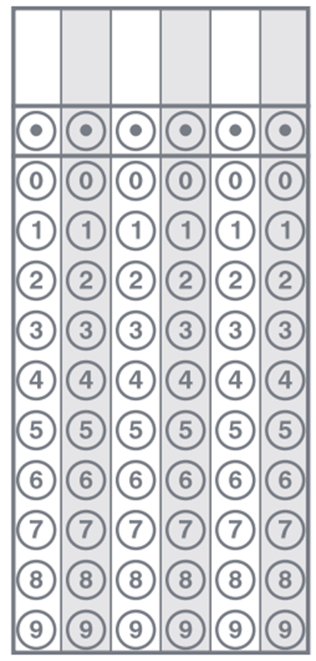

Page 4
Part B: How many seashells do three children get? Enter your answer into the box:

Part C: Fill in the boxes above on the tape diagram to show part A and part B.

Constructed Response Question
Directions: Write your answer to the questions in the spaces provided. This question has more than one part. Be sure to show all of the work you do to find your answer. Even if you cannot answer all parts, answer as many as you can. You may get points for answering part of a question. Write your answers clearly.

Jamie buys 21 feet of rope. She cuts it into pieces that are 3 feet long each.

Part A: How many pieces of rope does she cut?

Part B: If she needs a total of 12 pieces of rope, how many more pieces does she need?

