
Module 1 Topic B Quiz
Division as an unknown factor problem
Name____________________#_____ Date_________
Directions:
Bubble the letter to the correct answer. Read the questions carefully. Think and work out the problem before marking your answer choice.

1) Look at the picture below. Which equation matches the picture?

Ⓐ 5 ÷ 3 = 15
Ⓑ 3 ÷ 5 = 15
Ⓒ 15 x 3 = 5
Ⓓ 15 ÷ 3 = 5
Use the diagram below to complete problems 3 and 4.

3) Look at the triangles below. Divide the triangles into groups of two.

2) Jamie has 12 pencils. She puts them into two equal groups. How many pencils are in each group? Draw a picture if you need to.

Ⓐ 6
Ⓑ 12
Ⓒ 14
Ⓓ 24
4. How many groups of triangles do you have?

Ⓐ 2
Ⓑ 3
Ⓒ 4
Ⓓ 5

Page 2
5) Jamie purchased 12 bananas to make banana splits. Each banana split needs 2 bananas. Which equation can Jamie use to find out how many banana splits he can make?

Ⓐ 2 x 12 =24
Ⓑ 2 + 6 = 8
Ⓒ 12÷2=6
Ⓓ 8 – 6 = 2

For problems 8 and 9, use the following equation.

12 ÷ 6 =______

8) What is another way to solve the equation?

Ⓐ 6 + 12 = _______
Ⓑ 6 x ___ = 12
Ⓒ 12 - ______ = 12
Ⓓ 6 - _____ = 12
6. Each mini pizza at Rouses has 5 pepperonis on it. How many pepperonis are on 6 pizzas? Draw a picture if you need to.

Ⓐ 5 x 6 = 30
Ⓑ 5 + 6 = 11
Ⓒ 6 – 5 = 1
Ⓓ 5 x 6 = 11

7. Jessica made 18 pieces of fudge for the bake sale. She will divide the fudge up equally into Zyploc bags. Jessica puts 3 pieces of fudge into each bag. How many bags of fudge can Jessica make?

Ⓐ 26 Fill in the blanks to write an equation that matches.
Ⓑ 22 _______ ÷ ________ = __________
Ⓒ 15
Ⓓ 6 What does the quotient represent?
____________________________________________________________________
9) What number should go in the blank?

Ⓐ 2
Ⓑ 4
Ⓒ 6
Ⓓ 8
Page 3
Constructed Response Question
Directions: Write your answer to the questions in the spaces provided. This question has more than one part. Be sure to show all of the work you do to find your answer. Even if you cannot answer all parts, answer as many as you can. You may get points for answering part of a question. Write your answers clearly.

Riley has 20 pencils. He divides the 20 pencils onto four desks. Each desk has the same number of pencils.

Part A: Draw the correct number of pencils on each desk. Each box represents one desk.

Part B: There are _____ pencils on each table. Enter your answer into the box:
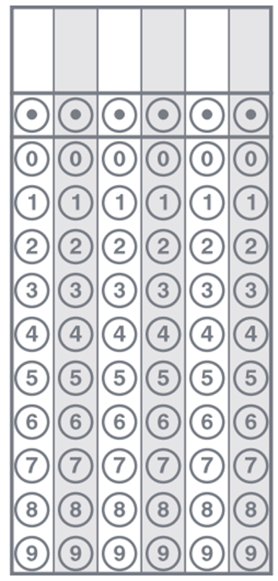

Part C: Fill in the blanks.

______ ÷ _______ = __________
Page 4
Constructed Response Question
Directions: Write your answer to the questions in the spaces provided. This question has more than one part. Be sure to show all of the work you do to find your answer. Even if you cannot answer all parts, answer as many as you can. You may get points for answering part of a question. Write your answers clearly.

Jessica put 24 eggs into egg cartons. Each egg carton holds six eggs.

Part A: Circle the eggs in groups of six.

How many eggs are in each group? ______________________________

Part B: Fill in the blanks with the correct number.

___x 6 = 24 24 ÷ 6 = ____

What does the number in the blank represent?__________________________

Part C: Drawn an array below to model the problem.

